
Actividad 3: Abstract Gráfico
Inteligencia artificial para textos científicos
Ileana Tapia Castillo – A01773374
Profesor: Andrés Antonio Abundis Serrano
Fecha: 17/09/2026
Tema: Robots colaborativos (cobots) en manufactura

Artículo base:
Palanisamy, C., Perumal, L., & Chin, C. W. (2025). A Comprehensive Review of Collaborative Robotics in Manufacturing. Engineering, Technology & Applied Science Research, 15(2), 21970–21975. https://doi.org/10.48084/etasr.9709
Prompt utilizado:
1. Task context: Generate a professional graphical abstract for a scientific review paper. The image should function as a visual summary of the research methodology, findings, and conclusion.
2. Tone context: The tone must be scientific, clean, professional, and clear, like an infographic from a high-impact journal (e.g., Nature or an MDPI journal). Use a consistent, limited color palette (navy blue, steel gray, and a clean green/orange accent). Flat vector style, no 3D, no clutter.
3. Background data: The study is "A Comprehensive Review of Collaborative Robotics in Manufacturing" by Palanisamy, Perumal & Chin (2025), Engineering, Technology & Applied Science Research, 15(2). It is a systematic literature review (2015-2024, Scopus/Web of Science/IEEE Xplore) on collaborative robots (cobots) in manufacturing, covering benefits, industry applications, human-robot interaction, safety, programming interfaces, and adoption challenges.
4. Detailed task description & rules: Create a widescreen (16:9) image organized into three horizontal sections.
Top Title Banner: "A Comprehensive Review of Collaborative Robotics in Manufacturing" with subtitle "Palanisamy, Perumal & Chin (2025)".
Top Row (Methodology): a left-to-right flow with 3 icons connected by arrows.
Icon 1: database icon, label "Systematic Search (2015-2024)".
Icon 2: funnel icon, label "Study Selection".
Icon 3: document with magnifying glass icon, label "Thematic Synthesis".
Middle Section (Key Findings), two panels side by side:
Left Panel, title "Benefits & Industry Applications", bullets: Higher productivity and reduced repetitive strain; Applications in assembly, machine tending, healthcare, logistics, agriculture; Case studies: OMRON TM12 at CLECA, UR10 at Opel.
Right Panel, title "Challenges & Research Themes", bullets: Human-robot interaction and no-code programming interfaces; ML-based safety and collision avoidance; High cost, training needs, risk of job displacement.
Bottom Section, heading "CONCLUSION & FUTURE DIRECTIONS", bullets: Advance intuitive HRI (NLP, gesture recognition); Develop AI-driven, real-time learning cobots; Modular low-cost designs and universal safety standards; Reskilling programs to offset job displacement.
5. Examples: Use the visual style of a scientific graphical abstract, similar to those in Kidney International or Nature reviews, with clear visual separation between sections.
6. Conversation history: Not applicable.
7. Immediate task: Generate the graphical abstract now based on the detailed description above.
8. Step by step: First create the three-section horizontal layout. Place the title banner. Then build the methodology flow with the 3 icons and exact labels. Then design the two-panel findings section with bulleted lists as specified. Finally add the conclusion box at the bottom with its bulleted list. Ensure all text is legible, correctly spelled, and exactly as provided.
9. Output formatting: A single, high-resolution PNG or JPEG image, 16:9 aspect ratio.
10. Prefilled response: Not applicable.

1.- Claude (diseño HTML/CSS)
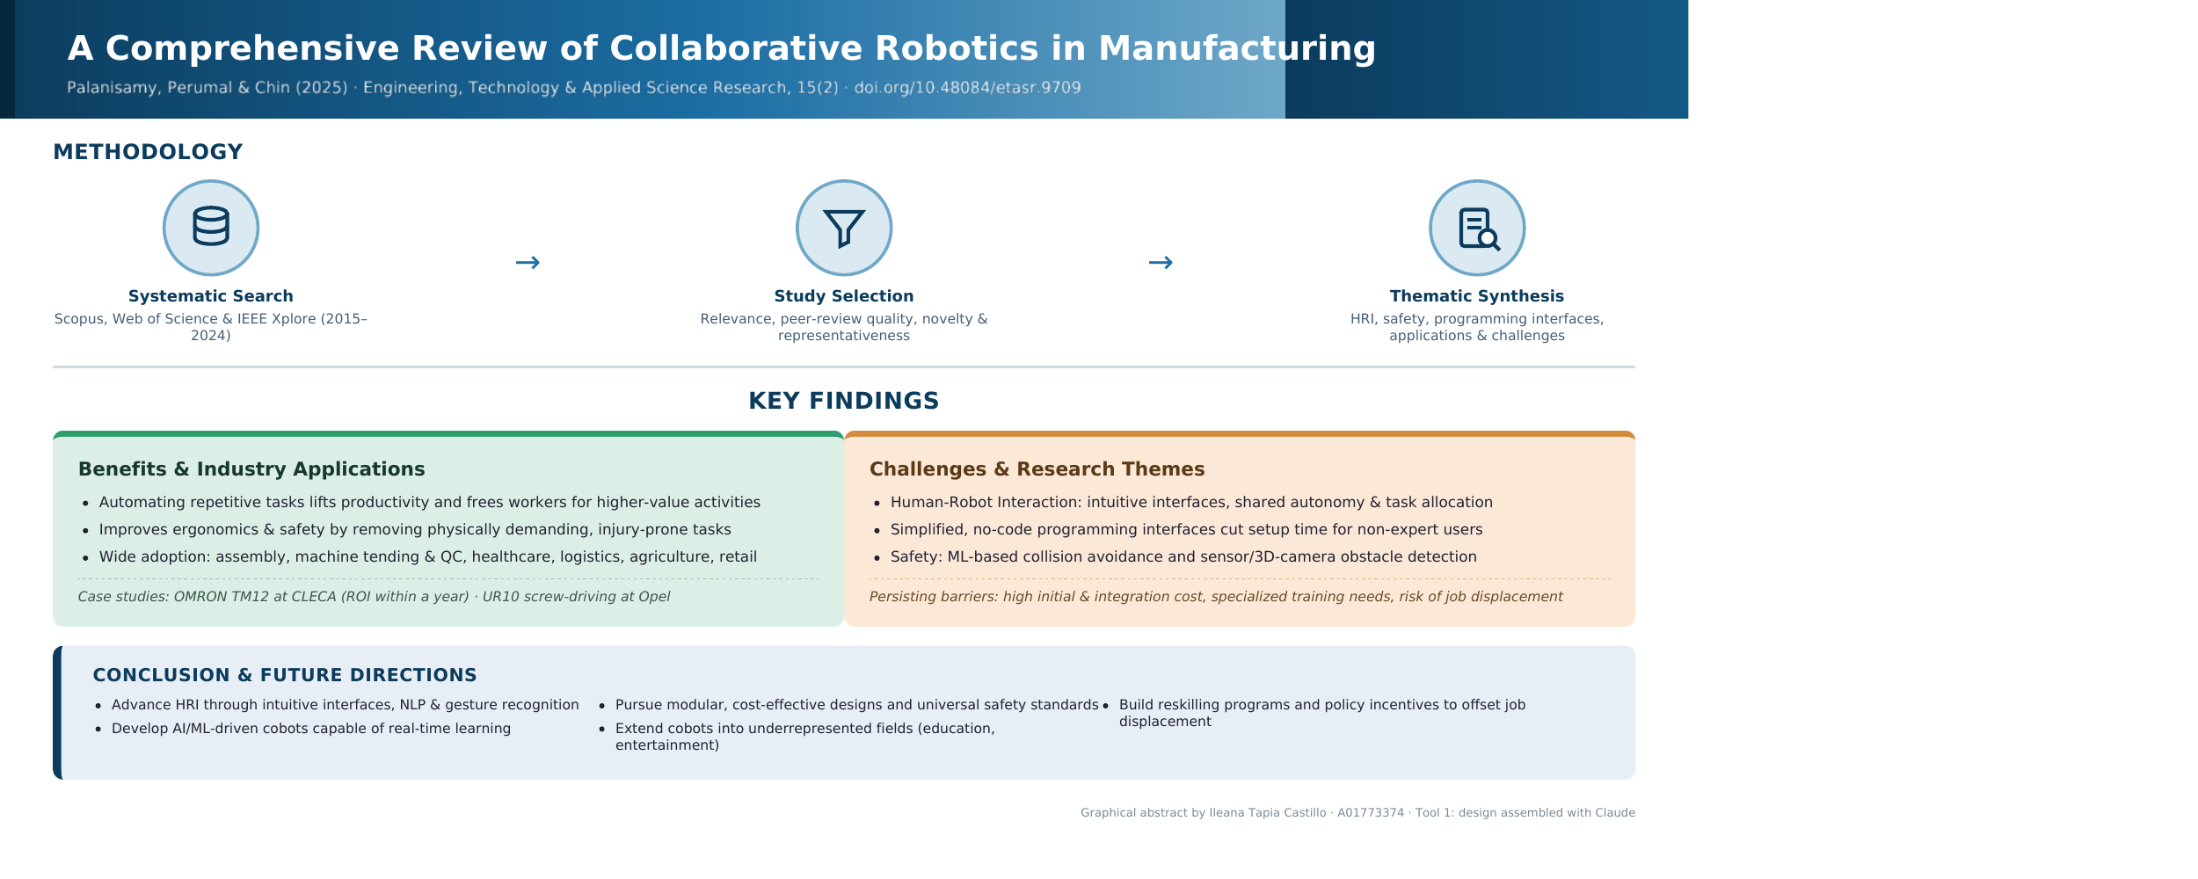

2.- Gemini
