Alejandro Ossio, A01209122

Gerardo Naranjo, A01209499

Roberto Figueroa, A01209689

**Laboratory Exercise 01: Computer Interfacing and Peripheral Equipment**

**08/22/2018**

**Material:**

* TTL logic gates: 74LS04, 74LS00, 74LS08, 74LS02, 74LS32, 74LS86, 74LS14 (Schmitt trigger).
* CMOS logic gates: CD4069, CD4081, CD4001, CD4071, CD4070, CD40106 (Schmitt trigger).
* Diodes: 1N4148 or 1N914.
* One 2.2K resistor, one 15pF capacitor, one 47pF capacitor (used as a 50 pF).
* One protoboard.
* One breadboard.
* Two power supplies, 1 fixed at 5V and the other variable from 0 to 5V.
* 2 multimeters.

**Description of the practice. Part 1: Obtain $V_{IL}$, $V_{IH}$, $V_{OL}, V_{OH}$, $V_{M}$, $V_{TW}$ and $V_{LS}$ in tabular using Excel for each of the gates shown in Figure 1. Load the TTL and CMOS outputs according to Figure 2. Once yo have a voltage table for each of the gates in Figure 1, plot the voltage transfer characteristic curve using Excel. It should roughly look like Figure 3.**

|  |  |  |  |
| --- | --- | --- | --- |
|  |  |  | |
| NOT  74LS04 (TTL)  CD4069 (CMOS) | NAND  74LS00 (TTL)  CD4011B (CMOS) | AND  74LS08 (TTL)  CD4081B (CMOS) | |
|  |  |  | |
| NOR  74LS02 (TTL)  CD4001B (CMOS) | OR  74LS32 (TTL)  CD4071B (CMOS) | XOR  74LS86 (TTL)  CD4070B (CMOS) | |
| Figure 1: TTL and CMOS Logic Gates for Part 1 of exercise | | | |
|  | | |  | |
| Figure 2: TTL Output Load (RL = 2.2k; CL = 15pF) | | | Figure 2: CMOS Output Load (CL = 50pF) | |
|  | | |  | |
| Figure 3: Voltage transfer characteristic for the 74LS04 | | | Figure 3: Voltage transfer characteristic for the CD4069B | |

Results are on next page.

**Results:**

**74LS04:**

$$V_{IH}=1.15V$$

$$V_{IL}=0.6V$$

$$V_{OH}=4.36V$$

$$V_{OL}=0.21V$$

$$V_{M}≈1.2V$$

$$V_{LS}=V_{OH}-V_{OL}=4.36V-0.21V=4.15V$$

$$V_{TW}=V_{IH}-V_{IL}=1.15V-0.6V=0.55V$$

**74LS14**

$$V_{IH}=1.6V$$

$$V_{IL}=0.7V$$

$$V_{OH}=4.39V$$

$$V_{OL}=0.18V$$

$$V_{M}≈0.7V$$

$$V_{LS}=V_{OH}-V_{OL}=4.39V-0.18V=4.21V$$

$$V_{TW}=V_{IH}-V_{IL}=1.6V-0.7V=0.9V$$

**CD4069:**

$$V_{IH}=3.2V$$

$$V_{IL}=1.65V$$

$$V_{OH}=4.9V$$

$$V_{OL}=0.01V$$

$$V_{M}≈0.V$$

$$V_{LS}=V_{OH}-V_{OL}=4.9V-0.01V=4.89V$$

$$V_{TW}=V_{IH}-V_{IL}=3.2V-1.65V=1.55V$$

**CD40106:**

$$V_{IH}=2.3V$$

$$V_{IL}=2.25V$$

$$V_{OH}=4.96V$$

$$V_{OL}=0V$$

$$V_{M}≈2.2V$$

$$V_{LS}=V_{OH}-V_{OL}=4.96V-0V=4.96V$$

$$V_{TW}=V_{IH}-V_{IL}=2.3V-2.25V=0.05V$$

**Now than you have the voltage transfer characteristic curves for each gate in Figure 1, use the setup depicted in Figure 4 to obtain the voltage transfer characteristics again. Setup the oscilloscope to display the input signal from the signal generator which is connected to the input of the gate to channel 1. Connect channel 2 of the oscilloscope to the output of the D.U.T. Use the X-Y graph of the oscilloscope. Try to save or take pictures of the oscilloscopes screen to include them in your report.**

|  |
| --- |
|  |
| Figure 4: Obtaining voltage transfer characteristic curve (VTC) with a signal generator and oscilloscope |

Results are on next page.

**74LS04:**

Format YT:

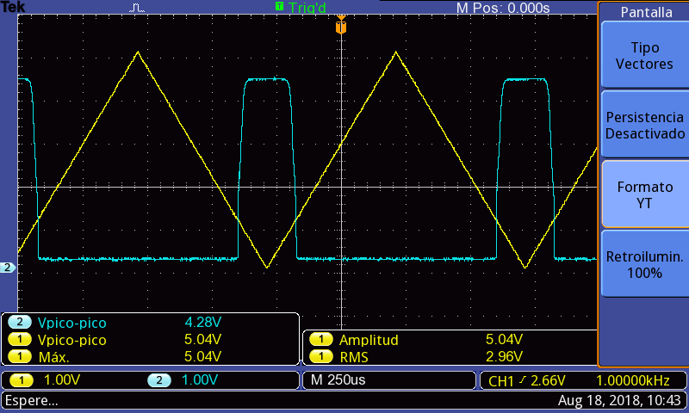

Format XY:

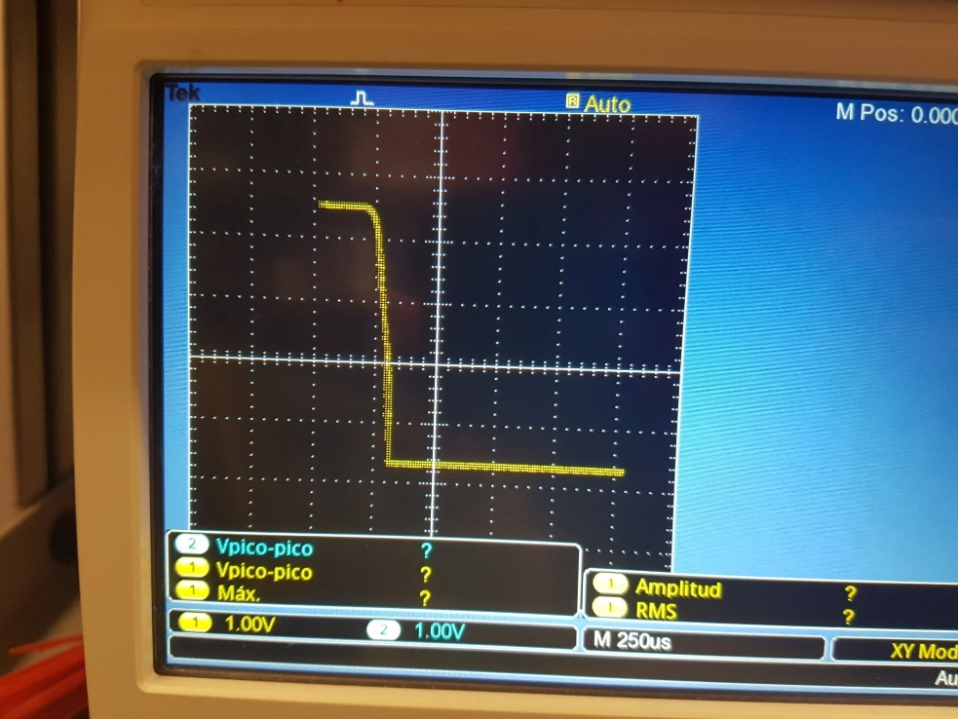

**74LS14:**

Format YT:

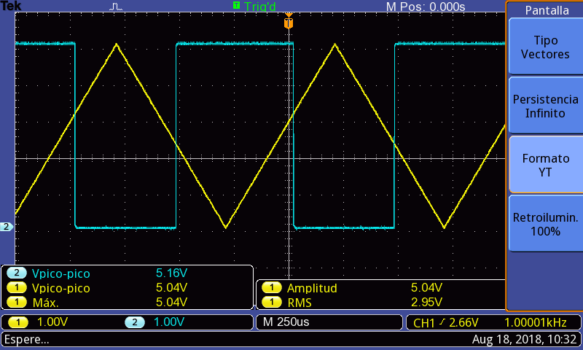

Format XY:

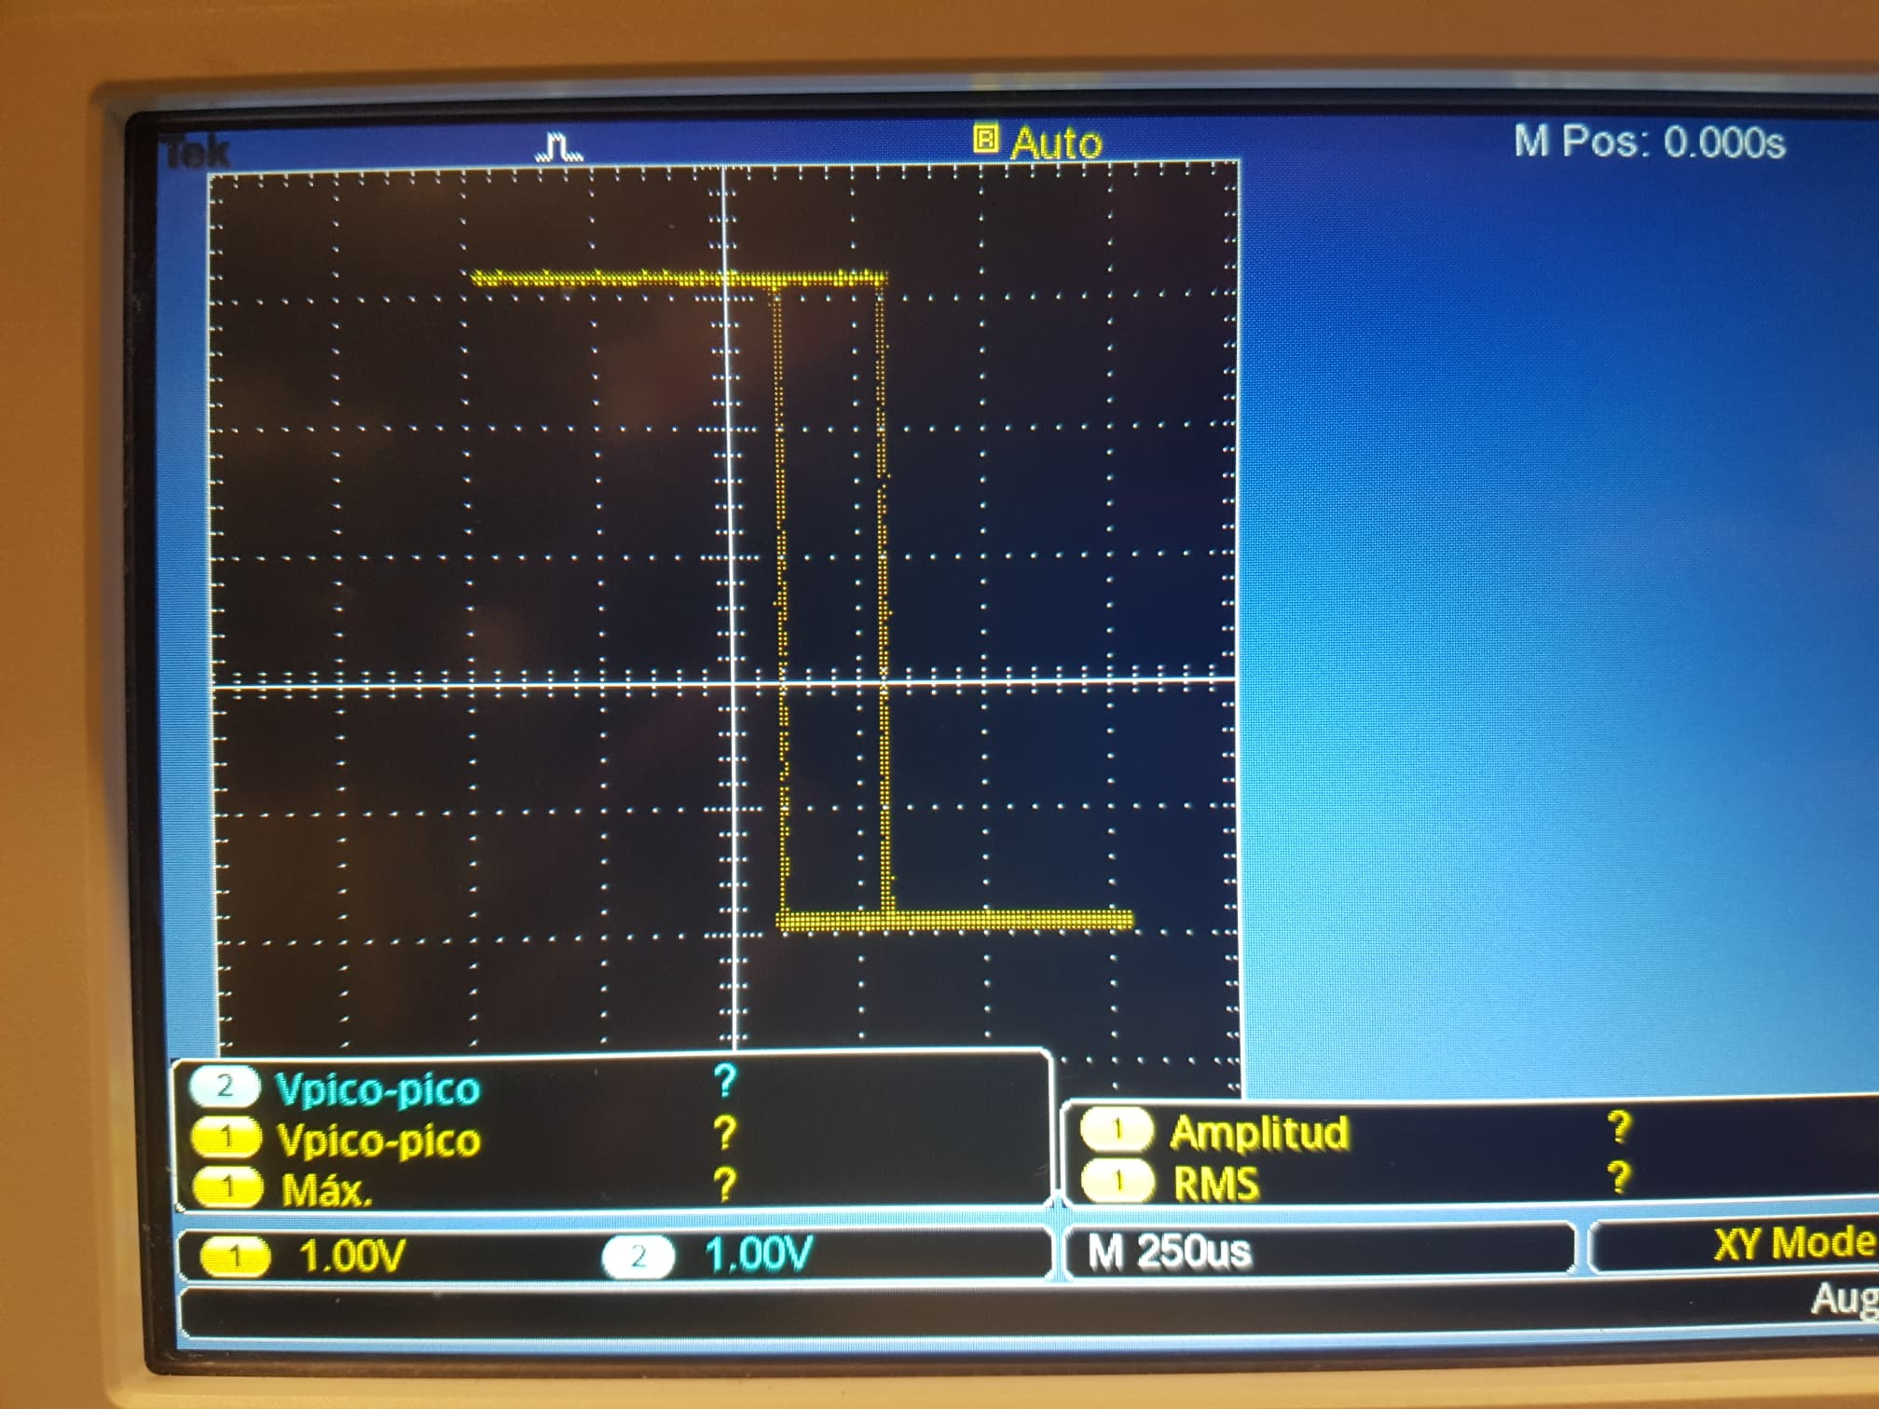

**CD4069:**

Format YT:

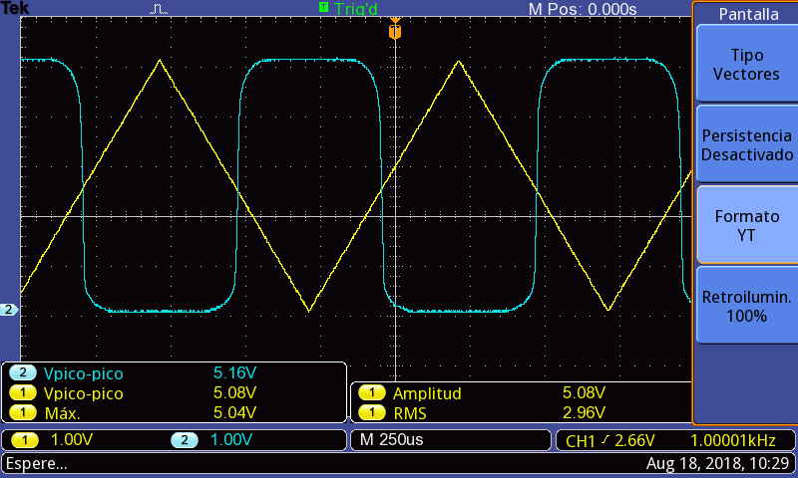

Format XY:

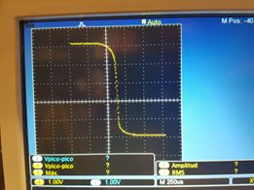

**CD40106:**

Format YT:

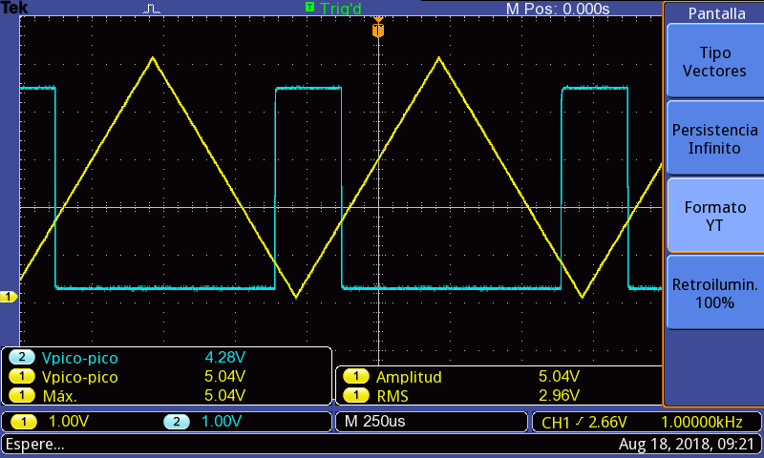

Format XY:

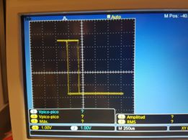

**Conclusions:**

We achieve all goals on this activity, with an exception at the first exercise (74LS04) with the graphic because we believe that we ignore some extern physical condition in the protoboard. Another challenge was determinate the most approx. Vm value from Excel graph.

We can appreciate the Schmitt Trigger it’s a better response circuit, as show in graphs. We also learn how to interpret the graphic, using the values for $V_{IL}$, $V_{IH}$, $V_{OL}$ and $V_{OH}$ to be able to use the chips on the right way.

Something new we also learn how to do it, its plotting the graphic on the format XY on the oscilloscope.