Alejandro Ossio, A01209122

Gerardo Naranjo, A01209499

Roberto Figueroa, A01209689

Computer Interfacing and Peripheral Equipment

Laboratory Exercise 03a

Rick L. Swenson

Lab Objective:

Understanding timing parameters, looking closely at glitches, measuring propagations delays

Material:

* TTL logic gates: 74LS04 (Inverter). 74LS08 (AND)
* CMOS logic gates: CD4069 (Totem-Pole Inverter).
* Function Generator, Power supply, Multimeter and Oscilloscope

Introduction:

The timing parameters commonly used in digital circuitry are:

: rise-time

: fall-time

: Propagation Delay Low to High

: Propagation Delay High to Low

δ: Average propagation delay

|  |  |
| --- | --- |
|  |  |
| Figure 1: Timing parameters | Average Propagation Delay |

Part 1: Measuring Timing Parameters

Assemble the circuit shown in Figure 2. Obtain and measure , , , and δ using an oscilloscope. First try with a TTL 74LS04 inverter and then with a CMOS CD4069.

|  |
| --- |
|  |
| Figure 2: Measuring Timing Parameters |

**74LS04:**

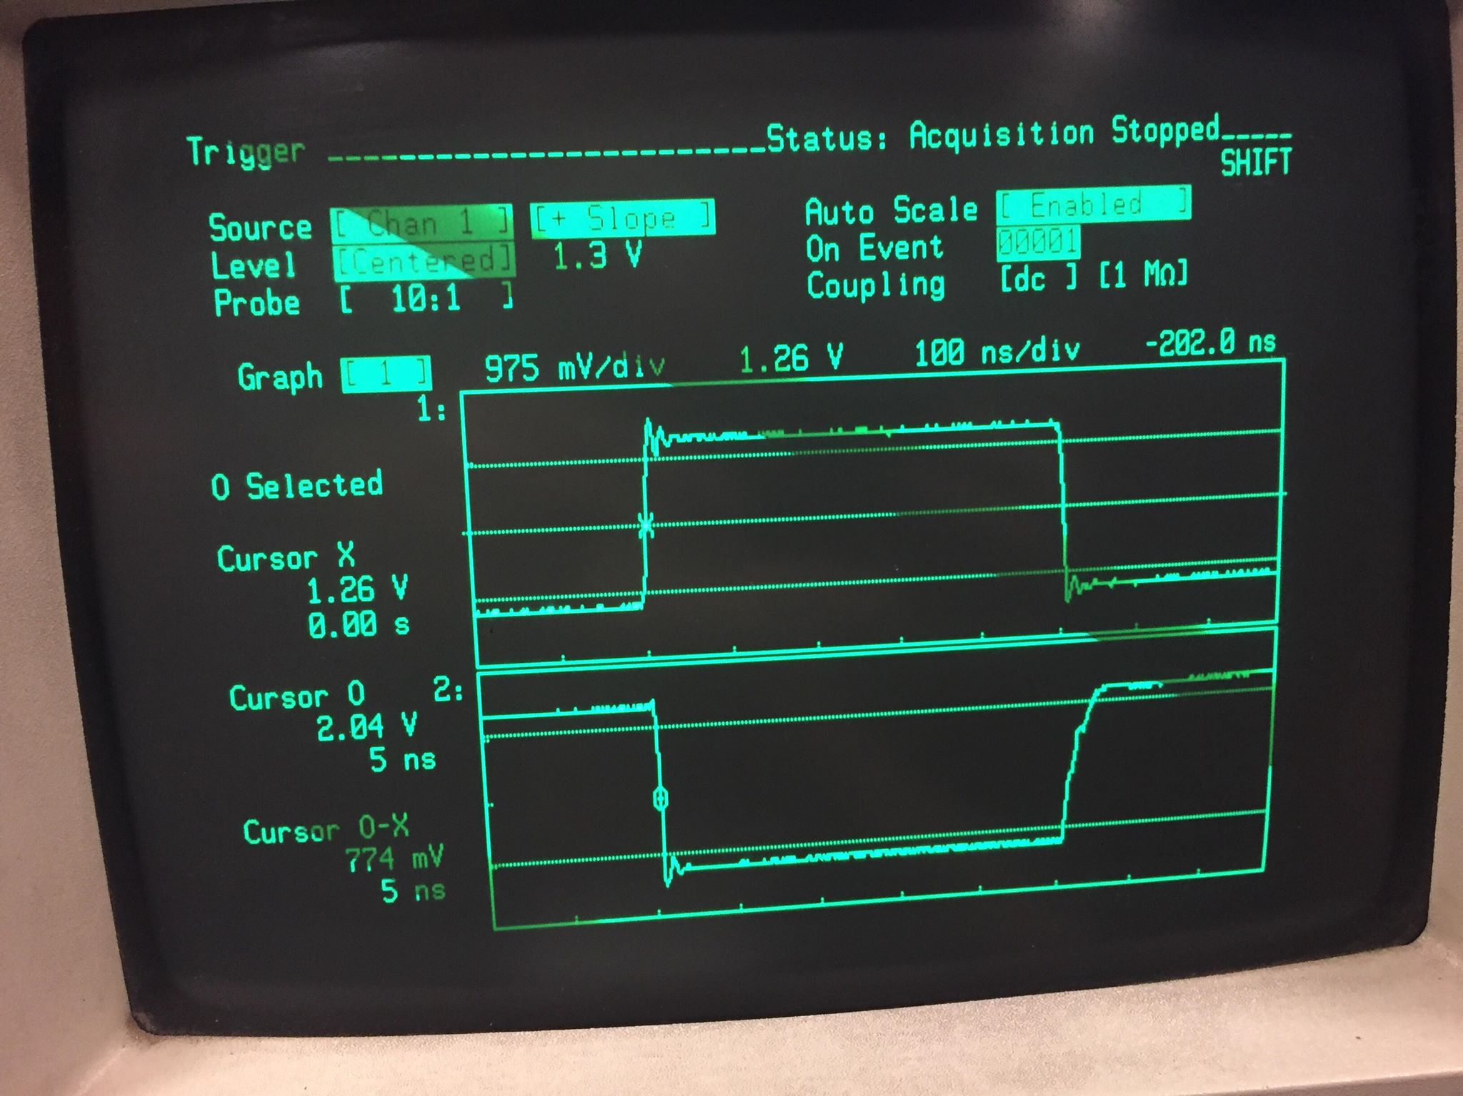

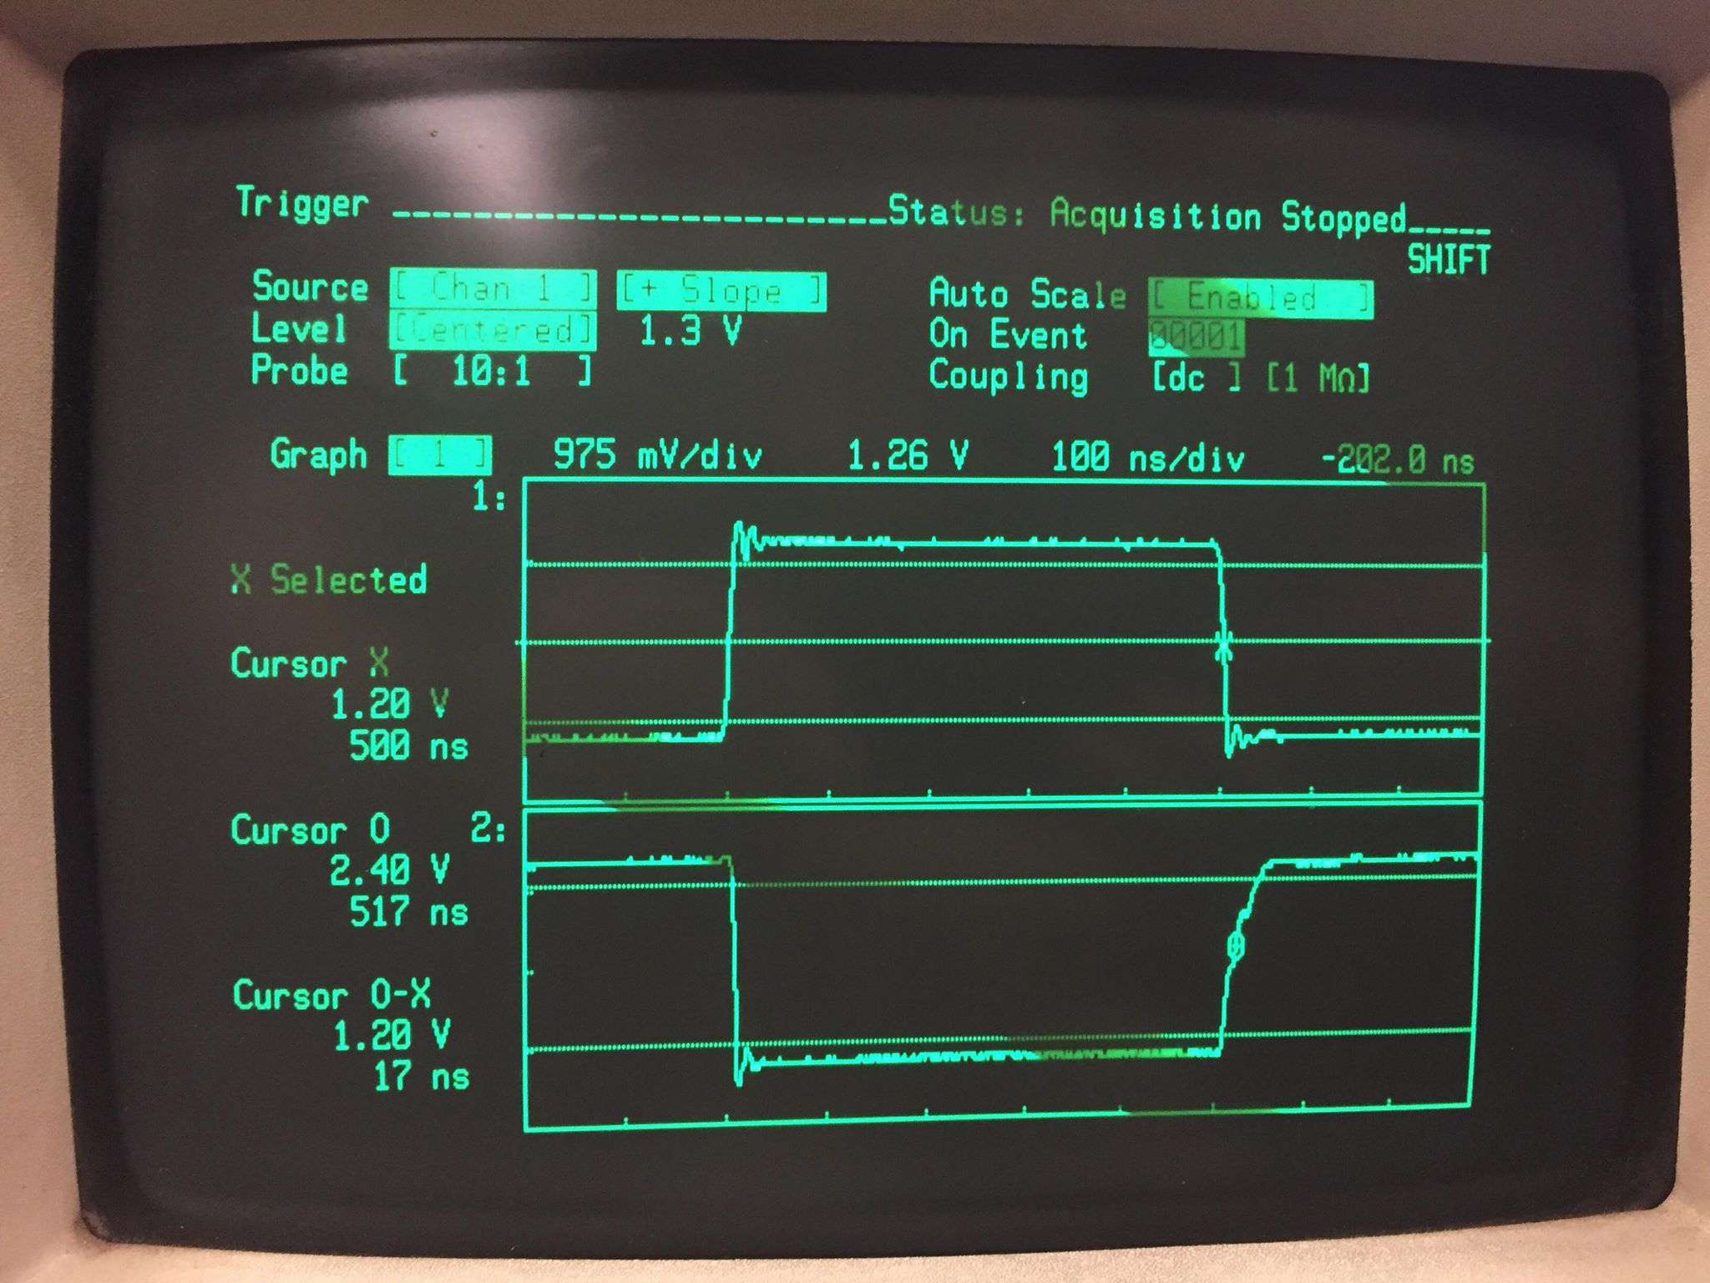

**CD4069:**

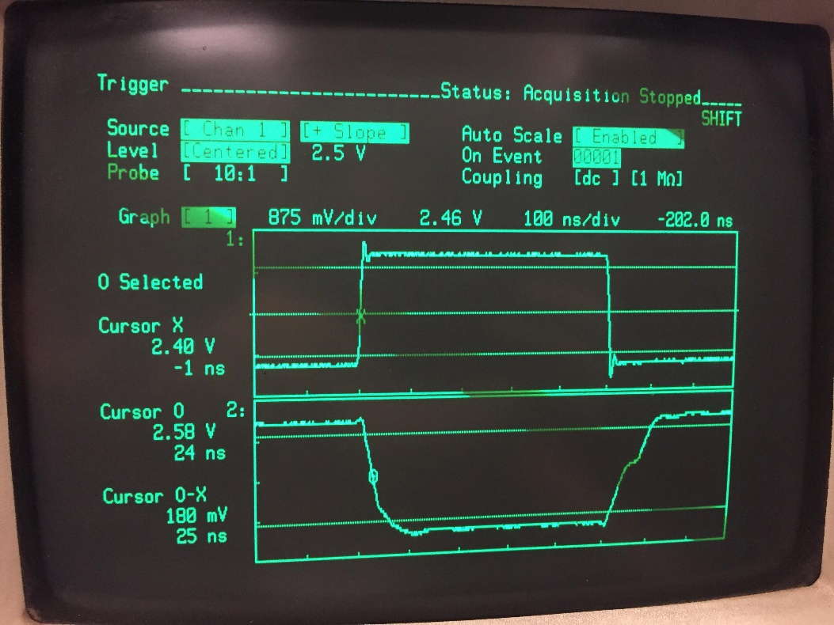

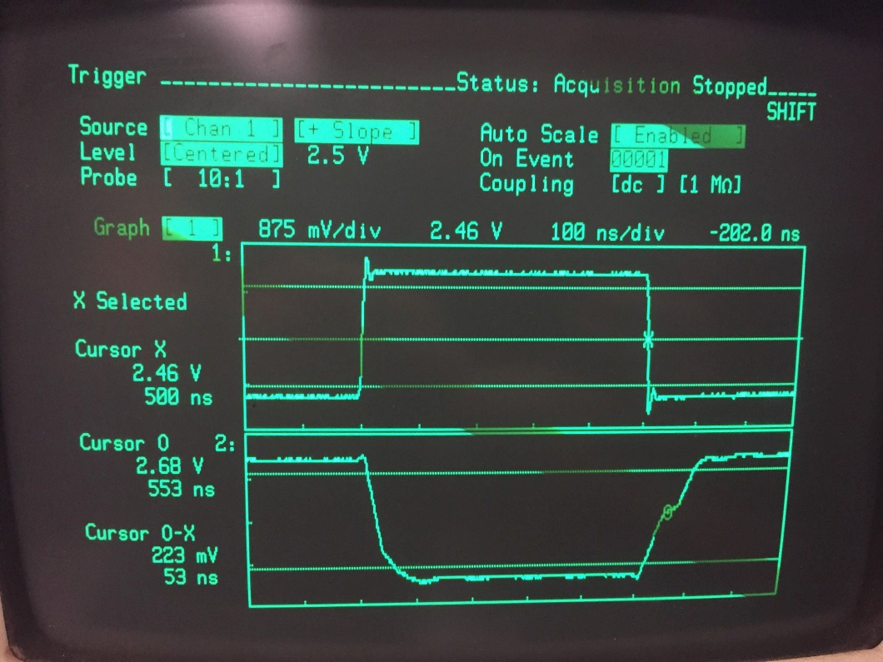

Part 2: Looking closely for glitches.

Assemble the circuit shown in Figure 3. Obtain the timing diagram shown in Figure 3 (right)

|  |  |
| --- | --- |
|  |  |
| Figure 3: Looking for a Glitch | Timing diagram showing glitch |

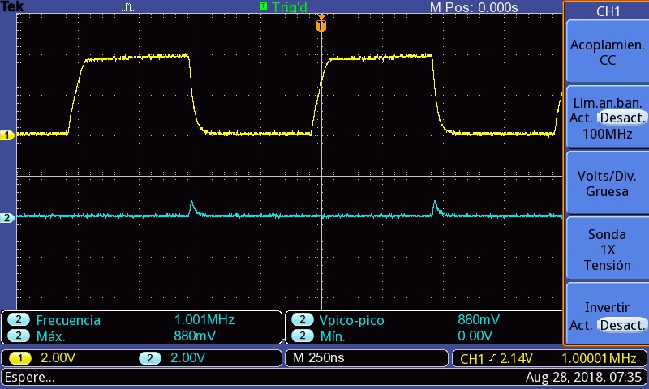

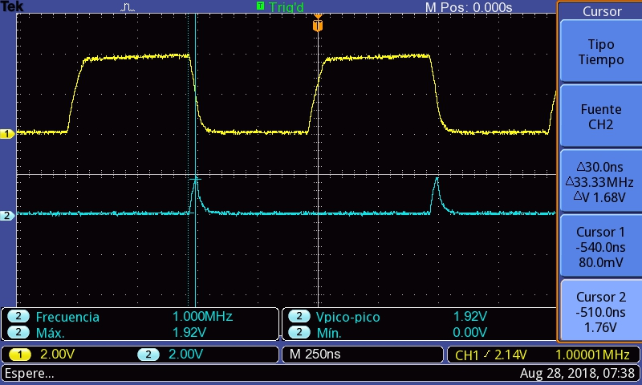

Part 3: Ring Oscillator

Assemble the circuit shown in Figure 4. It is called a ring oscillator. It is a simple way of determining the average propagation delay for a digital circuit. Notice that an odd number of gates is required to make it oscillate at full frequency. Determine the average propagation delay δ by carefully taking measurements in the oscilloscope.

|  |
| --- |
|  |
| Figure 4: A ring Oscillator |

