Gerardo Daniel Naranjo Gallegos, A01209499

Roberto Figueroa Saavedra, A01209689

09/05/2018

**Practice 01: PWM**

**Filter:**

The formula for the frequency is the following, from which, we can clear for the value of the capacitor:

$$Fc=\frac{1}{RC(2π)} ∴C=\frac{1}{RFc(2π)}$$

We propose a resistance of 3.3K $Ω$ and when measuring it with a multimeter it gives us a real value of $3.26KΩ$. Thus, we replace in the previous formula to obtain the value of the capacitor, which gives us a value of:

$$C=\frac{1}{(5Hz)(3.26KΩ)(2π)}=9.76μF$$

When looking for a capacitor of $10 μF$ as a commercial value, we measure it to obtain its real value, which is $9.86μF$. Therefore, we recalculated the frequency, to know how accurate the filter will be, the result is as follows. Very accurate:

$$Fc=\frac{1}{(3.26KΩ)(9.86μF)(2π)}=4.95Hz$$

Therefore, we have the following circuit:

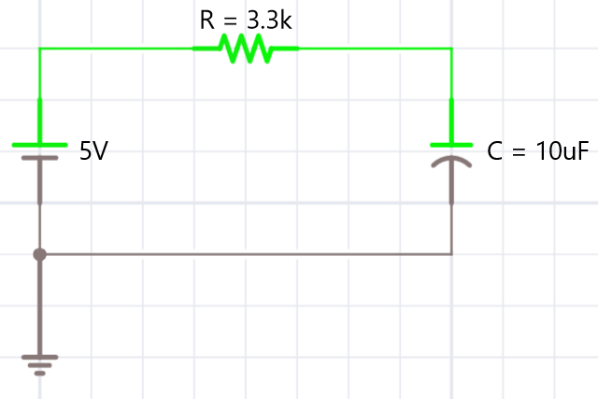

In addition, we add a voltage follower to the filter. We use a UA741CP (741).

**Code:**

Regarding the code used in the Arduino, we generate the following:

void setup() {

// initialize the serial communication:

Serial.begin(9600);

// initialize the pin 10 as the PWM output:

pinMode(10, OUTPUT);

}

void loop() {

// check if data has been sent from the computer:

if (Serial.available()) {

// read the Serial String:

String x = Serial.readString();

//Check if the format is ok:

if(x>="0" && x<="5.1")

{

//Converting the variable of the input from String to Float:

float y=x.toFloat();

//Checking if the value of the input is ok:

if(y>=0.0 && y<=5.0)

{

//Making the convertion:

y=(y*255.0)/5.0;

//PWM on the output (pin 10):

analogWrite(10,y);

//Print on Serial Monitor:

Serial.print("Generando PWM de: ");

Serial.println(y);

}

else

Serial.println("Rango incorrecto");

}

else

Serial.println("Error de formato");

}

}

**Questions to solve:**

Which is the circuit of a voltage follower?

It can be a 741, as we use.

[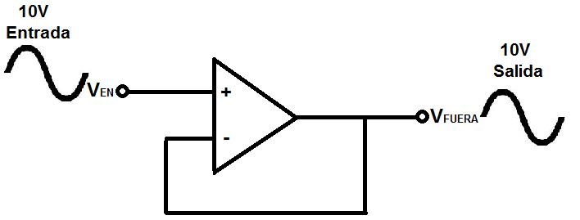](https://www.google.com.mx/url?sa=i&rct=j&q=&esrc=s&source=images&cd=&cad=rja&uact=8&ved=2ahUKEwi8m_6-iqXdAhUCna0KHUu1AeoQjRx6BAgBEAU&url=http%3A%2F%2Fwww.learningaboutelectronics.com%2FArticulos%2FSeguidor-de-voltaje.php&psig=AOvVaw2EyCc7Hv5RC5RxeYC3r9sU&ust=1536278755012267)

What is the relationship between the duty cycle and the average voltage of a PWM signal?

The duty cycle is going to be the average voltage of the PWM signal when pass the filter.

What is the relationship between dB and attenuation level?

G

What is the relationship between decades and attenuation level of a filter?

Attenuation level starts

What is the Equation for RC filter?

$$Fc=\frac{1}{RC(2π)}$$

How do you select the cutting frequency of a filter based on the attenuation level specification?

G

What is the relationship between the ripple of a filtered signal and the cutting frequency?

G

# **References:**

Aprender Sobre La Electrónica. (s.f.). *¿Qué Es Un Seguidor de Voltaje?* Obtenido de learningaboutelectronics: http://www.learningaboutelectronics.com/Articulos/Seguidor-de-voltaje.php