

**HYPNOSIA Controller**

|  |  |
| --- | --- |
|  | Graduate Gregory Geraci |

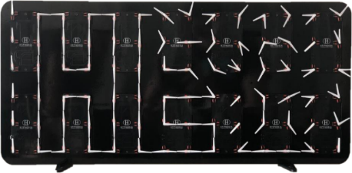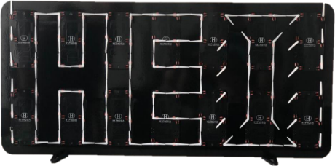

Bachelor’s Thesis   
| 2020 |



Degree programme

*Industrial Systems*

Field of application

*Infotronics*

Supervising professor

*Dr Silvan Zahno*

*silvan.zahno@hevs.ch*

**Objectives**

The project consists in developing and implementing a prototype of a bi-axes movements matrix display that allows the creation of the most hypnotizing animations.

**Methods | Experiences | Results**

The matrix display consists of 84 bi-axes movements produced by SOPROD SA. The ultimate goal is to control animations via Bluetooth according to the user's wishes.

The system is composed of a MASTER (Raspberry Pi), a GATEWAY (processor) and 13 SLAVES (processor). The system works as follows: the Raspberry Pi (MASTER) manages the Bluetooth connection and transmits the data required to control the movement matrix to the processor (GATEWAY) via SPI. This processor then processes the data received via SPI and transmits the data to all other processors (SLAVES) via a CAN bus. Each processor controls 6 bi-axes movements.

The first prototype developed gives conclusive results.



The diagram above shows the communications:

* Smartphone - MASTER via Bluetooth
* MASTER - GATEWAY via SPI
* GATEWAY - SLAVES via **CAN**

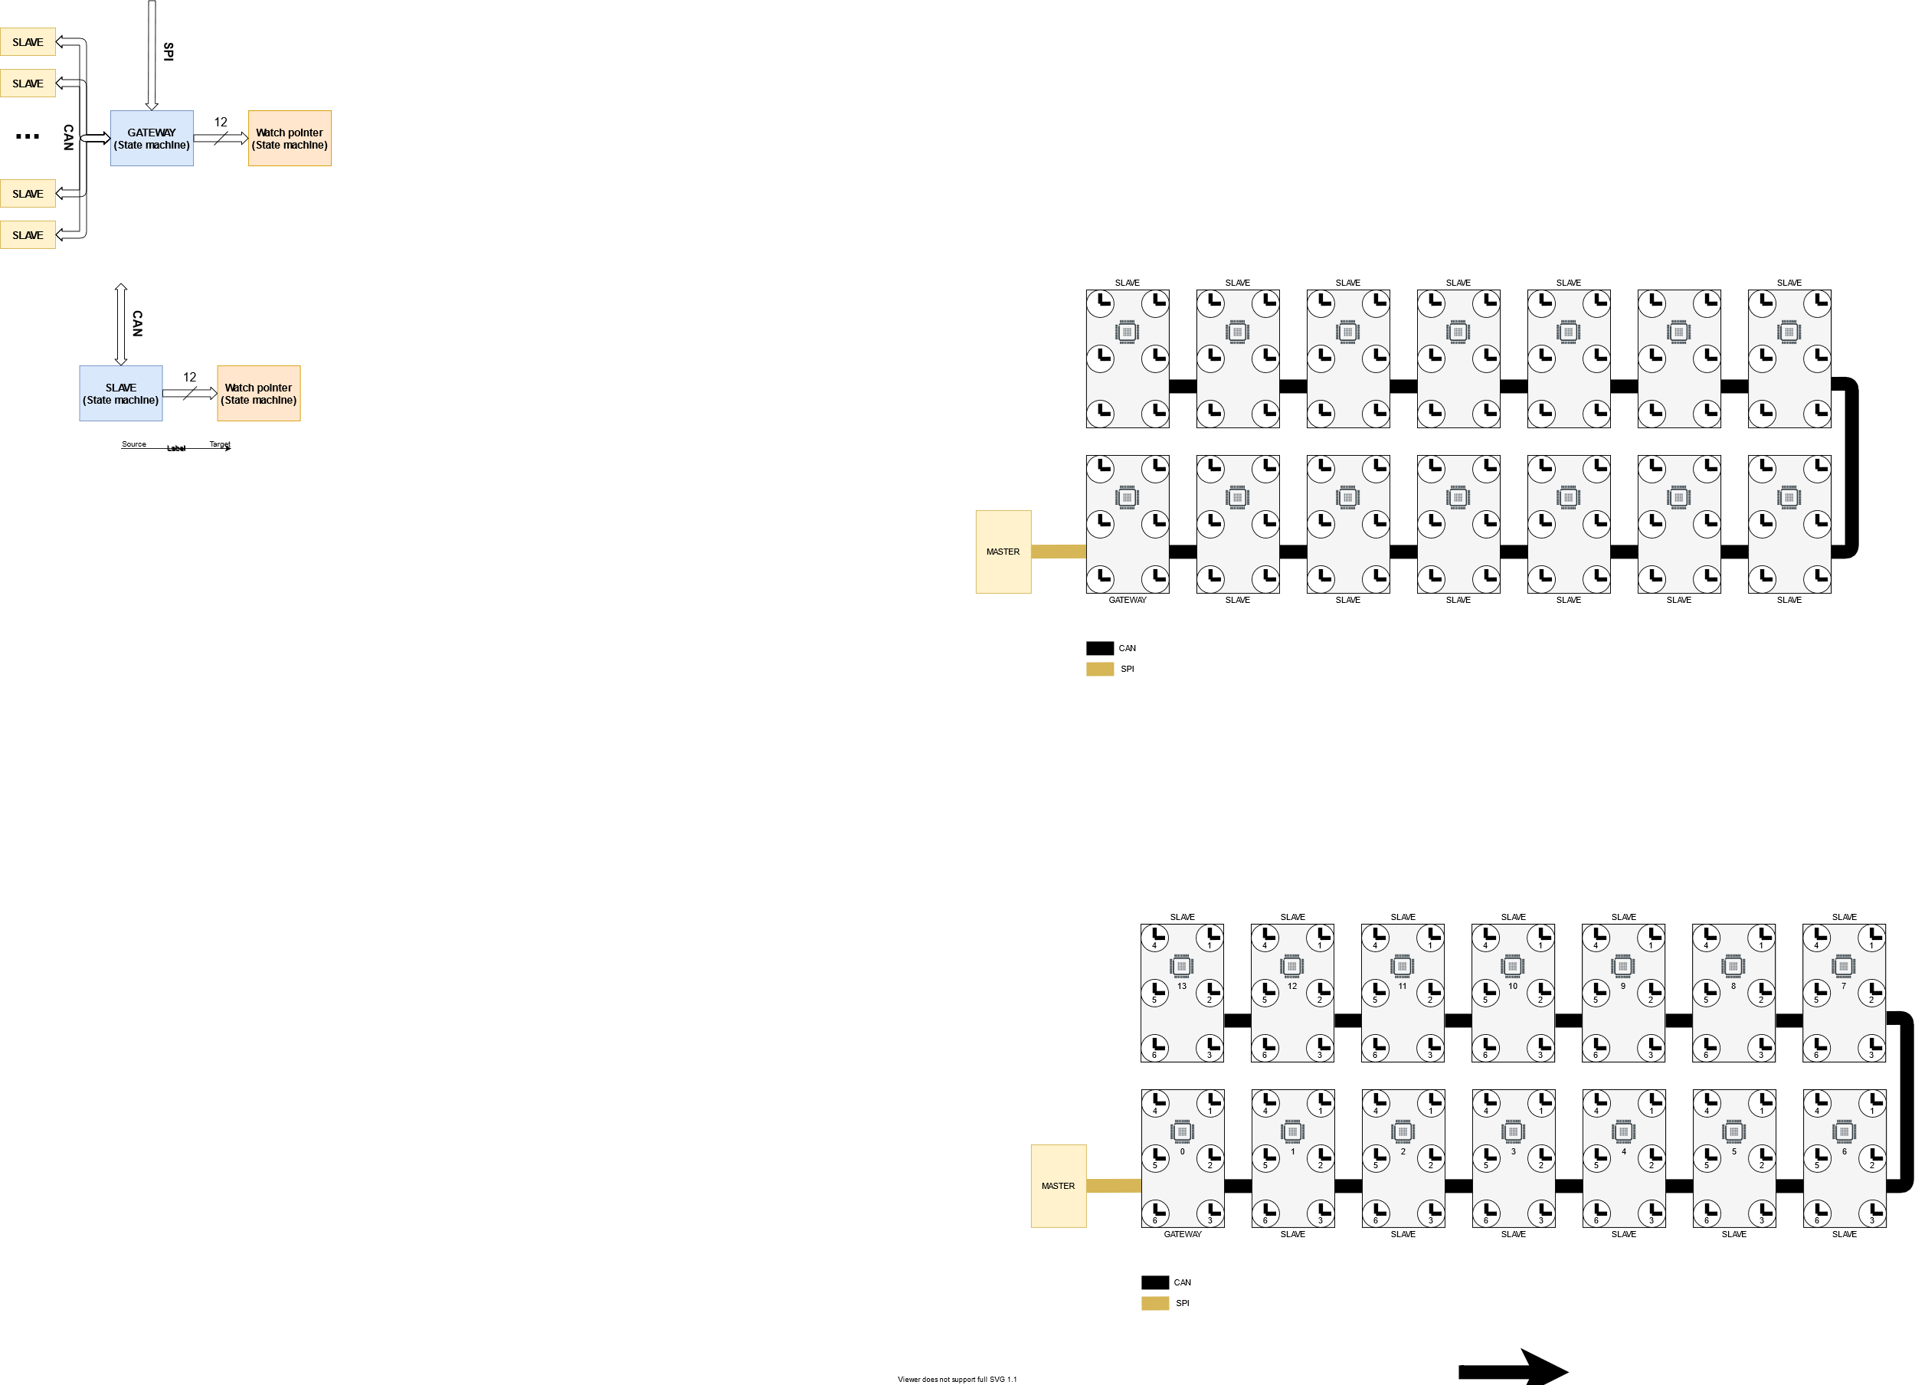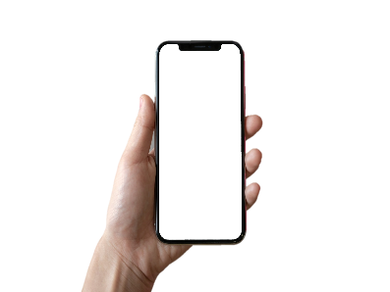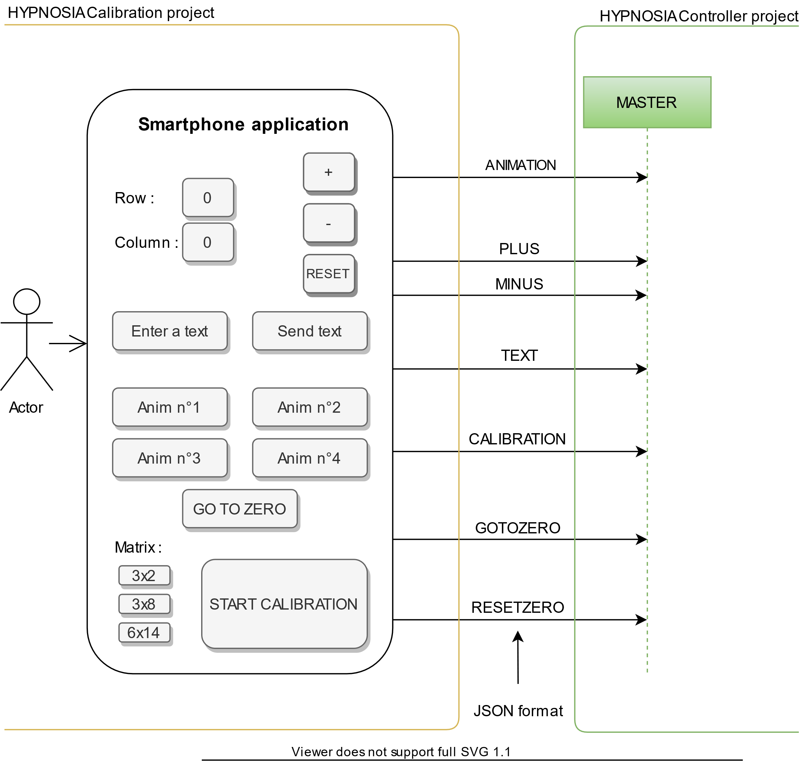

Rawyl1_RVBRawyl1_RVBRawyl1_RVB