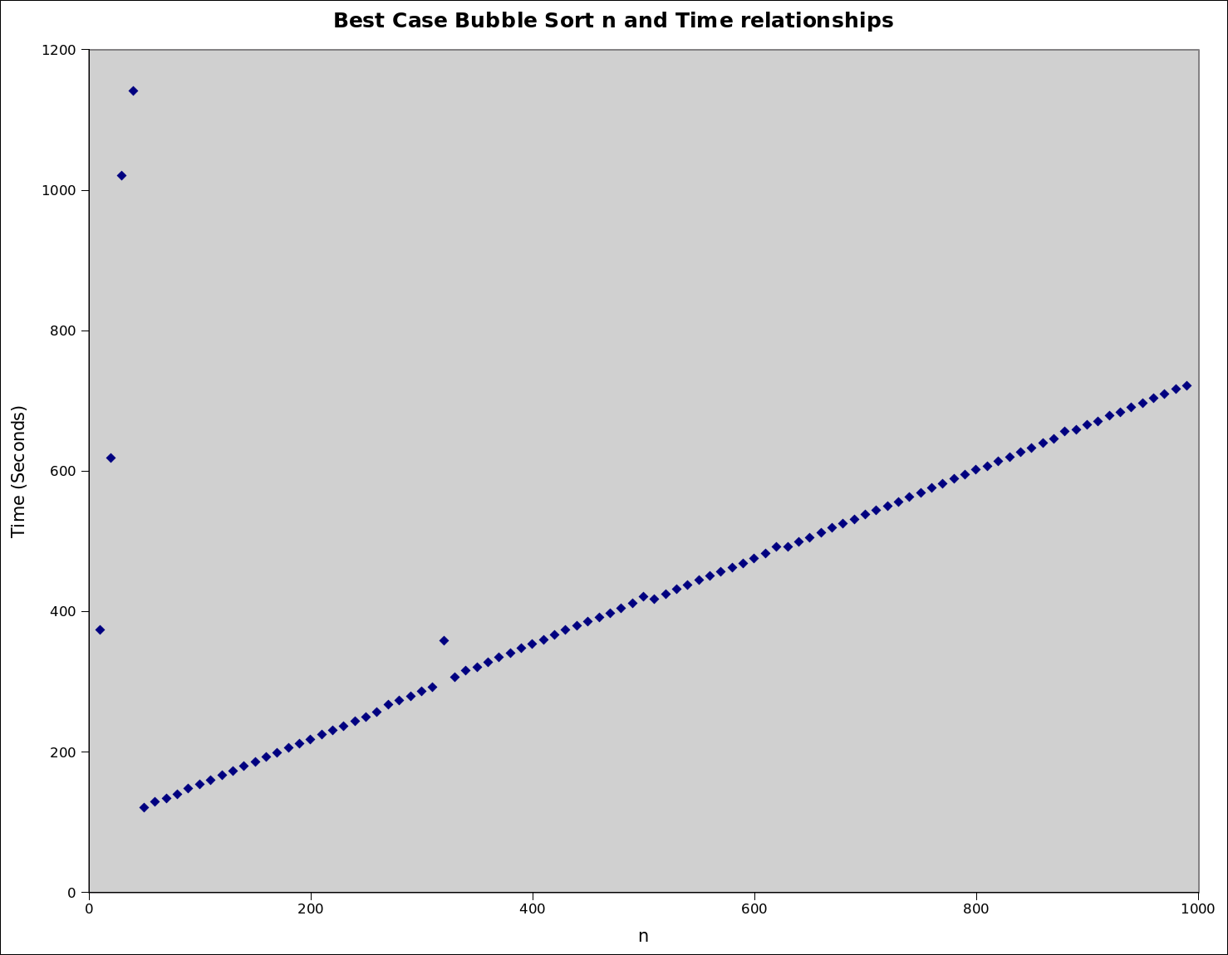
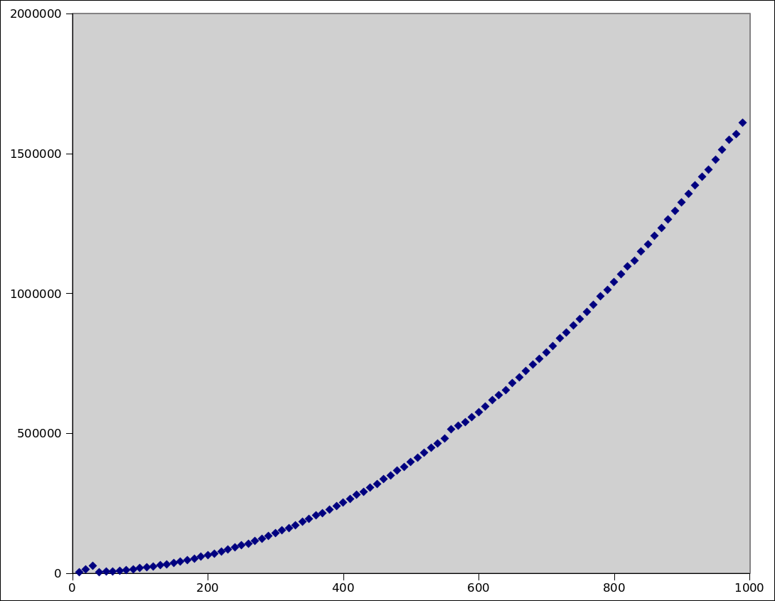
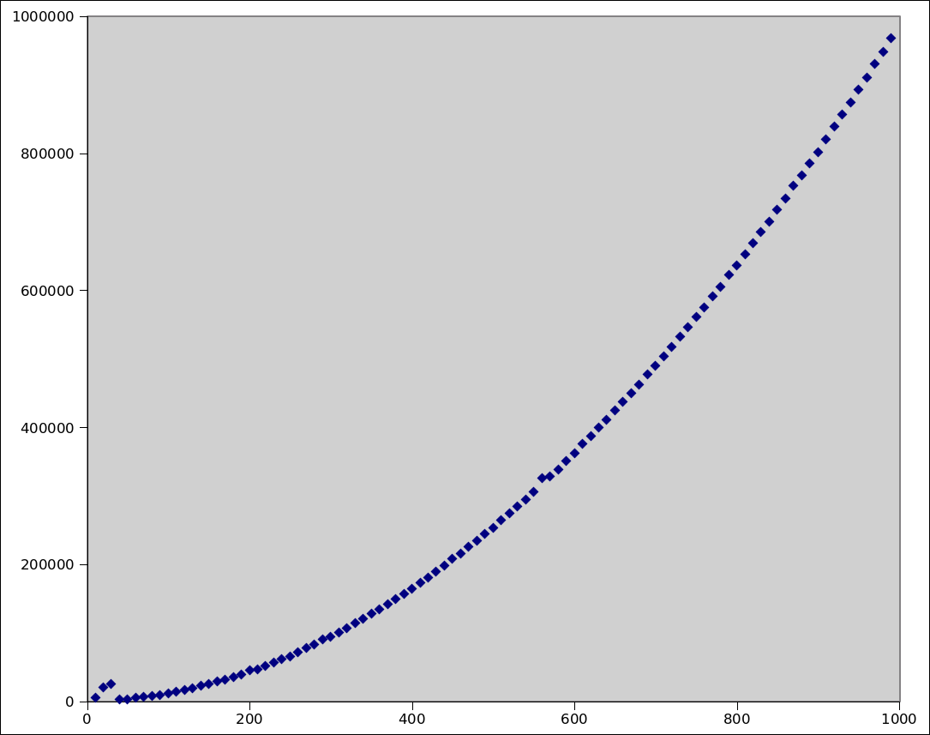
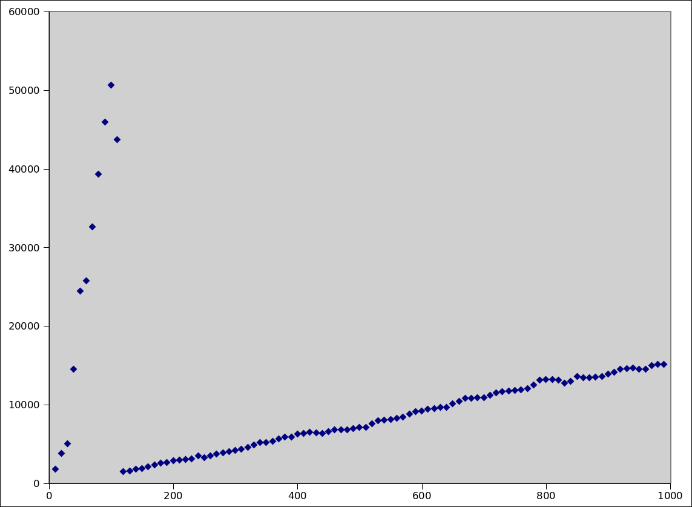
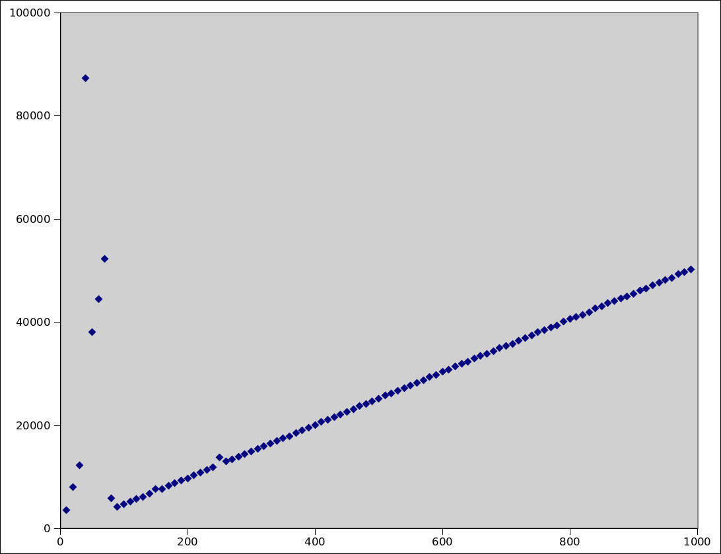
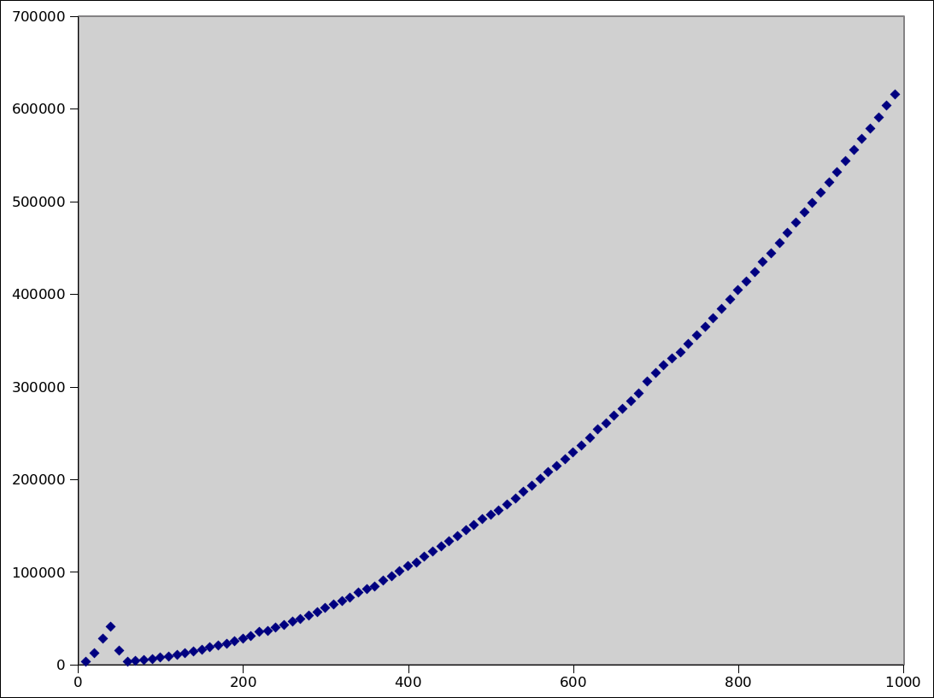
Run time analysis of bubble sort and quick sort

Student Number: 1100682
Student Name: Geraint Harries
Year: 2nd
Module Code: CM2303
Module Name: Algorithms and Data Structures
Lecturer Name: Christine Mumford

INTRODUCTION

This report aims to compare the runtime of two sorting algorithms; bubble sort and quick sort. Both algorithms have different run-time complexities. The complexities I expect for each are as follows:

Bubble Sort

Best Case Scenario: O(n)
Average Case Scenario: O(n²)
Best Case Scenario: O(n²)

Quick Sort

Best Case Scenario: O(nlogn)
Average Case Scenario: O(nlogn)
Worse Case Scenario: O(n²)

The algorithms will be tested in best case, average case and worse case scenarios. The best case aims to model how the algorithm performs under perfect conditions i.e. when the data is already sorted. The worst case scenario aims to model the worst conditions and see how the algorithm performs under those conditions. This case allows the algorithm to do most 'work'. The average case aims to model how the algorithm performs under 'common' conditions such as an array of random numbers rather than sorted numbers.

Another aim of this report is to see how the algorithm scale for an increase of an n sized array of numbers to sort. The predictions above suggest how I think the algorithms will scale in each scenario.

DESIGN

Bubble Sort Pseudo code:

Algorithm bubble–sort3(n, A)
Input: An array, A, of numbers of length n.
Output: The array, A sorted
limit n 1
done 0
while done = 0 do
done 1
for j 1 to limit do
if A[j + 1] < A[j] then
temp A[j]
A[j] A[j + 1]
A[j + 1] temp
done 0
end if
limit limit 1
end for
end while

Bubble Sort Java code:

public void bubble_srt(int x ){
int t, limit = x - 1;
boolean done = false;

while (done == false){

done = true;

for(int j = 0; j < limit; j++){
if(RandArray[j+1] < RandArray[j]){

t = RandArray[j];
RandArray[j]=RandArray[j+1];
RandArray[j+1]=t;

done = false;

}
}
}
}

Quick Sort Pseudo Code:

i = low
j = high
pivot = numbers[low + (high-low)/2]

if low >= high
return

while i <= j
while numbers[i] < pivot
i = i + 1

while numbers[j] > pivot
j = j - 1

if i <= j
exchange(i, j)
i = i + 1
j = j - 1

if low < j
quicksort(low, j)
if i < high
quicksort(i, high)

Quick Sort Java Code

private static void quicksort(int low, int high) {
int i = low, j = high; // Get the pivot element from the middle of the list
//int pivot = numbers[low + (high-low)/2]; // bestcase + average case
int pivot = numbers[low]; //worst case

if (low >= high) return;

while (i <= j) {

while (numbers[i] < pivot) {
i++;
}

while (numbers[j] > pivot) {
j--;
}

if (i <= j) {
exchange(i, j);
i++;
j--;
}
}

if (low < j)
quicksort(low, j);
if (i < high)
quicksort(i, high);
}

IMPLEMENTATION

Bubble Sort

Referenced From Lewis John-Hall who created from the pseudo-code from: https://learningcentral.cf.ac.uk/bbcswebdav/pid-2714221-dt-content-rid-2907213_2/courses/1213-CM2303/SuppNotes2%283%29.pdf

public void bubble_srt(int x ){
int t, limit = x - 1;
boolean done = false; //Initiate done and set it to false

while (done == false){
done = true;
for(int j = 0; j < limit; j++){
if(RandArray[j+1] < RandArray[j]){ //check if the entry in the next array slot is greater than the entry in the current array slot

t = RandArray[j];
RandArray[j]=RandArray[j+1]; //by using temporary memory the two values are switched
RandArray[j+1]=t;

done = false; //makes the system repat the sort if a change was made
}
}
}
}

Quick Sort

Referenced From Lewis John-Hall who referenced it from: http://www.vogella.com/articles/JavaAlgorithmsQuicksort/article.html

private static void quicksort(int low, int high) {
int i = low, j = high; // Get the pivot element from the middle of the list
//int pivot = numbers[low + (high-low)/2]; // bestcase + average case
int pivot = numbers[low]; //worst case

if (low >= high) return;

while (i <= j) { // Divide into two lists

// If the current value from the left list is smaller then the pivot
// element then get the next element from the left list

while (numbers[i] < pivot) {
i++;
}
// If the current value from the right list is larger then the pivot
// element then get the next element from the right list

while (numbers[j] > pivot) {
j--;
}

// If we have found a values in the left list which is larger then
// the pivot element and if we have found a value in the right list
// which is smaller then the pivot element then we exchange the
// values.
// As we are done we can increase i and j
if (i <= j) {
exchange(i, j);
i++;
j--;
}
}
// Recursion
if (low < j)
quicksort(low, j);
if (i < high)
quicksort(i, high);
}

TESTING

Bubble Sort

The code prints out blah blah

Code:

import java.util.Random;
class bubblesort{
public int[] RandArray;
public static Random myRandom = new Random();

public bubblesort (int x) {

RandArray = new int[x];
for(int i = 0; i < x; i++) { //generates random numbers for array size X
RandArray[i] = myRandom.nextInt(100); //Average case
//RandArray[i] = x-i; //worst case
//RandArray[i] = i; //best case
}
}

public void bubble_srt(int x ){
int t, limit = x - 1;
boolean done = false;

while (done == false){

done = true;

for(int j = 0; j < limit; j++){
if(RandArray[j+1] < RandArray[j]){ //check if the entry in the next array slot is greater than the entry in the current array slot

t = RandArray[j];
RandArray[j]=RandArray[j+1]; //by using temporary memory the two values are switched
RandArray[j+1]=t;

done = false; //makes the system repat the sort if a change was made
System.out.println(RandArray[0] + "," + RandArray[1] + "," + RandArray[2] + "," + RandArray[3] + "," + RandArray[4] + "," + RandArray[5] + "," + RandArray[6] + "," + RandArray[7] + "," + RandArray[8] + "," + RandArray[9]);
}
}
}
}
}

Output:

9,33,69,45,35,32,61,54,79,74
9,33,45,69,35,32,61,54,79,74
9,33,45,35,69,32,61,54,79,74
9,33,45,35,32,69,61,54,79,74
9,33,45,35,32,61,69,54,79,74
9,33,45,35,32,61,54,69,79,74
9,33,45,35,32,61,54,69,74,79
9,33,35,45,32,61,54,69,74,79
9,33,35,32,45,61,54,69,74,79
9,33,35,32,45,54,61,69,74,79
9,33,32,35,45,54,61,69,74,79
9,32,33,35,45,54,61,69,74,79

Quick Sort

Blah blah

Code:

import java.util.Random;

class Quickclock {

public static int[] numbers = {23,67,98,46,17,95,1234,46,11,314,956};

public static void main (String args[]){

quicksort(0, 10);

}

private static void quicksort(int low, int high) {
int i = low, j = high; // Get the pivot element from the middle of the list
int pivot = numbers[low + (high-low)/2]; // bestcase + average case

System.out.println("the pivot is:" + pivot);

if (low >= high) return;

while (i <= j) { // Divide into two lists

// If the current value from the left list is smaller then the pivot
// element then get the next element from the left list

while (numbers[i] < pivot) {
i++;
}
// If the current value from the right list is larger then the pivot
// element then get the next element from the right list

while (numbers[j] > pivot) {
j--;
}

// If we have found a values in the left list which is larger then
// the pivot element and if we have found a value in the right list
// which is smaller then the pivot element then we exchange the
// values.
// As we are done we can increase i and j
if (i <= j) {
exchange(i, j);
i++;
j--;
}
}

System.out.println(numbers[0] + "," + numbers[1] + "," + numbers[2] + "," + numbers[3] + "," + numbers[4] + "," + numbers[5] + "," + numbers[6] + "," + numbers[7] + "," +numbers[8] + "," +numbers[9] + "," + numbers[10]);
// Recursion

if (low < j)
quicksort(low, j);
if (i < high)
quicksort(i, high);
}

private static void exchange(int i, int j) {
int temp = numbers[i];
numbers[i] = numbers[j];
numbers[j] = temp;
}
}

Output:

the pivot is:95
23,67,11,46,17,46,1234,95,98,314,956
the pivot is:11
11,67,23,46,17,46,1234,95,98,314,956
the pivot is:46
11,46,23,17,46,67,1234,95,98,314,956
the pivot is:23
11,17,23,46,46,67,1234,95,98,314,956
the pivot is:46
11,17,23,46,46,67,1234,95,98,314,956
the pivot is:98
11,17,23,46,46,67,98,95,1234,314,956
the pivot is:98
11,17,23,46,46,67,95,98,1234,314,956
the pivot is:314
11,17,23,46,46,67,95,98,314,1234,956
the pivot is:1234
11,17,23,46,46,67,95,98,314,956,1234

EXPERIMENTAL METHOD

As stated, I tested best, average and worst case scenarios. Below is a breakdown of how I achieved the appropriate environments.

Case Scenario | Bubble | Quick
Best | Array data already sorted in ascending order | Array data sorted in ascending order, Pivot in middle of data
Average | Array data in random order | Array data in random order, Pivot in middle of data
Worse | Array data sorted in descending order | Array data in random order, Pivot in either highest or lowest array value

I decided to record and compare the data by using the nanotime function in java. I used this method rather than counters as counters can interfere with the results by adding time to the function. It is also is far easier to compare the two functions using time as it is more empirical.

RESULTS

The first 10% of the results are always very 'random'. This is due to java compiler optimisation. The java compiler, after several runs of a program, optimises itself and therefore the first 10% is subject to the compilers optimisation. The results after the first 10% seem as predicted.

Bubble Sort – Best Case
10 | 373.92 | 210 | 224.18 | 410 | 359.36 | 610 | 482.28 | 810 | 606.76
20 | 617.82 | 220 | 230.19 | 420 | 365.9 | 620 | 491.22 | 820 | 614.12
30 | 1020.31 | 230 | 236.96 | 430 | 373.04 | 630 | 491.43 | 830 | 619.33
40 | 570.405 ** | 240 | 243.02 | 440 | 378.91 | 640 | 498.97 | 840 | 626.82
50 | 120.5 | 250 | 249.91 | 450 | 385.65 | 650 | 504.97 | 850 | 632.39
60 | 128.39 | 260 | 256.4 | 460 | 391.47 | 660 | 511.52 | 860 | 639.65
70 | 133.05 | 270 | 266.8 | 470 | 397.39 | 670 | 518.74 | 870 | 645.47
80 | 139.44 | 280 | 272.77 | 480 | 403.89 | 680 | 524.4 | 880 | 656.4
90 | 147.62 | 290 | 279.5 | 490 | 411.64 | 690 | 530.32 | 890 | 658.03
100 | 153.73 | 300 | 285.94 | 500 | 420.95 | 700 | 537.47 | 900 | 665.71
110 | 159.84 | 310 | 292.23 | 510 | 417.14 | 710 | 543.32 | 910 | 670.76
120 | 166.98 | 320 | 358.41 | 520 | 424.05 | 720 | 550.14 | 920 | 678.01
130 | 172.56 | 330 | 306.45 | 530 | 431.02 | 730 | 555.87 | 930 | 683.2
140 | 179.45 | 340 | 315.41 | 540 | 436.89 | 740 | 562.92 | 940 | 690.91
150 | 185.12 | 350 | 320.46 | 550 | 443.93 | 750 | 568.72 | 950 | 696.14
160 | 192.2 | 360 | 327.3 | 560 | 450.45 | 760 | 576.14 | 960 | 703.39
170 | 198.68 | 370 | 333.95 | 570 | 455.91 | 770 | 581.59 | 970 | 709.25
180 | 205.33 | 380 | 339.9 | 580 | 462.25 | 780 | 588.66 | 980 | 716.63
190 | 211.11 | 390 | 346.97 | 590 | 468.41 | 790 | 594.1 | 990 | 721.56
200 | 217.6 | 400 | 352.96 | 600 | 475.43 | 800 | 601.36

** this value was originally an anomalous value. I therefore discounted it and used the average of the surrounding values as not to distort the graph results.

Bubble Sort – Average Case

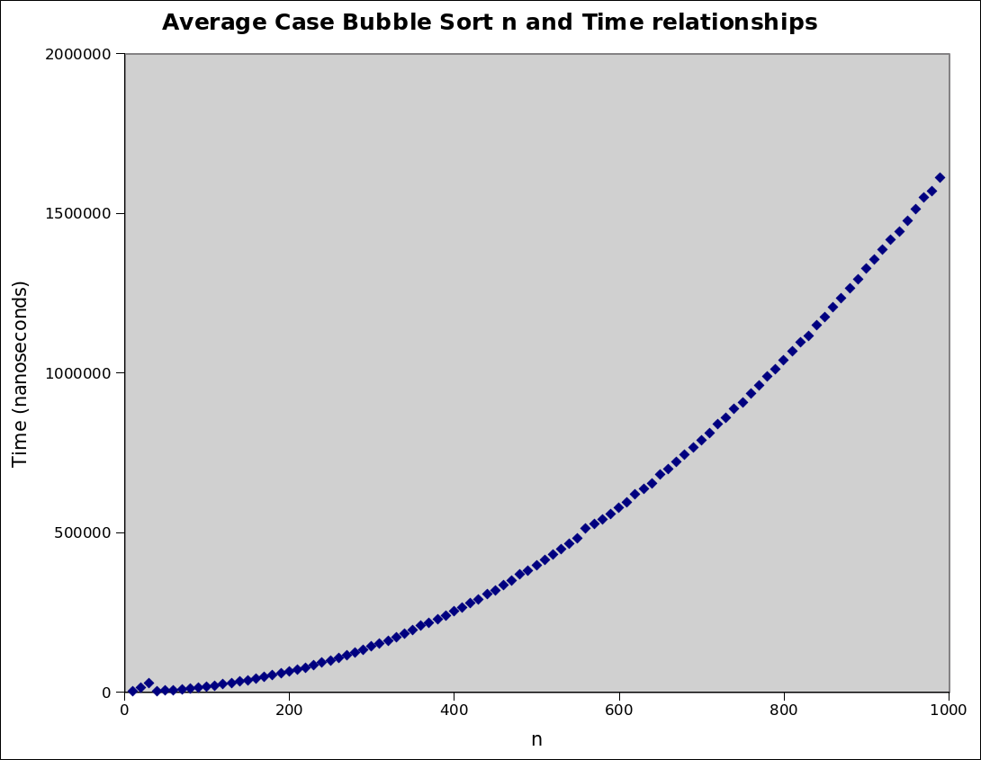
10 | 3242.25 | 210 | 70678.9 | 410 | 265693 | 610 | 594899 | 810 | 1067117
20 | 14552.9 | 220 | 77399.5 | 420 | 279535 | 620 | 618236 | 820 | 1096487
30 | 27488.6 | 230 | 84210.5 | 430 | 291246 | 630 | 635330 | 830 | 1115295
40 | 3280.75 | 240 | 91888.6 | 440 | 306150 | 640 | 654278 | 840 | 1149456
50 | 4920.96 | 250 | 99291.2 | 450 | 319246 | 650 | 680230 | 850 | 1175248
60 | 6879.78 | 260 | 106224 | 460 | 335896 | 660 | 699531 | 860 | 1206619
70 | 9036.09 | 270 | 115491 | 470 | 348591 | 670 | 721608 | 870 | 1233758
80 | 11493.2 | 280 | 124031 | 480 | 367787 | 680 | 744961 | 880 | 1264878
90 | 14557.0 | 290 | 133103 | 490 | 379661 | 690 | 766445 | 890 | 1293487
100 | 17609.2 | 300 | 142402 | 500 | 397690 | 700 | 788971 | 900 | 1325376
110 | 20849.9 | 310 | 152571 | 510 | 412800 | 710 | 812387 | 910 | 1354676
120 | 24458.5 | 320 | 161599 | 520 | 430122 | 720 | 839002 | 920 | 1384991
130 | 29492.1 | 330 | 172518 | 530 | 447735 | 730 | 859247 | 930 | 1416586
140 | 32563.3 | 340 | 182888 | 540 | 464246 | 740 | 885836 | 940 | 1442906
150 | 37097.1 | 350 | 193244 | 550 | 482022 | 750 | 907730 | 950 | 1476856
160 | 42066.0 | 360 | 207644 | 560 | 513441 | 760 | 934070 | 960 | 1512899
170 | 46984.2 | 370 | 215548 | 570 | 527208 | 770 | 960153 | 970 | 1548276
180 | 52458.4 | 380 | 227799 | 580 | 540693 | 780 | 988462 | 980 | 1569928
190 | 58292.2 | 390 | 239804 | 590 | 556526 | 790 | 1012333 | 990 | 1609956
200 | 64586.0 | 400 | 252246 | 600 | 576442 | 800 | 1039766

Bubble Sort – Worst Case
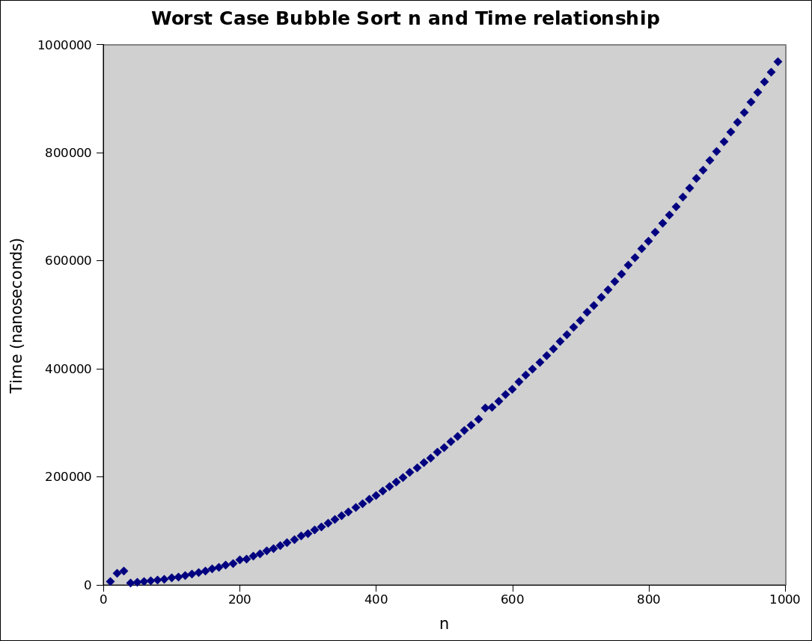

10 | 4940.58 | 210 | 47415.6 | 410 | 173269 | 610 | 375760 | 810 | 652565
20 | 20867.3 | 220 | 52285.7 | 420 | 181015 | 620 | 387520 | 820 | 668208
30 | 25090.1 | 230 | 56313.9 | 430 | 189944 | 630 | 399338 | 830 | 684604
40 | 2487.76 | 240 | 61727.1 | 440 | 198646 | 640 | 410972 | 840 | 699963
50 | 3518.08 | 250 | 66073.4 | 450 | 207892 | 650 | 424332 | 850 | 717768
60 | 4970 | 260 | 72015.8 | 460 | 215947 | 660 | 436649 | 860 | 733709
70 | 6336.93 | 270 | 77850.5 | 470 | 225853 | 670 | 449921 | 870 | 752059
80 | 8339.5 | 280 | 83171.5 | 480 | 234670 | 680 | 462463 | 880 | 767376
90 | 9897.16 | 290 | 90477.3 | 490 | 244610 | 690 | 476938 | 890 | 785418
100 | 12182.6 | 300 | 94830.4 | 500 | 253847 | 700 | 489423 | 900 | 801668
110 | 14265.6 | 310 | 101228 | 510 | 264361 | 710 | 504068 | 910 | 820262
120 | 16943.0 | 320 | 107266 | 520 | 273984 | 720 | 517215 | 920 | 838386
130 | 19321.5 | 330 | 114140 | 530 | 284903 | 730 | 532250 | 930 | 856298
140 | 22468.2 | 340 | 120643 | 540 | 295001 | 740 | 545872 | 940 | 874262
150 | 25256.3 | 350 | 127774 | 550 | 306183 | 750 | 561252 | 950 | 893165
160 | 28770.6 | 360 | 134483 | 560 | 326164 | 760 | 575046 | 960 | 910787
170 | 31844.4 | 370 | 142136 | 570 | 328369 | 770 | 590874 | 970 | 930341
180 | 35850.8 | 380 | 149219 | 580 | 338908 | 780 | 605207 | 980 | 948106
190 | 39281.3 | 390 | 157467 | 590 | 351238 | 790 | 622120 | 990 | 968344
200 | 45287.1 | 400 | 164804 | 600 | 362126 | 800 | 635959

Quick Sort – Best Case

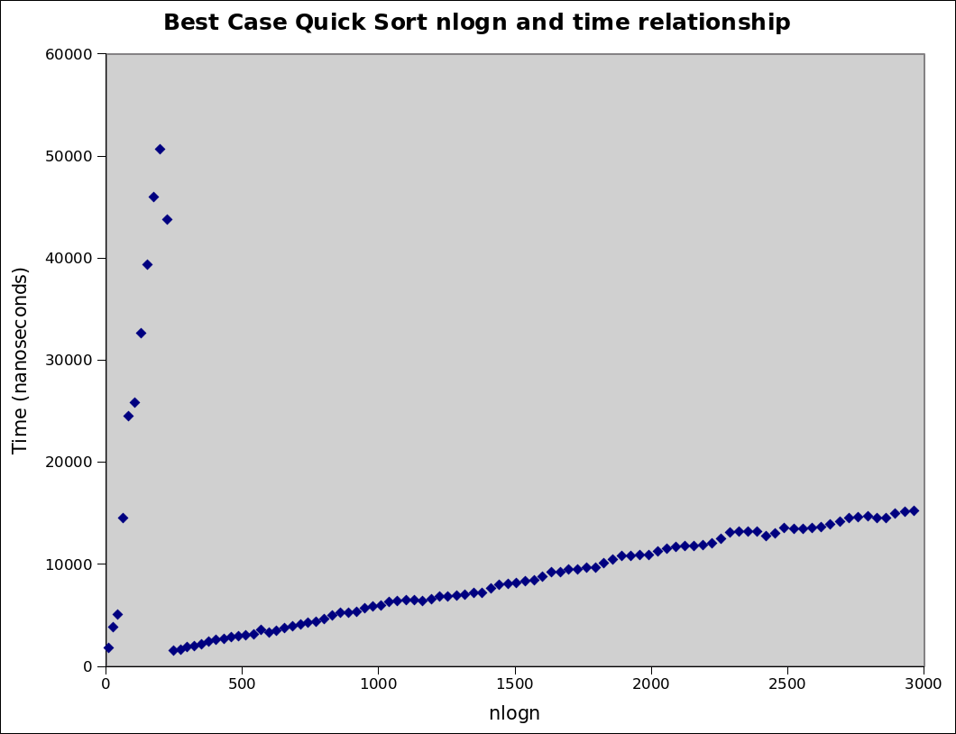
To show a nlogn run-time relationship, I plotted Time against nlogn. There is a linear relationship showing that the best case quick sort conforms to the nlogn run-time prediction. Below is the original data (n and time). There seemed no need to add a column for nlogn.

10 | 1791.5 | 210 | 2960.06 | 410 | 6322.59 | 610 | 9415.44 | 810 | 13185.0
20 | 3796.07 | 220 | 3003.06 | 420 | 6482.69 | 620 | 9472.2 | 820 | 13141.5
30 | 5001.43 | 230 | 3091.58 | 430 | 6416.86 | 630 | 9664 | 830 | 12739.0
40 | 14528.1 | 240 | 3527.81 | 440 | 6339.82 | 640 | 9639.42 | 840 | 13008.0
50 | 24430.5 | 250 | 3283.5 | 450 | 6559.03 | 650 | 10116.3 | 850 | 13560.3
60 | 25759.4 | 260 | 3471.81 | 460 | 6791.74 | 660 | 10432.8 | 860 | 13467.3
70 | 32617.3 | 270 | 3729.5 | 470 | 6809.8 | 670 | 10778.6 | 870 | 13448.4
80 | 39335.2 | 280 | 3853.46 | 480 | 6847.94 | 680 | 10795.5 | 880 | 13542.5
90 | 45942.4 | 290 | 4037.31 | 490 | 6966.79 | 690 | 10858.1 | 890 | 13586.2
100 | 50660.7 | 300 | 4213.71 | 500 | 7124.82 | 700 | 10899.5 | 900 | 13858.1
110 | 43690.8 | 310 | 4355.13 | 510 | 7145.26 | 710 | 11180.4 | 910 | 14126.1
120 | 1527 | 320 | 4601.53 | 520 | 7565.85 | 720 | 11529.0 | 920 | 14503.6
130 | 1605.96 | 330 | 4921.95 | 530 | 7940.01 | 730 | 11687.4 | 930 | 14571.4
140 | 1839.56 | 340 | 5213.79 | 540 | 8012.11 | 740 | 11770.2 | 940 | 14662.2
150 | 1917.89 | 350 | 5183.21 | 550 | 8131.79 | 750 | 11793.4 | 950 | 14516.9
160 | 2123.21 | 360 | 5321.91 | 560 | 8303.62 | 760 | 11882.0 | 960 | 14517.8
170 | 2377.63 | 370 | 5662.72 | 570 | 8409.78 | 770 | 12030.2 | 970 | 14962.6
180 | 2545.14 | 380 | 5869.86 | 580 | 8785.53 | 780 | 12485.5 | 980 | 15120.6
190 | 2651.08 | 390 | 5917.48 | 590 | 9146.75 | 790 | 13088.6 | 990 | 15163.4
200 | 2849.6 | 400 | 6279.74 | 600 | 9223.85 | 800 | 13163.6

Quick Sort – Average Case

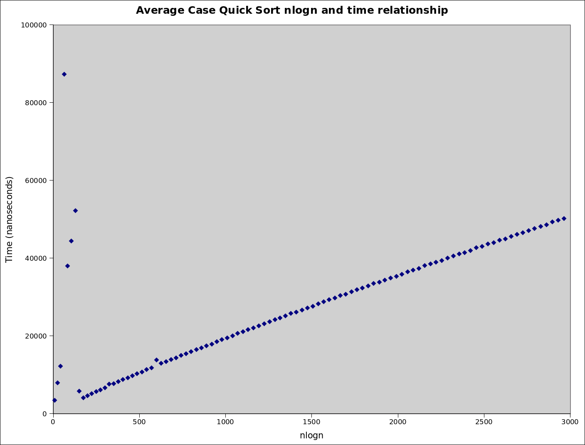
Similarly with this graph, I have also plotted Time against nlogn to confirm a nlogn relationship.

10 | 3463.83 | 210 | 10280.0 | 410 | 20595.2 | 610 | 30738.8 | 810 | 41016.5
20 | 7952.38 | 220 | 10737.6 | 420 | 21054.3 | 620 | 31341.0 | 820 | 41413.9
30 | 12212.7 | 230 | 11343.9 | 430 | 21578.6 | 630 | 31890.8 | 830 | 41891.8
40 | 87293.2 | 240 | 11772.6 | 440 | 22077.2 | 640 | 32249.4 | 840 | 42626.8
50 | 38003.8 | 250 | 13764.5 | 450 | 22572.1 | 650 | 32858.4 | 850 | 43035.7
60 | 44380.7 | 260 | 12919.5 | 460 | 23099.9 | 660 | 33431.7 | 860 | 43592.6
70 | 52184.1 | 270 | 13330.2 | 470 | 23677.1 | 670 | 33798.1 | 870 | 43978.3
80 | 5804.56 | 280 | 13881.3 | 480 | 24117.7 | 680 | 34342.7 | 880 | 44588.3
90 | 4103.71 | 290 | 14330.5 | 490 | 24618.0 | 690 | 34902.0 | 890 | 44934.4
100 | 4648.7 | 300 | 14943.6 | 500 | 25162.4 | 700 | 35343.4 | 900 | 45504.2
110 | 5122.83 | 310 | 15389.6 | 510 | 25740.0 | 710 | 35771.8 | 910 | 46091.0
120 | 5635.95 | 320 | 15890.7 | 520 | 26139.0 | 720 | 36413.6 | 920 | 46517.7
130 | 6116.72 | 330 | 16422.4 | 530 | 26671.6 | 730 | 36937.9 | 930 | 47098.4
140 | 6640.97 | 340 | 16929.7 | 540 | 27191.8 | 740 | 37366.6 | 940 | 47577.8
150 | 7592.87 | 350 | 17465.2 | 550 | 27633.3 | 750 | 38022.6 | 950 | 48095.6
160 | 7654.65 | 360 | 17879.1 | 560 | 28233.8 | 760 | 38468.6 | 960 | 48509.3
170 | 8190.89 | 370 | 18493.9 | 570 | 28750.4 | 770 | 38882.2 | 970 | 49263.5
180 | 8735.16 | 380 | 19013.6 | 580 | 29287.2 | 780 | 39367.7 | 980 | 49722.7
190 | 9231.02 | 390 | 19475.4 | 590 | 29742.2 | 790 | 40012.2 | 990 | 50180.4
200 | 9707.5 | 400 | 19968.5 | 600 | 30334.6 | 800 | 40555.1

Quick Sort – Worst Case

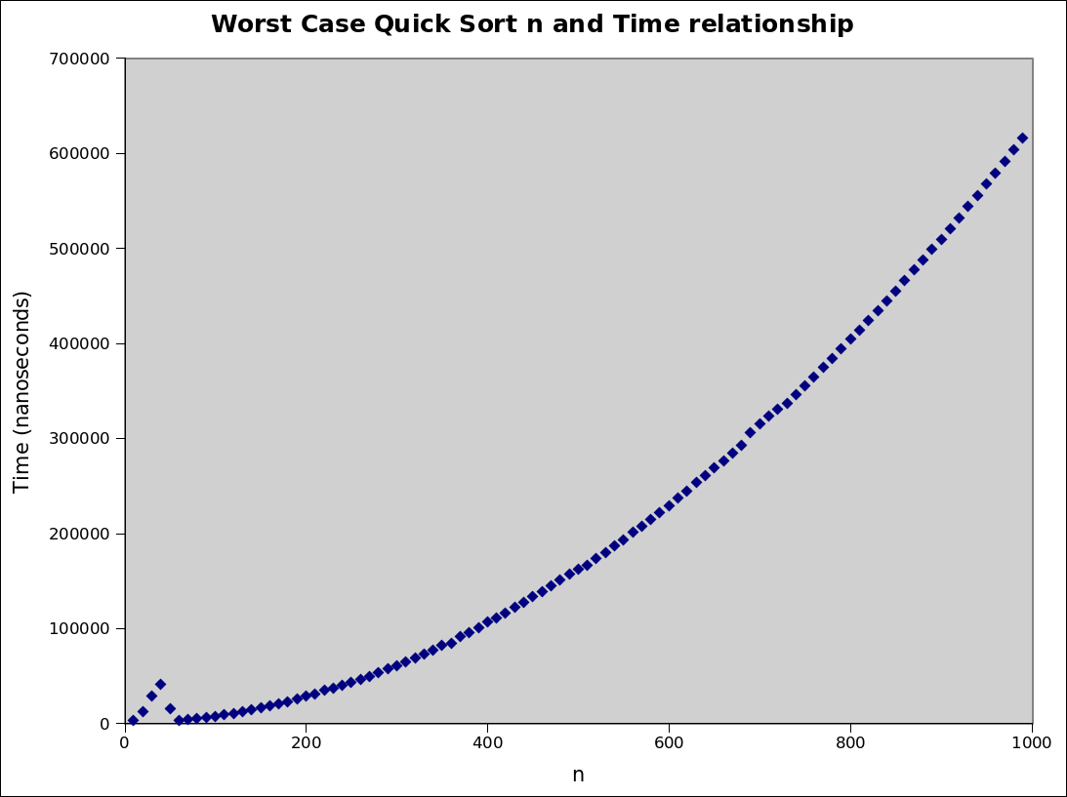
10 | 2706.86 | 210 | 30864.2 | 410 | 110321 | 610 | 236582 | 810 | 413940
20 | 12793.4 | 220 | 35112.1 | 420 | 116361 | 620 | 244507 | 820 | 423803
30 | 28476.6 | 230 | 36651.9 | 430 | 121926 | 630 | 253970 | 830 | 434404
40 | 40815.1 | 240 | 39781.9 | 440 | 127229 | 640 | 260479 | 840 | 444276
50 | 14904.4 | 250 | 42976.4 | 450 | 133174 | 650 | 268732 | 850 | 454799
60 | 3146.98 | 260 | 46179.3 | 460 | 138304 | 660 | 276278 | 860 | 465950
70 | 4164.43 | 270 | 49644.7 | 470 | 144901 | 670 | 284471 | 870 | 476785
80 | 5143.41 | 280 | 53363.3 | 480 | 150708 | 680 | 292919 | 880 | 487787
90 | 6342.11 | 290 | 57004.5 | 490 | 157161 | 690 | 305806 | 890 | 498264
100 | 7615.58 | 300 | 60820.8 | 500 | 161726 | 700 | 314560 | 900 | 509260
110 | 9155.83 | 310 | 64872.0 | 510 | 166521 | 710 | 323458 | 910 | 520259
120 | 10646.0 | 320 | 68862.3 | 520 | 173142 | 720 | 330169 | 920 | 531964
130 | 12527.0 | 330 | 72779.6 | 530 | 179687 | 730 | 336764 | 930 | 543508
140 | 14339.8 | 340 | 77407.0 | 540 | 186518 | 740 | 346065 | 940 | 555089
150 | 16427.5 | 350 | 81721.0 | 550 | 193056 | 750 | 355528 | 950 | 567490
160 | 18452.6 | 360 | 84487.8 | 560 | 200772 | 760 | 364563 | 960 | 578922
170 | 20686.5 | 370 | 91163.8 | 570 | 207748 | 770 | 374261 | 970 | 590717
180 | 22877.2 | 380 | 95779.5 | 580 | 214482 | 780 | 383830 | 980 | 603799
190 | 25547 | 390 | 100903 | 590 | 221903 | 790 | 393947 | 990 | 615464
200 | 28483.6 | 400 | 106523 | 600 | 229110 | 800 | 404341

CONCLUSION

In conclusion, I have confirmed my expectations, which match the outlined theories for each algorithm and their run-time complexities. From this analysis we can see that quick sort is generally a better algorithm in terms of run-time and scalability. We can see this as the worse case scenario for quick sort has the same run-time as the average time scenario for bubble sort. Given the successful output I have generated, my choice of nanotime over using counters has not affected my results.

