1.

Assumptions: The unit price does not change.
The products descriptions are unique

Total Sales depends on Unit Price and Quantity Sold.
However, Total Sales and Unit Price do not depend on Total Sales.

Product Description depends on Product Number.

Client Name depends on Client Number.

Salesperson name depends on Salesperson Number and the reverse is true.

Unit price depends on Product Number.
However, Product Number does not depend on Unit Price.
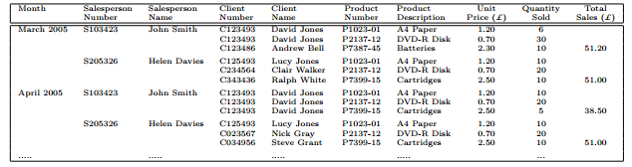

2.

Client Database

Client Number | Client Name
Primary Key

Sales Database

Month | Salesperson Number | Client Number | Product Number | Quantity Sold
 | Foreign Key

Salesperson Database

Salesperson Number | Salesperson Name
Primary Key

Product Database
Product Number | Product Description | Unit Price
Primary Key

3.

