**Regular Association Without Logistic Regression**

**---------------------------------------------------------------------------------------------------------------------**

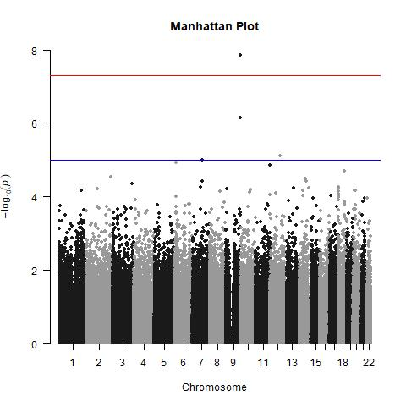

**Regular Association With Logistic Regression Using PC1**

**Regular Association With Logistic Regression Using PC2**

**Regular Association With Logistic Regression Using PC1 & PC2**

