Getting Ready for the MathWorks Radar Workshop
In this workshop, you will use a complimentary trial of MATLAB Online. The following provides step-by-step instructions to access MATLAB Online and the shared files needed for this workshop. A few notes:
- MATLAB Online is optimized for the Chrome browser. If you do not already have it, please download it before the session.
- Please go through the steps below before joining the workshop.
- Your MATLAB Online trial is already active so you can begin using it right away.
Step 1: Access your MATLAB Online Trial  Visit the following URL to access your complimentary trial of MATLAB Online and download the files you will need for the workshop.  https://www.mathworks.com/licensecenter/classroom/4866500/  Activation Key: 00796-50699-31767-47183-86302  Workshop Trial Label: 4866500  On this page, you may be asked to log into your MathWorks account. If so, please use the same email address that you used to register for the workshop.  Click on the “Access MATLAB Online” button.  Note: MATLAB Online is optimized for the Chrome Browser. | Step 2: Create a MathWorks account  Note: Skip this step if you already have a MathWorks account.  Go to: https://www.mathworks.com/mwaccount/register .  You will be asked to provide an email address and some additional information.
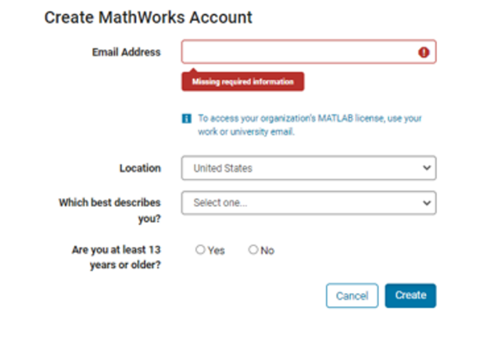 | Step 3: Upload the Workshop scripts in MATLAB Online  Visit the following GitHub repository where the files are stored. Click the ‘Open in MATLAB Online’ button in the ‘README.md’ file to open the files in MATLAB Online.  https://github.com/samlehman00/HandsOnIntroductionToRadarWorkflows_MathWorks/tree/main  Use the Open in MATLAB online button to get files in your online environment  