The Biochar Experimental Design

Hypotheses to be tested
As discussed in the Introduction tab, the process of making biochar leaves massive amounts of space where water, nutrients, and soil biota can be stored. In a desert environment like that around Fruita, water shortages can be a big problem. The primary question for this experiment is how much more water can be stored in a field with biochar than one without and for how long. A second research question is what does biochar contribute to quantity and quality of pasture production. A third topic is do the benefits of having biochar in the soil last for multiple years.
The experiment began in Spring 2023 at the Fruita Research Station of Colorado State University.

Experiment design
The image below shows the layout of the experimental field. It had previously been an unused plot planted to mixed pasture grasses. The field was divided into four strips, numbered 1 to 4 from left (west) to right (east). Each strip is about 46 ft wide and 280 ft long.
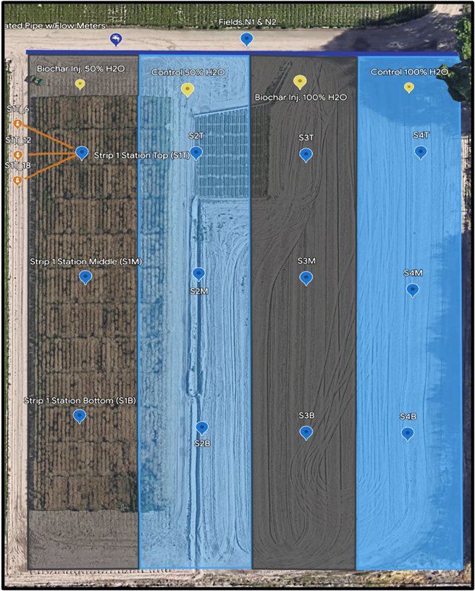
Figure 1. Experiment layout

In spring 2023, biochar was injected into strips 1 and 3 every 6 inches to an approximate depth of 6 inches. Strips 2 and 4 had no biochar amendment.

Irrigation
Water for the field is done using furrow irrigation, with the furrows 30 inches apart. Irrigation water is applied at the north end (top of the image) and runs down the furrows, infiltrating into the soil until it is saturated. Any excess runs into a drainage ditch at the south end of the field.
Irrigation is applied to the east two rows (strips 3 and 4) roughly every two weeks during the growing season. The two west strips are irrigated only once a month.

Biochar source and application
The biochar used in this experiment is made from pistachio shells and was purchased from VGrid Energy Systems, Camarillo, California. More details and chemical analysis results will be available in the Additional Information tab.
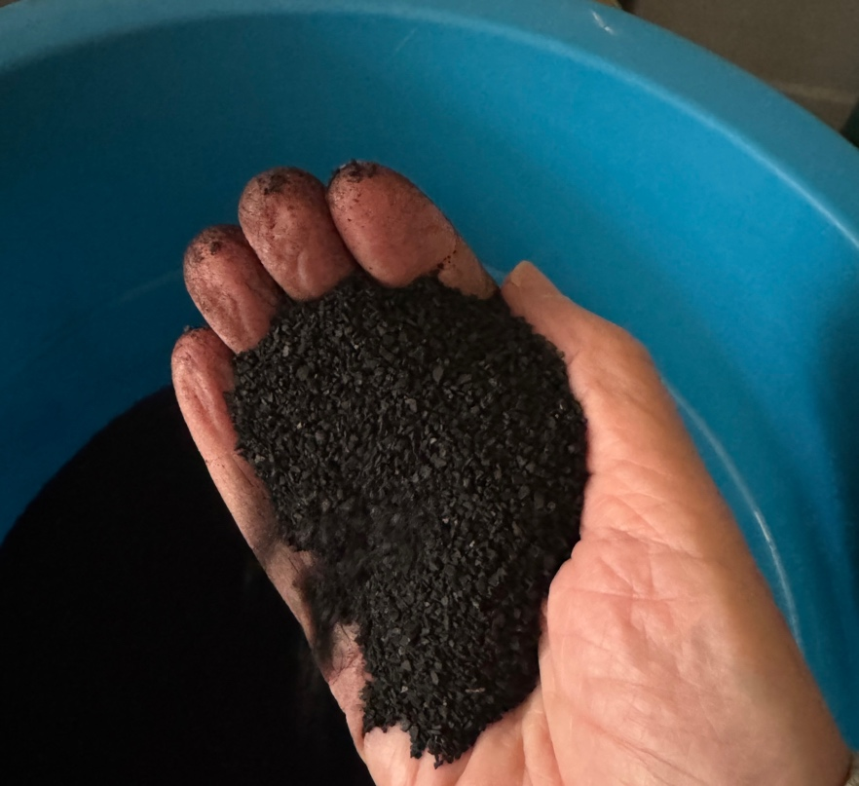
Figure 2. Pistachio shell biochar
The process to collect soil moisture, electrical conductivity, and temperature is described in detail in the Technical Details tab.

Soil sampling
Soil samples for each strip have been collected in early spring and late fall and analyzed by Ward Labs in Kearney, Nebraska. Soils were sampled for both mineral and biological activity, once in the spring and once in the fall.
Table 1. Soil sampling dates
2023 | April 4, October 11
2024 | March 22, November 7
2025 | April 2

Fertilizer application
The Ward Labs fertilizer recommendations based on the soil samples for each strip were followed.

Yield quality and quantity measurements
Coming soon.

