Welcome to the Fruita Biochar Project
Note: This is an early version of this website. Expect problems. If you find one or just have a suggestion for improvements, please email nelson.gerald.c@gmail.com.
This is an introduction to the project. Here’s what you can expect:
- An introduction to what biochar is and why it is potentially valuable in western Colorado (and other drought prone areas of the world).
- Overview of the biochar experiment at the Colorado State University research station outside Fruita, CO.
- Digital data collection results in graphical (Main Data Display tab) and tabular form (Summary Statistics tab)
- Technical details on the data collection process.
- Coming soon, biochar source and characteristics, fertilizer application, soil results and yield quantity and quality

What is biochar?
Biochar is the solid material obtained from the thermochemical conversion of biomass in an oxygen-limited environment (International Biochar Initiative). The surface area inside the biochar pores is approximately 2,000 ft/gram (about half a basketball court!). Its water holding capacity is up to 7 times its weight in water (Figure 1).
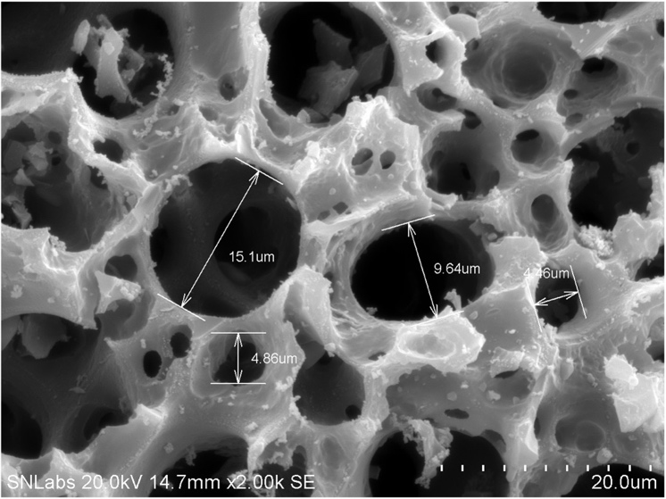
Figure 1. Scanning electron microscope image of biochar

Plant biology and biochar structure
For those interested in chemistry, a bit of biological history is in order. Most biochar is plant-based. A key element of vascular plants is the carbohydrate lignin which consists of carbon rings (the hexagonal elements in the figures below) and various molecular add-ons (Figure 2). It provides the support structure for plants allowing them to adapt to life on land. Figure 3 is a similar diagram for a well-processed biochar. Note that the components that make lignin a carbohydrate almost gone, leaving only the hexagonal structures. Microbes have evolved to break down and extract nutrients from carbohydrates but not carbon rings. This is why biochar remains in the soil for 100s to 1000s of years.
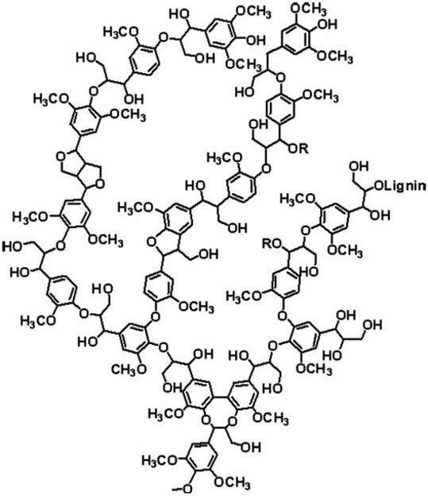  Figure 2. Lignin chemical structure | 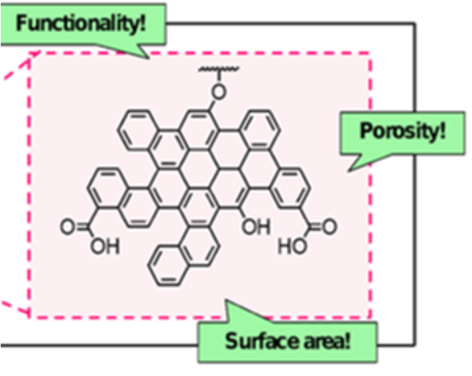  Figure 3. Biochar chemical structure
Image sources:
Figure 2- https://www.sciencedirect.com/topics/materials-science/lignin
Figure 3 - https://www.envchemgroup.com/nanostructures-biochar.html

