The Biochar Experimental Design

Hypotheses to be tested
As discussed in the Introduction tab, the process of making biochar leaves massive amounts of space available in the biochar pores where water, nutrients, and soil biota can be stored. In a desert environment like that around Fruita, Colorado, water shortages can be a big problem. The primary research question for this experiment is how much more water can be stored in a field with biochar than in a field without and for how long. A second research question is what does biochar contribute to quantity and quality of pasture production. A third topic is do the benefits of having biochar in the soil last for multiple years.
The experiment began in Spring 2023 at the Fruita Research Station of Colorado State University. This writeup covers the period from 2023 to the end of 2025.

Experiment design
The image below shows the layout of the experimental field. It had previously been an unused plot planted to mixed pasture grasses. The field was divided into four strips, numbered 1 to 4 from left (west) to right (east). Each strip is about 46 ft wide and 280 ft long.
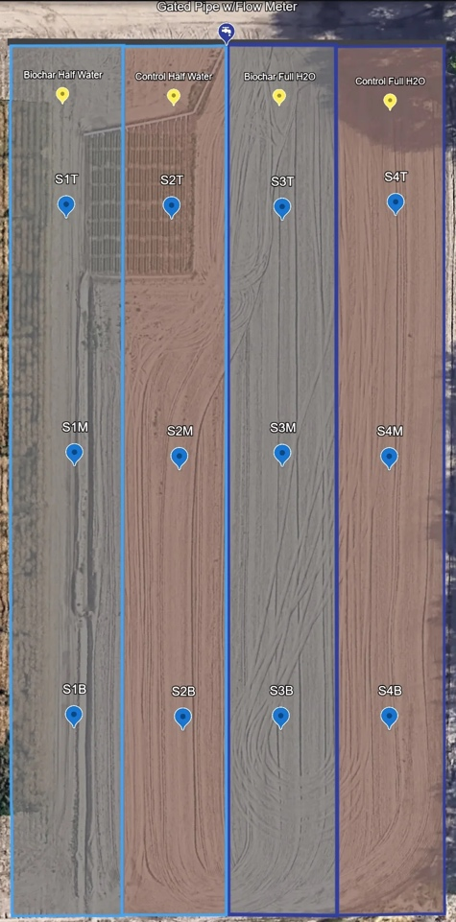
Figure 1. Experiment layout
In spring 2023, biochar was injected into strips 1 and 3 every 6 inches to an approximate depth of 6 inches. Strips 2 and 4 had no biochar amendment.

Irrigation
Water for the field is done using furrow irrigation, with the furrows 30 inches apart. Irrigation water is applied at the north end (top of the image) and runs down the furrows, infiltrating into the soil until it is saturated. Any excess runs into a drainage ditch at the south end of the field.
Irrigation is applied to the east two rows (strips 3 and 4) roughly every two weeks during the growing season. The two west strips are irrigated only once a month.

Biochar source and application
The biochar used in this experiment is made from pistachio shells and was purchased from VGrid Energy Systems, Camarillo, California. More details and chemical analysis results will be available in the Additional Information tab.
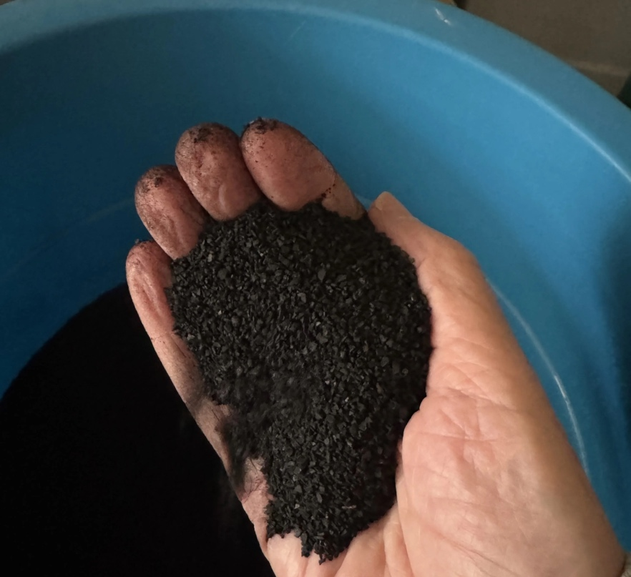
Figure 2. Pistachio shell biochar
The process to collect soil moisture, electrical conductivity, and temperature is described in detail in the Technical Details tab.

Soil sampling
Soil samples for each strip have been collected in early spring and late fall and analyzed by Ward Labs in Kearney, Nebraska. Soils were sampled for both mineral and biological activity, once in the spring and once in the fall.
Table 1. Soil sampling dates
2023 | April 4, October 11
2024 | March 22, November 7
2025 | April 2, November 3

Fertilizer application
The Ward Labs fertilizer recommendations based on the soil samples for each strip were followed. Data on timing and quantity are available on the Bulk Downloads tab.

Yield quality and quantity measurements
Grasses were harvested three times a season in each of the four strips with measurements on dried biomass content and analyzed for nutrient composition by strip (Pasture Quality Metrics and Biomass (Field Samples) tabs.
Soil Chemistry and Biological Activity
Soil samples were collected in each strip twice a year, in the spring and fall. The data were sent to Ward Labs for testing for both chemical composition and biological activity (Soil Biological Health and Soil Chemistry tabs. As with all the data presented here, these data can be downloaded using the Bulk Downloads tab.

