Welcome to the Fruita Biochar Project
The Fruita Biochar Project is beginning its fourth year, 2026. This is the second version of this website. It has many new features! Please explore and if you find problems or have a suggestion for improvements, please email nelson.gerald.c@gmail.com.
This is an introduction to the project and the website. Here’s what you can expect:
- An introduction to what biochar is and why it is potentially valuable in western Colorado (and other drought prone areas of the world).
- Overview of the biochar experiment at the Colorado State University research station, located outside Fruita, CO.
Two categories of collected data – from continuous monitoring and lab-based results – are reported.
- The Continuous Monitoring Data tab includes graphical (Interactive Plots) and tabular formats (Summary Statistics).
- The Lab-Based Results tab includes results that present data on forage quality (Pasture Quality Metrics) and quantity (Biomass (Field Samples)), soil biological health (Biological Health) and soil chemistry (Soil Chemistry).
The remaining tabs are
- Technical details on the data collection process.
- Bulk download of all data available – Campbell Scientific sensor data, local weather variables, fertilizer application and irrigation water applied, soil results and yield quantity and quality.
- Acknowledgements of everyone who has made this project possible.

What is biochar?
Biochar is the solid material obtained from the thermochemical conversion of biomass in an oxygen-limited environment (International Biochar Initiative). The surface area inside the biochar pores is approximately 2,000 ft/gram (about half a basketball court!). Its water holding capacity is up to 7 times the weight of the biochar (Figure 1).
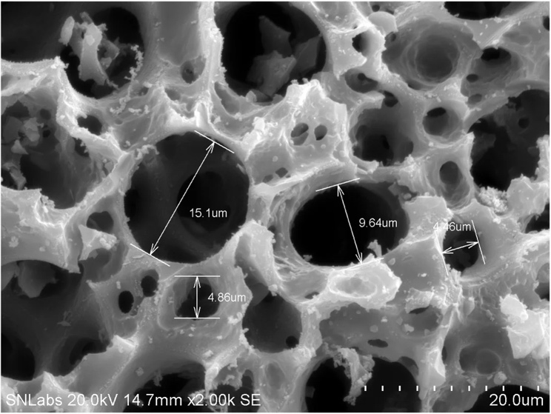
Figure 1 Scanning electron microscope image of biochar

Plant biology and biochar structure
For those interested in chemistry, a bit of biological history is in order. Most biochar is plant-based. A key element of vascular plants is the carbohydrate lignin which consists of carbon rings (the hexagonal elements in the figures below) and various molecular add-ons (Figure 2). It provided the support structure for plants allowing them to adapt to life on land. Figure 3 is a similar diagram for a well-processed biochar. Note that the components that make lignin a carbohydrate almost gone, leaving only the hexagonal structures. Microbes have evolved to break down and extract nutrients from carbohydrates but not carbon rings. This is why biochar remains in the soil for 100s to 1000s of years.
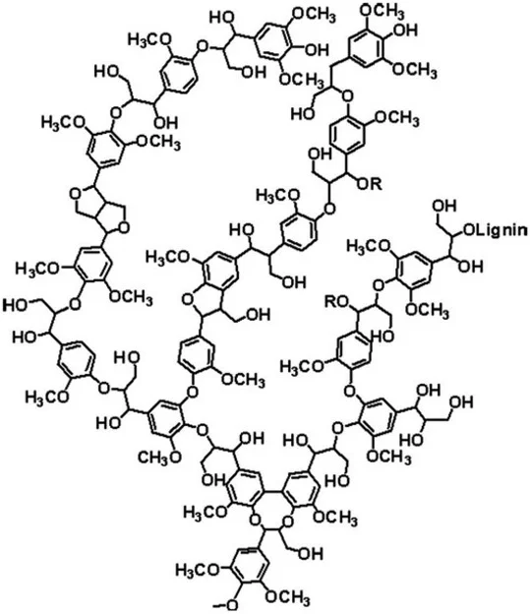  Figure 2. Lignin chemical structure | 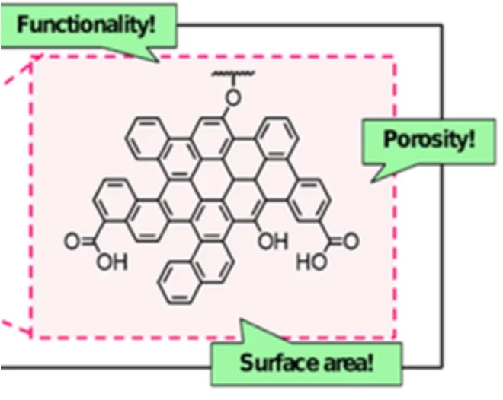  Figure 3. Biochar chemical structure
Image sources:
Figure 2- https://www.sciencedirect.com/topics/materials-science/lignin
Figure 3 - https://www.envchemgroup.com/nanostructures-biochar.html

