Pawesome User Manual
Table of Contents

Pawesome Pet Care Management System

User Manual
Version: 0.4 Date: 25 October 2026 For: Customers and authorized Pawesome staff Project: Pawesome — Web-Based Pet Management Information System

Document control
Version | Date | Change
0.1 | 2026-10-20 | Initial draft
0.2 | 2026-10-22 | Tested draft with screenshots
0.3 | 2026-10-25 | Rewritten in plain language for end users
0.4 | 2026-10-25 | Audited against the current system: added boarding care steps, approval confirmations, payment-reference rule, pet-photo rules, Controlled Drugs, and new manager pages

Contents
- Introduction
- How to use this manual
- Getting started
- Customer guide
- Receptionist guide
- Cashier guide
- Inventory guide
- Veterinary guide
- Manager guide
- Admin guide
- Super Receptionist guide
- Staff self-service and the attendance kiosk
- A note about the Payroll role
- How a booking moves through the system
- Common problems and what to do
- Keeping information safe
- List of screenshots
- Words used in this manual
- Quick guide: where each role starts
- Keeping this manual up to date

1. Introduction

1.1 About this manual
This manual explains how to use Pawesome, step by step. It is written for customers and staff. You do not need any technical background to follow it.

1.2 What Pawesome does
Pawesome is a pet care management system. Customers use it to register their pets and book services such as grooming, veterinary appointments, and pet hotel stays. Staff use it to review bookings, take payments, manage stock, record medical care, and handle reports and payroll.

1.3 Who can use it
Pawesome has separate workspaces for these roles:
- Customer — books services and manages pets.
- Receptionist — reviews bookings, handles walk-in customers, and manages boarding care.
- Cashier — takes payments and makes sales at the point of sale.
- Inventory — manages products, stock, and suppliers.
- Veterinary — handles appointments and medical records.
- Manager — reviews reports and handles staff attendance, leave, payroll, and approvals.
- Admin — manages user accounts and system settings.
- Super Receptionist — combines the receptionist, cashier, and inventory roles.
What you can see and do depends on the role of your account. If a page is missing or you are told you have no access, ask your administrator.

1.4 What you need
- The Pawesome website address, given to you by your administrator.
- An account with a username and password. Customers can create their own; staff accounts are created by the administrator.
- A computer or mobile device with a modern browser (Chrome, Edge, Firefox, or Safari).

1.5 Keeping your account safe
- Use only your own account. Do not share your password.
- Do not put passwords or customer information in screenshots or shared files.
- Check that you are on the right page before saving or submitting anything.
- Sign out when you are done, especially on a shared computer.

2. How to use this manual
- Each task is written as numbered steps. Follow them in order.
- Text in bold is a button, menu, or page name exactly as it appears on screen.
- Screenshots are numbered (Figure UM-001, UM-002, and so on). A full list is in Section 17.
- Read the chapter for your role. You only need the parts that apply to you.

3. Getting started

3.1 Sign in
Purpose: Open your Pawesome workspace.
- Open the Pawesome website address in your browser.
- Select Log In if the login page is not already showing.
- Enter your Username and Password.
- Select Sign In.
Expected result: You arrive at the workspace for your role. New customers who have not verified their email are sent to the email verification page first.
If something goes wrong: Check your username and password and try again. If you forgot your password, see Section 3.3.
Screenshot: Figure UM-001 — Login page (screenshots/UM-001-login.png).
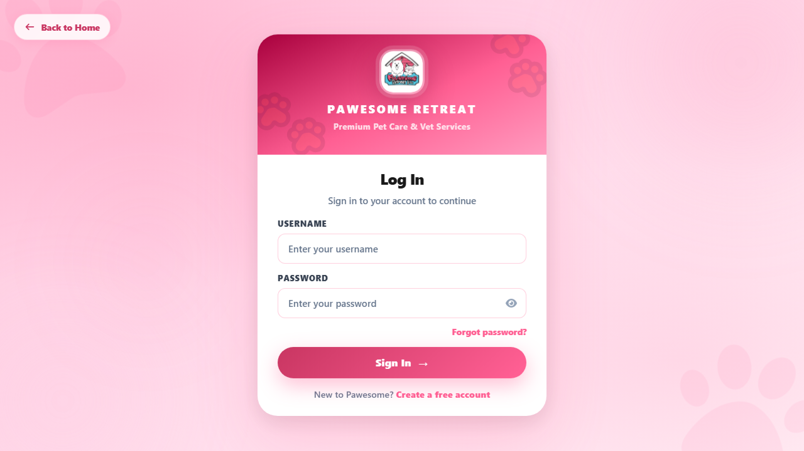

3.2 Create a customer account
Purpose: Register for a customer account.
- On the Pawesome home page, select Register.
- Fill in Personal Information — your first name, last name, and email address. The other fields (middle name, suffix, date of birth, contact number) are optional.
- Continue to Account Setup. Choose a username and a password, then type the password again to confirm it.
- Complete the Emergency Contact step.
- Review your details, then accept the Terms of Service and Privacy Policy.
- Submit the form.
- Check your email and follow the verification link before making bookings.
Expected result: Your account is created and a verification email is sent to your address. See Section 3.3 for what to do next.

3.3 Verify your email and reset a forgotten password
Verify your email:
- Open the verification email sent to your address.
- Select the link in the email. It stays valid for 60 minutes.
- Sign in when asked.
If the email does not arrive, check your spam folder or request a new link from the verification page.
Reset a forgotten password:
- On the login page, select Forgot Password.
- Enter your registered email address and submit.
- Open the reset email and select the link within 60 minutes.
- Enter a new password and confirm it.
- Sign in with your new password.
Expected result: After verification you can make bookings. After a password reset you can sign in with the new password.
Note: The sign-in and reset pages never say whether an email is registered. This is normal and protects your account.

3.4 Sign out
Select Logout or Log Out in the side menu. Confirm if asked. Always sign out on shared computers.

4. Customer guide
The customer menu contains: Services, My Pets, My Requests, Notifications, History, Medical, Reports, Profile, and Log Out.

What the booking statuses mean
Status | What it means | What to do
Pending | Staff are reviewing your request. | Wait for a decision.
Ongoing | Your booking is approved or the service is in progress. | Bring your pet at the scheduled time.
Pickup | Your pet is ready to go home. | Collect your pet.
Done | The service is finished. | Nothing needed.
Cancelled | The booking was cancelled. | Book again if needed.

Payment status | What it means | What to do
Not paid | No payment has been made yet. | Pay online or at the counter.
Verifying payment | Your payment proof is being checked. | Wait for the cashier.
Paid | Payment is confirmed and a receipt was issued. | Keep the receipt number.
Payment rejected | The proof you sent could not be accepted. | Read the reason and send corrected proof.
Partly paid | Part of the amount is still due. | Settle the remaining balance.
Refunded | Your payment was returned. | Contact staff if unsure why.

4.1 Add or manage a pet
Purpose: Keep your pet's information ready for bookings.
- Open My Pets.
- To add a pet, select Add Pet (or Add your first pet if the list is empty).
- Fill in the pet's details. You can also add a photo — it must be a JPG, PNG, or WebP image under 10 MB.
- Save the form.
- To change a pet, select Edit.
- To remove a pet from the active list, select Archive. To bring it back, open Archived Pets and select Restore Pet.
- To see past records for a pet, select Medical History or View History.
Expected result: The pet appears in your active list and can be chosen when booking.
Note: Archived pets cannot be used for new bookings until you restore them. iPhone HEIC photos are not accepted — save or share the photo as JPG or PNG instead.
Screenshot: Figure UM-003 — My Pets (screenshots/UM-003-customer-pets.png).
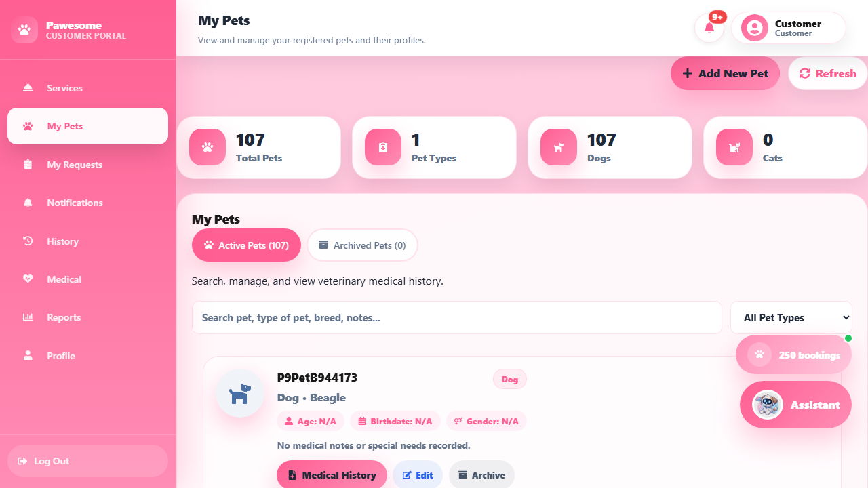

4.2 Book a grooming or veterinary service
Purpose: Request a service for one of your pets.
Before you start: Sign in with a verified account and make sure your pet is registered and active in My Pets.
- Open Services.
- Find the service you want and select Book Now.
- In the booking form, choose your pet and the specific service.
- Pick a date and an available time.
- Add notes or describe your pet's concern.
- Check the booking details and the price on the review screen.
- Select Go back to fix anything, or Confirm booking to send the request.
- Open My Requests to see the new request.
Expected result: Your request appears in My Requests with the status Pending. Staff will review it.
If something goes wrong: If a time slot is taken, the form will tell you — pick another slot. Bookings are blocked until your email is verified.
Screenshots: Figure UM-004 — booking review before sending (screenshots/UM-004-booking-review.png); Figure UM-004a — filled grooming form (screenshots/UM-004a-grooming-form-filled.png); Figure UM-004b — request shown after sending (screenshots/UM-004b-grooming-submitted.png).
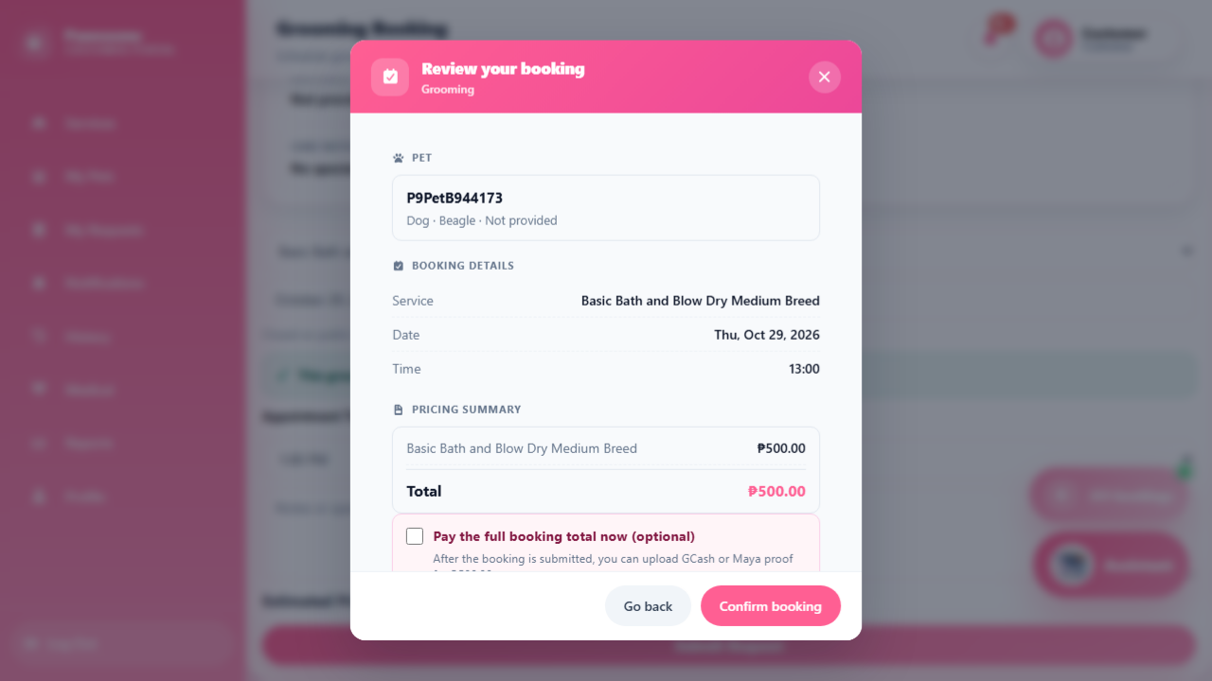
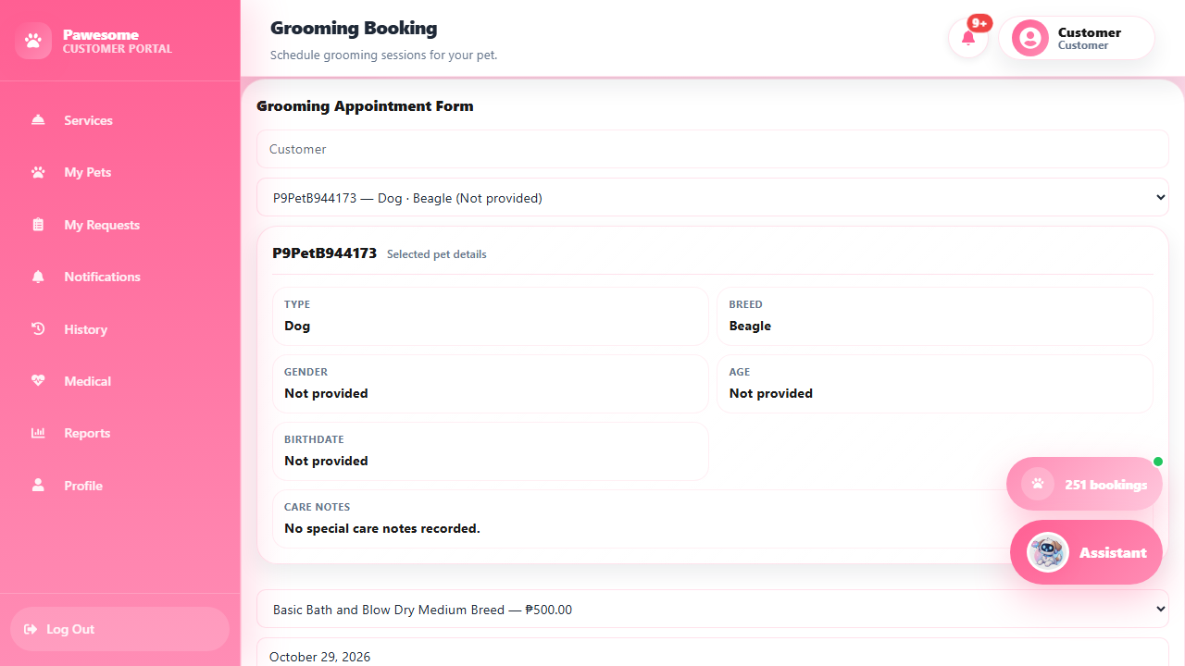
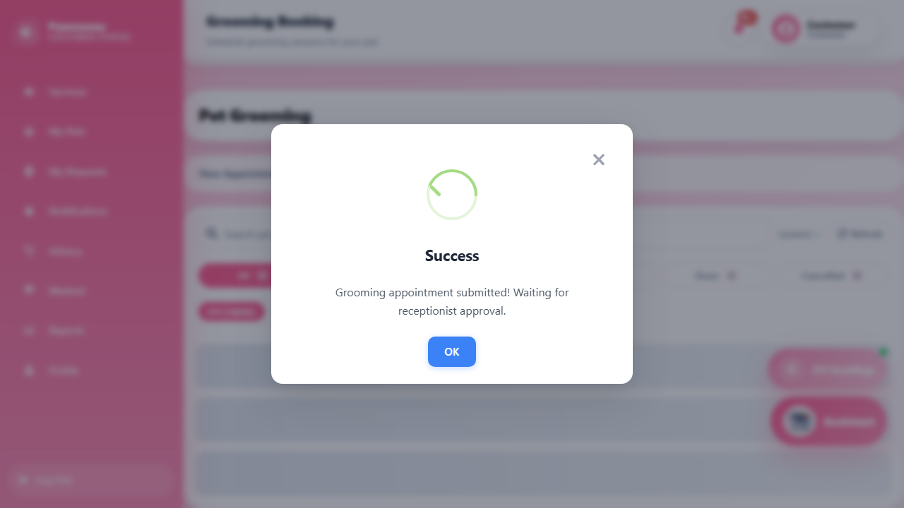

4.3 Book a Pet Hotel stay
Purpose: Reserve a boarding stay for your pet.
Before you start: Have a photo or scan of your pet's vaccination card ready to upload.
- Open Services, find Pet Hotel, and select Book Now.
- Select New Reservation.
- Choose your pet and the Stay Date. The form shows the Stay Duration — a same-day stay with check-out by 6:00 PM.
- Choose a room if one is offered.
- Add notes if needed, and attach the Vaccination Card file.
- Review the booking and price, then select Submit Boarding Request and confirm.
- Track the request under My Requests.
Expected result: Your reservation appears as Pending. The receptionist checks the vaccination card and the room before approving the stay.
Note: A vaccination card is required — the receptionist cannot approve a hotel booking without it. If your chosen room fills up, staff may assign a suitable room or ask you to pick another date.
Screenshot: Figure UM-017 — Pet Hotel reservation form with vaccination card upload (screenshots/UM-017-hotel-reservation-form.png).
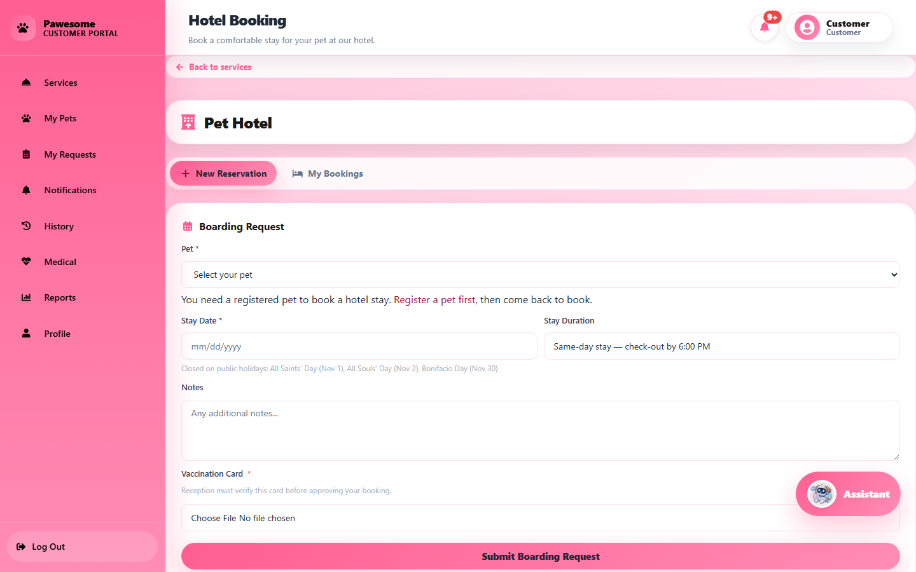

4.4 Track requests, pay online, or cancel
Purpose: Check your bookings, pay for them online, or cancel a request you no longer need.
- Open My Requests. Use the tabs (All, Pending, Ongoing, Pickup, Done, Cancelled) to find a booking.
- To pay, select Pay now on the booking.
- Choose GCash or Maya, enter the payment reference number, and upload your proof of payment (jpg, png, or pdf, up to 5 MB).
- Submit and wait — the payment shows Verifying payment while the cashier checks it.
- If the payment is rejected, read the reason shown and select Resubmit payment with corrected details.
- To cancel a request you no longer need, use the cancel action on the booking. Paid or in-progress bookings may need staff help to cancel — ask at the counter if the option is not available.
- After a veterinary visit, the clinic may bill additional charges. These are paid the same way — GCash or Maya with a reference number and proof.
Expected result: Once the cashier confirms the payment, the booking shows Paid with a receipt number. You can open the receipt from your payments view.
Important: Each reference number can be used only once. If you reuse a GCash or Maya reference from another payment, the system will reject it — enter the correct reference for this specific payment.
Screenshot: Figure UM-015 — My Requests list (screenshots/UM-015-customer-request-paid.png).
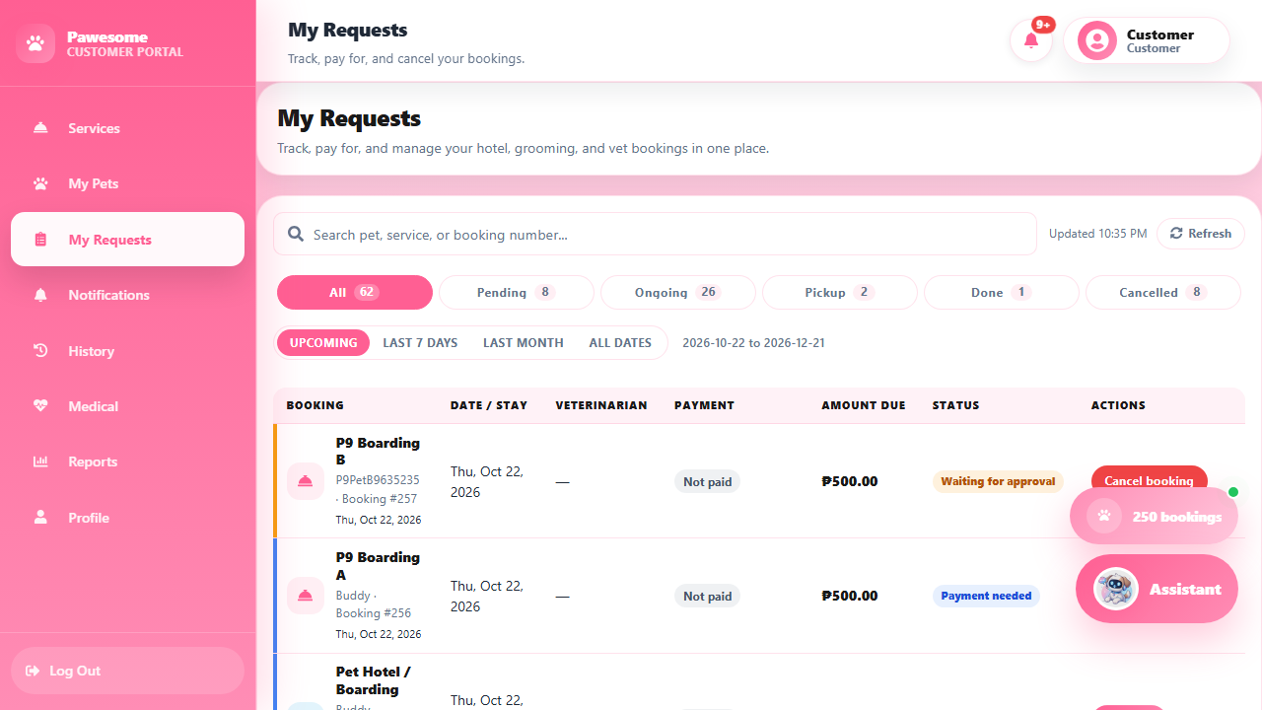

4.5 A note about the store
Product browsing and customer checkout in the online store are not available in this version. You can still book and pay for services as described above. For product purchases, ask the staff at the counter.

4.6 Other customer pages
- Notifications — messages about your bookings and account. You can also change your email notification settings here.
- History — your past bookings and transactions.
- Medical — your pet's medical records from the clinic (Figure UM-011, screenshots/UM-011-customer-medical.png).
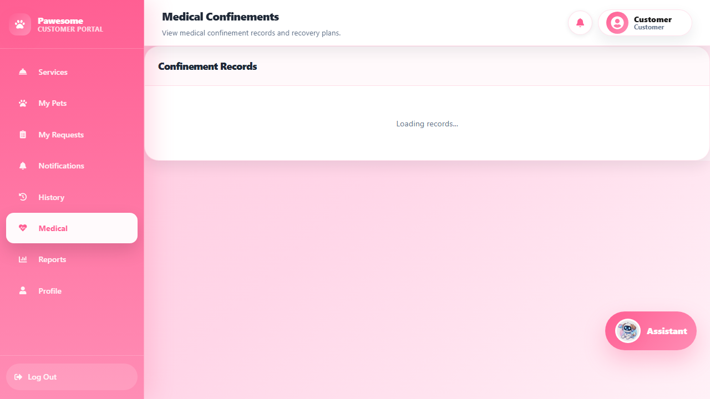
- Reports — summaries of your activity.
- Profile — your account details and profile photo. If you do not upload a photo, the system shows your initials.
Screenshot: Figure UM-002 — customer Services page (screenshots/UM-002-customer-services.png).
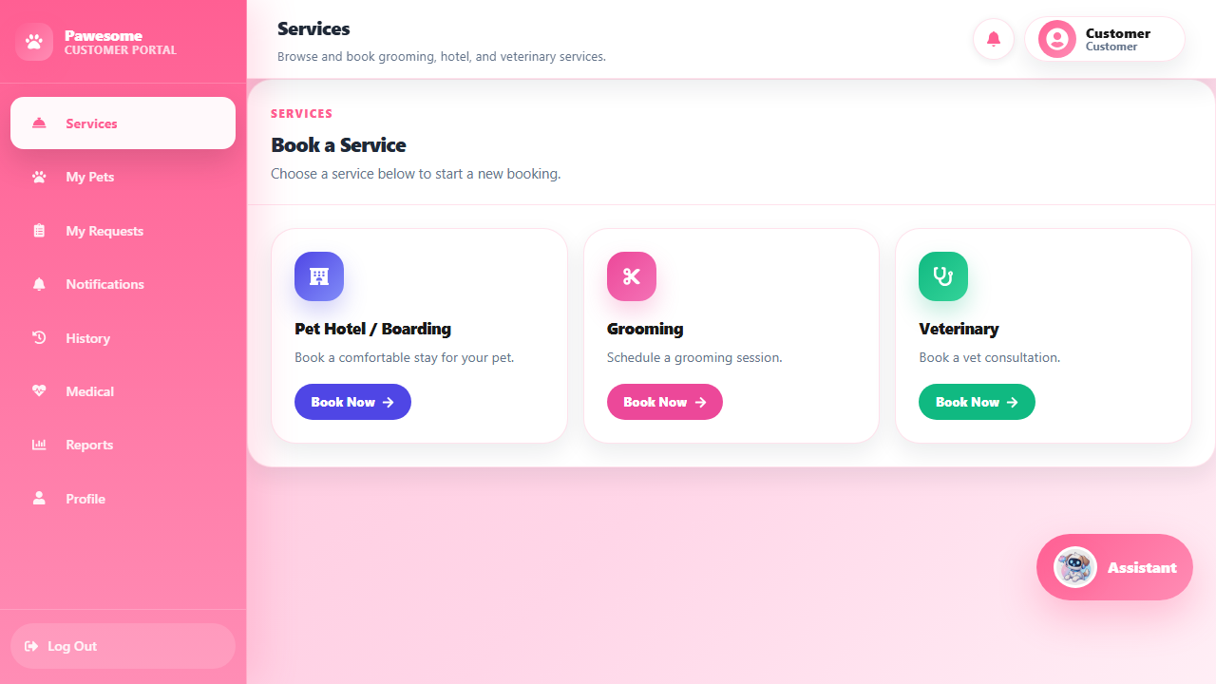

5. Receptionist guide
The receptionist menu contains: Booking (Hotel, Veterinary, Grooming), Manage Services, Walk-ins, Customer Profile, Chatbot, Live Chat, History, Reports, My Payroll, Profile, and Logout.

5.1 Review and decide on a booking
Purpose: Check a customer's request and approve or reject it.
- Open Booking, then choose Hotel, Veterinary, or Grooming.
- Use the search or the status filter to find the request.
- Open the row's actions menu to see its details — review the pet, owner, service, schedule, and any attached files.
- For Pet Hotel requests, check and verify the vaccination card first — approval is not allowed without it.
- For veterinary requests, choose the veterinarian when asked.
- From the actions menu, select Approve or Reject.
- A confirmation asks "Are you sure you want to approve this request?" — check the request number and select Confirm to proceed, or Cancel to go back. Rejections ask for a reason.
- Reopen the record to confirm the new status.
Expected result: The booking moves to Approved or Rejected, and the customer is notified. For hotel bookings, the system assigns or keeps the reserved room.
Note: Always give a clear reason when rejecting — the customer sees it. If the room is already full, approval is blocked; coordinate another room or date with the customer. Pressing approve twice is safe — only the first approval takes effect.
Screenshot: Figure UM-005 — grooming booking queue (screenshots/UM-005-receptionist-grooming-queue.png).
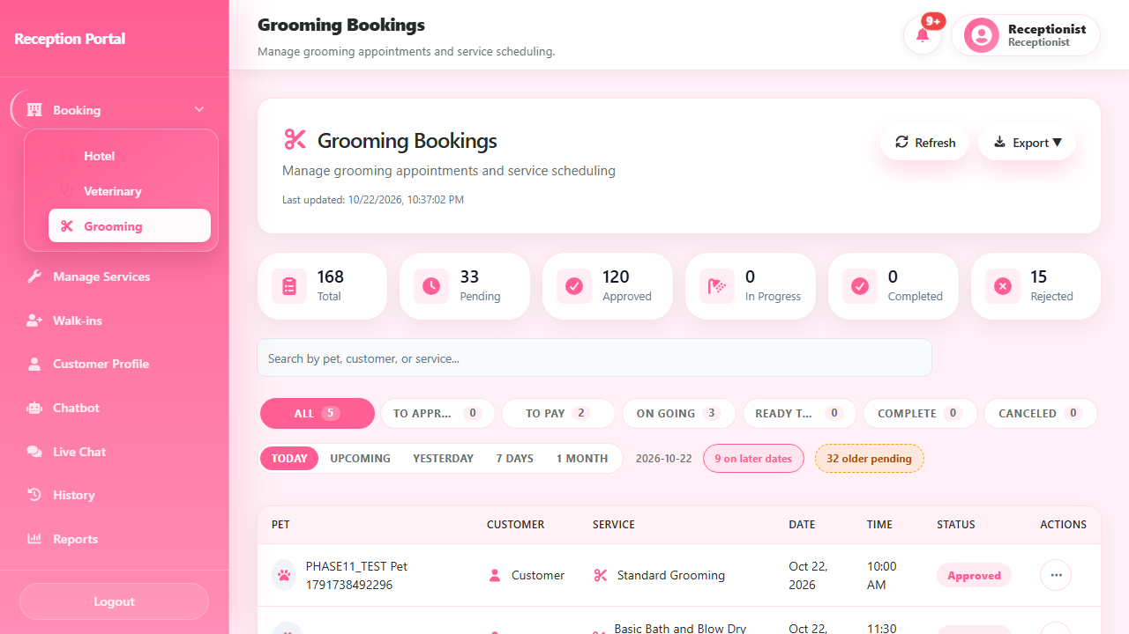

5.2 Manage a boarding stay
Purpose: Look after a pet during its approved Pet Hotel stay.
- Open Booking → Hotel and find the approved boarding.
- When the pet arrives, use Check In on the record.
- During the stay, open the record and use Add Care Log to record care (choose the log type and write notes).
- When the stay is done, use Ready for Pickup — this tells the customer their pet can be collected.
- When the owner collects the pet, use Check Out to close the stay.
Expected result: The boarding record shows each step, and the customer can follow the status from their side.

5.3 Add a walk-in customer
Purpose: Book a service for a customer who is physically at the shop.
- Open Walk-ins.
- Select the service and fill in the customer, pet, and service details.
- Review the details and confirm.
- Approve the new booking so the customer can pay at the counter.
- Check Recent Walk-in Bookings on the same page to see today's walk-ins, and use Open list to jump to that service's booking queue.
Expected result: The booking is created, appears in the recent list, and the cashier can collect payment for it.
Screenshot: Figure UM-018 — Walk-ins page with the recent bookings list (screenshots/UM-018-receptionist-walkins.png).
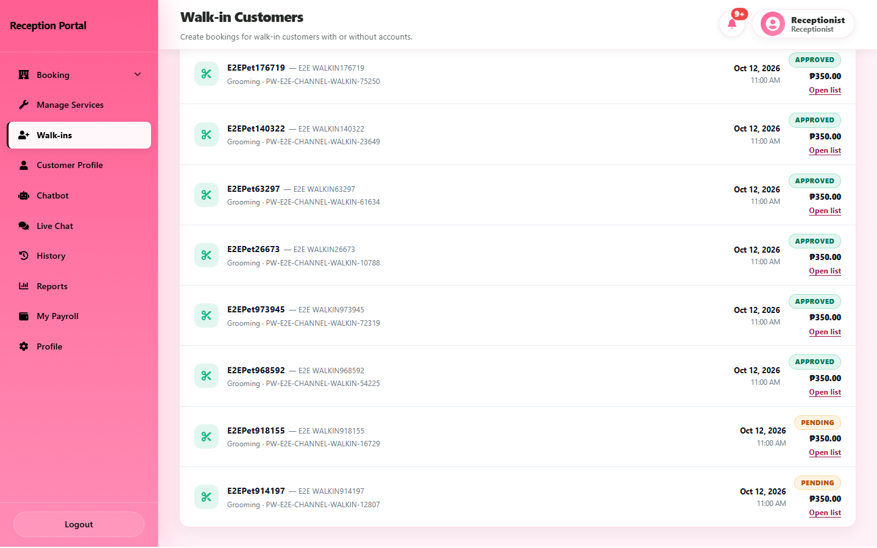

5.4 Other receptionist pages
- Customer Profile — look up customers and their pets.
- Manage Services — review the services offered.
- Chatbot and Live Chat — answer customer questions.
- History and Reports — past bookings and summaries.
- My Payroll, Profile — your own staff pages (see Section 12).

6. Cashier guide
The cashier menu contains: Dashboard, POS, Transactions, History, Reports, My Payroll, Profile, and Logout.

6.1 Check a customer payment
Purpose: Confirm or reject a payment for a service booking.
- Open POS, then Payment Approvals.
- Find the request and review the reference, amount, and payment method.
- Select View Proof to check the uploaded receipt or screenshot.
- Choose the right action:
  - Verify — the online payment (GCash or Maya) checks out.
  - Collect Payment / Collect Cash — the customer is paying at the counter. Cash is the usual method; you can also record a GCash or Maya payment made at the counter — enter its reference number. Use counter collection only for walk-in bookings, or for online bookings whose proof was rejected.
  - Reject — the proof is wrong, unreadable, or uses a reference already used on another payment. Pick the reason from the list in the Reject Payment dialog.
- Confirm in the dialog.
Expected result: A verified or collected payment marks the booking Paid and produces a receipt number. A rejected payment leaves your queue and goes back to the customer with your reason — it returns if the customer sends new proof.
Note: Do not record an online payment as cash while its proof is still waiting — verify or reject the proof instead.
Screenshot: Figure UM-006 — Payment Approvals with a pending GCash payment (screenshots/UM-006-cashier-payment-approvals.png).
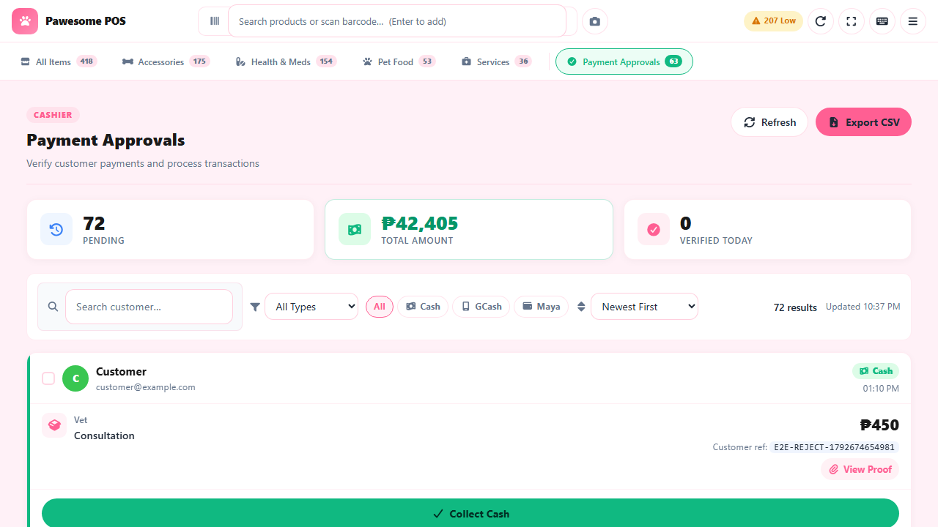
Screenshot: Figure UM-019 — Reject Payment dialog with reason list (screenshots/UM-019-cashier-reject-dialog.png).
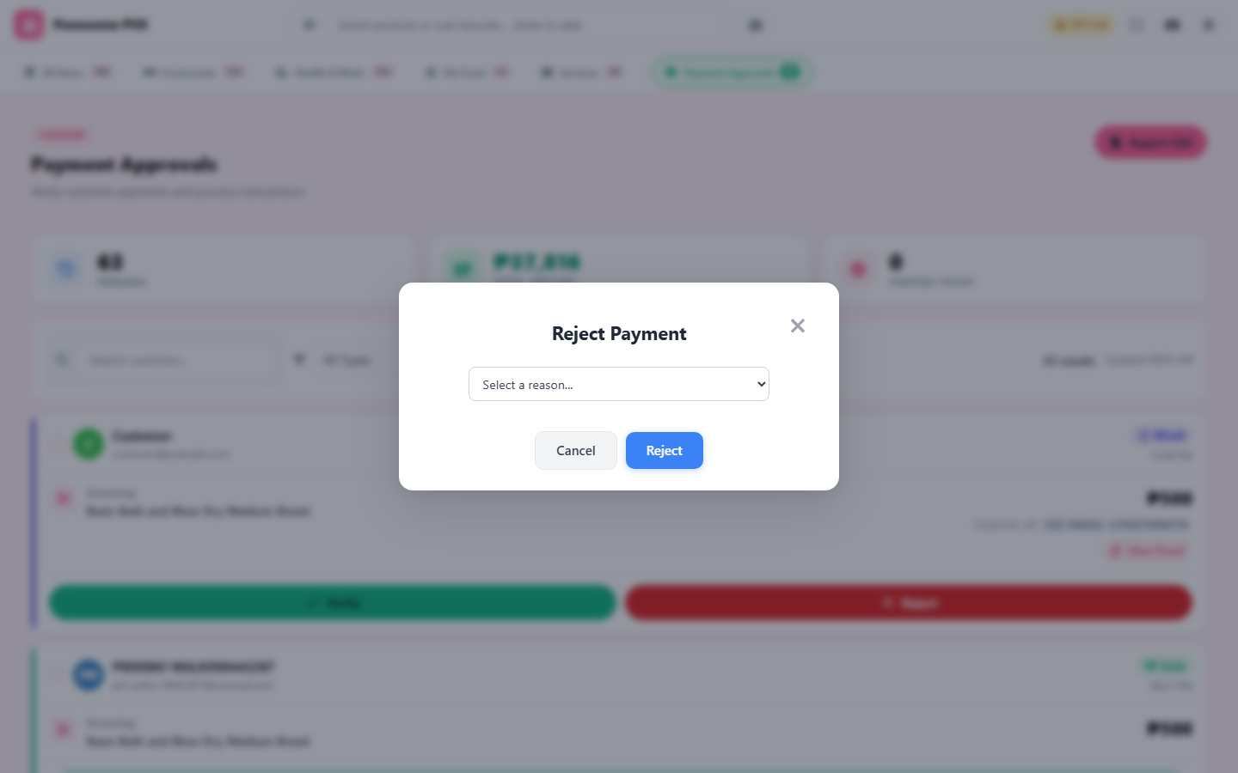

6.2 Make a sale at the POS
Purpose: Sell products or services over the counter.
- Open POS.
- Browse or search the item tabs (All Items, Accessories, Health & Meds, Pet Food, Services) and add items to the cart.
- Check the quantities and the total.
- Choose the customer, or leave it as Walk-in Customer.
- Select Proceed to Payment, choose the payment method, and enter the amount received. The sale cannot be completed if the cash given is less than the total.
- Complete the sale.
- Review the receipt — it carries the Pawesome clinic logo and can be printed. Past sales are under Transactions and History.
Expected result: The sale is recorded, a receipt is produced, and stock counts update.
Note: If you are unsure whether a sale went through (for example, after a network error), check Transactions before ringing it up again — do not submit the same sale twice.
Screenshot: Figure UM-020 — POS cart with an item and the Proceed to Payment button (screenshots/UM-020-cashier-pos-cart.png).
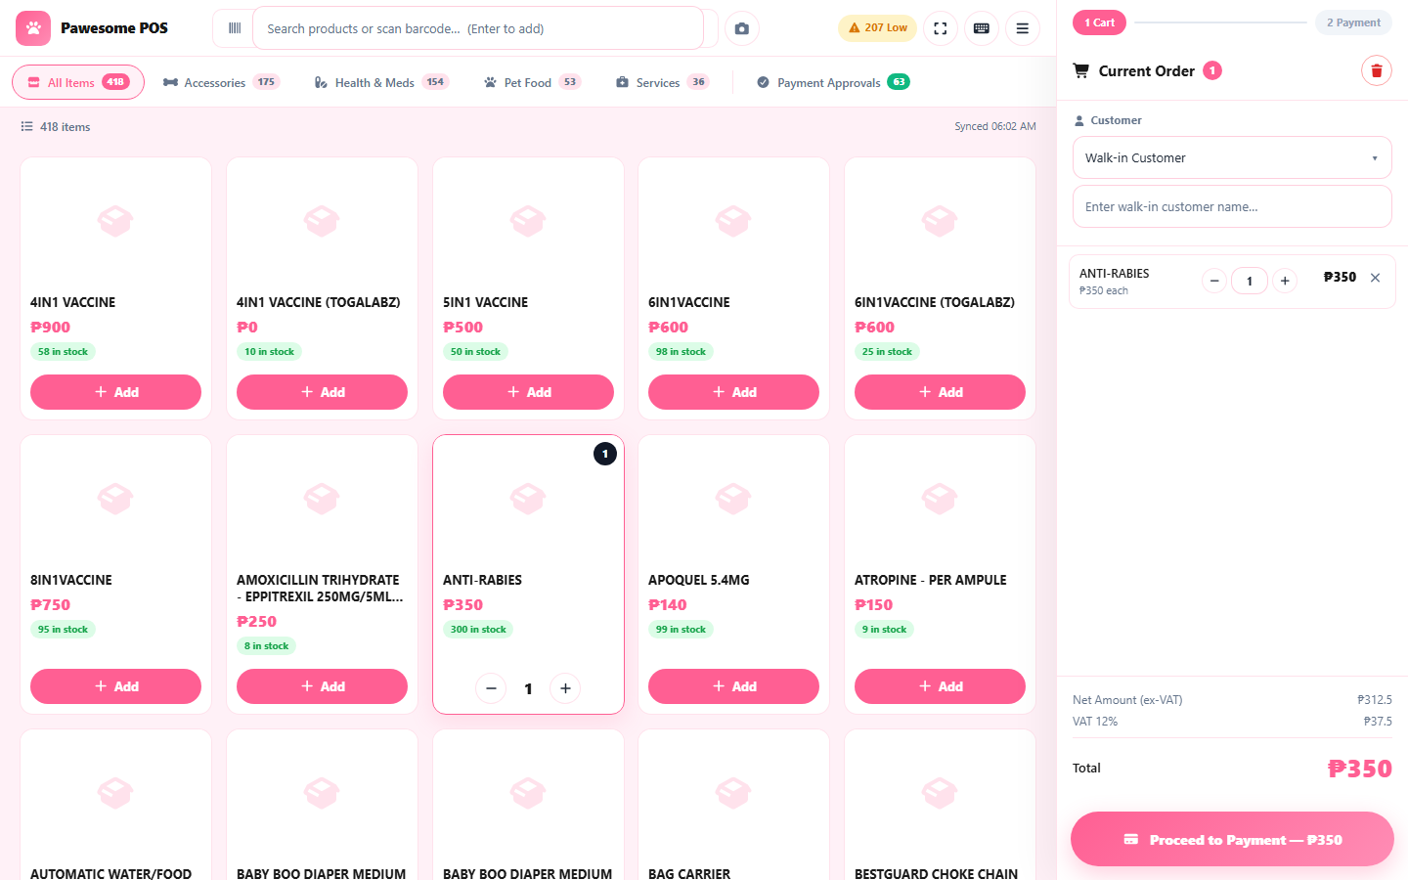

6.3 View transactions and reports
Open Transactions or History to review past sales — filter by date or search for a receipt. Use Reports for sales summaries.
Screenshot: Figure UM-014 — cashier dashboard (screenshots/UM-014-cashier-dashboard.png).
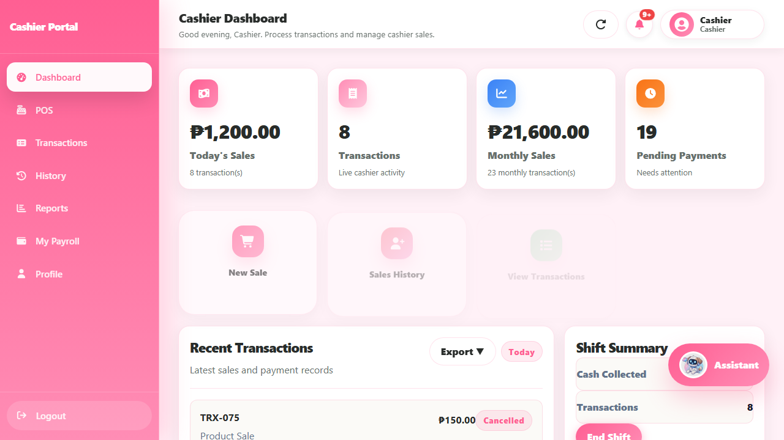

7. Inventory guide
The inventory menu contains: Dashboard, Stock Management, Suppliers, History, Controlled Drugs, Barcode Generator, Reports, Monthly Audit, Audit Reports, Audit Analytics, My Payroll, Profile, and Logout.

7.1 Find an item and check stock
- Open Stock Management.
- Search by name, or filter by category, brand, supplier, or status (In Stock, Low Stock, Out of Stock).
- Select View Info on an item for details, or History for its stock movements.
- Use Reports, History, and the audit pages to review records.
Screenshot: Figure UM-007 — Stock Management (screenshots/UM-007-inventory-stock.png).
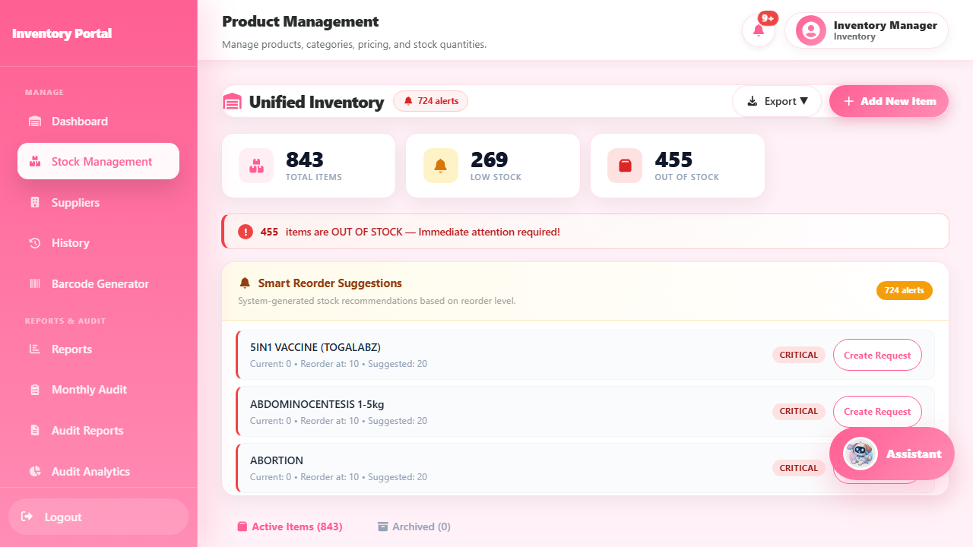

7.2 Update an item or its stock
Purpose: Change item details or correct the stock count.
- Find the item in Stock Management.
- Select Edit to change item details, or Adjust Stock to fix the count.
- Enter the values and the reason for the change.
- Review and save, then confirm the movement in History.
Note: Adjust Stock can only reduce a count or correct it to a counted value — it cannot raise stock above the recorded level. To add stock, record it as a new received batch instead. Some adjustments are held for manager approval (see Section 9.4).
Expected result: The item shows the updated details or count, and the change appears in History.

7.3 Suppliers, barcodes, and stock audits
- Suppliers — add and review supplier records.
- Barcode Generator — create barcodes for items.
- Monthly Audit — record a physical stock count. Differences between the system count and your count go to the manager for review.
- Audit Reports and Audit Analytics — review past counts and variances.
Note: Audits and stock changes affect inventory records. Double-check item, count, and reason before saving.

7.4 Controlled Drugs register
Purpose: Review the required record of controlled medicines.
- Open Controlled Drugs.
- Review the register — each row shows when a controlled item moved, the type of movement, the quantity change, the new balance, the staff and witness involved, and the pet where relevant.
Expected result: You can trace every movement of a controlled medicine.
Note: Entries are created by the system when controlled items are dispensed or adjusted — you do not type them in by hand. Weekly counts need a counter and a separate witness. Items must be marked as controlled drugs to appear here.
Screenshot: Figure UM-024 — Controlled Drug Register (screenshots/UM-024-inventory-controlled-drugs.png).
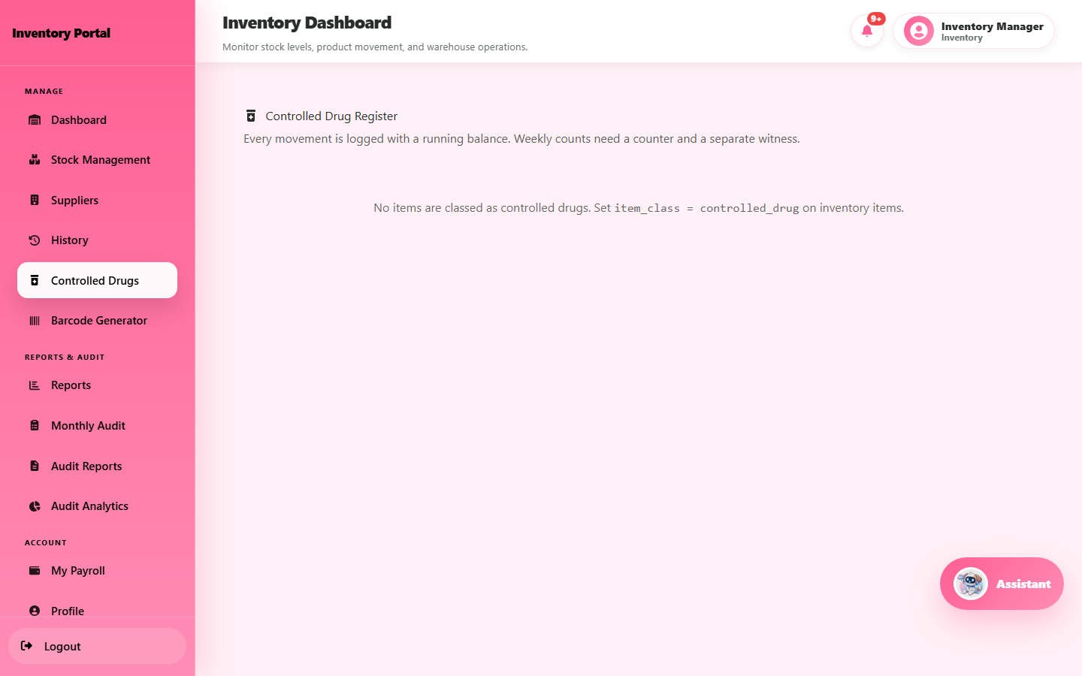

8. Veterinary guide
The veterinary menu contains: Dashboard, Appointments, Customer Profiles, Current Boarders, Services, History, Reports, My Payroll, Profile, and Logout.

8.1 Handle an appointment
Purpose: See your appointments and record the consultation.
- Open Appointments. The cards at the top show today's count, pending, approved, and completion rate.
- Open the appointment and review the patient and service details.
- Select Start Consultation when you begin.
- Record the consultation: concern, examination, assessment, treatment plan, and vitals. Add prescriptions or items used where needed.
- Choose Needs Confinement if the pet must stay at the clinic.
- Select Save Draft to continue later, or Finalize & Review Bill to finish. A finalized record can no longer be edited — later changes go in as dated corrections.
- Review the bill and send it for payment. The visit closes automatically once the payment is confirmed.
Expected result: The appointment moves through consultation to billing, and closes when the customer pays. Additional charges appear on the customer's side for online payment or counter settlement.
Note: Medical records are sensitive. Enter only real findings for the actual patient.
Screenshots: Figure UM-008 — appointments list (screenshots/UM-008-veterinary-appointments.png); Figure UM-016 — an approved appointment (screenshots/UM-016-vet-appointment-approved.png).
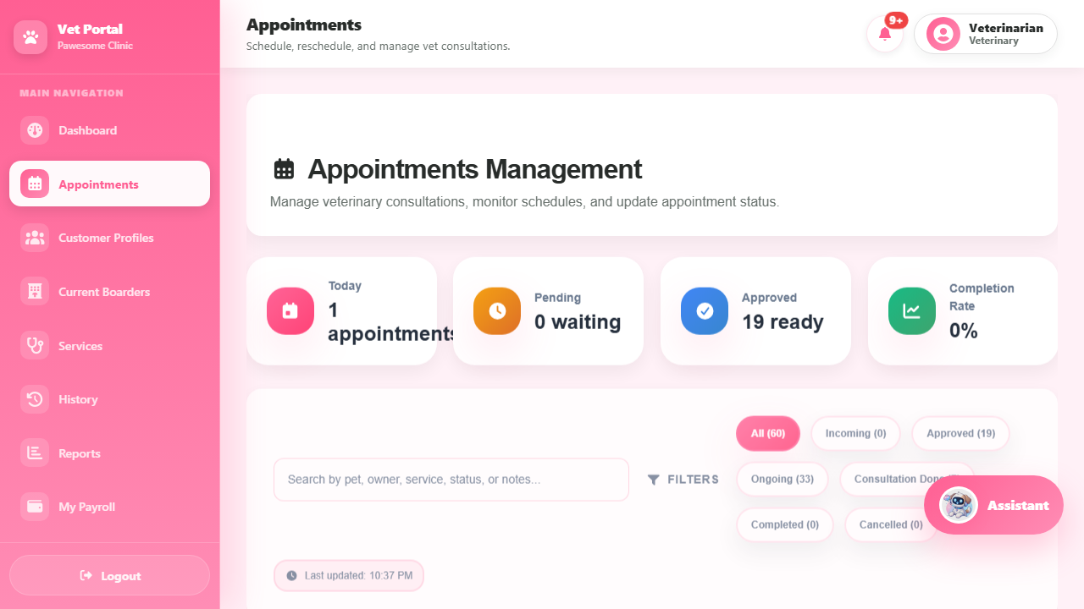
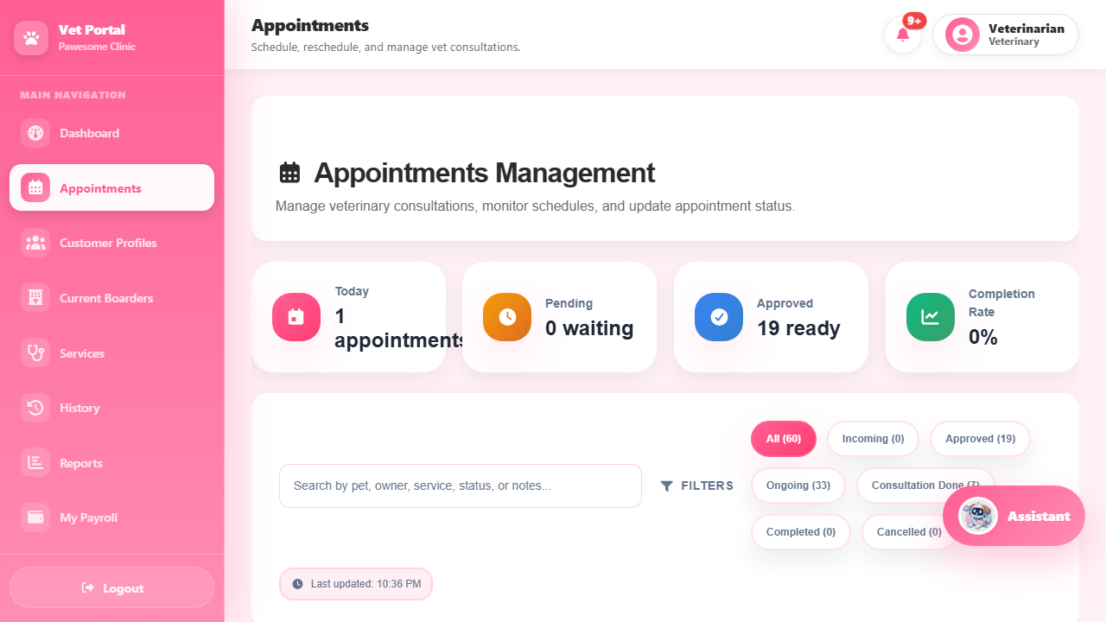
Screenshot: Figure UM-021 — consultation screen for an ongoing appointment (screenshots/UM-021-vet-consultation.png).
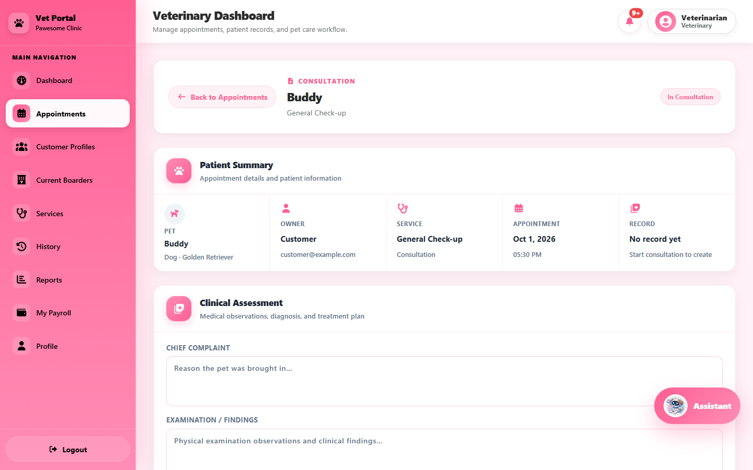

8.2 Other veterinary pages
- Current Boarders — pets currently staying at the clinic.
- Customer Profiles — owner and pet records.
- Services, History, Reports — service details, past work, and summaries.
- Medication hand-outs (dispensing), confinement records, and vaccination certificates are handled from the consultation and record screens — follow your clinic's procedure for these.
Check you have the right pet and appointment before saving any record.

9. Manager guide
The manager menu contains: Dashboard, Reports, Staff Management, Employee Directory, Attendance, Day-Off Schedule, Employee ID Cards, Leave, Invoice Approvals, Receipt Scanner, Controlled Drugs, Payroll, Holidays, Salary Loans, 13th Month, Remittance Reports, DTR Report, History / Audit Trail, My Leave, My Attendance, Profile, and Logout.

9.1 View reports
- Open Reports and pick the report you need.
- Set the date range and any filters, then refresh.
- Review the summary cards and the table.
- Export or print only if your role allows it, and keep exported files private.
Expected result: The report shows the figures for the period you chose.
Screenshot: Figure UM-009 — manager reports (screenshots/UM-009-manager-reports.png).
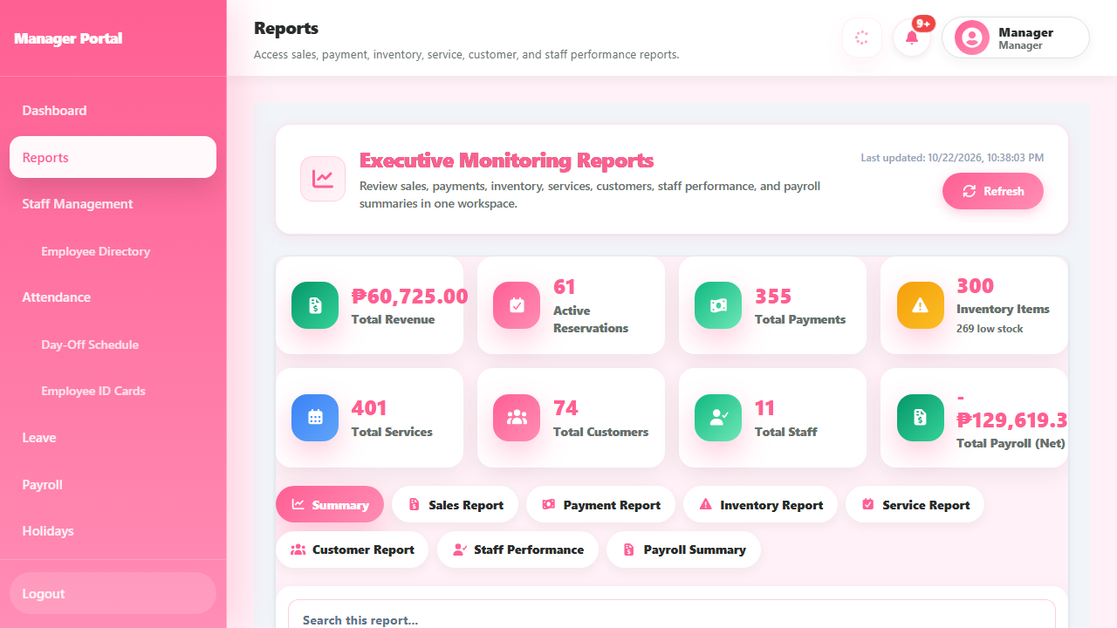

9.2 Attendance, day-offs, and leave
- Attendance — review staff time records. Staff clock in and out on the attendance kiosk (Section 12.2) and can see their own records under My Attendance.
- Day-Off Schedule — set each employee's regular weekly day off. These days are used by attendance, leave, and payroll.
- Leave — approve or reject leave requests. Employees file leave under My Leave. Approving deducts from the employee's leave balance; rejecting asks for a reason. A request with no remaining balance cannot be filed.

9.3 Payroll and staff records
- Payroll — create, calculate, review, and release payroll for a pay period.
- Staff Management and Employee Directory — staff records.
- Employee ID Cards — print staff IDs.
- Holidays, Salary Loans, 13th Month, Remittance Reports, DTR Report — related payroll pages.
Note: Always check the amounts and the pay period before releasing payroll. Some of these pages may still be under preparation — confirm with the administrator which are in use.

9.4 Invoice Approvals, Receipt Scanner, and Controlled Drugs
- Invoice Approvals — waivers, write-offs, and large adjustments need your approval, and inventory count variances are reviewed here too. The page has two tabs: Invoice Adjustments and Inventory Variances. Each entry shows who requested it, the reason, and the amounts involved. Check the details before approving.
- Receipt Scanner — settings for the tool that helps read GCash and Maya receipts during payment checks: provider patterns, accepted status text, wallet accounts, and accuracy figures.
- Controlled Drugs — the same controlled-medicines register described in Section 7.4.
Screenshot: Figure UM-023 — Invoice Approvals with the adjustment and variance tabs (screenshots/UM-023-manager-invoice-approvals.png).
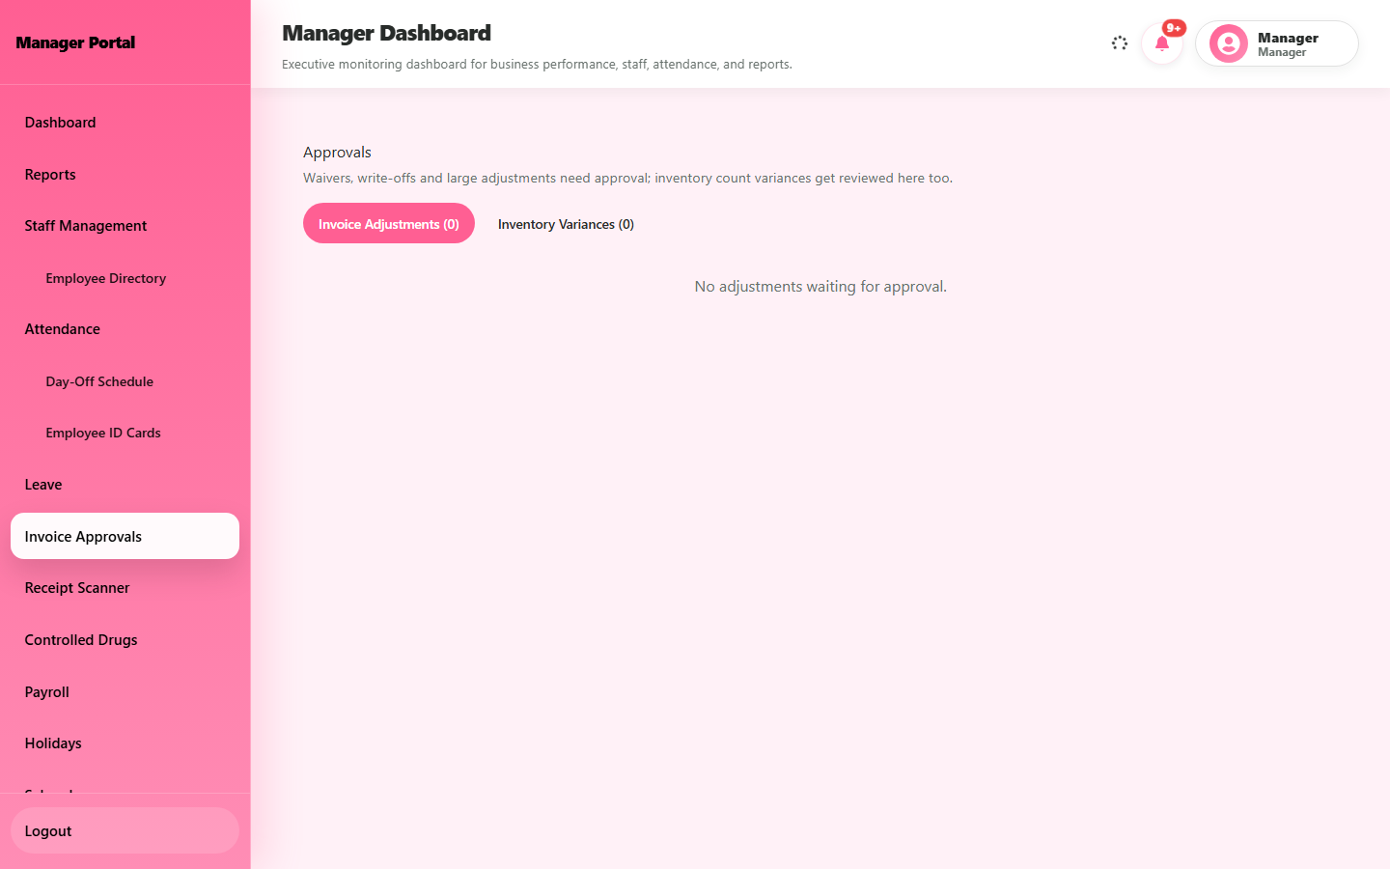

10. Admin guide
The admin menu contains: Dashboard, Manage Users, Create User, Employee Directory, Audit History, Login History, Chatbot Logs, Live Chat, All Reports, Payroll Reports, Settings, Landing Page Editor, Profile, and an Operations Hub that opens the front desk, cashier, inventory, HR, and veterinary workspaces.

10.1 Manage user accounts
Purpose: Create and maintain staff and customer accounts.
- Open Manage Users to see all accounts. Use the search and the role or status filters.
- Check the person's details and role before changing anything.
- To add someone, open Create User and fill in the form. Choose one of the eight roles: Admin, Manager, Receptionist, Super Receptionist, Veterinary, Cashier, Inventory, or Customer.
- Save. You can also change a role, deactivate, archive, or delete an account when needed.
- The new user receives a welcome email with a link to set their own password — you never need to send them a password yourself.
Expected result: The account appears in the user list and the new user can sign in after setting their password.
Note: Deactivating an account blocks sign-in. Confirm the right person before making changes.
Screenshot: Figure UM-010 — Manage Users (screenshots/UM-010-admin-manage-users.png); Figure UM-022 — Create User form (screenshots/UM-022-admin-create-user.png).
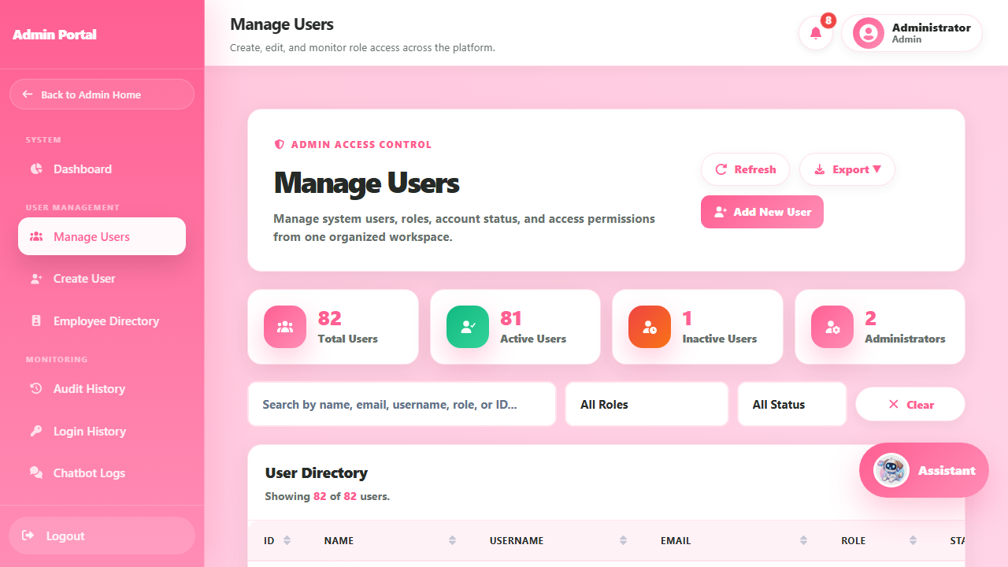
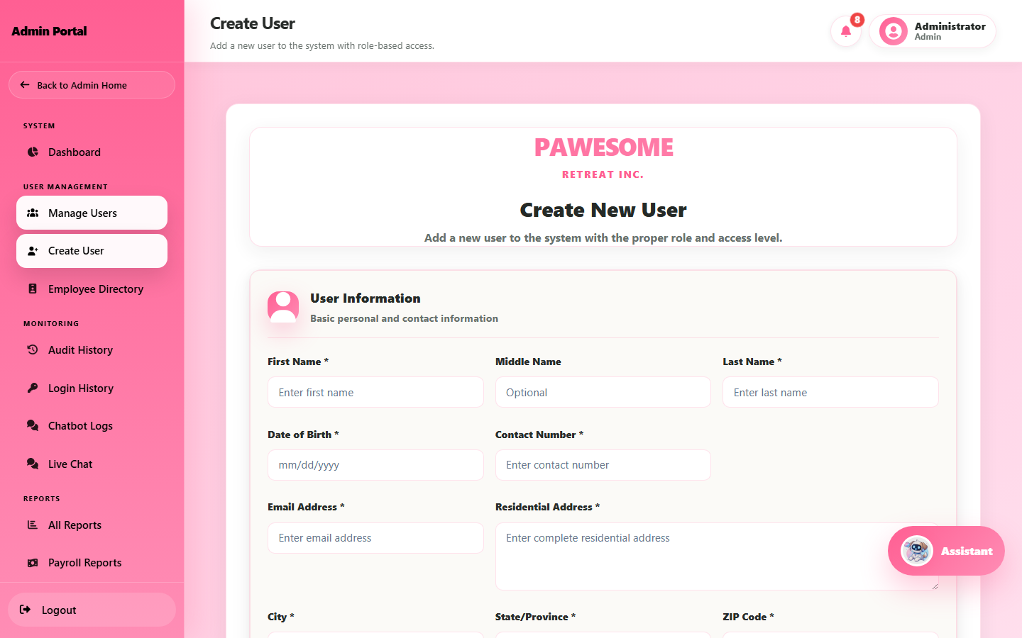

10.2 Other admin pages
- Audit History and Login History — who did what and when.
- All Reports and Payroll Reports — system-wide summaries.
- Chatbot Logs and Live Chat — customer conversations.
- Settings and Landing Page Editor — system options and the public home page.
- Operations Hub — quick entry to the staff workspaces. Admin can open staff pages but not the customer portal.

11. Super Receptionist guide
The Super Receptionist workspace combines three jobs: front desk, cashier, and inventory. The menu is grouped into Front Desk, Cashier, Inventory, and Account sections.
Use the same steps as the Receptionist (Section 5), Cashier (Section 6), and Inventory (Section 7) chapters. This role does not include manager, veterinary, admin-only, or customer-portal functions.
Screenshot: Figure UM-012 — Super Receptionist workspace (screenshots/UM-012-super-receptionist.png).
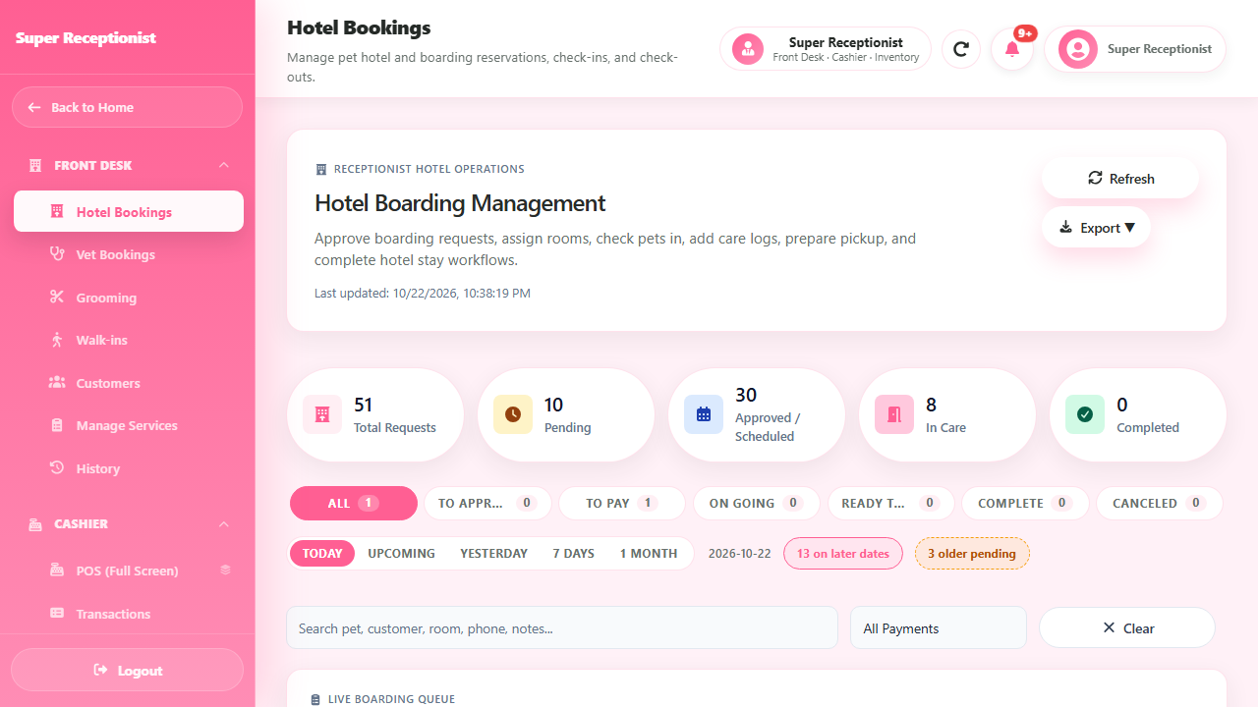

12. Staff self-service and the attendance kiosk

12.1 My Payroll, My Attendance, and My Leave
Staff roles have pages for their own records:
- My Payroll — view your payslips. Keep payslip details private.
- My Attendance — see your own time records and file a correction if a punch is missing or wrong.
- My Leave — file a leave request and check your balance.
A manager reviews correction and leave requests. Approved leave is deducted from your balance.

12.2 Attendance kiosk
The attendance kiosk is a shared screen where staff record their time in and out.
- Open the kiosk screen.
- Enter the kiosk PIN given by the manager.
- Scan your employee barcode (or follow the punch method in use) to record time in or time out.
Expected result: Your attendance is recorded for the day.
Note: Once the day is complete, the kiosk will not accept more punches. If your punch is missing or wrong, file a correction under My Attendance.
Screenshot: Figure UM-013 — attendance kiosk sign-in (screenshots/UM-013-attendance-kiosk.png).
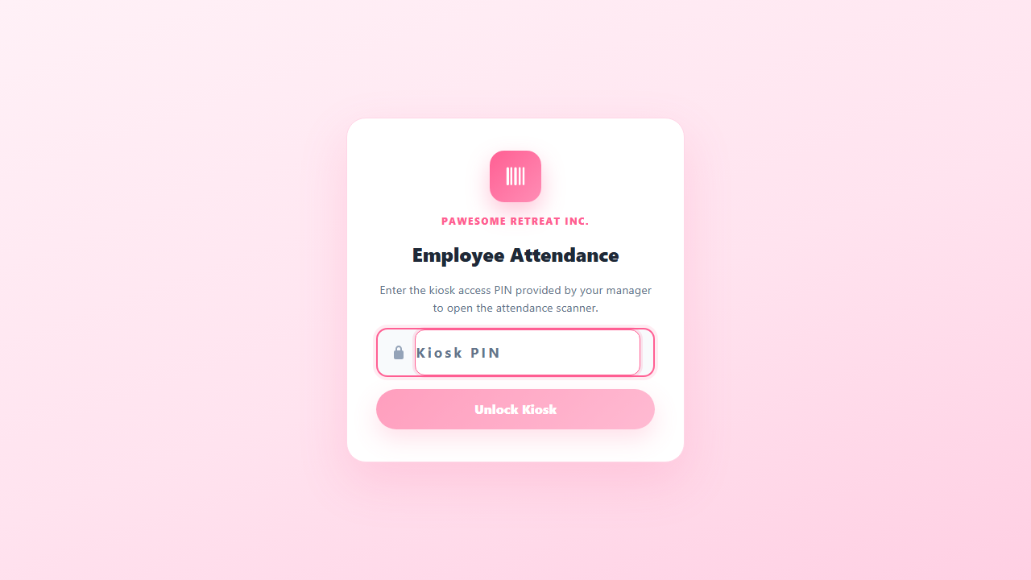

13. A note about the Payroll role
There is no separate Payroll Manager account. Payroll is handled by the Manager (Section 9.3), and every employee can view their own payslips under My Payroll. If you are asked to create a payroll-only account, check with the administrator first.

14. How a booking moves through the system
A typical online booking works like this:
- Customer books a service and sends online payment proof with a unique reference number.
- Receptionist reviews the request, confirms the decision, and approves or rejects it.
- Cashier checks the payment proof and confirms it — a receipt is issued.
- Staff perform the service. For pet hotel stays, the receptionist checks the pet in, records care logs, and checks the pet out. For vet visits, the appointment closes after billing.
- Customer watches the status under My Requests and keeps the receipt number.
Walk-in customers skip the online steps: the receptionist books them at the counter and the cashier collects payment there.

15. Common problems and what to do
Problem | What to try
Cannot sign in | Check for typing errors and that Caps Lock is off. Use Forgot Password if needed. If it still fails, your account may be inactive — ask the administrator.
Sent to the verification page | Open the verification email and select the link, or request a new one.
No verification or reset email | Check spam/junk folders. Request a resend. Make sure you typed the right email.
Cannot submit a booking | Confirm your email is verified, your pet is active in My Pets, and the time slot is still open.
Pet does not appear in the booking form | Add the pet in My Pets first, or restore it if it is archived.
Pet photo will not upload | Use a JPG, PNG, or WebP image under 10 MB. iPhone HEIC photos are not accepted — share them as JPG instead.
Pet Hotel date or room unavailable | Choose another date or room — availability can change before you submit.
Hotel booking cannot be approved | A vaccination card must be attached and verified first, and a room must be available or assigned.
Payment button missing | The booking may already be paid, or it may not be ready for payment yet. Check its status.
Payment rejected | Read the reason shown. Common causes: unclear photo, wrong amount, or a reference number already used on another payment. Fix it and use Resubmit payment.
Cashier cannot take cash for an online booking | Allowed only if the booking was a walk-in, or its online proof was rejected. Pending proofs must be verified or rejected as proofs.
Product checkout not working | Online store checkout is not available in this version. Ask staff about in-store purchases.
Stock cannot be increased through Adjust Stock | Record the new stock as a received batch instead; Adjust Stock only reduces or corrects counts.
Page missing or "access denied" | Your role does not include that page. Ask the administrator if you believe you should have access.
Something looks wrong or the site is down | Note the page and the time, do not resubmit, and report it to the staff or administrator.

16. Keeping information safe
- Keep your password private and never share your account.
- Only open and change records your role is meant to handle.
- Do not put real payment details or personal information in test data, screenshots, or shared files.
- Payments, stock changes, medical records, user accounts, and payroll are permanent records — check before saving.
- If a submission's result is unclear, check the record first instead of submitting again.
- Sign out when finished, especially on shared devices.

17. List of screenshots
All screenshots were taken from the working system using test accounts and test data.
Figure | File | What it shows
UM-001 | UM-001-login.png | Login page
UM-002 | UM-002-customer-services.png | Customer Services page
UM-003 | UM-003-customer-pets.png | My Pets
UM-004 | UM-004-booking-review.png | Booking review before sending
UM-004a | UM-004a-grooming-form-filled.png | Filled grooming form
UM-004b | UM-004b-grooming-submitted.png | Request list after sending
UM-005 | UM-005-receptionist-grooming-queue.png | Receptionist grooming queue
UM-006 | UM-006-cashier-payment-approvals.png | Payment Approvals page
UM-007 | UM-007-inventory-stock.png | Stock Management
UM-008 | UM-008-veterinary-appointments.png | Veterinary appointments
UM-009 | UM-009-manager-reports.png | Manager reports
UM-010 | UM-010-admin-manage-users.png | Manage Users
UM-011 | UM-011-customer-medical.png | Customer medical records
UM-012 | UM-012-super-receptionist.png | Super Receptionist workspace
UM-013 | UM-013-attendance-kiosk.png | Attendance kiosk sign-in
UM-014 | UM-014-cashier-dashboard.png | Cashier dashboard
UM-015 | UM-015-customer-request-paid.png | My Requests list
UM-016 | UM-016-vet-appointment-approved.png | Approved vet appointment
UM-017 | UM-017-hotel-reservation-form.png | Pet Hotel reservation form
UM-018 | UM-018-receptionist-walkins.png | Walk-ins recent bookings list
UM-019 | UM-019-cashier-reject-dialog.png | Reject Payment dialog
UM-020 | UM-020-cashier-pos-cart.png | POS cart during a sale
UM-021 | UM-021-vet-consultation.png | Consultation screen
UM-022 | UM-022-admin-create-user.png | Create User form
UM-023 | UM-023-manager-invoice-approvals.png | Invoice Approvals page
UM-024 | UM-024-inventory-controlled-drugs.png | Controlled Drug Register

18. Words used in this manual
Term | Meaning
Booking / request | A service a customer asks for — grooming, vet visit, or pet hotel stay.
Payment proof | The receipt or screenshot a customer uploads for an online payment.
Payment reference | The transaction or reference number from a GCash or Maya payment. Each one can be used for only one payment.
Online booking | A request sent through the website by the customer.
Walk-in | A booking made by the receptionist for a customer who is at the shop.
Receipt number | The reference produced when a payment is confirmed.
Care log | A note the receptionist adds to a boarding stay (feeding, medicine, and so on).
Controlled drug register | The required record of movements for controlled medicines.
Workspace | The set of pages your role can open.
Super Receptionist | A staff role combining receptionist, cashier, and inventory access.
Notes on this version:
- This manual matches the system as of October 2026.
- Online store checkout for customers is not currently available.
- A few payroll and report pages may still be under preparation; ask the administrator if a page listed here is not yet in use.

19. Quick guide: where each role starts
Role | You start at | Main jobs
Customer | Services page | Pets, bookings, payments, requests
Receptionist | Booking queues | Review bookings, walk-ins, boarding care, customer records
Cashier | POS | Sales, payment checks, transactions
Inventory | Stock Management | Stock, suppliers, batches, audits, controlled drugs
Veterinary | Appointments | Consultations, boarders, medical records
Manager | Dashboard / Reports | Reports, attendance, leave, payroll, approvals
Admin | Dashboard | Users, history, reports, settings
Super Receptionist | Combined workspace | Front desk + cashier + inventory

20. Keeping this manual up to date
This manual should be checked again whenever the system changes, and before final submission it should be reviewed by someone using it for the first time. Record future changes in the document-control table at the top.

