ACID - 4 properties of any database system that help in making sure that we are able to perform the transections in a reliable manner

Transaction is just a single unit of work (Can be one query or multiple)

Example

Transfer from acc 1 to acc 2 (this is one transaction but consist of different steps

Check acc have enough

Updating the acc

Transfer to the second acc

Atomicity – database able to perform the transections in an atomic manner.

Database support the atomic transaction which means either the whole transaction must finish or should be able to revert the database to the old state. So, we don’t have a corrupted data

If database supports atomic transection, one of these 3 steps fails whole transection fail and database will not corrupt if all pass it should update to the latest state

Example using the bank acc transection

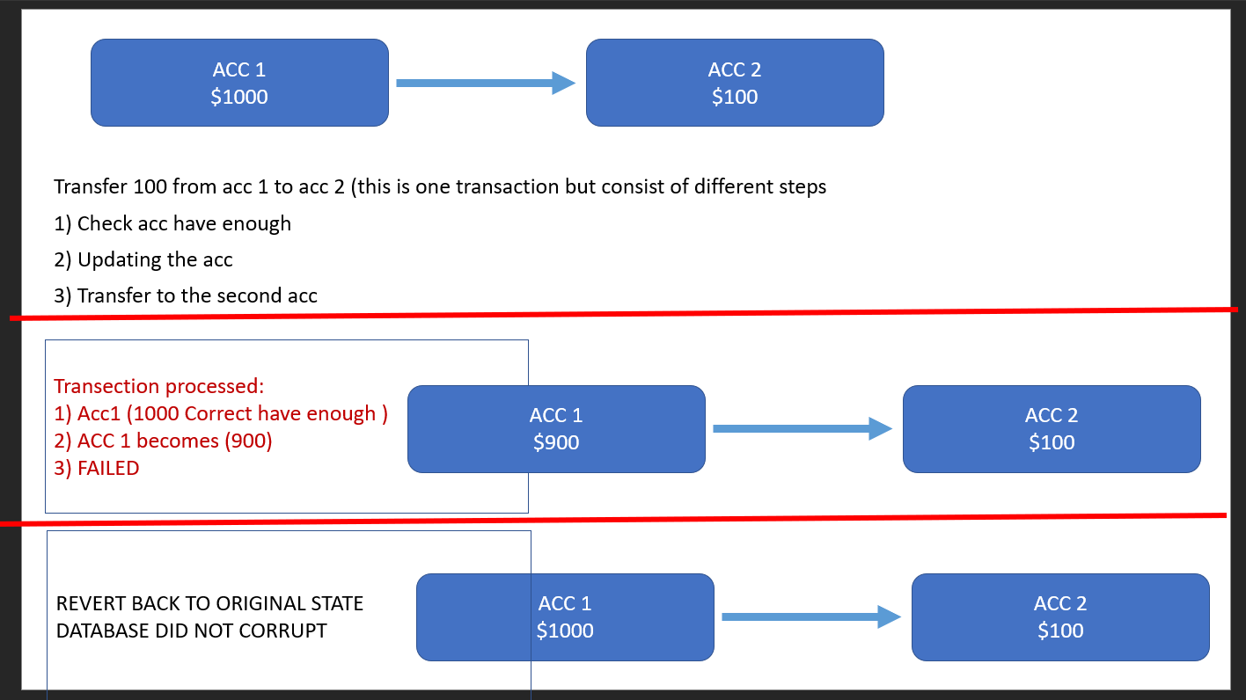

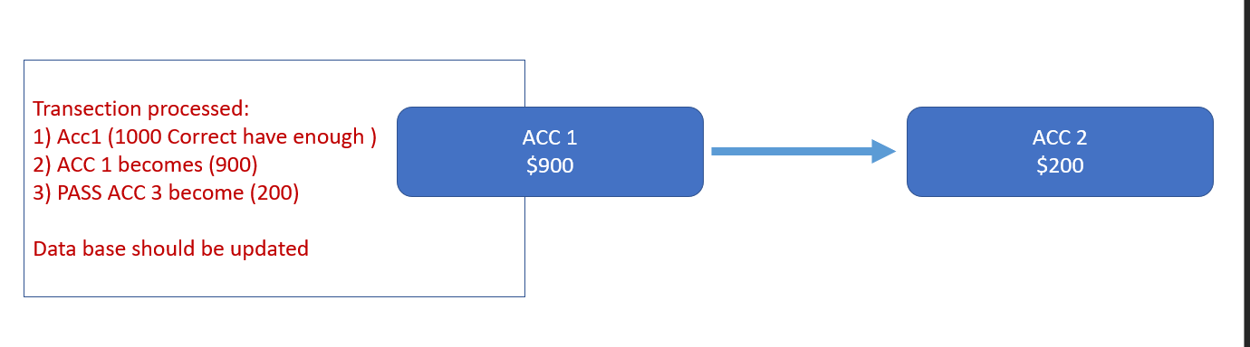

Consistency -> database should help in achieving the correct data dtate

Database helps by making sure that the constrains that we have set for our data must be followed.

Example using the bank example above.

Bank should have constrain on the amount column i.e it cannot be negative.

The database must make sure that the constrain must be followed and cannot allow the negative values inside that column in the data base

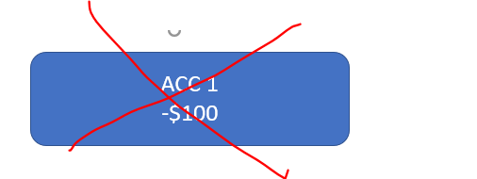

Isolation

Which is mainly about the concurrency control so how the database should perform when there are concurrent executions.

So example 2 transection (1000 and 100 withdrawal) happen same time form a $1000 account. Will results in -100.

Isolation should help to run concurrent transection in sequential order to prevent error like this

Durability

Once transection have been commited the data must be written to storage (non volatile like HDD ). So data must be there nto corrupted

Transection logs are used to record all the transections so in case of failure can retrieve and undo the errors.