ISTS System Design Document

Date: 12/18/19

Author: Gerald Arocena

Reviewer(s): Krithika Sundararajan

Whole document structure overview here?

* Level 5 design is achieved through the use of modularity via packages and interface-only access.

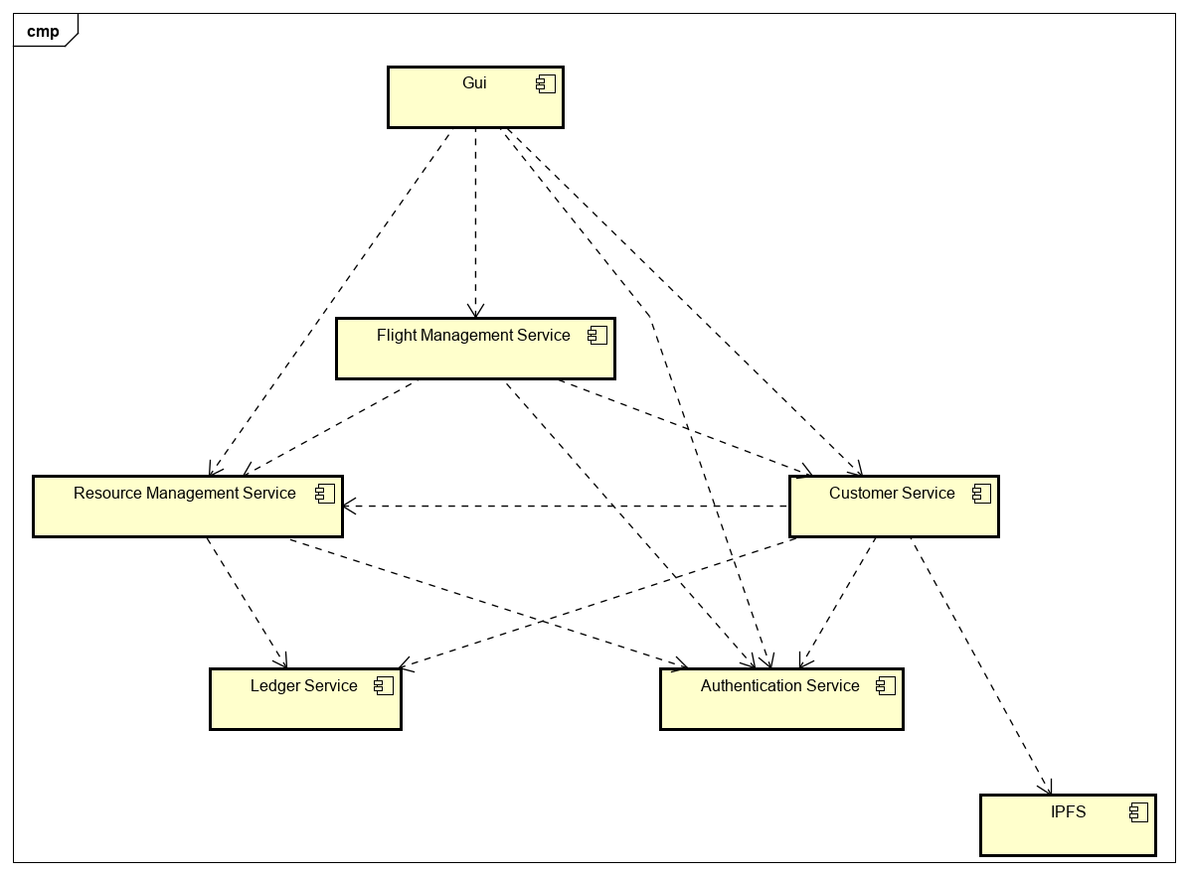

ISTS Resource Management Service Design Document

Document structure overview here.

# Introduction

*A high-level description of this document, for example, “This document defines the design for the Canonical Model”.*

Overview

*Overview of the problem to be solved. What is the problem and why is it being solved? How will the resulting solution provide business value?*

*Consider adding a diagram that explains how this component fits into the overall System with some descriptive text explaining the diagram.*

# Requirements

*This section provides a summary of the requirements for the <Component Name>.*

*Provide your understanding of the requirements, both functional and nonfunctional. Reference the provided Requirements and System Architecture documents. Do not cut and paste from the requirements document.*

*Product Manager and others can read this to understand what requirements your design will support. There is already a requirements doc, so keep this brief and to the point, highlighting the important requirements that the design is addressing. Structure in a way to provide a requirements checklist for your design.*

# Use Cases

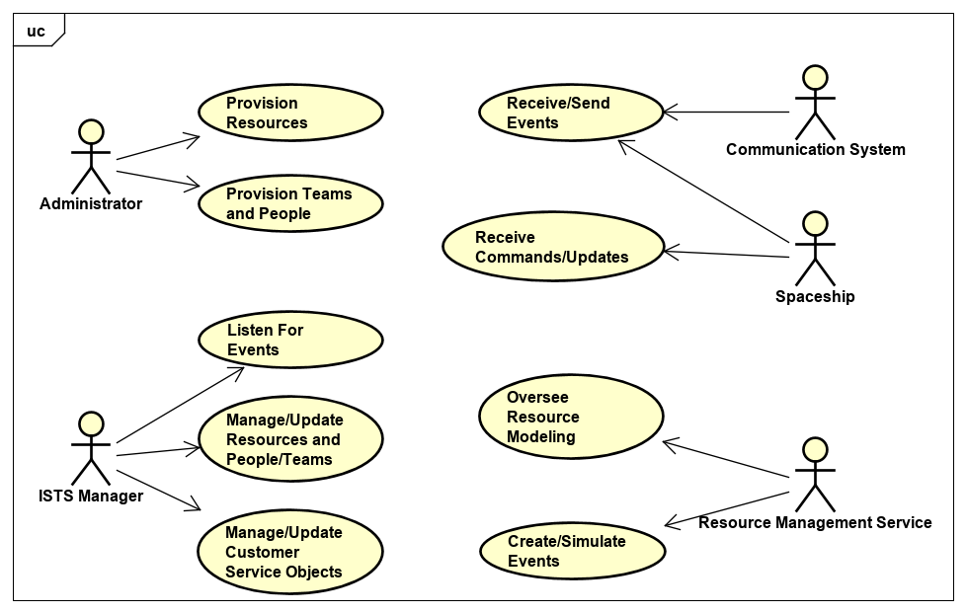

# Implementation

*This section of the document will describe the implementation details for ...*

*The implementation section should cover the following topics:*

* *What are the classes, and their properties, associations and methods?*
* *What are the important interfaces and how they will be implemented?*
* *How are the requirements addressed?*

# Class Diagram

*The following class diagram defines the classes defined in this design. Remember to include exception classes.*

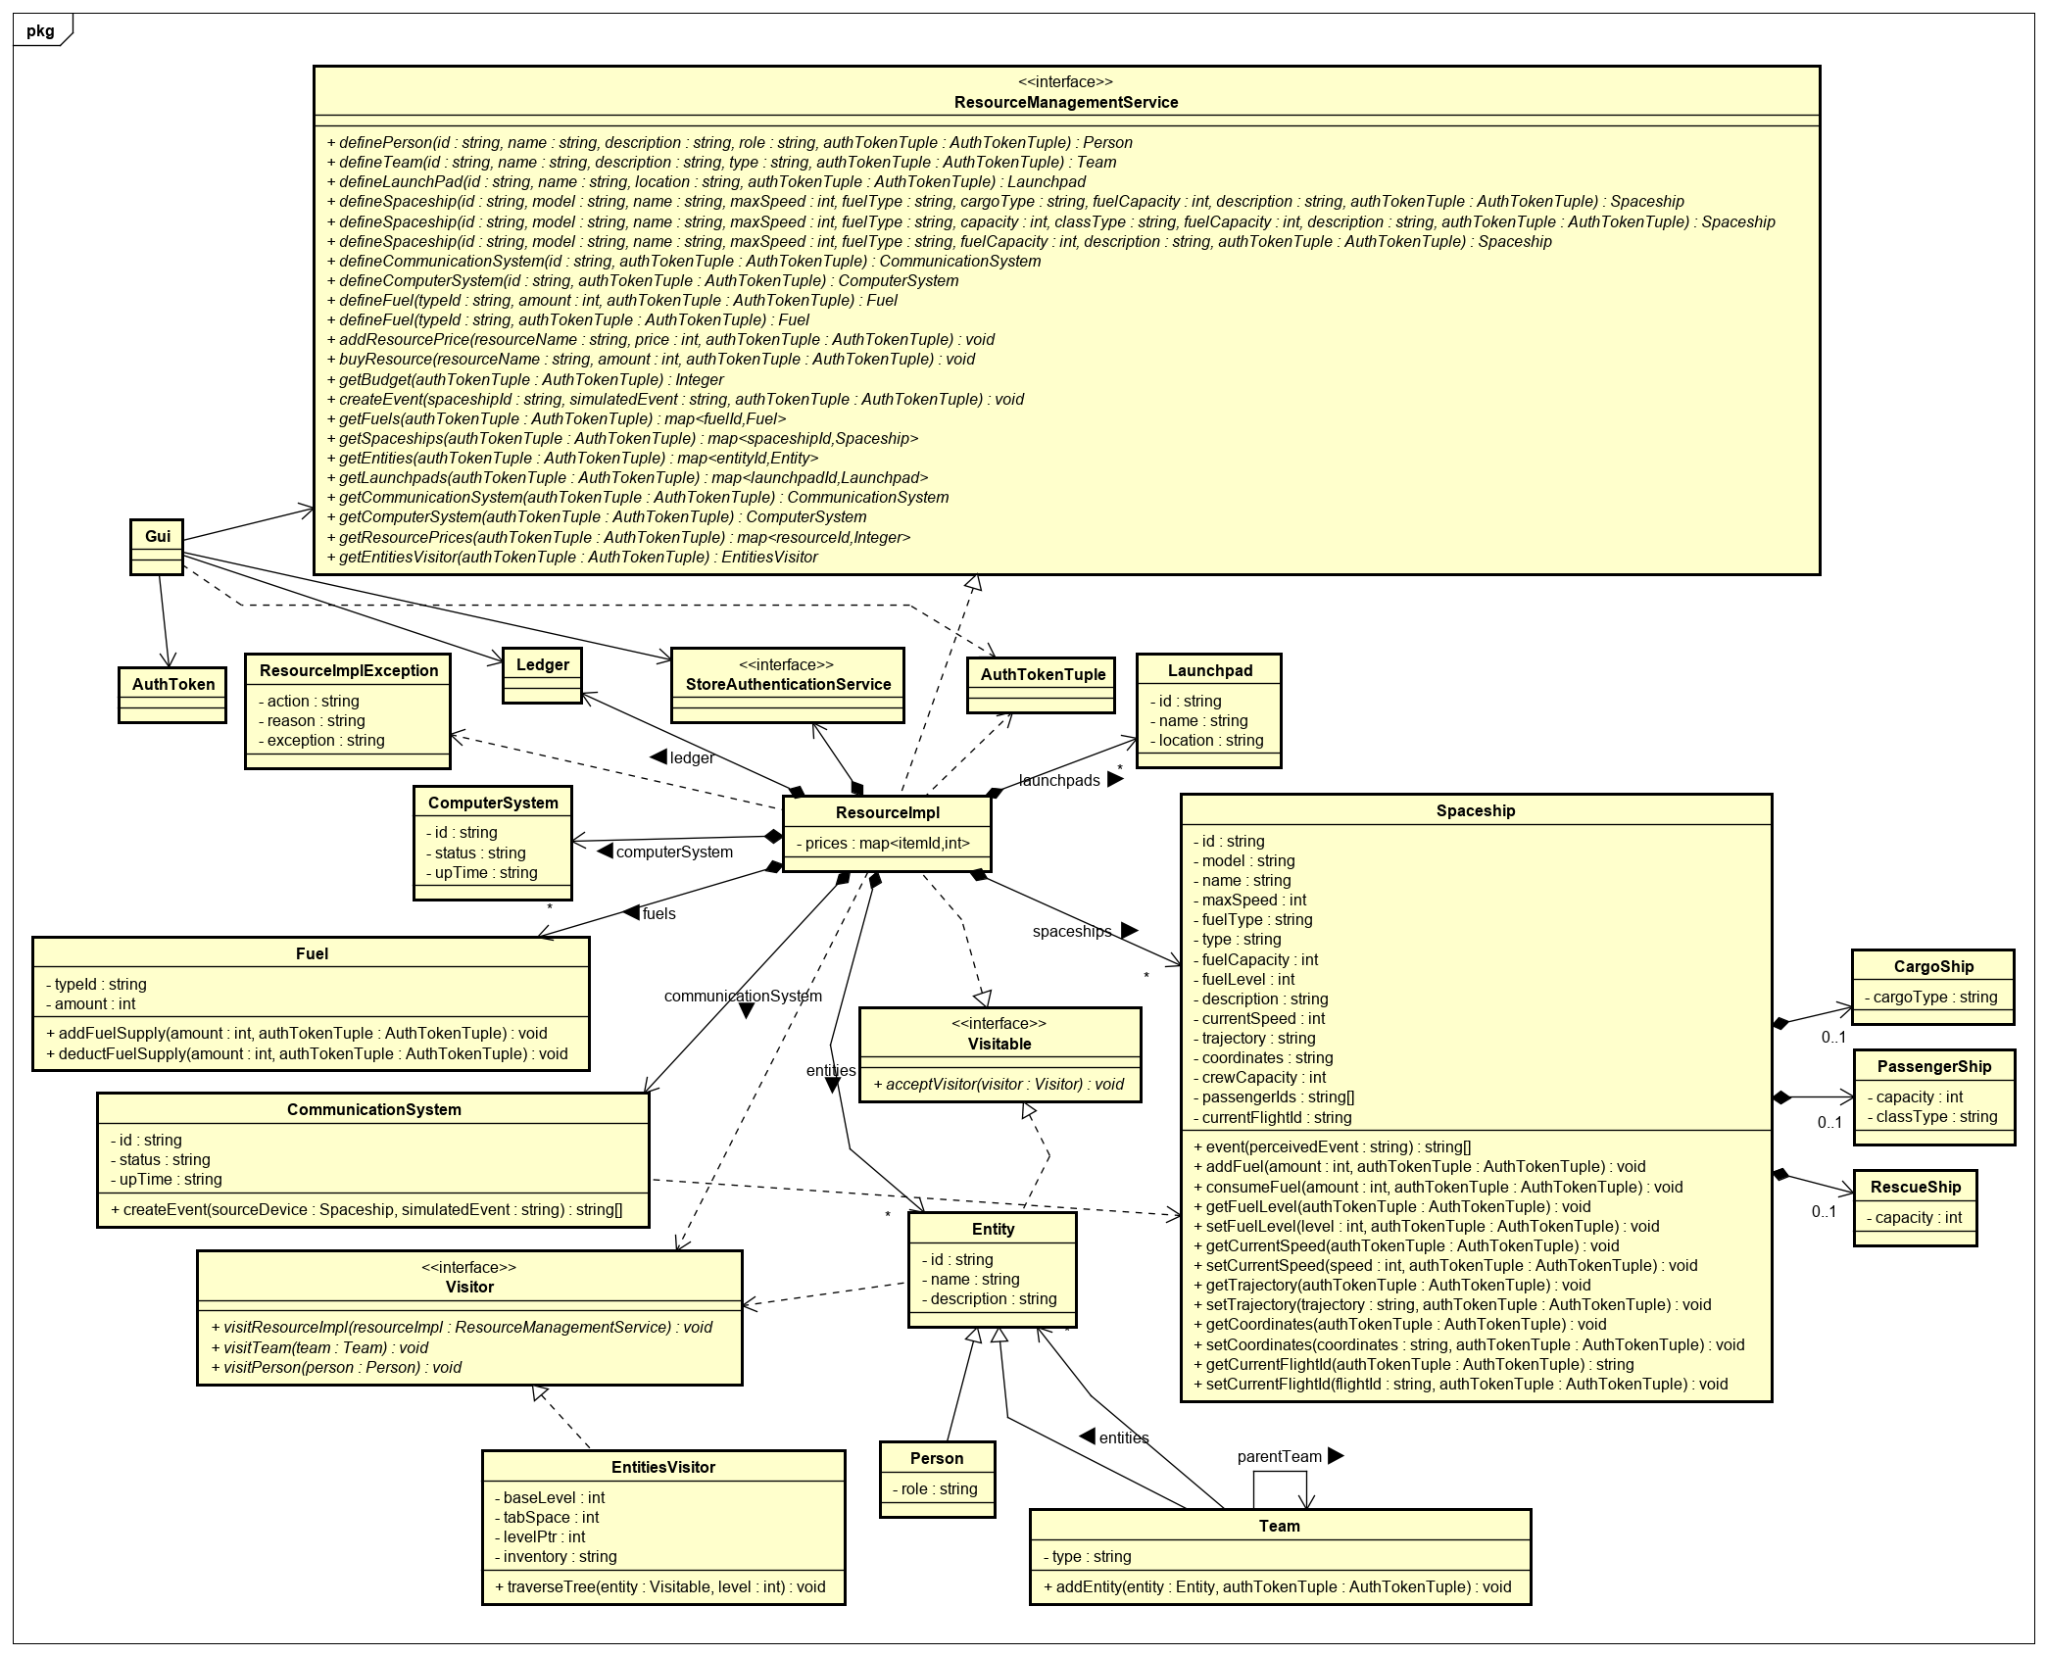

# Class Dictionary

*This section specifies the class dictionary for the class … defined within the package …*

## ResourceManagementService (Interface)

*Class 1 description*

***Methods***

|  |  |  |
| --- | --- | --- |
| **Method Name** | **Signature** | **Description** |
| definePerson | (id : string, name : string, description : string, role : string, authTokenTuple : AuthTokenTuple) : Person |  |
| defineTeam | (id : string, name : string, description : string, type : string, authTokenTuple : AuthTokenTuple) : Team |  |
| defineLaunchPad | (id : string, name : string, location : string, authTokenTuple : AuthTokenTuple) : Launchpad |  |
| defineSpaceship | (id : string, model : string, name : string, maxSpeed : int, fuelType : string, cargoType : string, fuelCapacity : int, description : string, authTokenTuple : AuthTokenTuple) : Spaceship |  |
| defineSpaceship | (id : string, model : string, name : string, maxSpeed : int, fuelType : string, capacity : int, classType : string, fuelCapacity : int, description : string, authTokenTuple : AuthTokenTuple) : Spaceship |  |
| defineSpaceship | (id : string, model : string, name : string, maxSpeed : int, fuelType : string, fuelCapacity : int, description : string, authTokenTuple : AuthTokenTuple) : Spaceship |  |
| defineCommunicationSystem | (id : string, authTokenTuple : AuthTokenTuple) : CommunicationSystem |  |
| defineComputerSystem | (id : string, authTokenTuple : AuthTokenTuple) : ComputerSystem |  |
| addResourcePrice | (resourceName : string, price : int, authTokenTuple : AuthTokenTuple) : void |  |
| buyResource | (resourceName : string, amount : int, authTokenTuple : AuthTokenTuple) : void |  |
| getBudget | (authTokenTuple : AuthTokenTuple) : Integer |  |
| createEvent | (spaceshipId : string, simulatedEvent : string, authTokenTuple : AuthTokenTuple) : void |  |
| defineFuel | (typeId : string, amount : int, authTokenTuple : AuthTokenTuple) : Fuel |  |
| defineFuel | (typeId : string, authTokenTuple : AuthTokenTuple) : Fuel |  |
| getFuels | (authTokenTuple : AuthTokenTuple) : map<fuelId, Fuel> |  |
| getSpaceships | (authTokenTuple : AuthTokenTuple) : map<spaceshipId : Spaceship> |  |
| getEntities | (authTokenTuple : AuthTokenTuple) : map<entityId : Entity> |  |
| getLaunchpads | (authTokenTuple : AuthTokenTuple) : map<launchpadId : Launchpad> |  |
| getCommunicationSystem | (authTokenTuple : AuthTokenTuple) : CommunicationSystem |  |
| getComputerSystem | (authTokenTuple : AuthTokenTuple) : ComputerSystem |  |
| getResourcePrices | (authTokenTuple : AuthTokenTuple) : map<resourceId, Integer> |  |
| getEntitiesVisitor | (authTokenTuple : AuthTokenTuple) : EntitiesVisitor |  |

## Visitable (Interface)

Implements… Visitor Pattern

***Methods***

|  |  |  |
| --- | --- | --- |
| **Method Name** | **Signature** | **Description** |
| acceptVisitor | (visitor : Visitor) : void | Calls the visit method on the given visitor that corresponds to a Visitable object passing in the object as a parameter. |

## ResourceImpl

Implements ResourceManagementService and Visitable interfaces.

***Properties***

|  |  |  |
| --- | --- | --- |
| **Property Name** | **Type** | **Description** |
| prices | map<resourceId, Integer> |  |

***Associations***

|  |  |  |
| --- | --- | --- |
| **Association Name** | **Type** | **Description** |
| entities | map<entityId, Entity> |  |
| launchpads | map<launchpadId, Launchpad> |  |
| spaceships | map<spaceshipId, Spaceship> |  |
| communicationSystem | CommunicationSystem |  |
| computerSystem | ComputerSystem |  |
| fuels | map<fuelId, Fuel> |  |
| ledger | Ledger |  |
| authenticator | StoreAuthenticationService |  |

## ResourceImplException

The ResourceImplException is thrown when errors occur in the ResourceImpl. It extends java.lang.Exception. The exception includes the action that was being performed and the reason for the exception.

***Properties***

|  |  |  |
| --- | --- | --- |
| **Property Name** | **Type** | **Description** |
| action | string | Command performed during exception occurrence. |
| reason | string | Reason for exception being thrown. |
| exception | string | Name of the exception being thrown, e.g., “ResourceImplException”. |

## *Entity*

Entity is an abstract class that implements Visitable. Visitor pattern…

***Properties***

|  |  |  |
| --- | --- | --- |
| **Property Name** | **Type** | **Description** |
| id | string |  |
| name | string |  |
| description | string |  |

## Team

Extends Entity

***Methods***

|  |  |  |
| --- | --- | --- |
| **Method Name** | **Signature** | **Description** |
| addEntity | (entity : Entity, authTokenTuple : AuthTokenTuple) : void |  |

***Properties***

|  |  |  |
| --- | --- | --- |
| **Property Name** | **Type** | **Description** |
| type | string |  |

***Associations***

|  |  |  |
| --- | --- | --- |
| **Association Name** | **Type** | **Description** |
| entities | map<entityId, Entity> |  |
| parentTeam | Team |  |

## Person

Extends Entity.

***Properties***

|  |  |  |
| --- | --- | --- |
| **Property Name** | **Type** | **Description** |
| role | string |  |

## Visitor (Interface)

Per the Visitor design pattern, the Visitor interface accesses (or “visits”) each of the ResourceImpl obect’s Entity objects in order to do something interesting with each such as collect information or print information to stdout.

***Methods***

|  |  |  |
| --- | --- | --- |
| **Method Name** | **Signature** | **Description** |
| visitResourceImpl | (resourceImpl : ResourceManagementService) : void | Accesses the ResourceImpl object and does something interesting. |
| visitTeam | (team : Team) : void | Accesses a Team object and does something interesting. |
| visitPerson | (person : Person) : void | Accesses a Person object and does something interesting. |

## EntitiesVisitor

Implements Visitor. Does an inventory of the Entity objeccts (Persons and Teams) and collects interesting information in the process.

***Methods***

|  |  |  |
| --- | --- | --- |
| **Method Name** | **Signature** | **Description** |
| traverseTree | (entity : Visitable, level : int) : void | Traverse ResourceImpl’s tree of entities to visit each entity and recursively on Team entities. |

***Properties***

|  |  |  |
| --- | --- | --- |
| **Property Name** | **Type** | **Description** |
| baseLevel | int | The number of space indentations from the left margin for top-level entity objects in the entities tree (for readability when printed to stdout). |
| tabSpace | int | How many spaces are in one indentation. |
| levelPtr | int | A temporary pointer that tracks the levels in the entities structure. |
| inventory | string | The inventory of the entities (including any interesting information on them). |

## Launchpad

*Class 1 description*

***Properties***

|  |  |  |
| --- | --- | --- |
| **Property Name** | **Type** | **Description** |
| id | string |  |
| name | string |  |
| location | string |  |

## Fuel

*Class 1 description*

***Methods***

|  |  |  |
| --- | --- | --- |
| **Method Name** | **Signature** | **Description** |
| addFuelSupply | (amount : int, authTokeTuple : AuthTokenTuple) : void |  |
| deductFuelSupply | (amount : int, authTokeTuple : AuthTokenTuple) : void |  |

***Properties***

|  |  |  |
| --- | --- | --- |
| **Property Name** | **Type** | **Description** |
| typeId | string |  |

***Associations***

|  |  |  |
| --- | --- | --- |
| **Association Name** | **Type** | **Description** |
| amount | int |  |

## CommunicationSystem

*Class 1 description*

***Methods***

|  |  |  |
| --- | --- | --- |
| **Method Name** | **Signature** | **Description** |
| createEvent | (sourceShip : Spaceship, simulatedEvent : string) : string[] |  |

***Properties***

|  |  |  |
| --- | --- | --- |
| **Property Name** | **Type** | **Description** |
| id | string |  |
| status | string |  |
| upTime | integer |  |

## ComputerSystem

*Class 1 description*

***Properties***

|  |  |  |
| --- | --- | --- |
| **Property Name** | **Type** | **Description** |
| id | string |  |
| status | string |  |
| upTime | Integer |  |

# Implementation Details

The Resource Management Service is largely a modeling exercise. It’s a very stateful service that provides and oversees the resources in the ISTS system from and on which to act; the foundations on which other modules depend on.

* Spaceship holds a list of passenger id’s which can be added to when passengers board the ship.
* Added crewCapacity attribute to Spaceship and capacity attribute to Rescue Ship.
* Added currentFlightId attribute to Spaceship.

# Exception Handling

*Provide details on your exception handling. What types of exceptions are expected and how are they handled by the design? Describe your exception classes and their properties.*

# Testing

*Provide a testing strategy for testing the component.*

* *Functional*
* *Performance*
* *Regression*
* *Exception Handling*

# Risks

*Document any risks identified during the design process.*

*Are there parts of the design that may not work or need to be implemented with special care or additional testing?*

ISTS Customer Service Design Document

Document structure overview here.

# Introduction

*A high-level description of this document, for example, “This document defines the design for the Canonical Model”.*

Overview

*Overview of the problem to be solved. What is the problem and why is it being solved? How will the resulting solution provide business value?*

*Consider adding a diagram that explains how this component fits into the overall System with some descriptive text explaining the diagram.*

# Requirements

*This section provides a summary of the requirements for the <Component Name>.*

*Provide your understanding of the requirements, both functional and nonfunctional. Reference the provided Requirements and System Architecture documents. Do not cut and paste from the requirements document.*

*Product Manager and others can read this to understand what requirements your design will support. There is already a requirements doc, so keep this brief and to the point, highlighting the important requirements that the design is addressing. Structure in a way to provide a requirements checklist for your design.*

# Use Cases

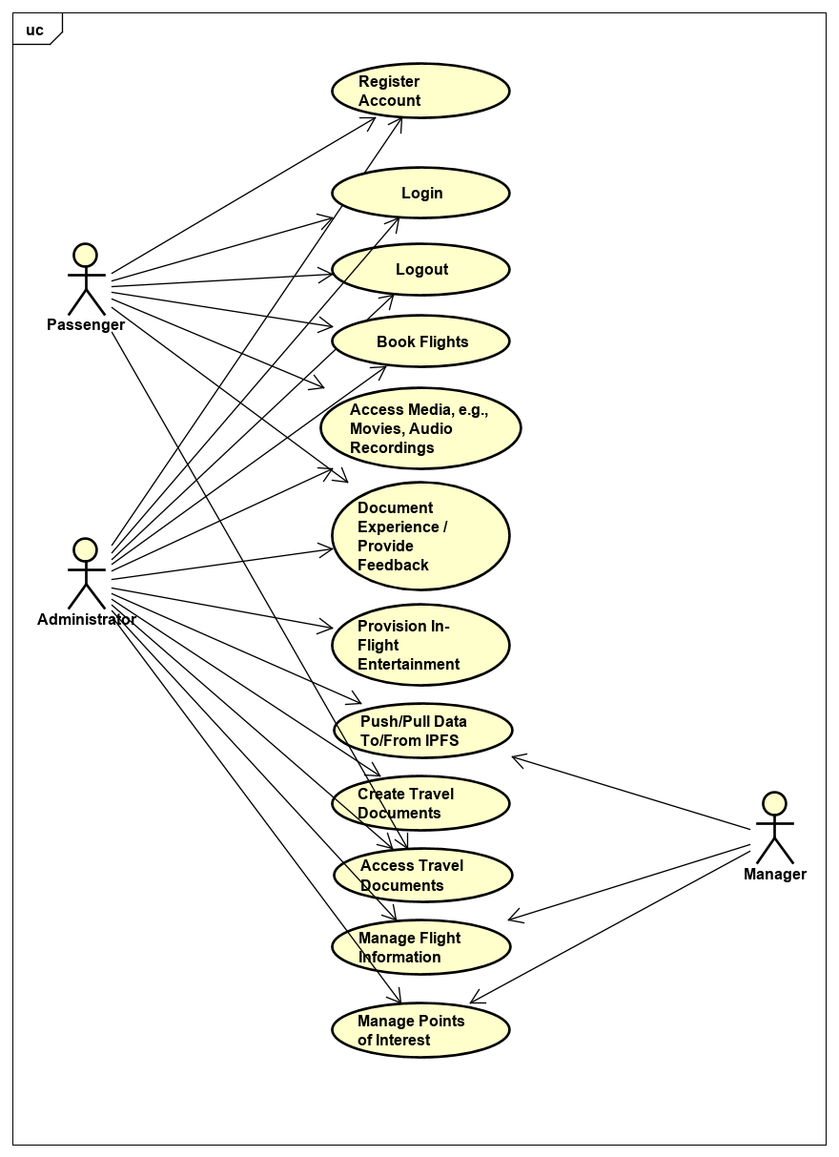

# Implementation

*This section of the document will describe the implementation details for ...*

*The implementation section should cover the following topics:*

* *What are the classes, and their properties, associations and methods?*
* *What are the important interfaces and how they will be implemented?*
* *How are the requirements addressed?*

# Class Diagram

*The following class diagram defines the classes defined in this design. Remember to include exception classes.*

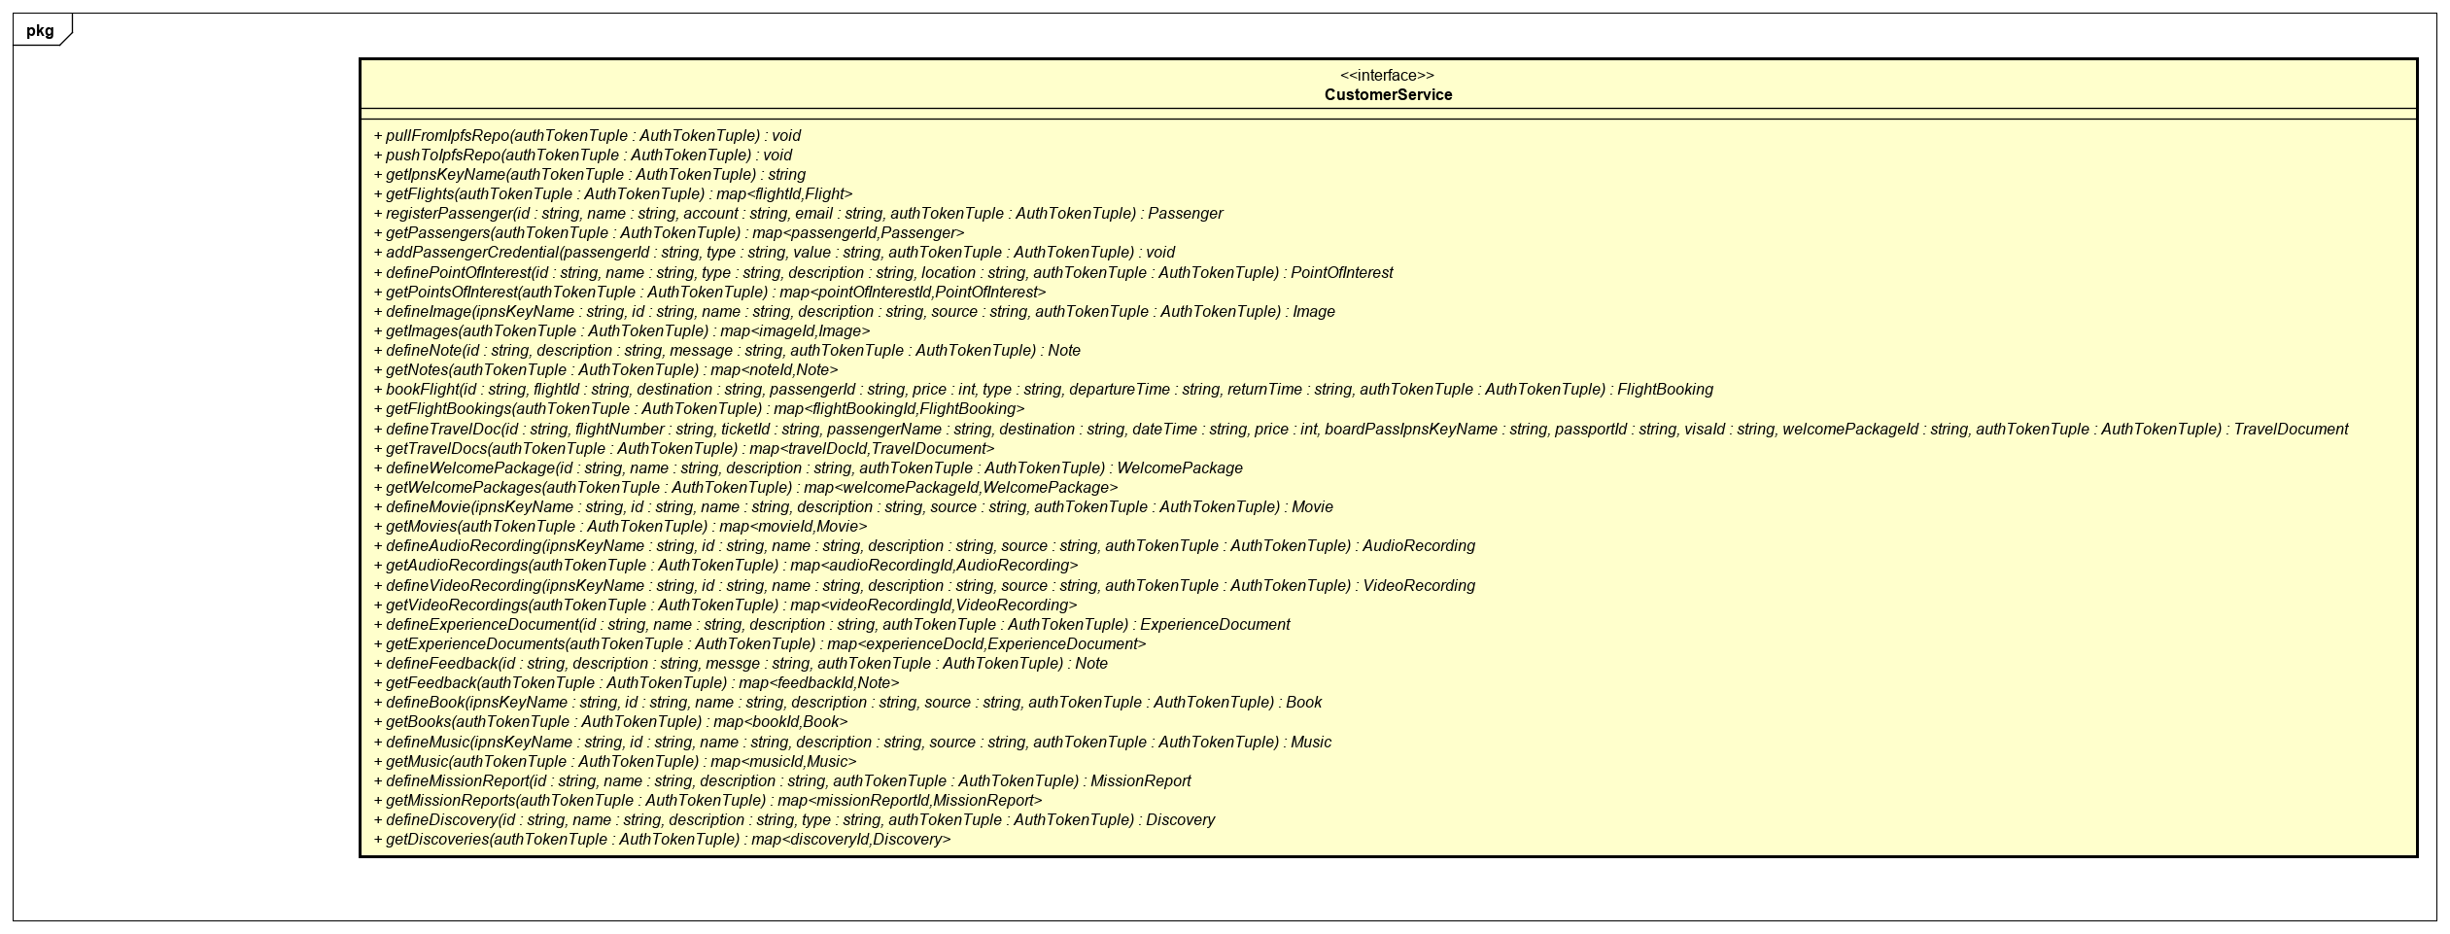

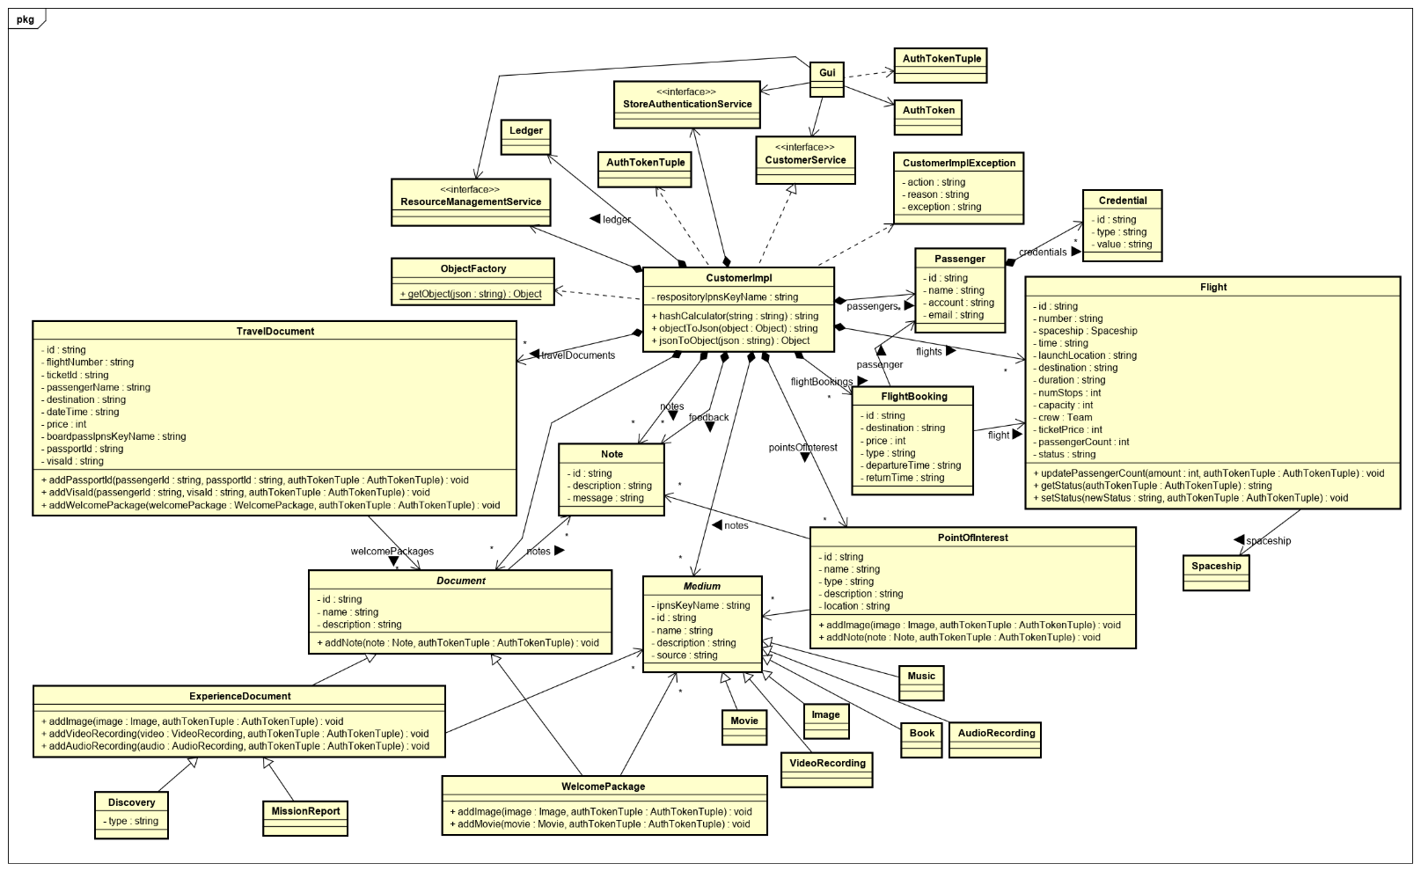

# Class Dictionary

*This section specifies the class dictionary for the class … defined within the package …*

## CustomerService (Interface)

*Class 1 description*

***Methods***

|  |  |  |
| --- | --- | --- |
| **Method Name** | **Signature** | **Description** |
| pullFromIpfsRepo | (authTokenTuple : AuthTokenTuple) : void |  |
| pushToIpfsRepo | (authTokenTuple : AuthTokenTuple) : void |  |
| getIpnsKeyName | (authTokenTuple : AuthTokenTuple) : string |  |
| getFlights | (authTokenTuple : AuthTokenTuple) : map<flightId, Flight> |  |
| registerPassenger | (id : string, name : string, account : string, email : string, authTokenTuple : AuthTokenTuple) : Passenger |  |
| getPassengers | (authTokenTuple : AuthTokenTuple) : map<passengerId, Passenger> |  |
| addPassengerCredential | (passengerId : string, type : string, value : string, authTokenTuple : AuthTokenTuple) : void |  |
| definePointOfInterest | (id : string, name : string, type : string, description : string, location : string, authTokenTuple : AuthTokenTuple) : PointOfInterest |  |
| getPointsOfInterest | (authTokenTuple : AuthTokenTuple) : map<pointOfInterestId, PointOfInterest> |  |
| defineImage | (ipnsKeyName : string, id : string, name : string, description : string, source : string, authTokenTuple : AuthTokenTuple) : Image |  |
| getImages | (authTokenTuple : AuthTokenTuple) : map<imageId, Image> |  |
| defineNote | (id : string, description : string, message : string, authTokenTuple : AuthTokenTuple) : Note |  |
| getNotes | (authTokenTuple : AuthTokenTuple) : map<noteId, Note> |  |
| bookFlight | (id : string, flightId : string, destination : string, passengerId : string, price : int, type : string, departureTime : string, returnTime : string, authTokenTuple : AuthTokenTuple) : FlightBooking |  |
| getFlightBookings | (authTokenTuple : AuthTokenTuple) : map<flightBookingId, FlightBooking> |  |
| defineTravelDoc | (id : string, flightNumber : string, ticketId : string, passengerName : string, destination : string, dateTime : string, price : int, boardPassIpnsKeyName : string, passportId : string, visaId : string, welcomePackageId : string, authTokenTuple : AuthTokenTuple) : TravelDocument |  |
| getTravelDocs | (authTokenTuple : AuthTokenTuple) : map<travelDocId, TravelDocument> |  |
| defineWelcomePackage | (id : string, name : string, description : string, authTokenTuple : AuthTokenTuple) : WelcomePackage |  |
| getWelcomePackages | (authTokenTuple : AuthTokenTuple) : map<welcomePackageId, WelcomePackage> |  |
| defineMovie | (ipnsKeyName : string, id : string, name : string, description : string, source : string, authTokenTuple : AuthTokenTuple) : Movie |  |
| getMovies | (authTokenTuple : AuthTokenTuple) : map<movieId, Movie> |  |
| defineAudioRecording | (ipnsKeyName : string, id : string, name : string, description : string, source : string, authTokenTuple : AuthTokenTuple) : AudioRecording |  |
| getAudioRecordings | (authTokenTuple : AuthTokenTuple) : map<audioRecordingId, AudioRecording> |  |
| defineVideoRecording | (ipnsKeyName : string, id : string, name : string, description : string, source : string, authTokenTuple : AuthTokenTuple) : VideoRecording |  |
| getVideoRecordings | (authTokenTuple : AuthTokenTuple) : map<videoRecordingId, VideoRecording> |  |
| defineExperienceDocument | (id : string, name : string, description : string, authTokenTuple : AuthTokenTuple) : ExperienceDocument |  |
| getExperienceDocuments | (authTokenTuple : AuthTokenTuple) : map<experienceDocumentId, ExperienceDocument> |  |
| defineFeedback | (id : string, description : string, messge : string, authTokenTuple : AuthTokenTuple) : Note |  |
| getFeedback | (authTokenTuple : AuthTokenTuple) : map<feedbackId, Note> |  |
| defineBook | (ipnsKeyName : string, id : string, name : string, description : string, source : string, authTokenTuple : AuthTokenTuple) : Book |  |
| getBooks | (authTokenTuple : AuthTokenTuple) : map<bookId, Book> |  |
| defineMusic | (ipnsKeyName : string, id : string, name : string, description : string, source : string, authTokenTuple : AuthTokenTuple) : Music |  |
| getMusic | (authTokenTuple : AuthTokenTuple) : map<musicId, Music> |  |
| defineMissionReport | (id : string, name : string, description : string, authTokenTuple : AuthTokenTuple) : MissionReport |  |
| getMissionReports | (authTokenTuple : AuthTokenTuple) : map<missionReportId, MissionReport> |  |
| defineDiscovery | (id : string, name : string, description : string, type : string, authTokenTuple : AuthTokenTuple) : Discovery |  |
| getDiscoveries | (authTokenTuple : AuthTokenTuple) : map<discoveryId, Discovery> |  |

## CustomerImpl

Implements CustomerService interface.

***Methods***

|  |  |  |
| --- | --- | --- |
| **Method Name** | **Signature** | **Description** |
| hashCalculator | (originalString : string) : string |  |
| objectToJson | (object : Object) : string |  |
| jsonToObject | (json : string) : Object |  |

***Properties***

|  |  |  |
| --- | --- | --- |
| **Property Name** | **Type** | **Description** |
| repositoryIpnsKeyName | string |  |

***Associations***

|  |  |  |
| --- | --- | --- |
| **Association Name** | **Type** | **Description** |
| ledger | Ledger |  |
| resourceImpl | ResourceManagementService |  |
| authenticator | StoreAuthenticationService |  |
| passengers | map<passengerId, Passenger> |  |
| credentialUserIndexes | map<id, Passenger> |  |
| pointsOfInterest | map<id, PointOfInterest> |  |
| images | map<imageId, Image> |  |
| notes | map<noteId, Note> |  |
| flightBookings | map<id, FlightBooking> |  |
| travelDocuments | map<id, TravelDocument> |  |
| welcomePackages | map<id, WelcomePackage> |  |
| experienceDocuments | map<id, ExperienceDocument> |  |
| movies | map<movieId, Movie> |  |
| videoRecordings | map<id, VideoRecording> |  |
| audioRecordings | map<id, AudioRecording> |  |
| feedback | map<feedbackId, Note> |  |
| music | map<musicId, Music> |  |
| books | map<bookId, Book> |  |
| flights | map<flightId, Flight> |  |
| missionReports | map<id, MissionReport> |  |
| discoveries | map<id, Discovery> |  |

## CustomerImplException

The CustomerImplException is thrown when errors occur in the CustomerImpl. It extends java.lang.Exception. The exception includes the action that was being performed and the reason for the exception.

***Properties***

|  |  |  |
| --- | --- | --- |
| **Property Name** | **Type** | **Description** |
| action | string | Command performed during exception occurrence. |
| reason | string | Reason for exception being thrown. |
| exception | string | Name of the exception being thrown, e.g., “CustomerImplException”. |

## Flight

*Class 1 description*

***Methods***

|  |  |  |
| --- | --- | --- |
| **Method Name** | **Signature** | **Description** |
| updatePassengerCount | (amount : int, authTokenTuple : AuthTokenTuple) : void |  |
| getStatus | (authTokenTuple : AuthTokenTuple) : string |  |
| setStatus | (status : string, authTokenTuple : AuthTokenTuple) : void |  |

***Properties***

|  |  |  |
| --- | --- | --- |
| **Property Name** | **Type** | **Description** |
| id | string |  |
| number | string |  |
| time | string |  |
| location | string |  |
| destination | string |  |
| duration | string |  |
| numStops | int |  |
| capacity | int |  |
| ticketPrice | int |  |
| passengerCount | int |  |
| status | string |  |

***Associations***

|  |  |  |
| --- | --- | --- |
| **Association Name** | **Type** | **Description** |
| spaceship | Spacheship |  |
| crewId | Team |  |

## Passenger

*Class 1 description*

***Properties***

|  |  |  |
| --- | --- | --- |
| **Property Name** | **Type** | **Description** |
| id | string |  |
| name | string |  |
| account | string |  |
| email | string |  |

***Associations***

|  |  |  |
| --- | --- | --- |
| **Association Name** | **Type** | **Description** |
| credentials | map<credentialId, Credential> |  |

## FlightBooking

*Class 1 description*

***Properties***

|  |  |  |
| --- | --- | --- |
| **Property Name** | **Type** | **Description** |
| id | string |  |
| destination | string |  |
| price | int |  |
| type | string |  |
| departureTime | string |  |
| returnTime | string |  |

***Associations***

|  |  |  |
| --- | --- | --- |
| **Association Name** | **Type** | **Description** |
| flight | Flight |  |
| passenger | Passenger |  |

## Medium

Abstract class

***Properties***

|  |  |  |
| --- | --- | --- |
| **Property Name** | **Type** | **Description** |
| ipnsKeyName | string |  |
| id | string |  |
| name | string |  |
| description | string |  |
| source | string |  |

## Image

Extends Medium

## Movie

Extends Medium

## Music

Extends Medium

## Book

Extends Medium

## VideoRecording

Extends Medium

## AudioRecording

Extends Medium

## Note

*Class 1 description*

***Properties***

|  |  |  |
| --- | --- | --- |
| **Property Name** | **Type** | **Description** |
| id | string |  |
| description | string |  |
| message | string |  |

## Document

Abstract class

***Methods***

|  |  |  |
| --- | --- | --- |
| **Method Name** | **Signature** | **Description** |
| addNote | (note : Note, authTokenTuple : AuthTokenTuple) : void |  |

***Properties***

|  |  |  |
| --- | --- | --- |
| **Property Name** | **Type** | **Description** |
| id | string |  |
| name | string |  |
| description | string |  |

***Associations***

|  |  |  |
| --- | --- | --- |
| **Association Name** | **Type** | **Description** |
| notes | map<noteId, Note> |  |

## WelcomePackage

Extends Document

***Methods***

|  |  |  |
| --- | --- | --- |
| **Method Name** | **Signature** | **Description** |
| addImage | (image : Image, authTokenTuple : AuthTokenTuple) : void |  |
| addMovie | (movie : Movie, authTokenTuple : AuthTokenTuple) : void |  |

***Associations***

|  |  |  |
| --- | --- | --- |
| **Association Name** | **Type** | **Description** |
| images | map<imageId, Image> |  |
| movies | map<movieId, Movie> |  |

## ExperienceDocument

Extends Document

***Methods***

|  |  |  |
| --- | --- | --- |
| **Method Name** | **Signature** | **Description** |
| addImage | (image : Image, authTokenTuple : AuthTokenTuple) : void |  |
| addVideoRecording | (videoRecording : VideoRecording, authTokenTuple : AuthTokenTuple) : void |  |
| addAudioRecording | (audioRecording : AudioRecording, authTokenTuple : AuthTokenTuple) : void |  |

***Associations***

|  |  |  |
| --- | --- | --- |
| **Association Name** | **Type** | **Description** |
| images | map<imageId, Image> |  |
| videoRecordings | map<id, VideoRecording> |  |
| audioRecordings | map<id, AudioRecording> |  |

## MissionReport

Extends ExperienceDocument

## Discovery

Extends ExperienceDocument

***Properties***

|  |  |  |
| --- | --- | --- |
| **Property Name** | **Type** | **Description** |
| type | string |  |

## PointOfInterest

*Class 1 description*

***Methods***

|  |  |  |
| --- | --- | --- |
| **Method Name** | **Signature** | **Description** |
| addImage | (image : Image, authTokenTuple : AuthTokenTuple) : void |  |
| addNote | (note : Note, authTokenTuple : AuthTokenTuple) : void |  |

***Properties***

|  |  |  |
| --- | --- | --- |
| **Property Name** | **Type** | **Description** |
| id | string |  |
| name | string |  |
| type | string |  |
| description | string |  |
| location | string |  |

***Associations***

|  |  |  |
| --- | --- | --- |
| **Association Name** | **Type** | **Description** |
| images | map<imageId, Image> |  |
| notes | map<mapId, Note> |  |

## TravelDocument

*Class 1 description*

***Methods***

|  |  |  |
| --- | --- | --- |
| **Method Name** | **Signature** | **Description** |
| addPassportId | (passengerId : string, passportId : string, authTokenTuple : AuthTokenTuple) : void |  |
| addVisaId | (passengerId : string, passportId : string, authTokenTuple : AuthTokenTuple) : void |  |
| addWelcomePackage | (welcomePackage : WelcomePackage, authTokenTuple : AuthTokenTuple) : void |  |

***Properties***

|  |  |  |
| --- | --- | --- |
| **Property Name** | **Type** | **Description** |
| id | string |  |
| flightId | string |  |
| ticketId | string |  |
| passengerName | string |  |
| destination | string |  |
| dateTime | string |  |
| price | int |  |
| boardPassIpnsKeyName | string |  |
| passportId | string |  |
| visaId | string |  |

***Associations***

|  |  |  |
| --- | --- | --- |
| **Association Name** | **Type** | **Description** |
| welcomePackages | map<id, WelcomePackage> |  |

## ObjectFactory

Implements Factory Design pattern.

***Methods***

|  |  |  |
| --- | --- | --- |
| **Method Name** | **Signature** | **Description** |
| getObject | (json : string) : Object | A static method |

# Implementation Details

* CustomerImpl has a reference to ResourceImpl so that it can add a registered passenger to the the persons in ResourcImpl. Also, so it can use ResourceImpl’s createEvent or its communication system to notify observers (i.e., the manager) of interesting mission reports, discoveries, etc.?

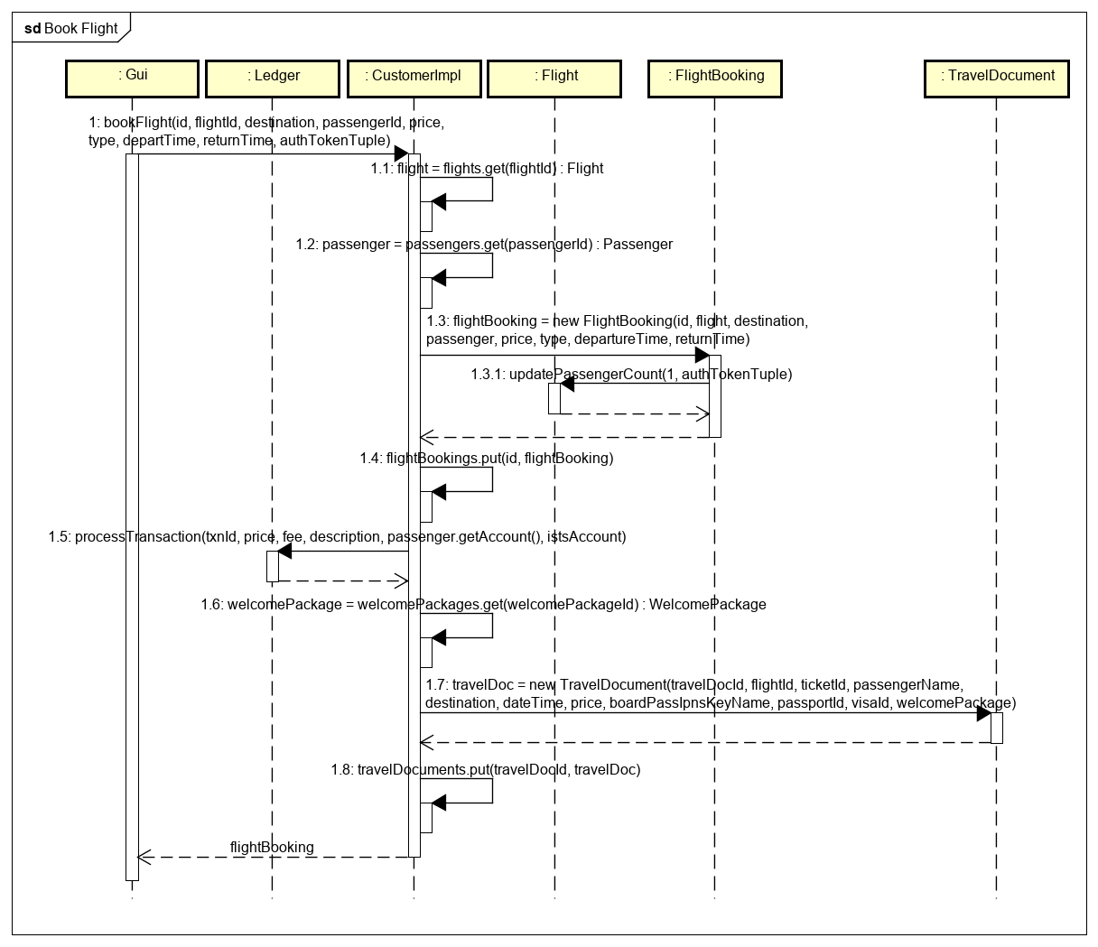

# Exception Handling

*Provide details on your exception handling. What types of exceptions are expected and how are they handled by the design? Describe your exception classes and their properties.*

# Testing

*Provide a testing strategy for testing the component.*

* *Functional*
* *Performance*
* *Regression*
* *Exception Handling*

# Risks

*Document any risks identified during the design process.*

*Are there parts of the design that may not work or need to be implemented with special care or additional testing?*

ISTS Flight Management Service Design Document

Document structure overview here.

# Introduction

*A high-level description of this document, for example, “This document defines the design for the Canonical Model”.*

Overview

*Overview of the problem to be solved. What is the problem and why is it being solved? How will the resulting solution provide business value?*

*Consider adding a diagram that explains how this component fits into the overall System with some descriptive text explaining the diagram.*

# Requirements

*This section provides a summary of the requirements for the <Component Name>.*

*Provide your understanding of the requirements, both functional and nonfunctional. Reference the provided Requirements and System Architecture documents. Do not cut and paste from the requirements document.*

*Product Manager and others can read this to understand what requirements your design will support. There is already a requirements doc, so keep this brief and to the point, highlighting the important requirements that the design is addressing. Structure in a way to provide a requirements checklist for your design.*

# Use Cases

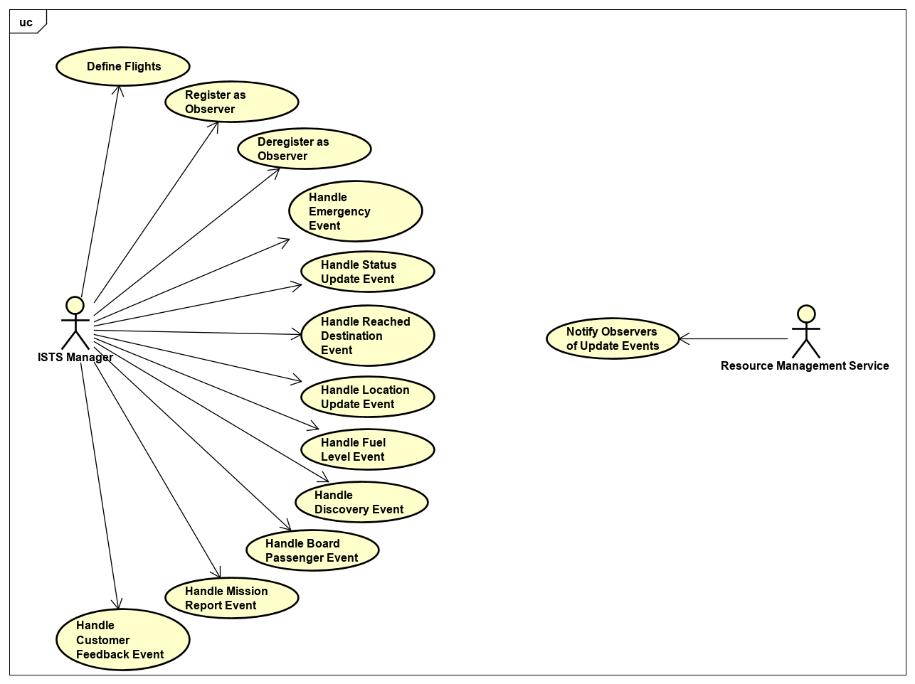

# Implementation

*This section of the document will describe the implementation details for ...*

*The implementation section should cover the following topics:*

* *What are the classes, and their properties, associations and methods?*
* *What are the important interfaces and how they will be implemented?*
* *How are the requirements addressed?*

# Class Diagram

*The following class diagram defines the classes defined in this design. Remember to include exception classes.*

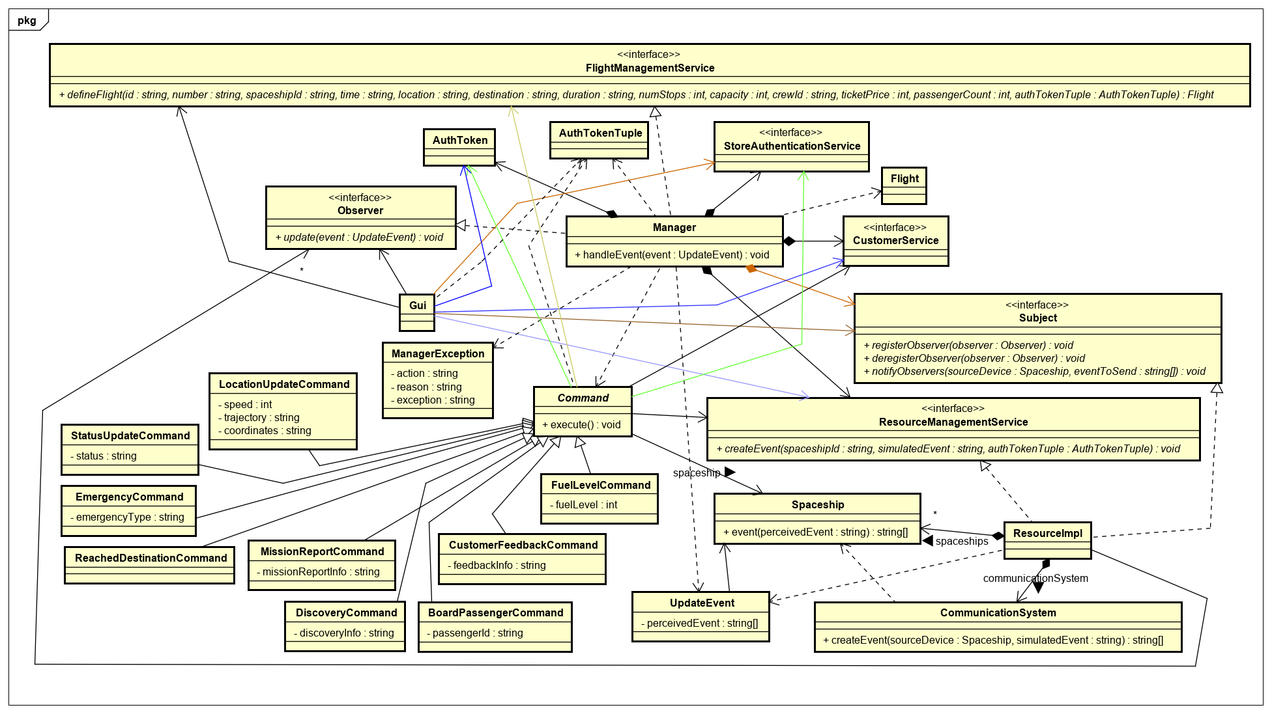

# Class Dictionary

*This section specifies the class dictionary for the class … defined within the package …*

## FlightManagementService (Interface)

*Class 1 description*

***Methods***

|  |  |  |
| --- | --- | --- |
| **Method Name** | **Signature** | **Description** |
| defineFlight | (id : string, number : string, spaceshipId : string, time : string, location : string, destination : string, duration : string, numStops : int, capacity : int, crewId : string, ticketPrice : int, passengerCount : int, authTokenTuple : AuthTokenTuple) : Flight |  |

## Observer (Interface)

*Class 1 description*

***Methods***

|  |  |  |
| --- | --- | --- |
| **Method Name** | **Signature** | **Description** |
| update | (event UpdateEvent): void |  |

## Manager

Implements FlightManagementService and Observer interfaces.

***Methods***

|  |  |  |
| --- | --- | --- |
| **Method Name** | **Signature** | **Description** |
| handleEvent | (event : UpdateEvent) : void |  |

***Associations***

|  |  |  |
| --- | --- | --- |
| **Association Name** | **Type** | **Description** |
| resourceImpl | ResourceManagementService; Subject |  |
| customerImpl | CustomerService |  |
| authenticator | StoreAuthenticationService |  |
| authToken | AuthToken | The Manager needs its own AuthToken with the proper access permissions to interface with the other modules such as when defining flights. |

## ManagerException

The ManagerException is thrown when errors occur in the Manager. It extends java.lang.Exception. The exception includes the action that was being performed and the reason for the exception.

***Properties***

|  |  |  |
| --- | --- | --- |
| **Property Name** | **Type** | **Description** |
| action | string | Command performed during exception occurrence. |
| reason | string | Reason for exception being thrown. |
| exception | string | Name of the exception being thrown, e.g., “ManagerException”. |

## Subject (Interface)

*Class 1 description*

***Methods***

|  |  |  |
| --- | --- | --- |
| **Method Name** | **Signature** | **Description** |
| registerObserver | (observer : Observer) : void |  |
| deregisterObserver | (observer : Observer) : void |  |
| notifyObservers | (sourceDevice : Spaceship, eventToSend : string[]) : void |  |

## ResourceImpl

Implements Subject

***Methods***

|  |  |  |
| --- | --- | --- |
| **Method Name** | **Signature** | **Description** |
| createEvent | (spaceshipId : string, simulatedEvent : string, authTokenTuple : AuthTokenTuple) : void |  |

***Associations***

|  |  |  |
| --- | --- | --- |
| **Association Name** | **Type** | **Description** |
| observers | Observer[] |  |
| spaceships | map<spaceshipId, Spaceship> |  |
| communicationSystem | CommunicationSystem |  |
| authenticator | StoreAuthenticationService | Used to check access permissions on the ResourceImpl object’s methods. |

## CommunicationSystem

*Class 1 description*

***Methods***

|  |  |  |
| --- | --- | --- |
| **Method Name** | **Signature** | **Description** |
| createEvent | (sourceDevice : Spaceship, simulatedEvent : string) : string[] |  |

## Spaceship

*Class 1 description*

***Methods***

|  |  |  |
| --- | --- | --- |
| **Method Name** | **Signature** | **Description** |
| event | (perceivedEvent : string) : string[] |  |

## UpdateEvent

The UpdateEvent class represents an event that is sent from a Subject (e.g., the Resource Management Service) to an Observer (e.g., the Manager) defined by the Observer pattern. It is created in the notifyObservers method of the Subject when it calls an Observer’s update method.

***Properties***

|  |  |  |
| --- | --- | --- |
| **Property Name** | **Type** | **Description** |
| perceivedEvent | string[] | The event that the source Spaceship perceived and sent. |

***Associations***

|  |  |  |
| --- | --- | --- |
| **Property Name** | **Type** | **Description** |
| sourceShip | Spaceship | The Spaceship that sent the originating event to the Communication System (and ultimately to the Resource Management Service) for notifying observers. |

## *Command*

The Command class encapsulates the actions that need to be performed for one type of event in its execute method including the commands sent to a spaceship, and the Resource Management and Customer services. It is an abstract class that each event extends with a corresponding Command subclass. When a new Command is made it is executed right away.

***Methods***

|  |  |  |
| --- | --- | --- |
| **Method Name** | **Signature** | **Description** |
| execute | () : void | Defines the executable actions that are needed in response to an event. |

***Associations***

|  |  |  |
| --- | --- | --- |
| **Property Name** | **Type** | **Description** |
| sourceShip | Spaceship | The source spaceship that perceived/sent the original event. |
| resourceImpl | ResourceManagementService | A reference to the Resource Management Service that the self-sufficient Command classes depend on. |
| customerImpl | CustomerService |  |
| manager | FlightManagementService |  |
| authToken | AuthToken | To perform their functions the Command classes need an authToken with the appropriate access permissions. |

## EmergencyCommand

Extends Command.

***Properties***

|  |  |  |
| --- | --- | --- |
| **Property Name** | **Type** | **Description** |
| emergencyType | string |  |

## StatusUpdateCommand

Extends Command.

***Properties***

|  |  |  |
| --- | --- | --- |
| **Property Name** | **Type** | **Description** |
| status | string |  |

## ReachedDestinationCommand

Extends Command.

## LocationUpdateCommand

Extends Command.

***Properties***

|  |  |  |
| --- | --- | --- |
| **Property Name** | **Type** | **Description** |
| speed | int |  |
| trajectory | string |  |
| coordinates | string |  |

## FuelLevelCommand

Extends Command.

***Properties***

|  |  |  |
| --- | --- | --- |
| **Property Name** | **Type** | **Description** |
| fuelLevel | int |  |

## MissionReportCommand

Extends Command.

***Properties***

|  |  |  |
| --- | --- | --- |
| **Property Name** | **Type** | **Description** |
| missionReportInfo | string |  |

## DiscoveryCommand

Extends Command.

***Properties***

|  |  |  |
| --- | --- | --- |
| **Property Name** | **Type** | **Description** |
| discoveryInfo | string |  |

## CustomerFeedbackCommand

Extends Command.

***Properties***

|  |  |  |
| --- | --- | --- |
| **Property Name** | **Type** | **Description** |
| feedbackInfo | string |  |

## BoardPassengerCommand

Extends Command.

***Properties***

|  |  |  |
| --- | --- | --- |
| **Property Name** | **Type** | **Description** |
| passengerId | string |  |

# Implementation Details

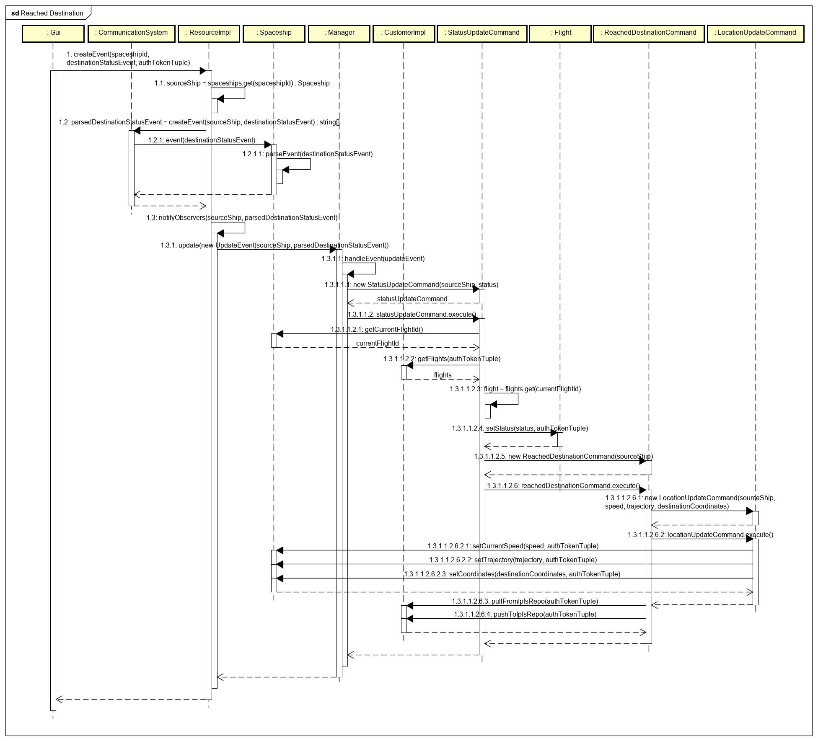

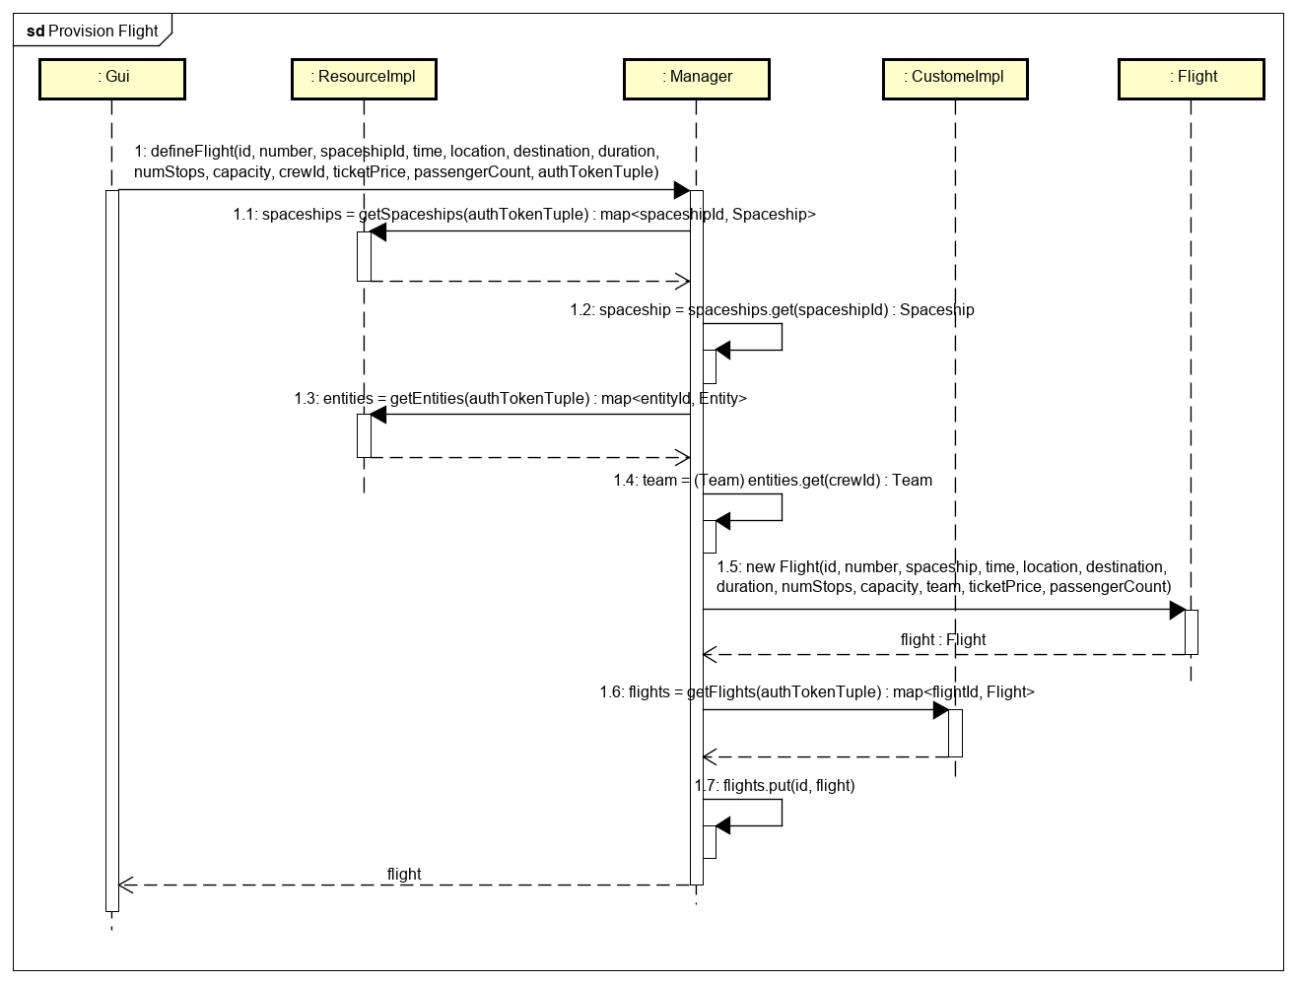

# Exception Handling

*Provide details on your exception handling. What types of exceptions are expected and how are they handled by the design? Describe your exception classes and their properties.*

# Testing

*Provide a testing strategy for testing the component.*

* *Functional*
* *Performance*
* *Regression*
* *Exception Handling*

# Risks

*Document any risks identified during the design process.*

*Are there parts of the design that may not work or need to be implemented with special care or additional testing?*