# GUI

The Resource Management GUI will only be used by administratrative users of the ISTS. When users first sign in to the service (explained in the Customer service specification’s GUI section), the most up-to-date Resource Management data is automatically downloaded from the remote persistence storage location on the IPFS to local memory. Below is what the main menu screen of the UI should approximately look like:

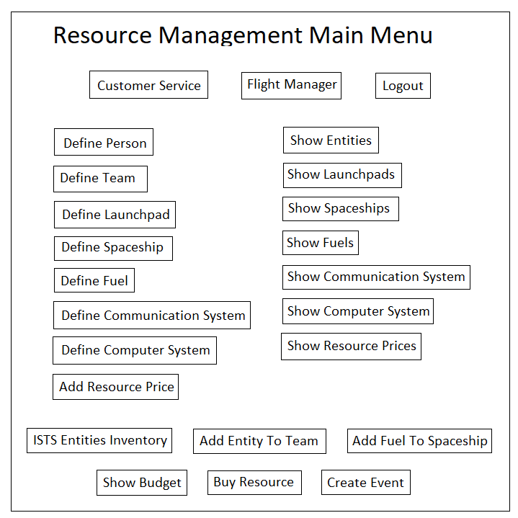

Caption: The main menu screen of the Resource Management service UI.

The middle left column of buttons on the main menu that allow the user to define the state of each of the resources when clicked on bring up a form window that should look approximately like the following:

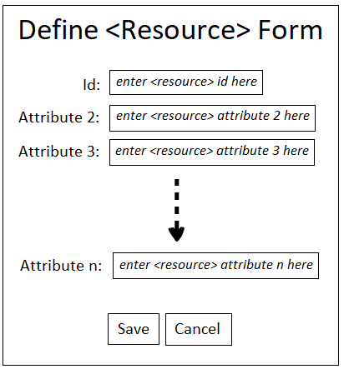

Caption: The generic “Define <Resource>” form of the Resource Management GUI where n is the number of attributes. It allows users to create a resource by definings its attributes in the form and then clicking the save button.

The middle right column of buttons on the main menu that show the information each of the types of resources contain when clicked on bring up a form window that should look approximately like the following:

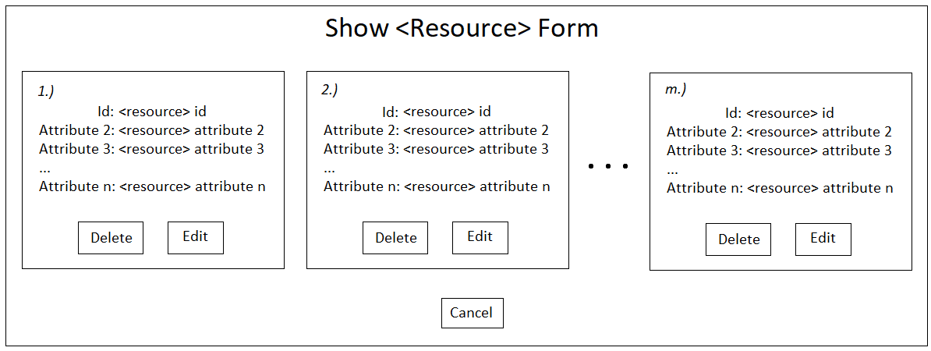

Caption: The generic “Show <Resource>” form of the Resource Management GUI where n is the number of attributes and m is the number of the specific resource. It allows users to view, update, and delete resources. When clicking on an edit button, the corresponding resource’s “Define <Resource>” form should be brought up in a new window to allow for updating.

The bottom two rows of buttons in the main menu involve functions that perform or provide support for some type of behavior on or manipulation of resource data. For instance, the “ISTS Entities Inventory” button brings up a window that shows an organized form view of the people and teams that make up the ISTS organization. This could be used to organize groups of people, e.g., flight crews and passengers, in order to support managing flights. More interactive functionality could also be included.

The top row of buttons on the main menu are for navigational purposes such as directing users to other ISTS services or logging out.

The “Create Event” button on the main menu, brings up a form that allows the user to create/simulate an event by typing in an event with the appropriate event command-line syntax. A log of events and their corresponding actions are printed to stdout after each event.

# GUI

The Customer service GUI will be used by passengers and administrators of the ISTS and is the main point of entry into the service. Administrators can navigate to the Resource Management, and Flight Manager GUIs from it while non-administrative passengers can only use the Customer service. When users first sign in to the service, the most up-to-date Customer service data for the user is automatically downloaded from the remote persistence storage location on the IPFS to local memory. Below is what the login/register form should approximately look like:

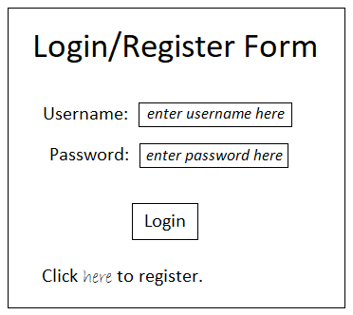

Caption: The login/register form for the Customer service GUI. The “Click here to register.” link at the bottom opens up a “Define <Customer Object>” form (defined later in this section) when clicked where passengers can fill out registration information to create an account.

After users login, they should be brought to the main menu. Below is what the main menu screen of the Customer service UI should approximately look like:

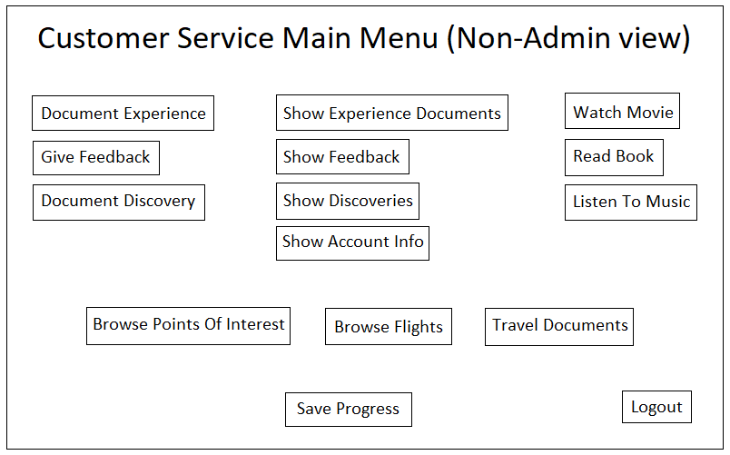

Caption: The main menu screen of the Customer service UI for non-administrative passengers. The Admin GUI is shown at the end of this section.

The top left column of buttons on the main menu that allow the user to create documents when clicked on bring up a form window that should look approximately like the following:

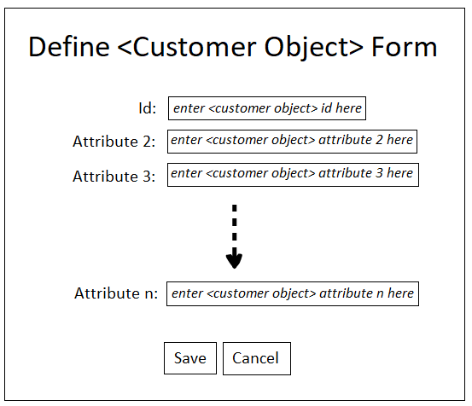

Caption: The generic “Define <Customer Object>” form of the Customer service GUI where n is the number of attributes. It allows users to create a document such as a discovery made on a trip by defining its attributes in a form and then hitting the save button.

For Customer objects that contain media (e.g., Discovery), the “Define <Customer Object>” form should include media management functionality that should look approximately like the following:

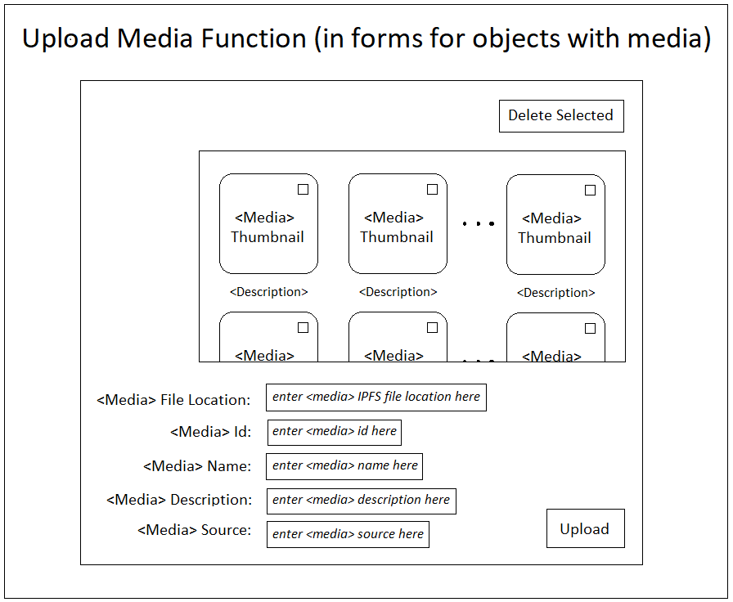

Caption: The upload-media functionality that’s included on forms for defining Customer objects that contain media, e.g., experience documentation can have video recordings. Clicking on a thumbnail opens the media in another window for an enlarged view and/or to be listened to or read. Uploading new media creates a new clickable thumbnail in the list for the media. Media can also be checked and deleted from the list.

The “Show <Customer Object>” buttons in the top middle column of the main menu show the information each of the types of Customer objects contain when clicked on and should bring up a form window that should look approximately like the following:

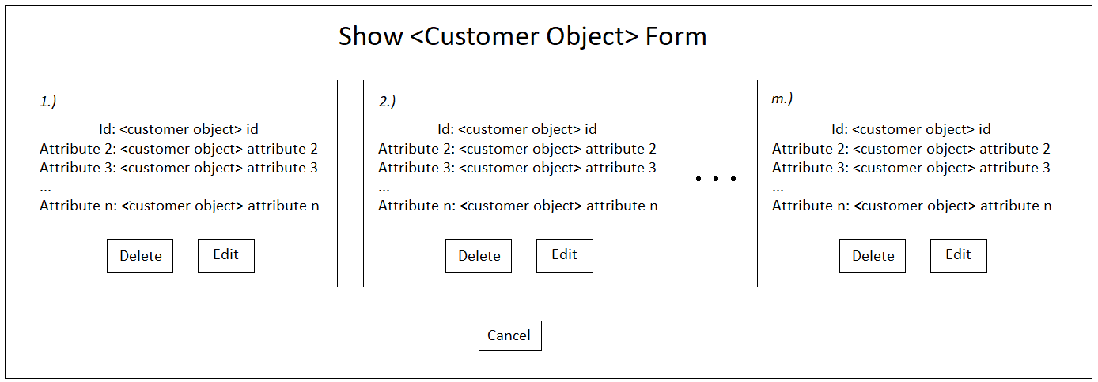

Caption: The generic “Show <Customer Object>” form of the Customer service GUI where n is the number of attributes and m is the number of the specific Customer object. It allows users to view, update, and delete resources. When clicking on an edit button, the corresponding Customer service object’s “Define <Customer Object>” form should be brought up in a new window to allow for editing.

The middle row of buttons (above the “Save Progress” button) in the main menu are for browsing points of interest and flights, booking flights, and accessing important travel documents and flight information after booking a flight. These can’t be edited by passengers; only read (except passengers can upload their passport and visa information on the form that opens when they click on the “Travel Documents” button). The “Browse Flights” button brings up another window for booking flights that looks approximately like the following:

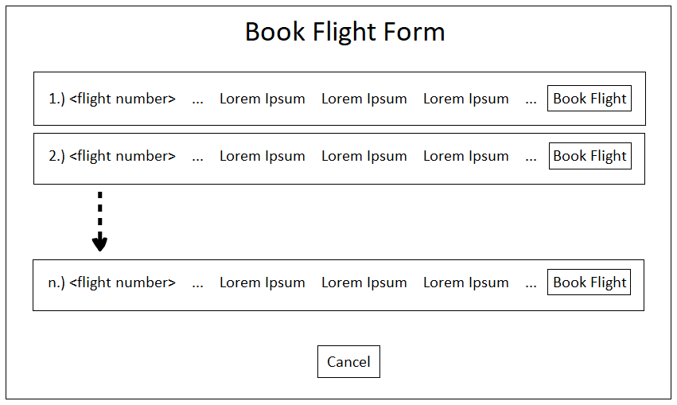

Caption: The form for booking flights in the Customer service GUI where n is the number of flights. It allows users to browse available flights and book them by clicking the “Book Flight” button.

The top right column of buttons in the main menu allow passengers to access in-flight entertainment. These can’t be edited by passengers; only read. Clicking on them should bring up a form that looks approximately like the following:

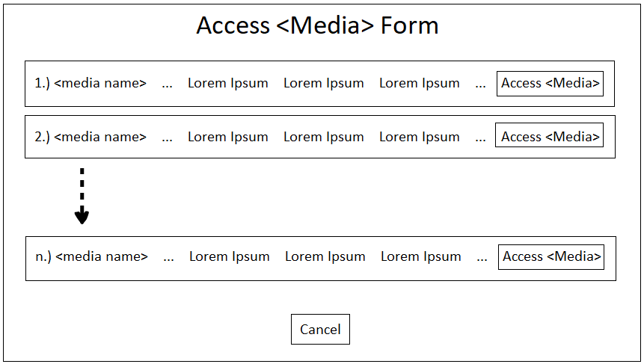

Caption: The generic form for allowing users to pick media out from a list for entertainment purposes during the flight where n is the number of list items. Users can click on the “Access <Media>” button to stream it. Media offered includes movies, music, and books.

The bottom “Save Progress” button on the main menu uploads any local data updates/changes made in local memory to the remote IPFS for persistence, so that it can be retrieved again at a later time.

**Admin GUI**

The Admin view of the Customer service GUI is the same as non-admin passenger’s except for the following:

* Admins not only get back a view of their own data but every passenger’s when showing experience documents, feedback, discoveries, and accounts.
* Admins can navigate to other services (Resource and Flight Manager).
* Admins can define more types of Customer objects and edit them than regular passengers, e.g, points of interest, travel documents, in-flight entertainment, welcome packages, and mission reports.
* Admins can view (and edit) all passenger account information, and all flight booking records.

The following is what the Admin’s main menu should approximately look like:

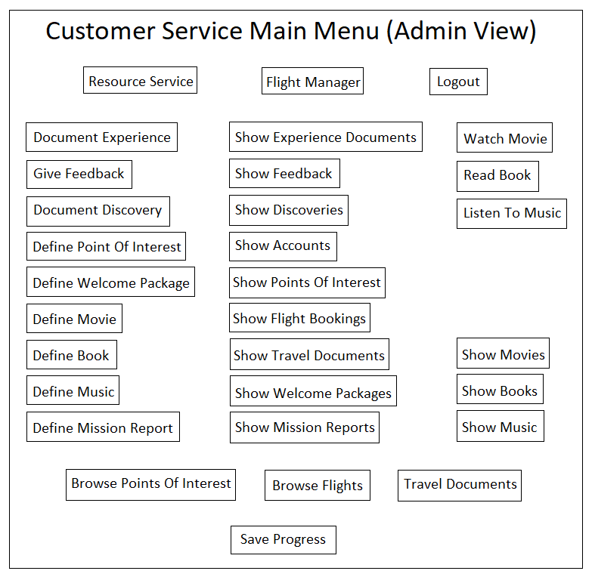

Caption: The main menu screen of the Customer service UI for Admins.