Data Structures and Algorithms Report
Waypoint Storage and Route Editing
Gerald Chukwudalu Otuadimma
25928399

1. Introduction and implementation context
This report compares three data structures for a GPS waypoint and route program: a fixed array, a linked list and a binary search tree. The real problem is not just storing data, but choosing a structure that fits the operation being carried out. In my final code, one WayPoint object stores the useful fields from the CSV file: name, code, latitude, longitude, height in metres and description. The file is read in Program.ReadFileWayPoints, where SplitCsvLine deals with commas inside quoted descriptions, ConvertElevationToMeters normalises feet to metres, and BuildDescription joins the remaining description text.
All loaded waypoints are stored in WayPointArray, which wraps a private WayPoint[] and a numberOfWayPoints counter. Routes are stored using my own linked-list classes, Route and Link, rather than the built-in C# collection. I also added WayPointTree and TreeNode as a binary search tree index by waypoint name.
2. Critical comparison of the data structures
A fixed array is a good match for storing all waypoints after the file has been loaded. File.ReadAllLines already gives the number of lines, so WayPointArray can be created with enough space at the start. AddWayPoint then places the new object at numberOfWayPoints and increments the count. This is simple and efficient: adding to the next free position is O(1), and reading by index is also O(1). The weakness is searching. FindByNameOrCode must scan from the first stored waypoint until it finds a match, so its worst case is O(n). Arrays are also poor for editing a route in the middle because insertion or deletion normally means moving later items along.
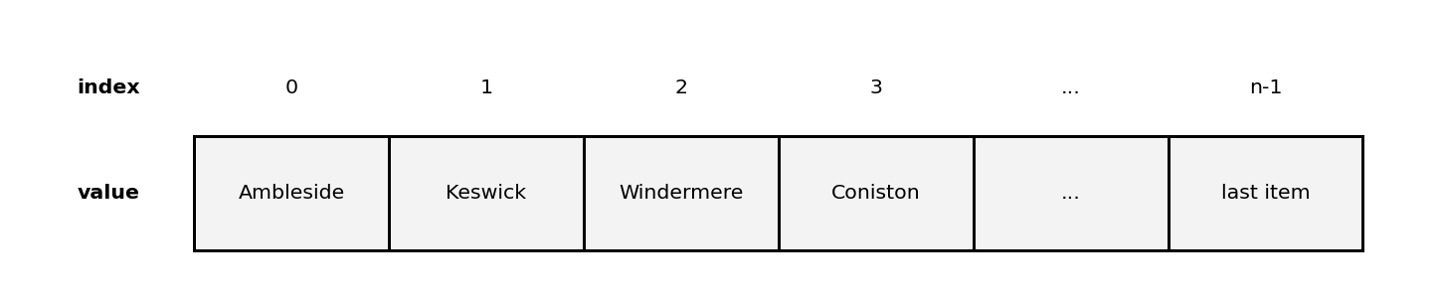
Figure 1: WayPointArray stores loaded WayPoint objects in fixed positions

For route editing, the linked list is more suitable than the array. A route is an ordered list chosen by the user, and the user may add a waypoint to the front, add to the end, insert at a position, remove a waypoint, or reverse the route. In Route, each Link stores one WayPoint and a Next reference. AddFront is O(1) because it only changes the first reference. AddEnd is also O(1) in my final code because the Route class has a last pointer, so it no longer has to walk along the whole list to find the end. InsertAtPosition and RemoveWayPoint still have O(r) worst-case time because the route may need to be searched first, where r is the number of waypoints in the route. This reflects the normal trade-off of linked lists: editing links is cheap once the position is found, but direct indexing is not available.

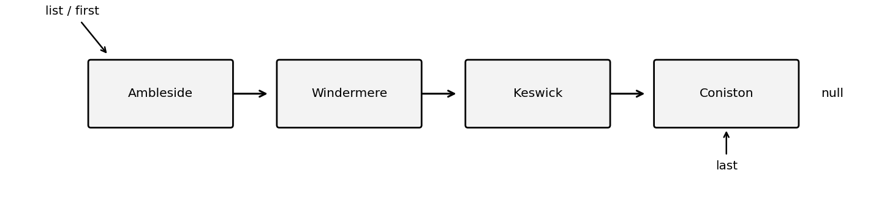
Figure 2: Route uses Link nodes with first and last references

A binary search tree is useful when the main task is searching or displaying data in sorted order. In WayPointTree, each node compares the new waypoint name with the current node. Smaller names go left and larger names go right. InOrder traversal then prints the waypoints alphabetically. In practice, I used the tree while loading the file so that duplicate waypoint names are rejected before the object is added to WayPointArray. This is more relevant to the taught topic than using a HashSet or Dictionary, because it demonstrates recursive InsertItem and Find methods. A balanced tree can search in O(log n), but my tree is not self-balancing, so its worst case is O(n) if the data arrives in a sorted or near-sorted order. That is an important limitation, not something to hide.
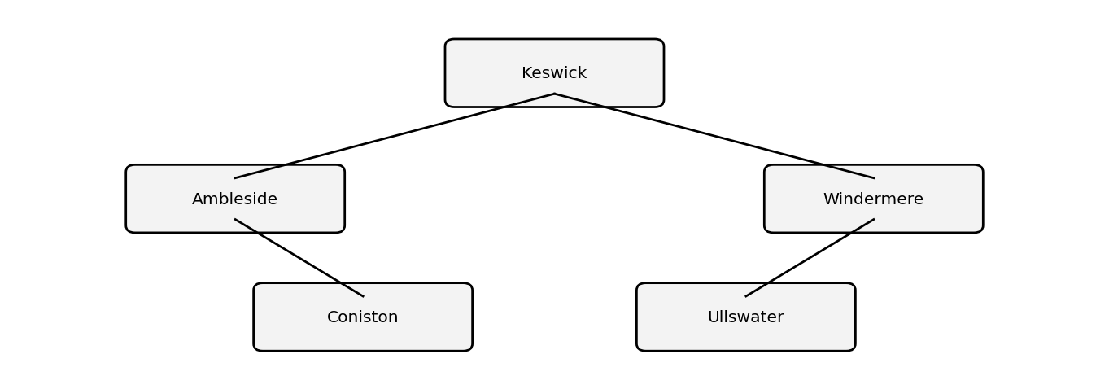
Figure 3: Binary search tree stores waypoint names by alphabetical order

Overall, I would keep the array as the main store for all waypoints because it is compact, simple and fits the one-time CSV loading task. I would keep the linked list for routes because the route order is user-defined, not alphabetical or numerical. The binary search tree should be treated as an index over the waypoint names, not as the main route structure. It improves exact-name lookup and duplicate checking, but it would be unsuitable for storing a route because an in-order traversal would sort the waypoints and destroy the planned route sequence.
3. Summary comparison linked to my code
Structure | Used in my code | Best fit | Main limitation
Array | WayPointArray with WayPoint[] and numberOfWayPoints | Main store for all loaded waypoints | Linear search and fixed capacity
Linked list | Route and Link with Data, Next, list and last | User-edited route order | No direct index access; search is O(r)
Binary search tree | WayPointTree and TreeNode with root, Left and Right | Exact-name search, duplicate rejection and sorted output | Can become O(n) if unbalanced

4. Complexity analysis of the highest-cost method
The method I selected is Program.ReadFileWayPoints because it processes every CSV line, builds each valid WayPoint, inserts it into the binary search tree, and then stores it in the array. Most route methods in my program are at most linear in the number of route nodes, but this method can be more expensive because each tree insertion depends on the current tree height. Let n be the number of CSV lines, k be the average length of one line, and h be the height of the tree during insertion.
Actual code line in Program.ReadFileWayPoints | Cost | Reason
66 string[] linesInFile = File.ReadAllLines(fileName); | O(nk) | Reads all n CSV lines, where k is the average line length.
67 WayPointArray store = new WayPointArray(linesInFile.Length); | O(n) | Creates a fixed array with enough capacity for the loaded file.
68 allWayPointsTree = new WayPointTree(); | O(1) | Creates an empty binary search tree reference.
70 int lineNumber = 0; | O(1) | Initialises the line counter.
72 foreach (string line in linesInFile) | n iterations | Loops through each line in the file once.
74 lineNumber++; | O(1) | Constant-time counter update inside the loop.
77 if (lineNumber != 1 && line != "") | O(1) | Skips the heading row and any empty line.
79 string[] featuresInLine = SplitCsvLine(line); | O(k) | Scans the current line and handles commas inside quotes.
81 if (featuresInLine.Length >= 6) | O(1) | Checks that the record has enough fields.
83 string name = featuresInLine[0].Trim(); | O(k) | Trims a field from the current record.
84 string code = featuresInLine[1].Trim(); | O(k) | Trims a field from the current record.
85 string latitude = featuresInLine[3].Trim(); | O(k) | Trims a field from the current record.
86 string longitude = featuresInLine[4].Trim(); | O(k) | Trims a field from the current record.
87 int height = ConvertElevationToMeters(featuresInLine[5].Trim()); | O(k) | Cleans and converts the elevation value.
88 string description = BuildDescription(featuresInLine); | O(k) | Builds the description from the remaining CSV fields.
90 WayPoint newWayPoint = new WayPoint(name, code, latitude, longitude, height, description); | O(1) | Creates one WayPoint object.
93 if (allWayPointsTree.InsertItem(newWayPoint)) | O(h) | Recursive BST insert follows one path from the root to a leaf.
95 store.AddWayPoint(newWayPoint); | O(1) | Stores the waypoint at the next free array position.
101 return store; | O(1) | Returns the completed WayPointArray.
For one valid record, the main cost is O(k + h). Across the whole file, the method is O(nk + the sum of all tree insertion heights). If the binary search tree is reasonably balanced, h is about log n, so the expected complexity is O(nk + n log n), normally simplified to O(n log n) when line length is treated as bounded. In the worst case, the tree becomes unbalanced and h can grow to n, so insertion costs can add up to 1 + 2 + 3 + ... + n, giving O(n²). The array insertion is not the cause of the higher cost; the risk comes from the unbalanced binary search tree.
5. Conclusion
The final design uses each data structure for the job it suits best. The array gives a simple fixed store for the waypoint file. The linked list gives flexible route editing without shifting array elements, and the added last pointer makes adding to the end efficient. The binary search tree gives a taught, recursive method for exact-name lookup, duplicate rejection and alphabetical display. The main improvement I would make in a professional system would be a balanced tree or dictionary for guaranteed faster lookup, but for this coursework the current design shows the required data structures and their practical trade-offs clearly.

References
Acharjya, P.P., Koley, S. and Barman, S. (2022) 'Analysis of the complexity of various linked lists', Turkish Journal of Computer and Mathematics Education, 11(2), pp. 886–895. Available at: https://turcomat.org/index.php/turkbilmat/article/view/11883 .
Cormen, T.H., Leiserson, C.E., Rivest, R.L. and Stein, C. (2022) Introduction to algorithms. 4th edn. Cambridge, MA: MIT Press. Available at: https://mitpress.mit.edu/9780262046305/introduction-to-algorithms/ .
Sonntag, B. and Colnet, D. (2023) RIP linked list: empirical study to discourage you from using linked lists any further [Preprint]. Available at: https://arxiv.org/abs/2306.06942 .
Horlova, O. (2021) Exploiting the array data model for genomic and spatial computation. PhD Thesis. Politecnico di Milano. Available at: https://www.politesi.polimi.it/retrieve/51cac1eb-e21e-4f8f-b05f-a2f188dad8f6/Olha_Horlova_PhD_Thesis.pdf .
Pandya, J. and Chakravarty, P. (2024) 'Impact of time complexity using array and linked list in data structure', International Journal of Data Structure Studies, 2(2), pp. 41–48. Available at: https://journals.stmjournals.com/ijdss/article=2024/view=181593/ .

