PROJECT REPORT
CellSense AI Portal
An AI driven mobile phone information website for ASKME Ltd.

Course | Advanced Diploma in Software Engineering (ADSE)
Faculty | OV-7228-ACCPAI-INTERSHIP-NIGERIA-ACE
Project | Semester 1 eProject: CellSense AI Portal
Client | ASKME Ltd.
Live site | https://geraldxtra.github.io/cellsenseai
Centre | ACE-LAGOS-14-AJAO
Batch code | 093
Students | Gerald (team lead), Student1726134
 | Ibrahim, Student1726552
 | Osakue, Student1726934
Submitted | 13 October 2026

Contents

1 Problem definition 3
1.1 The problem 3
1.2 Our solution 3
1.3 What we set out to do 3
1.4 Who uses it 4
1.5 Scope and limits 4
1.6 The features the brief asks for 4
1.7 The non-functional requirements 5
1.8 How the project covers the brief's AI terms 5
2 Design specifications 7
2.1 How the site is put together 7
2.2 The tools we chose 8
2.3 The pages 8
2.4 Look and feel 10
2.5 How each feature works 11
2.6 How we use AI 13
2.7 The data we store 14
2.8 The API 14
2.9 Security 15
3 Diagrams 17
3.1 Data flow diagrams 17
3.2 Flowcharts 19
4 Source code 42
4.1 What is in the zip 42
4.2 How the code is organised 42
4.3 Who built what 43
5 Test data 44
5.1 The data we tested with 44
5.2 How we tested 44
6 Installation instructions 46
6.1 What you need 46
6.2 Run the site 46
6.3 The .env files 46
6.4 Creating an account 47
6.5 Using your own database instead 47
6.6 If something goes wrong 47

1 Problem definition

1.1 The problem
ASKME Ltd. answers customer questions over the telephone. A large share of the calls are about mobile phones, and they keep coming back to the same five questions:
1. Which phone has a particular feature?
2. What are the specifications of a phone?
3. What does it cost now?
4. How is one phone different from another?
5. Which phone is best for my budget?

Every one of these calls is taken by a person. With thousands of them, that costs ASKME support time, it needs enough staff on the phones, and it costs money. Ordinary phone websites don't solve this. They show a list of specs and leave the customer to work out the rest on their own.

1.2 Our solution
We built CellSense AI, a website that answers those five questions by itself. A customer can type what they want the way they would say it, such as "5G phone with long battery life", and get the phones that match. They can open any phone to see its specs, its current guide price and how that price has moved, put two or three phones side by side, ask for the three phones that best fit their budget, or just ask the assistant in a chat window.
The AI parts use a pre-trained language model that our server calls through an API. We use Groq with the model openai/gpt-oss-120b. We did not train a model of our own. Every time our server asks the model something, it sends our own phone data with the question, so the answers stay on the phones we actually hold.
The site is a single page application. The browser side is React 19 with Vite, the server is Node 20 with Express 5, and the data lives in MongoDB Atlas. You can try it live at https://geraldxtra.github.io/cellsenseai.

1.3 What we set out to do
- Build a phone information website that uses AI to help people choose.
- Give each person recommendations based on their budget and needs.
- Compare phones side by side, with the best value marked.
- Offer an assistant for phone questions.
- Let people search in plain English.
- Keep phone details and prices up to date.
- Make buying a phone a simpler decision.
- Show how AI fits into a modern web application.

1.4 Who uses it
- Visitors can search, browse by brand, open phone pages, compare phones, get recommendations and use the assistant without an account.
- Customers with an account also get a personal dashboard with the phones they viewed, their searches, their favourites and their last recommendations. They can save favourites, write reviews and reset a forgotten password by email.
- The ASKME team use the admin dashboard to add new phones and record new guide prices.

1.5 Scope and limits
- We started with 60 phones, 12 each from Samsung, Apple, OnePlus, Xiaomi and Vivo. This is a starting catalogue, not every phone on sale. Admins can add more from the admin dashboard.
- Prices are guide prices in US dollars, each saved with the date it was checked. They are not live shop prices.
- The site needs an internet connection, because the database and the model are both online.
- We integrate a pre-trained model through its API. We don't build or train one.
- The price trend comes from the price history we store. It doesn't use wider market trends or how popular a phone is.
- The dashboard keeps what each person viewed, searched, saved and was recommended. Recommendations come from the answers on the Recommend page, so they don't yet learn from that history.

1.6 The features the brief asks for
The brief lists nine core features. This is what we built for each one.
No. | Feature in the brief | What we built
1 | AI mobile recommendation system | The Recommend page asks for the budget, the brand, what the phone is for (everyday, photos, gaming or work), the performance needed, and whether the camera, gaming and battery matter. Our rules shortlist the phones that fit, and the model ranks the top three with a reason for each. "Suggest a phone under $399 with a good camera" is a $399 budget with the camera marked as important.
2 | AI mobile assistant chatbot | The Assistant page, and a chat window on every other page, answer questions about specs, features, prices, brand comparisons and what to buy, such as "Compare Samsung and Apple phones under $599". The answers come from our own phone data.
3 | Smart mobile search | A plain-English search such as "Phone with 108MP camera" or "5G phone with long battery life" is turned into filters by the model and run on our database. If someone searches for a real phone we don't have, the model supplies its specs and we add it marked "Estimated".
4 | Dynamic smartphone information | Each phone page shows the brand, picture, processor, RAM, storage, cameras, battery, display, operating system and guide price, with a short plain-English summary written by the model. Phones and prices change through the admin pages and the nightly price check.
5 | AI-based mobile comparison | Compare puts two or three phones side by side in one table, from the same brand, different brands or the same price range. It covers price, processor, RAM, storage, cameras, battery, display and refresh rate, with the best value in each row in bold.
6 | Personalised user dashboard | A logged-in person's Dashboard shows their recently viewed phones, search history, favourites and last recommendations.
7 | Price prediction and trend analysis | Each phone page works out from its price history whether the price is falling, rising or steady, shows the history as a chart, and says whether it is a good time to buy.
8 | Brand-based navigation | Browse shows all phones or one brand's phones, with filters for price range and features (5G, RAM, battery and screen size) and sorting. The five brand cards on Home (Samsung, Apple, OnePlus, Xiaomi and Vivo) open each brand's page.
9 | AI product review summarisation | People with an account rate a phone from 1 to 5 and write a review. The model decides whether each review is positive, neutral or negative and writes a short summary of all of them, shown with the reviews.

1.7 The non-functional requirements
Requirement in the brief | How we met it
Works in all modern browsers | We used standard React, Bootstrap and CSS, with nothing tied to one browser, so the site runs in current versions of Chrome, Edge, Firefox and Safari.
Fully responsive | We built each page to its design at 1280 pixels wide and checked it at 768 pixels (tablet) and 375 pixels (phone). No page scrolls sideways, and wide tables scroll inside their own box.
Secure access and authentication | Passwords are hashed with bcrypt, new accounts need a code from their email, sign up and log in need the security tick, a password change ends every older login, and the server checks the admin role. Section 2.9 has the full list.
Fast loading | The app loads once, and after that only data moves between the browser and the server. Short searches don't use the model, and a phone's summary is written once and saved, so most pages never wait for the model.
Scalable AI modules | Every call to the model goes through one file, ai.service.js, using the common OpenAI-style API, so a bigger model or another provider is a change of settings. The AI requests have their own rate limit, and search, recommendations and review summaries fall back to our own rules when the model isn't available.
Attractive UI and UX | We designed every page before building it, and one theme file holds every colour, size and spacing value, so the whole site looks and feels the same. Section 2.4 has the details.

1.8 How the project covers the brief's AI terms
The brief names five areas of AI. This is where each one lives in our site.
Term in the brief | Where it is in CellSense AI
Artificial Intelligence | Smart search, the assistant, recommendations, the phone summaries and the review summaries all use the language model.
Machine Learning | A pre-trained model ranks the recommendations, writes the summaries and judges the mood of each review. We don't train our own.
Natural Language Processing | The model reads a plain-English search and turns it into filters, and it answers the assistant's questions.
Recommendation System | Our own rules shortlist phones by budget, brand and needs. The model then ranks the shortlist and explains each pick.
Predictive Analytics | Each phone page works out from its price history whether the price is falling, rising or steady, and says when it is a good time to buy. It is a trend, not a forecast.

2 Design specifications

2.1 How the site is put together
The site has four parts, and each one has one job.
- The browser runs our React app. It shows the pages, takes what the person types or clicks, and asks the server for data. The app loads once. After that only the data changes, so moving between pages is quick.
- The server is Node with Express. Every request goes to it. It checks who is asking, reads and writes the database, calls the model when a feature needs it, checks the security box on sign up and log in, sends emails, and sends the answer back.
- The database is MongoDB Atlas, which we reach through Mongoose.
- The model is the language model at Groq. Only the server talks to it.

We kept a few firm rules between these parts. The browser never talks to the database or the model directly. Only the server reads and writes the database, and only the server calls the model. The model never sees the database: it only sees the text we choose to send it. All our keys and passwords live in server/.env on the server, so the browser never sees them.
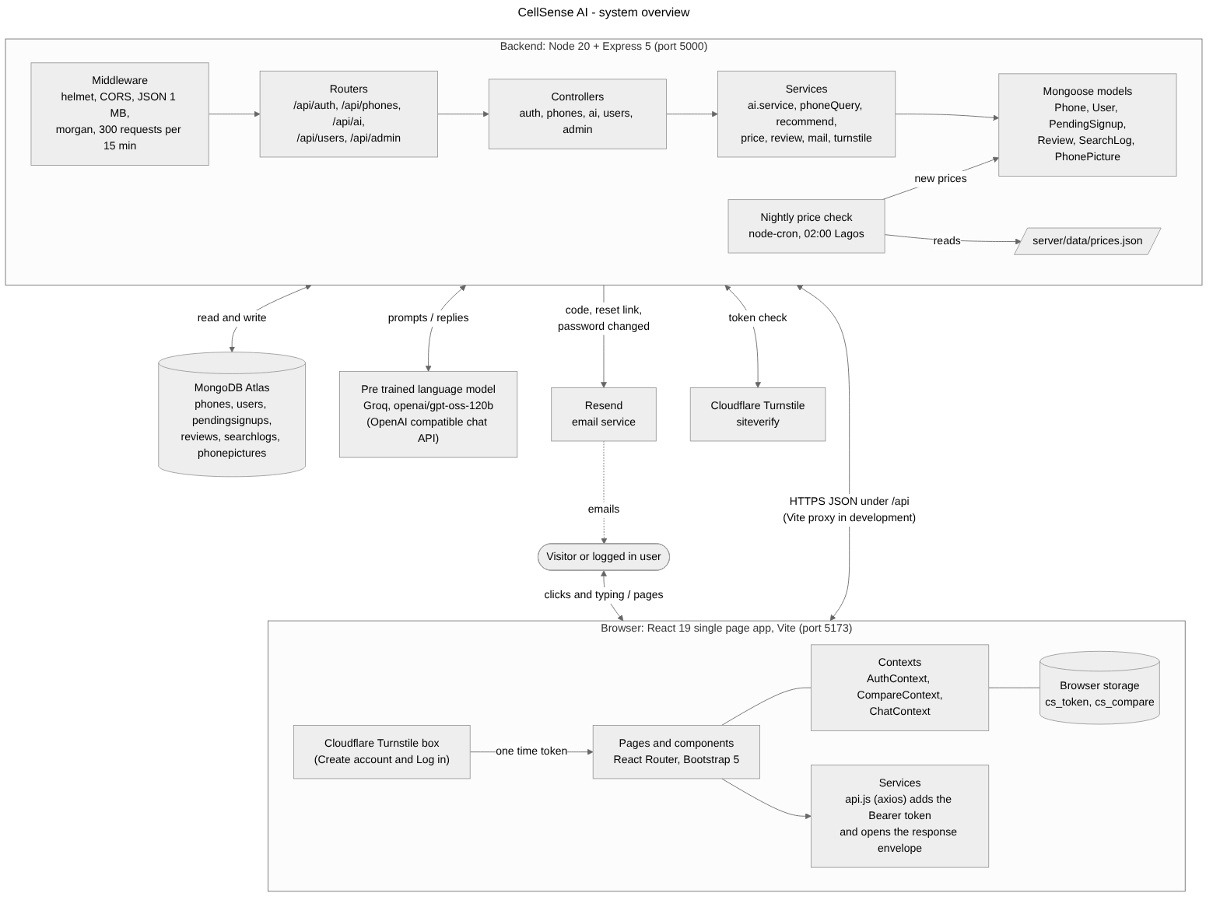
Figure 1. The browser (React), the backend (Express), MongoDB Atlas, the language model, Resend, Cloudflare Turnstile and the nightly price check, and which part talks to which.
Here is one search from start to finish. Someone types "5G phone with long battery life" and presses Search. The browser sends the words to our server. The server sees that they read like a sentence, so it asks the model to turn them into filters. Here the filters are 5G, a battery of at least 5000 mAh, and sorted by battery. The server runs those filters against the database and sends the matching phones back, and the browser shows them as cards. It also shows the filters as small chips under "Understood as", so the person can see how we read their words and remove any they don't want. A short search like "samsung" doesn't need the model at all. The server matches it straight against the phone names.
Every answer from our server has the same shape. When something works it is { ok: true, data }, and when it doesn't it is { ok: false, error: { message } }. Because of this, every page handles success and failure the same way, and we wrote every error message so it can be shown to the person exactly as it is.

2.2 The tools we chose
Part | What we used | Why we chose it
Browser app | React 19, Vite, React Router | We already knew React, and it let us build every page from shared parts such as the phone card. Vite gives a fast development server and passes /api requests to our server, so the browser only talks to one address.
Styling | Bootstrap 5 and our own CSS | Bootstrap gives us the grid and the form controls. One theme file holds every colour, size and spacing value, so all the pages look like one site.
Server | Node 20, Express 5 | It is the same language as the browser side. Express 5 sends errors from any route to one error handler, so every error comes back in the same shape.
Database | MongoDB Atlas with Mongoose | Phone specs differ from one phone to the next, so documents fit better than fixed table columns. Atlas is hosted online, so all three of us worked on the same data.
Login | JWT tokens and bcrypt | The server doesn't need to store sessions, and passwords are only ever stored as hashes.
AI | Groq, model openai/gpt-oss-120b | It is fast and cheap to call. It uses the common OpenAI-style chat API, so we could switch to another provider by changing three settings.
Email | Resend | It sends the sign-up code, the password reset link and the "password changed" notice.
Security check | Cloudflare Turnstile | The tick box on Create account and Log in stops scripts from making accounts in bulk or guessing passwords.
Scheduled job | node-cron | It runs the price check every night at 02:00, Lagos time.
Chart and icons | recharts, react-icons | The price history chart and the thin outline icons.

From the software list in the brief, we used React, Bootstrap and Node.js, and for the AI the OpenAI-style chat API, which Groq provides.

2.3 The pages
Page | Address | What it is for
Home | / | The search bar with example searches, a compare preview, an assistant preview and the five brands.
Search results | /search?q= | The phones that match a search, the "Understood as" chips, filters and sorting.
Browse | /browse and /browse/:brand | All phones or one brand, with filters for price, 5G, RAM, battery and screen, and sorting.
Phone page | /phones/:slug | Specs, guide price and the date it was checked, the price trend and chart, a plain-English summary and reviews.
Compare | /compare | Two or three phones in one table with the best value in each row in bold.
Recommend | /recommend | Five quick questions, then the three best phones with a reason for each.
Assistant | /assistant | The chat page. A small chat window with the same conversation opens from a button on every other page.
Dashboard | /dashboard | Recently viewed phones, favourites, search history and last recommendations. Login needed.
Profile | /profile | Name, password, logging out other devices, clearing history and deleting the account. Login needed.
Log in, Create account, Verify email | /login, /register, /verify-email | Signing in, and making an account with an emailed code.
Forgot password, Reset password | /forgot-password, /reset-password/:token | Getting a reset link by email and choosing a new password.
Admin | /admin | The list of every phone with its price, last check, trend and source. Admins only.
Add or edit a phone | /admin/phones/new, /admin/phones/:slug | The form for a phone's details, specs, price, summary and picture, with a live preview of its card. Admins only.
Record prices | /admin/prices | Entering the new guide prices from a price check. Admins only.
About | /about | About CellSense AI, ASKME Ltd., how prices work, and contact.
Page not found | any other address | A short message and a button back home.

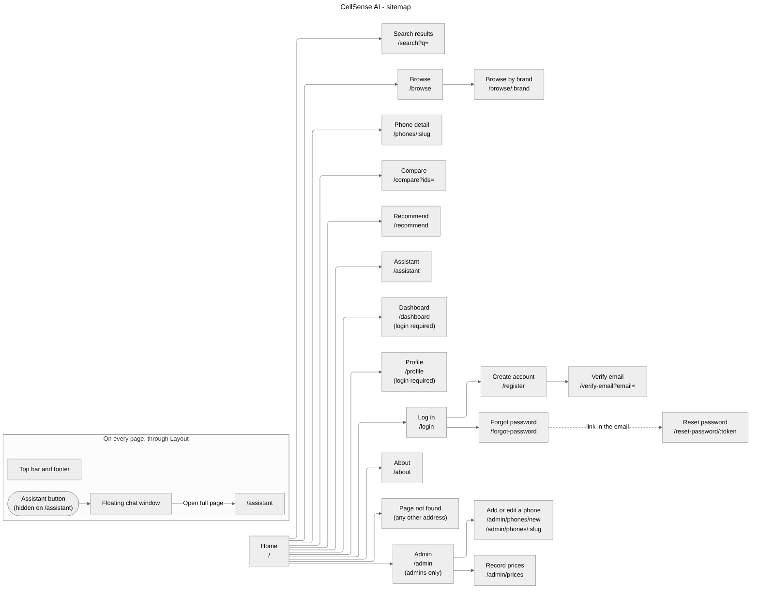
Figure 2. Every page and its route, the pages under Log in and Admin, and the assistant button that opens the floating chat window on every page but the Assistant page.

2.4 Look and feel
We designed every page before we built it. The designs are images in docs/ui/, and we built each page to match its design at 1280 pixels wide, then made sure it also works on a tablet (768 pixels) and a phone (375 pixels).
The look is deliberately quiet so that the phones stand out. Pages are white with very light grey bands between sections. Text and buttons are near-black, and buttons have softly rounded corners. Cards are white with rounded corners and no shadows, and thin grey lines separate rows. We use one warm orange for one thing only: the note that a phone's price is falling. There are no gradients and no other colours, and the icons are thin outlines.
Every colour, font size and spacing value is a variable in one file, client/src/styles/theme.css. No page types its own colours or sizes. That is how three people's pages ended up looking like one site. On a phone the top bar folds into a menu, the card grids drop to one column, and wide tables scroll inside their own box. Every page has a loading state, an empty state and an error state with a Try again button.
The admin pages use the same top bar, cards, tables and buttons as the rest of the site, so they feel like part of it rather than a separate tool. Their designs are admin.png, admin-add-phone.png and admin-record-prices.png in docs/ui/. The designs show sample rows, but the pages themselves show whatever is in the database.

2.5 How each feature works

Smart search
We try the cheap way first. If the search is short, like a brand or a model name, we match each word against the phone names in the database. If it reads like a sentence, we send it to the model instead. A search counts as a sentence when it has four or more words, has a dollar sign or a number of three digits or more, or uses a word like "under", "with", "best", "cheap", "camera" or "battery". The model replies with filters such as a price limit, 5G, a minimum battery or camera, a brand or a sort order. We keep only the filters we recognise and run them through the same database query that powers Browse. The model never picks the phones itself. It only turns words into filters.
If a search names a real phone we don't have, such as "Google Pixel 8", we ask the model for that phone's specs and a guide price. We save it, and we show it with an "Estimated" label and a note, because those numbers are the model's best guess. Every search is saved in a search log, and a logged-in person's searches also go into their search history.

Browse
Browse shows all phones, or one brand at a time using the tabs. The filter strip narrows the list by price range, 5G, 8 GB of RAM or more, a 5000 mAh battery or more, and a 120 Hz screen. The list can be sorted by newest, price, camera or battery. The filters are kept in the page address, so a reload or a shared link shows exactly the same list. We show 24 phones a page.

The phone page and the price trend
A phone page shows the picture, the specs table, the guide price with the date it was checked, a chart of the price history, the reviews, and buttons to add the phone to Compare or save it as a favourite. The first time anyone opens a phone's page, the model writes a one or two sentence summary of who the phone suits. We save it in the database, so it is only written once. If a logged-in person opens the page, we add the phone to their recently viewed list, which keeps the last 20.
The price trend is worked out from the saved price checks. We compare the latest price with the oldest check in the 90 days before it. If the latest price is 2% or more lower, the trend is falling, and the page says "Price has been falling. Waiting a little could save you money." in orange. If it is 2% or more higher, the trend is rising and the page suggests buying soon. Anything in between is steady. For example, the Galaxy S24 was $719 on 1 August 2026 and $689 on 1 October 2026. That is 4.2% lower, so its trend is falling.

Compare
Any phone card has a Compare tick box, and every phone page has an Add to compare button. The compare list holds up to three phones and is kept in the browser, so it survives a reload. The Compare page sends the phones to the server, which works out the winner of each number row: the lowest price, and the highest RAM, storage, cameras, battery, screen size and refresh rate. If phones tie, they all win, and a row where all the values are equal has no winner. Text rows such as the processor have no winner. This is our own code, not the model, so it is always right. The page also gives a link to the assistant with a ready-made question that names the phones.

Recommendations
The Recommend page asks five quick things: the budget, a brand (or any), what the phone is mostly for (everyday, photos, gaming or work), how much performance matters, and whether the camera, gaming or battery matter. Our own rules go first. We take the phones at or under the budget. If fewer than three fit, we raise the budget by 15% and say so on the page. We score each phone on camera, battery, speed and how new it is, giving more weight to what the person said matters, and keep the six best. The model then picks the best three from those six and writes a reason for each. Any pick that isn't on our shortlist is thrown out, so the model can't suggest a phone over the budget. If the model isn't available, we show our own top three with a reason built from the specs, such as "Guide price $289, with a 200 MP main camera." When the person is logged in, the picks are saved to their dashboard.

The assistant
The assistant has its own page and a small chat window that opens from a button on every other page. Both show the same conversation. When someone asks a question, the server picks up to ten phones from our database that relate to it: first any phone named in the recent messages, then phones inside any budget mentioned, sorted by camera, battery or price if the question is about that. It sends the model our rules, those phones with their guide prices and the dates they were checked, and the conversation. The rules say to answer only about phones, to use only the data we gave, to call prices "guide prices" and to keep answers short. Under the reply we show cards for the phones it mentions, but only phones we gave it, so every card links to a real page with real prices.

Reviews
A logged-in person can rate a phone from 1 to 5 and write a review, once per phone. The model reads the text and decides whether the review is positive, neutral or negative. If the model isn't available, the stars decide. At the top of the reviews, the model writes a one or two sentence summary of what people like and dislike. We save that summary and only write a new one when the number of reviews changes.

Accounts and passwords
To create an account, a person types their name, email and password and ticks the security box. The server checks the tick with Cloudflare, keeps the details waiting with the password hashed, and emails a 6-digit code. The account only exists once the right code is typed, which proves the person owns the email address. A code lasts 10 minutes and allows five tries, and a new code can be sent after a minute.
To log in, a person types their email and password and ticks the same security box. Logging in gives the browser a token that lasts seven days. The browser sends it with every request, so the server knows who is asking. A wrong email and a wrong password get the same message, so nobody can use the login form to find out who has an account.
If someone forgets their password, the Forgot password page always says "check your email", whether or not the email has an account. The emailed link works once and lasts an hour. Choosing a new password, or changing it on the Profile page, logs the account out on every other device.

Dashboard and profile
The dashboard shows four lists: recently viewed phones, favourites, search history and the last recommendations. Each list has its own empty state for a new account. On the Profile page a person can change their name, change their password, log out every other device, clear their search history or recently viewed list, or delete their account. Deleting needs the password, and it removes their reviews as well.

The admin dashboard
The admin pages are for the ASKME team. Every account has a role, either user or admin. Nobody can sign up as an admin. We make a team member an admin by setting the role on their account in the database. The server checks the role on every admin request and answers "Admins only" to anyone else, and the Admin link only appears in the menus for admins. The admin pages don't use the language model at all. They work straight on the database.
Everything on the admin pages comes from the database, so the numbers and the lists change as phones and prices change. The Admin page shows how many phones there are, how many are estimated, and the date of the latest price check. Below that is a list of every phone with its guide price, the date it was last checked, its trend, and where it came from: From our list, Estimated (a phone that a search added) or Added by admin. Admins can search the list, filter it by brand and by source, and page through it. The brand tabs and the brand choices in the form come from the brands in the database. From there they can:
- Add a phone. The form takes the brand, model, category, release year, all the specs, the guide price with the date it was checked, a short summary and a picture. While the admin types, a preview shows the phone card exactly as it will look on the site. The server checks every field and refuses a phone that is already in the list. The phone is saved with the source admin, and its first price becomes the first point in its price history. The picture must be a PNG of 2 MB or less. The server saves it in the database under the phone's slug, so it stays even when the hosted server restarts. If the picture is refused, the phone is still saved and the page says the picture wasn't. The new phone shows up on Browse, Search and Compare straight away.
- Edit a phone. Admins can change the category, release year, specs and summary. The brand and model stay fixed, because the page address and the picture name are built from them. Prices only change through Record prices, so every price stays in the history. An estimated phone that an admin has checked and saved loses its Estimated label.
- Record prices. The admin picks the date the prices were checked and types the new guide price for each phone whose price changed. The page works out the change as a percentage while they type, in orange when the price has dropped by 2% or more. Each new price becomes the current price and a new point in the price history, so the trend and the chart update at once. A phone already checked on or after that date is greyed out and skipped, so the same check can't be recorded twice. This uses the same code as the nightly price check, so the two always follow the same rules.

Before the admin pages, adding a phone meant editing a JSON file and re-running a script, and recording prices meant editing another file. Now the ASKME team can do both from the site.

The nightly price check
The server also runs a price check every night at 02:00, Lagos time. It reads a price list file, server/data/prices.json, which holds a date and a guide price for each phone. It uses the same rule as the Record prices page: a phone already checked on or after that date is skipped. This lets the team record a whole price list from a file when that is easier. The same check can be run by hand with npm run prices.

2.6 How we use AI
Every call to the model goes through one file on the server, server/src/services/ai.service.js. The model's address, key and name are three settings in server/.env, so we can change provider without touching any other code.
Feature | What the model does | What happens if the model isn't available
Search | Turns a sentence into filters, and gives the specs of a phone we don't have | The words are matched against phone names
Assistant | Answers questions from the phones we send it | It says "The AI features are not set up yet"
Recommendations | Ranks our shortlist and writes a reason for each pick | Our top three, with reasons built from the specs
Phone summary | Writes one or two sentences about who the phone suits | The summary box is hidden
Review mood | Says whether a review is positive, neutral or negative | The stars decide
Review summary | Writes one or two sentences about what people think | A line such as "3 reviews with an average of 4.3 out of 5."

We don't trust the model's replies blindly. Each call has a 20-second limit. We keep only the filter names we expect, and we check every number against a sensible range, for example a battery between 1000 and 10000 mAh and a price between $20 and $5000. Any recommendation that isn't on our shortlist is thrown out. Because each call costs time and money, one address can make at most 20 AI requests a minute.

2.7 The data we store
Everything is stored in MongoDB Atlas, in six collections.
Collection | What one document holds
phones | A phone's slug, brand, model, category, release year, specs, current guide price with the date it was checked, price history, summary, saved review summary, and where it came from (our list, the assistant or an admin).
users | A person's name, email, hashed password, role (user or admin), favourites, recently viewed phones (last 20), search history (last 50), last recommendations, a pending password reset, and a token version that lets us log out old devices.
pendingsignups | Sign-ups waiting for their email code: the name, email, hashed password, hashed code and tries used. MongoDB deletes them by itself after an hour.
reviews | The phone, the person, the name shown, the rating from 1 to 5, the text and the mood. One review per person per phone.
searchlogs | Every search: the words, the filters used, whether it went to the model, how many phones it found, and who searched if they were logged in.
phonepictures | A picture an admin uploaded: the phone's slug and the PNG itself, up to 2 MB.

A few choices are worth explaining. We used documents rather than tables because phones don't all have the same specs, and one document holds everything a phone page needs. Each phone has a slug built from its brand and model, such as samsung-galaxy-s24-plus for the Samsung Galaxy S24+. We use the slug in page addresses and as the picture's file name. The price history is a list inside the phone, so the chart and the trend come from a single document. The pictures of our 60 phones, and of the two phones we added on the admin pages, are PNG files in client/public/phones/, and the phone only stores the path. Pictures that admins upload from now on are kept in the database, in phonepictures, because the hosted server's disk is wiped whenever it restarts. The server sends them at /api/uploads/phones/<slug>.png. Both kinds are named after the slug, and if a picture is missing the site shows a grey phone shape with the name. Units are fixed across the site: RAM and storage in GB, cameras in MP, battery in mAh, screens in inches, refresh rate in Hz and prices in US dollars.

2.8 The API
Every server address starts with /api, and every answer uses the same { ok, data } or { ok, error } shape described in section 2.1.
Method | Address | What it does | Who can use it
GET | /health | Says the server is up | Anyone
POST | /auth/register | Starts a sign-up and emails a 6-digit code | Anyone
POST | /auth/verify-email | Checks the code, creates the account and logs in | Anyone
POST | /auth/resend-code | Sends a new code | Anyone
POST | /auth/login | Logs in and returns a token | Anyone
GET | /auth/me | Returns the logged-in person | Logged in
POST | /auth/forgot-password | Emails a reset link | Anyone
POST | /auth/reset-password | Sets a new password from the link | Anyone
GET | /phones | Lists phones with filters, sorting and pages | Anyone
GET | /phones/compare?ids= | Compares two or three phones and marks the best values | Anyone
GET | /phones/:slug | One phone, and whether it is a favourite | Anyone
GET | /phones/:slug/price-trend | The price history, the trend and the buying note | Anyone
GET | /phones/:slug/reviews | The reviews with the average rating | Anyone
POST | /phones/:slug/reviews | Posts a review | Logged in
GET | /phones/:slug/review-summary | The review summary and overall mood | Anyone
POST | /ai/search | Smart search | Anyone
POST | /ai/chat | The assistant | Anyone
POST | /ai/recommend | The top three recommendations | Anyone
GET | /users/me/dashboard | The four dashboard lists | Logged in
POST, DELETE | /users/me/favourites/:slug | Saves or removes a favourite | Logged in
GET, PATCH | /users/me/profile | Reads the profile or changes the name | Logged in
PATCH | /users/me/password | Changes the password | Logged in
POST | /users/me/sign-out-others | Logs out every other device | Logged in
DELETE | /users/me/search-history, /users/me/recently-viewed | Clears that list | Logged in
DELETE | /users/me | Deletes the account | Logged in
GET | /admin/phones | The phone list with its counts, trends, search, filters and pages | Admins
GET | /admin/phones/:slug | One phone for the edit form | Admins
POST | /admin/phones | Adds a phone | Admins
PATCH | /admin/phones/:slug | Changes a phone's category, release year, specs or summary | Admins
POST | /admin/phones/:slug/picture | Uploads a phone's picture (PNG, up to 2 MB) | Admins
GET | /uploads/phones/:slug.png | Sends a picture an admin uploaded | Anyone
POST | /admin/prices | Records new guide prices with the date they were checked | Admins

To stop abuse, each address can make at most 300 requests every 15 minutes. Tighter limits apply to the AI features (20 a minute), sign-ups (10 every 15 minutes), code tries (20 every 15 minutes), new codes (5 every 15 minutes), reset emails (5 every 15 minutes) and password or account changes (10 every 15 minutes).

2.9 Security
- Passwords are hashed with bcrypt and never stored or sent back as plain text. The same goes for the email codes and reset links: we only keep a hash of them.
- A new account needs the Cloudflare security tick and a code from its own email address. Logging in needs the same tick, so a script can't keep guessing passwords.
- Login tokens last seven days. The server checks the token on every protected request. Changing or resetting a password, or choosing "log out other devices", ends every older login at once.
- The login form and the Forgot password page give the same answer whether or not an email has an account, so nobody can use them to find out who is registered.
- Admin pages and admin requests check the account's role on the server, not only in the browser. Uploaded pictures must be PNG files of 2 MB or less.
- The server only accepts requests from our own site's address, adds standard security headers, refuses request bodies over 1 MB, and rate-limits every route as described in section 2.8.
- Every input is checked on the server and refused with a clear message if it is wrong. Typed text is made safe before it goes into a database search, and names are escaped in emails.
- Only the server holds the database password and the API keys. The browser never sees them.

3 Diagrams
These diagrams show the same flows described in section 2. We drew them in Mermaid. Each one is also in docs/diagrams/ as a PNG.

3.1 Data flow diagrams
The data flow diagrams show what data moves between the people, the outside services, the parts of our system and the places we store data. Level 0 shows the whole system as one process. Level 1 opens it up into eleven processes. We drew level 1 on three sheets so the labels on the arrows stay readable. The process numbers run from 1.0 to 11.0 across the three sheets. The boxes labelled D1 to D6 are where data is stored. On a two-way arrow the label reads "sent / returned".

DFD level 0 (context)
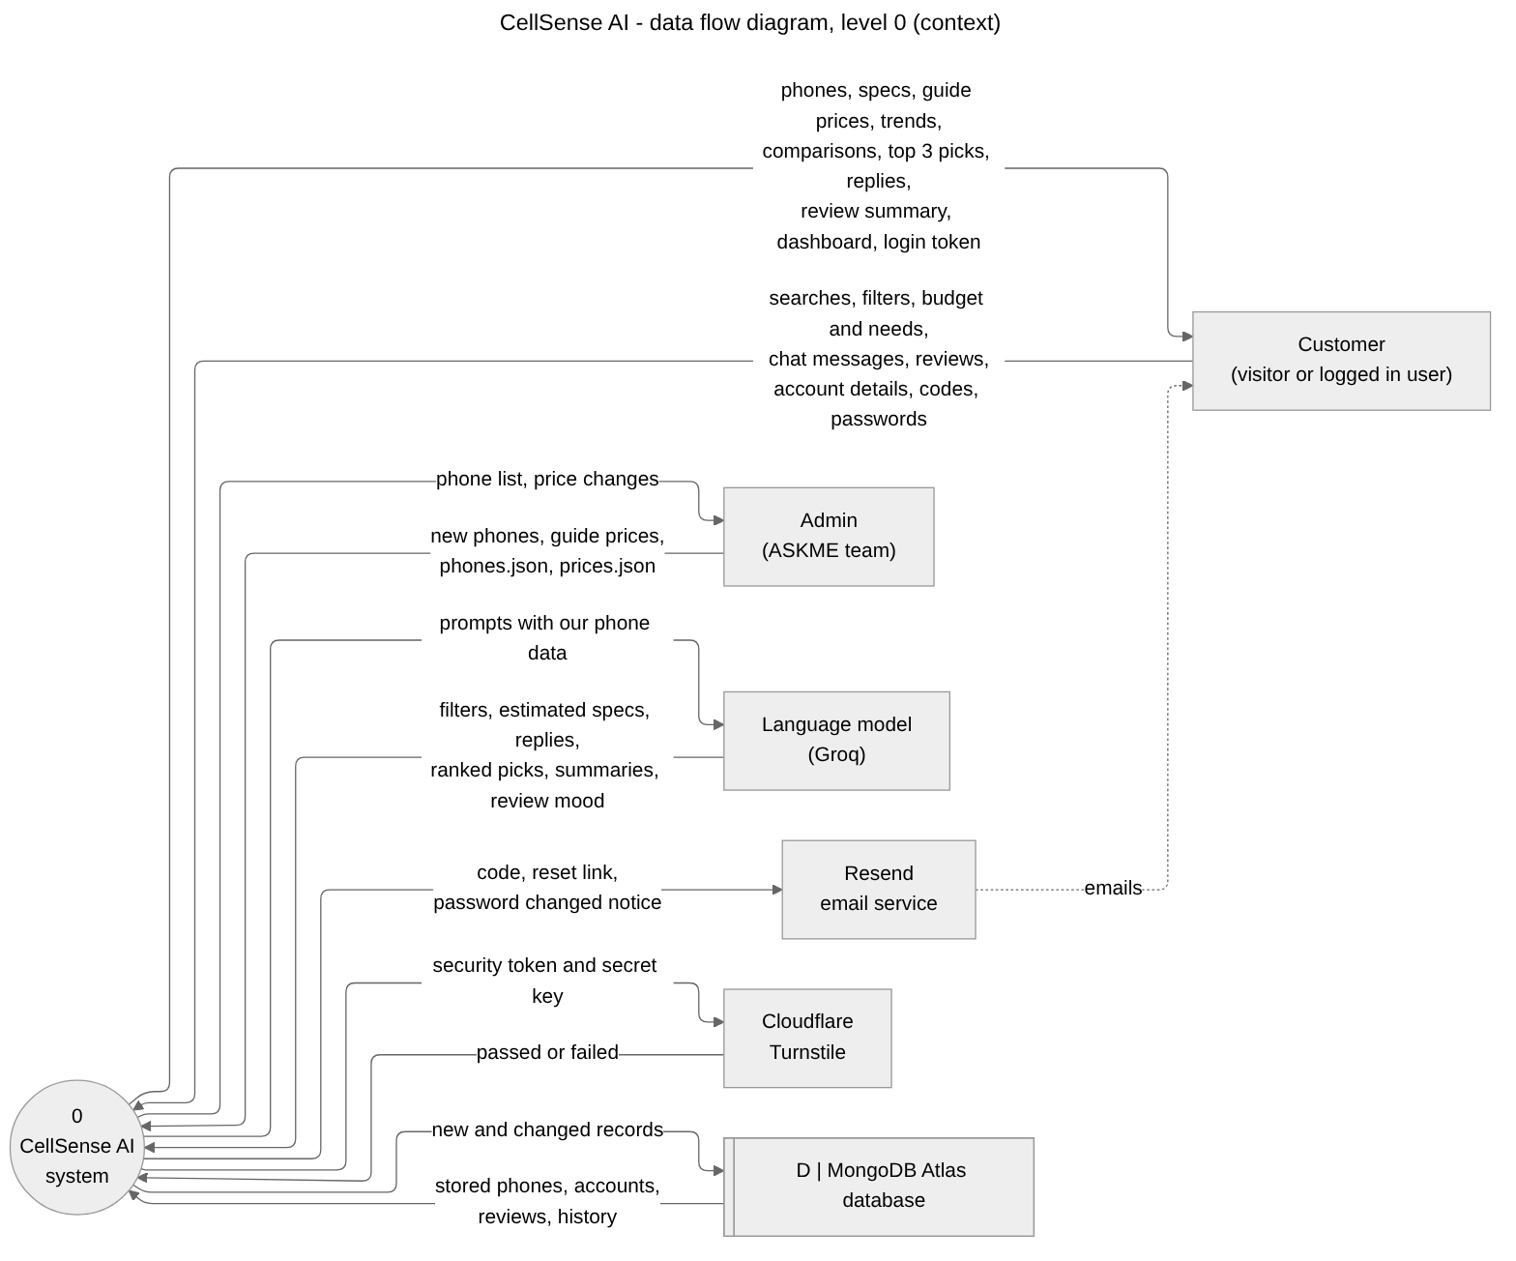
Figure 3. Level 0 data flow diagram: CellSense AI as one process, with the data that flows between it, the customer, the admin, the language model, Resend, Cloudflare Turnstile and the database.

DFD level 1, sheet A: accounts
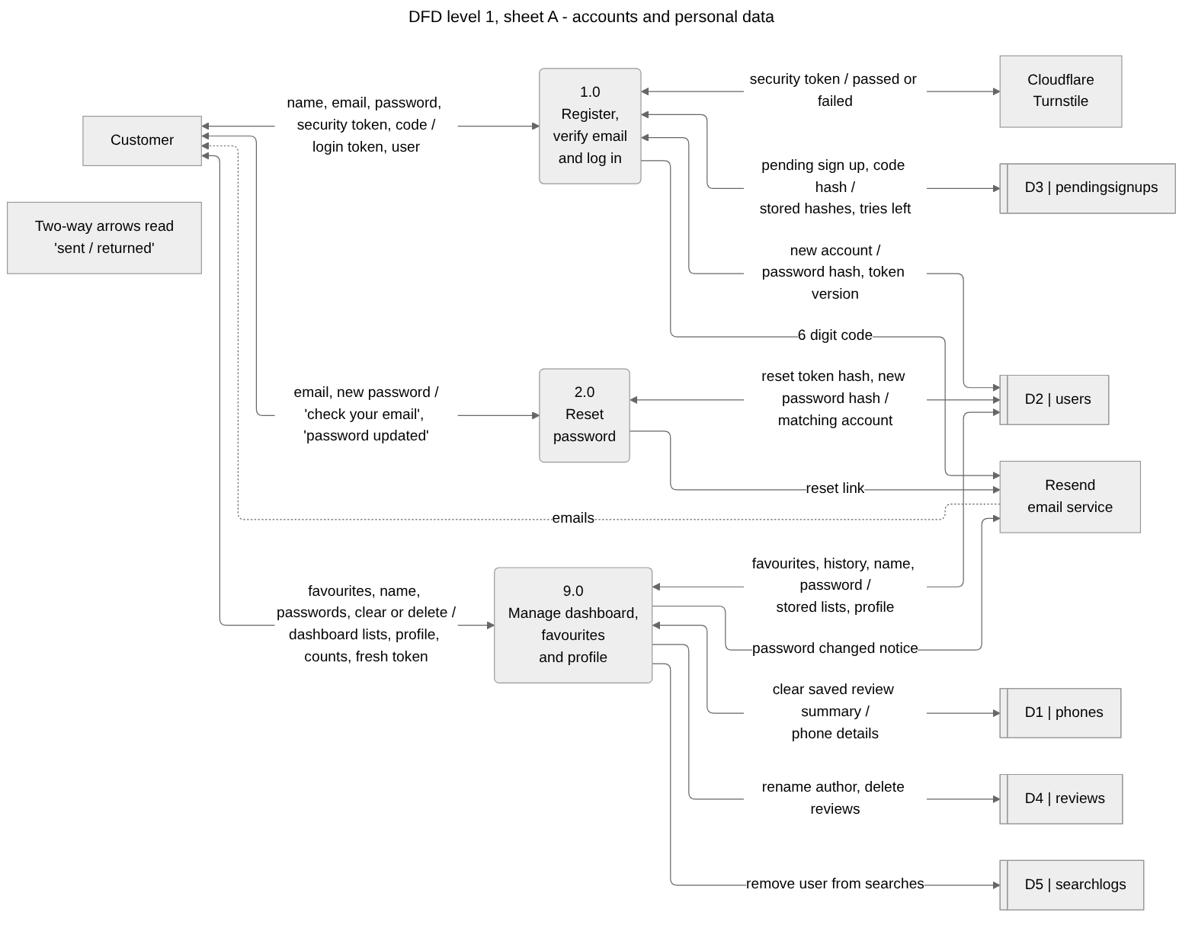
Figure 4. Level 1 data flow diagram, sheet A: registering, logging in, resetting a password and managing the dashboard and profile, with the users, pendingsignups, phones, reviews and searchlogs stores.

DFD level 1, sheet B: phones
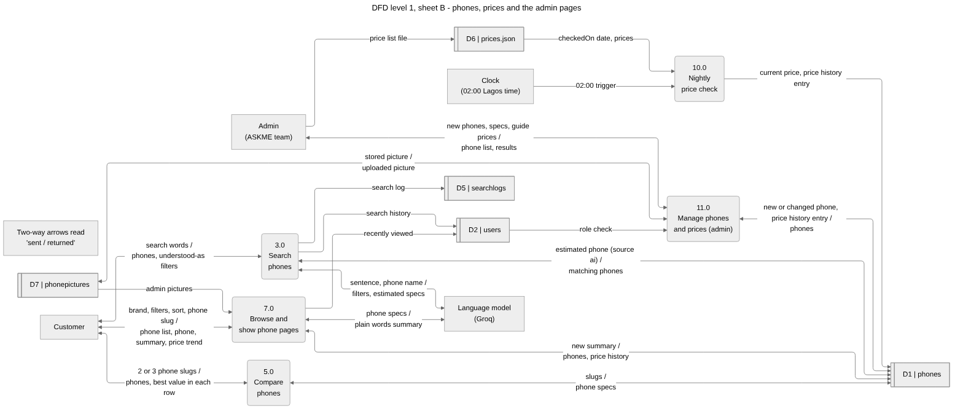
Figure 5. Level 1 data flow diagram, sheet B: searching, browsing and phone pages, comparing, the nightly price check and the admin pages, with the phones, users, searchlogs, price list and phonepictures stores.

DFD level 1, sheet C: AI help
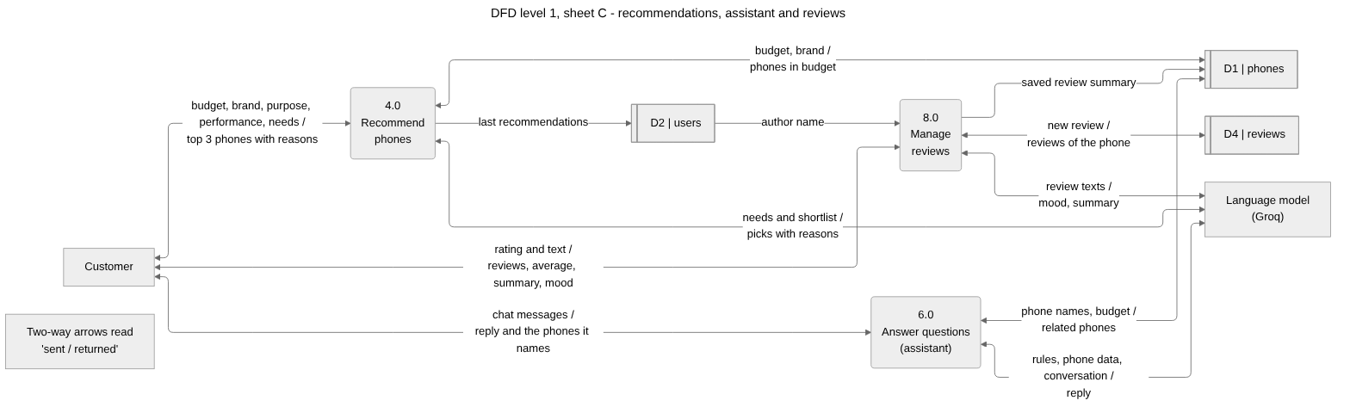
Figure 6. Level 1 data flow diagram, sheet C: recommendations, the assistant and reviews, with the language model and the phones, users and reviews stores.

3.2 Flowcharts
There is one flowchart for each main activity on the site. They all use the same shapes. A rounded shape is a start or end point, a rectangle is a step, and a diamond is a decision with the answer written on each arrow. A cylinder is a database collection being read or written, and a slanted box is what the person types. A rounded shape with a dashed border is an error, shown with the exact message the person sees. A box joined by a dotted line is a note.

How every request travels
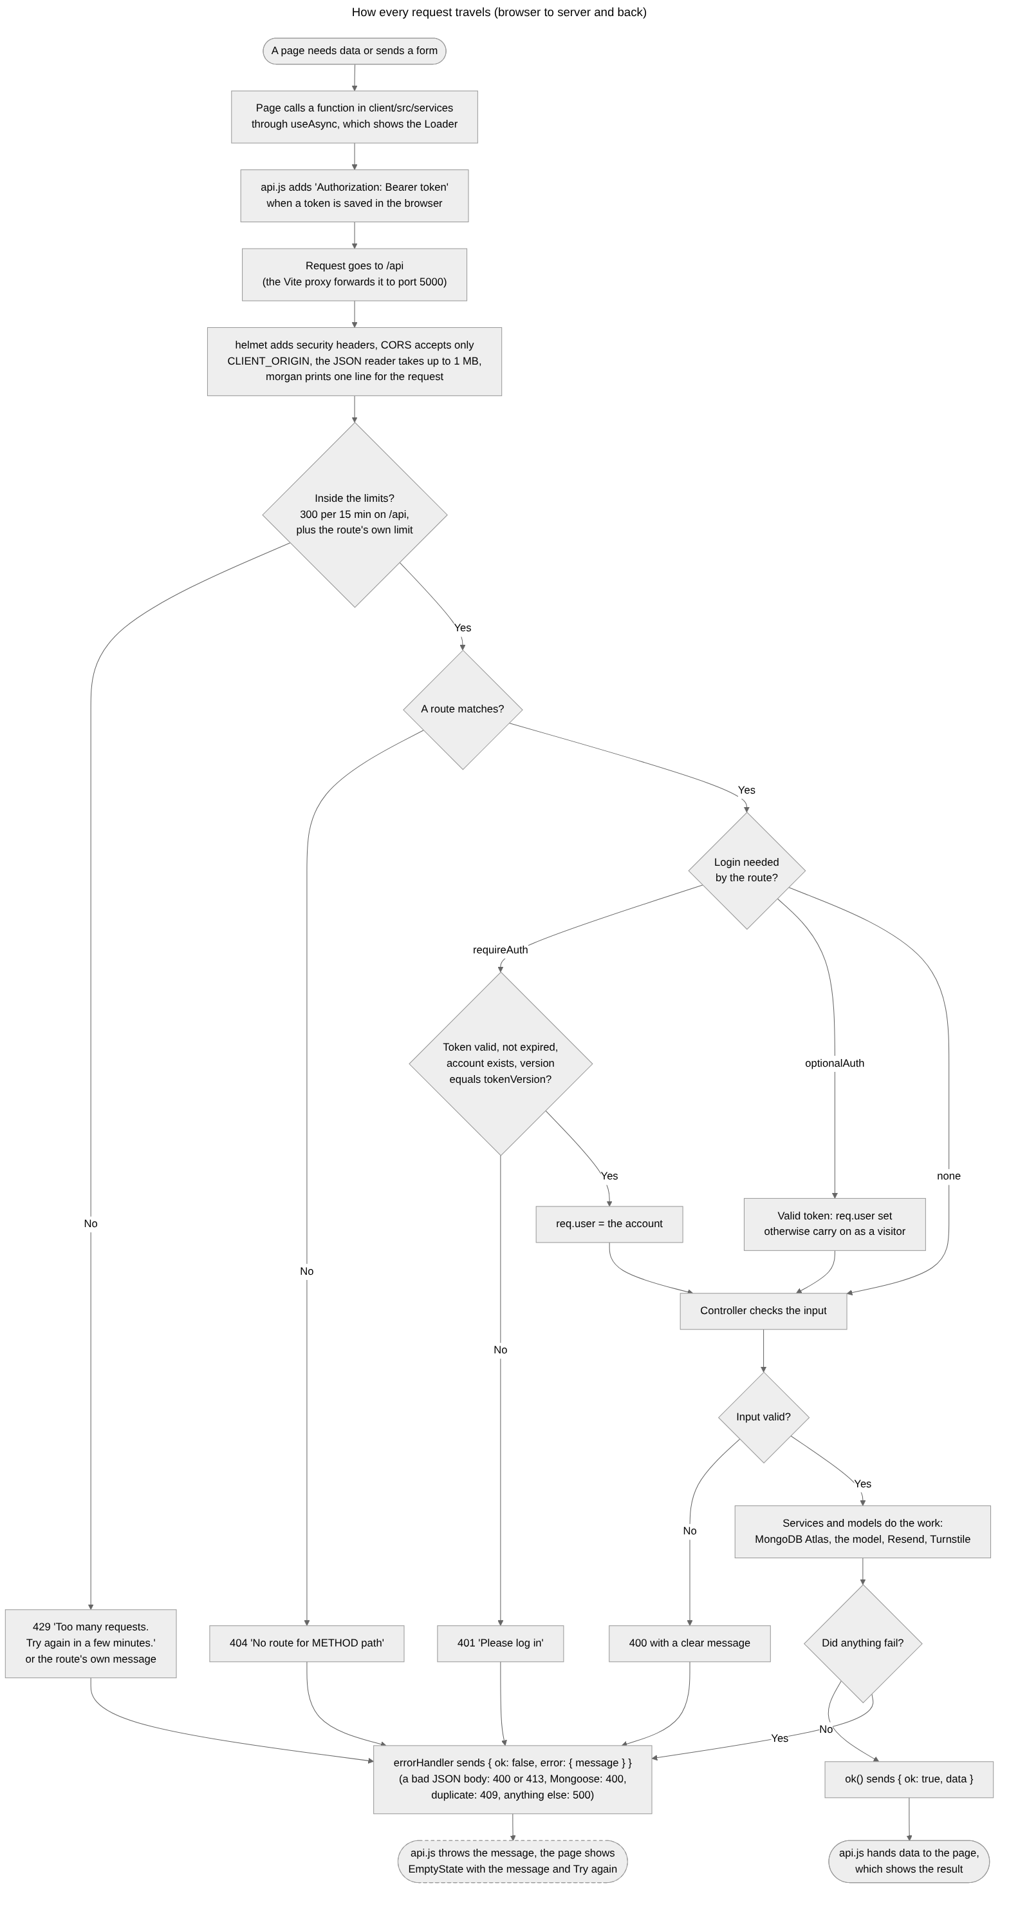
Figure 7. How every request travels: the service function and token in the browser, the security, size and rate limits, the route, the login check, the controller, and the success or error envelope back to the page.

Create account
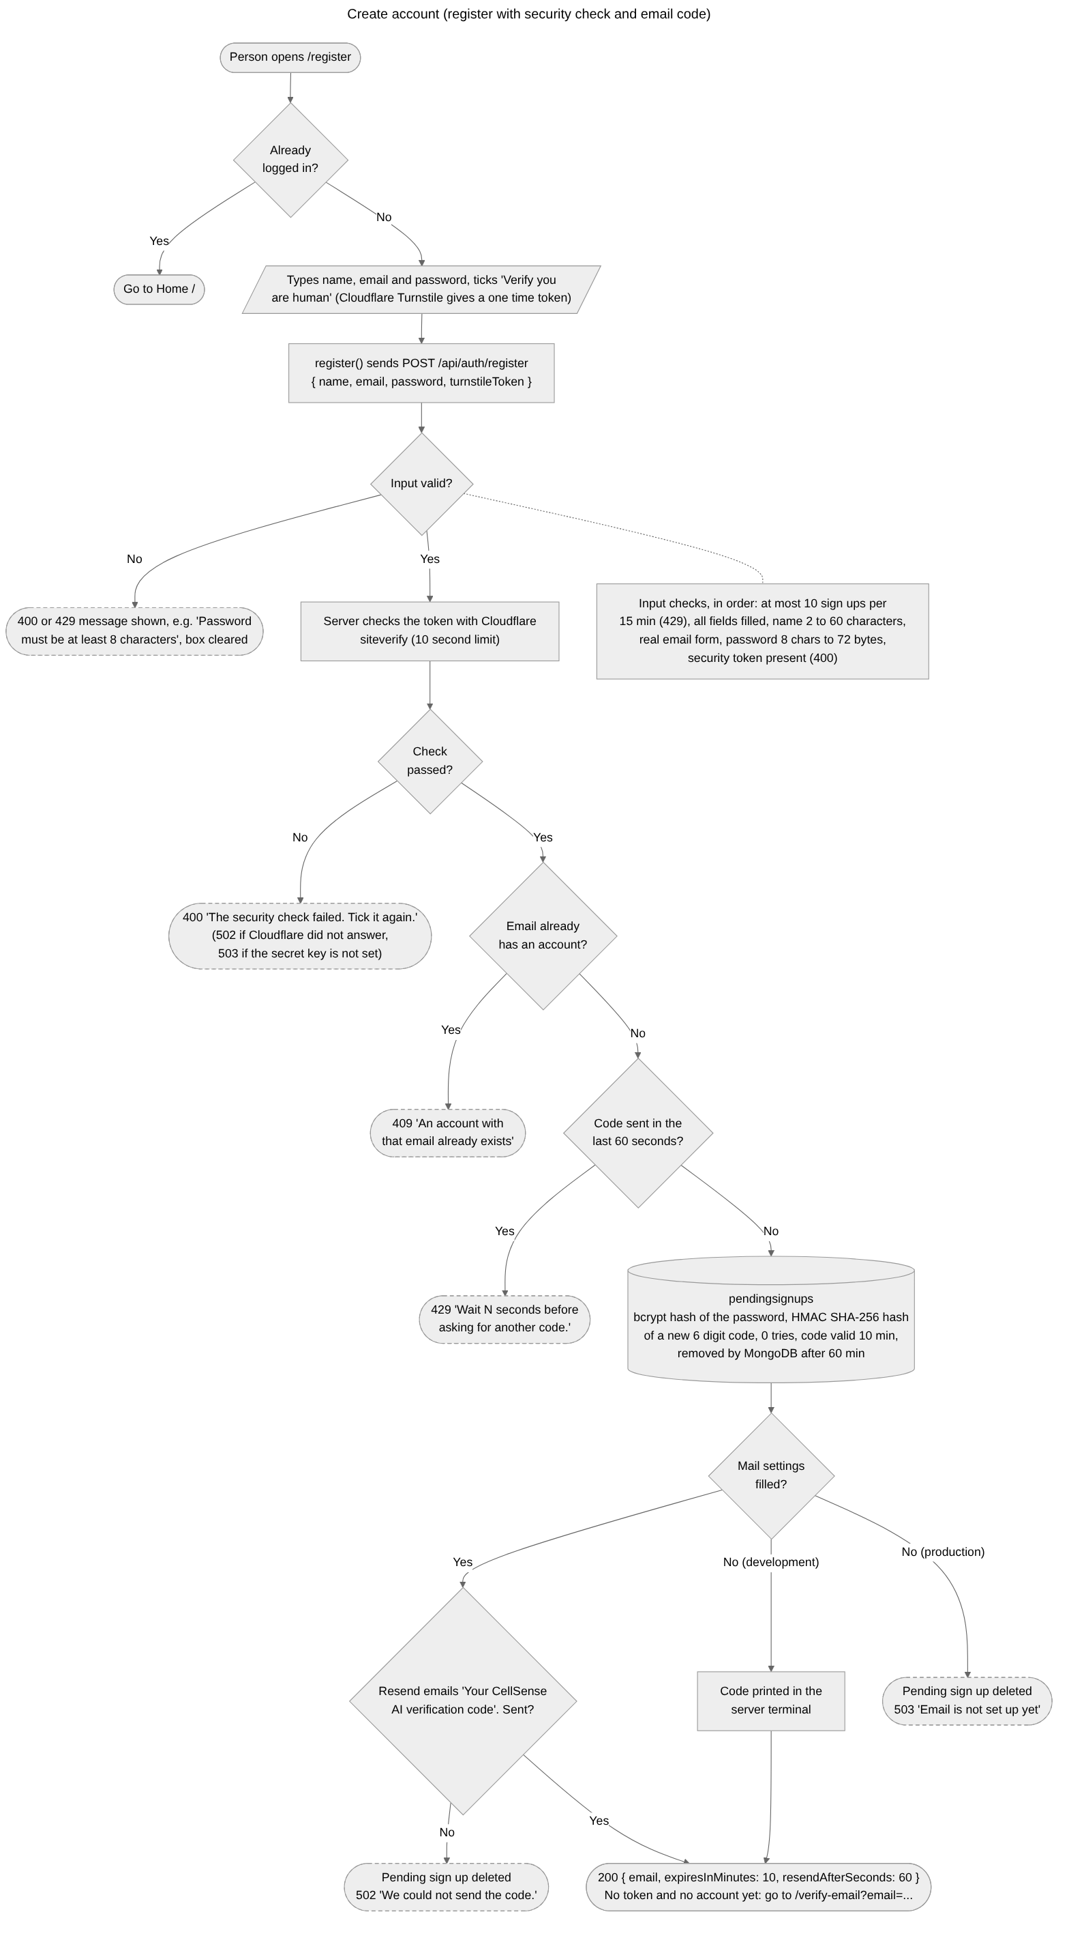
Figure 8. Create account: the Cloudflare Turnstile check, the input checks, the pending sign up with the bcrypt and HMAC hashes, and the 6 digit code emailed through Resend (no account until the code is confirmed).

Verify email and send a new code
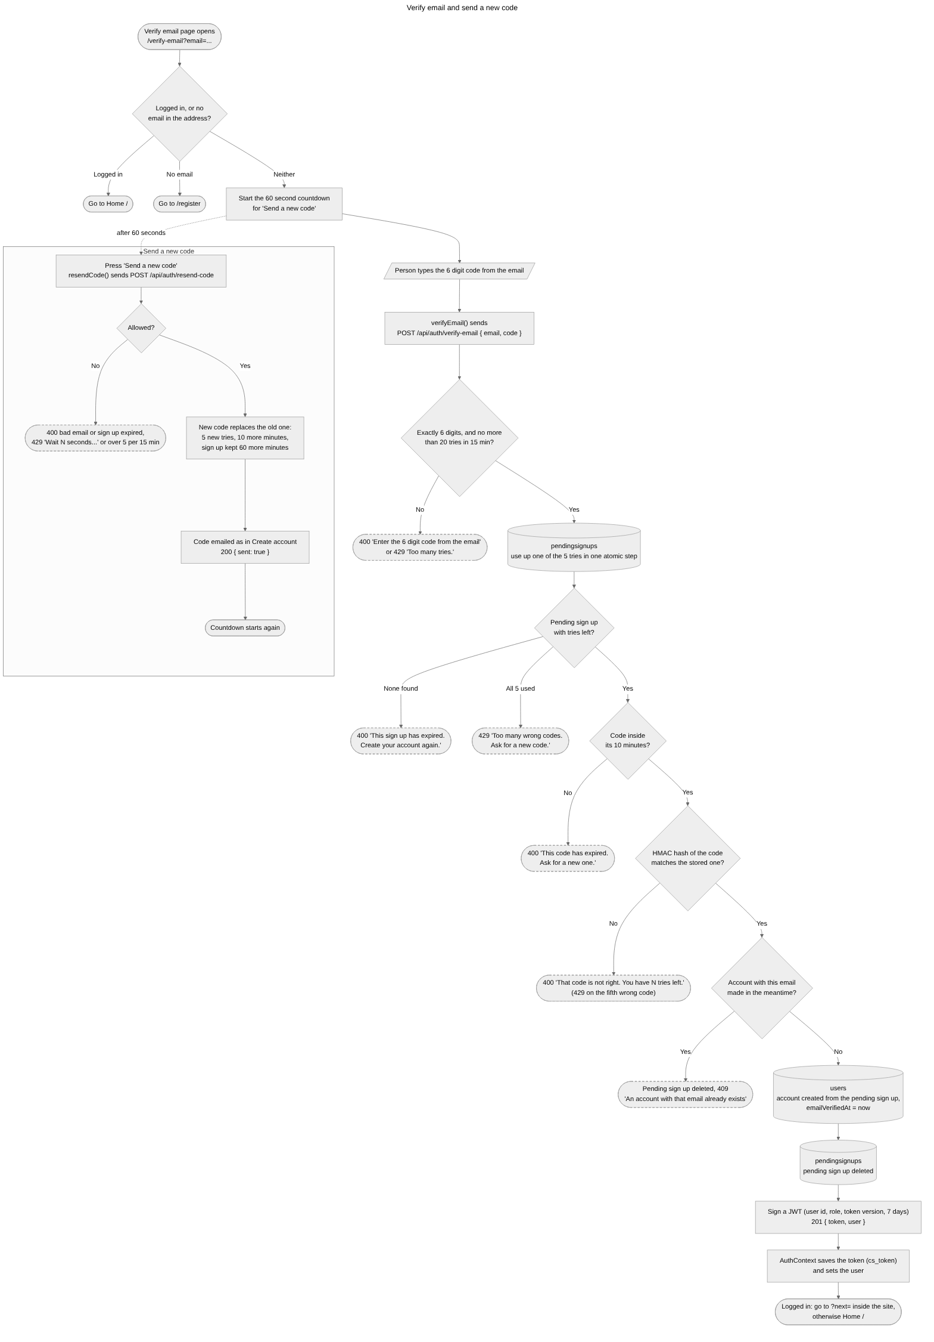
Figure 9. Verify email: the 6 digit code checked against its HMAC hash with five tries and a 10 minute limit, the account created and logged in, and the 'Send a new code' path after 60 seconds.

Log in
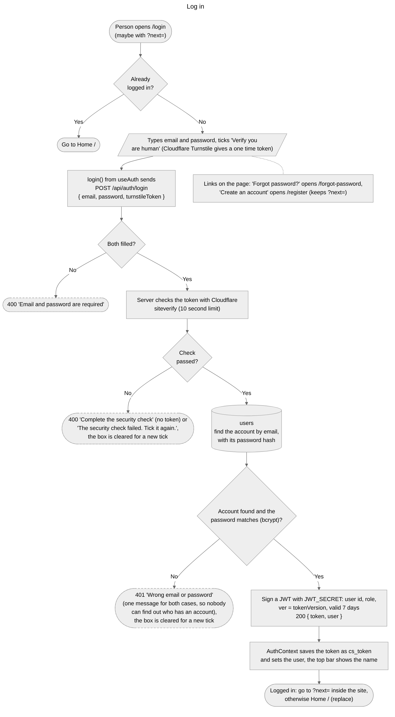
Figure 10. Log in: the Cloudflare Turnstile check, the email and password checked against the bcrypt hash, one message for a wrong email or password, and the JWT that lasts seven days and carries the token version.

Staying logged in and log out
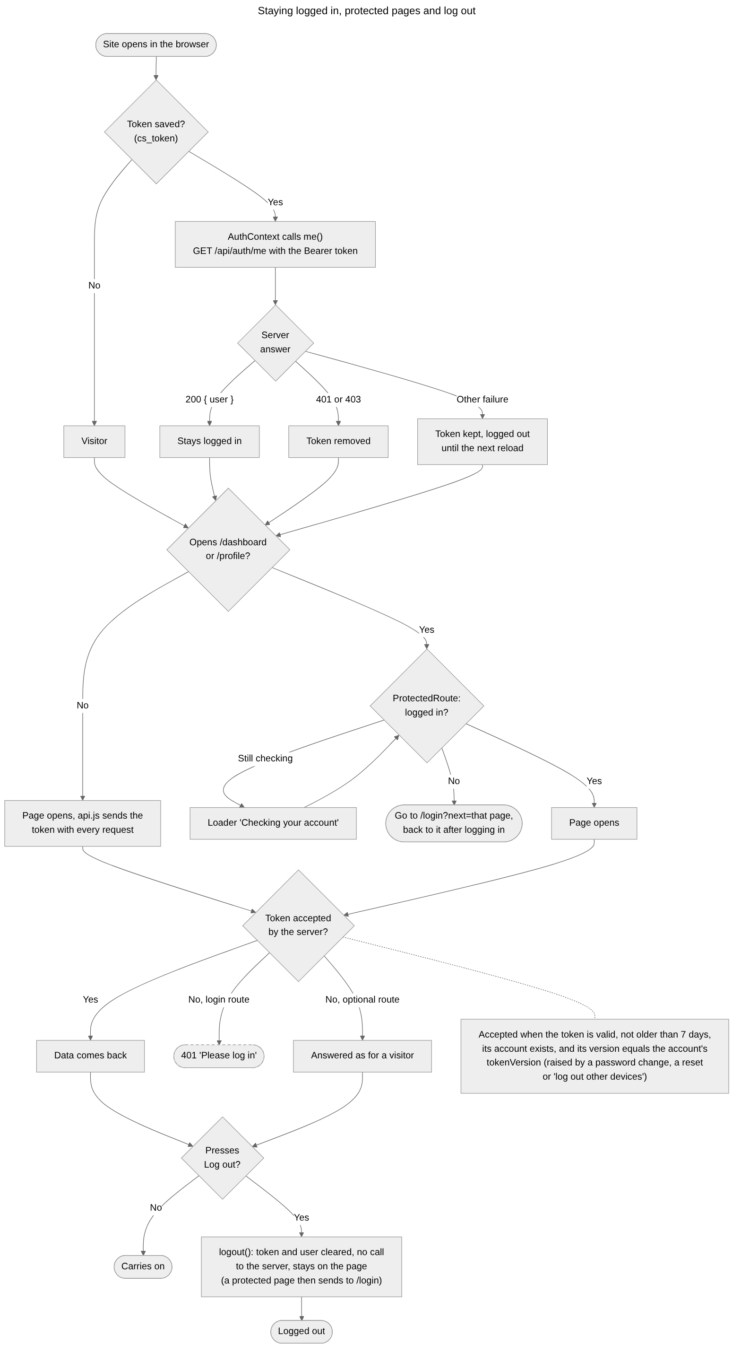
Figure 11. Staying logged in: the saved token checked with GET /api/auth/me when the site opens, ProtectedRoute on the Dashboard and Profile, the token check on every request, and log out.

Forgot and reset password
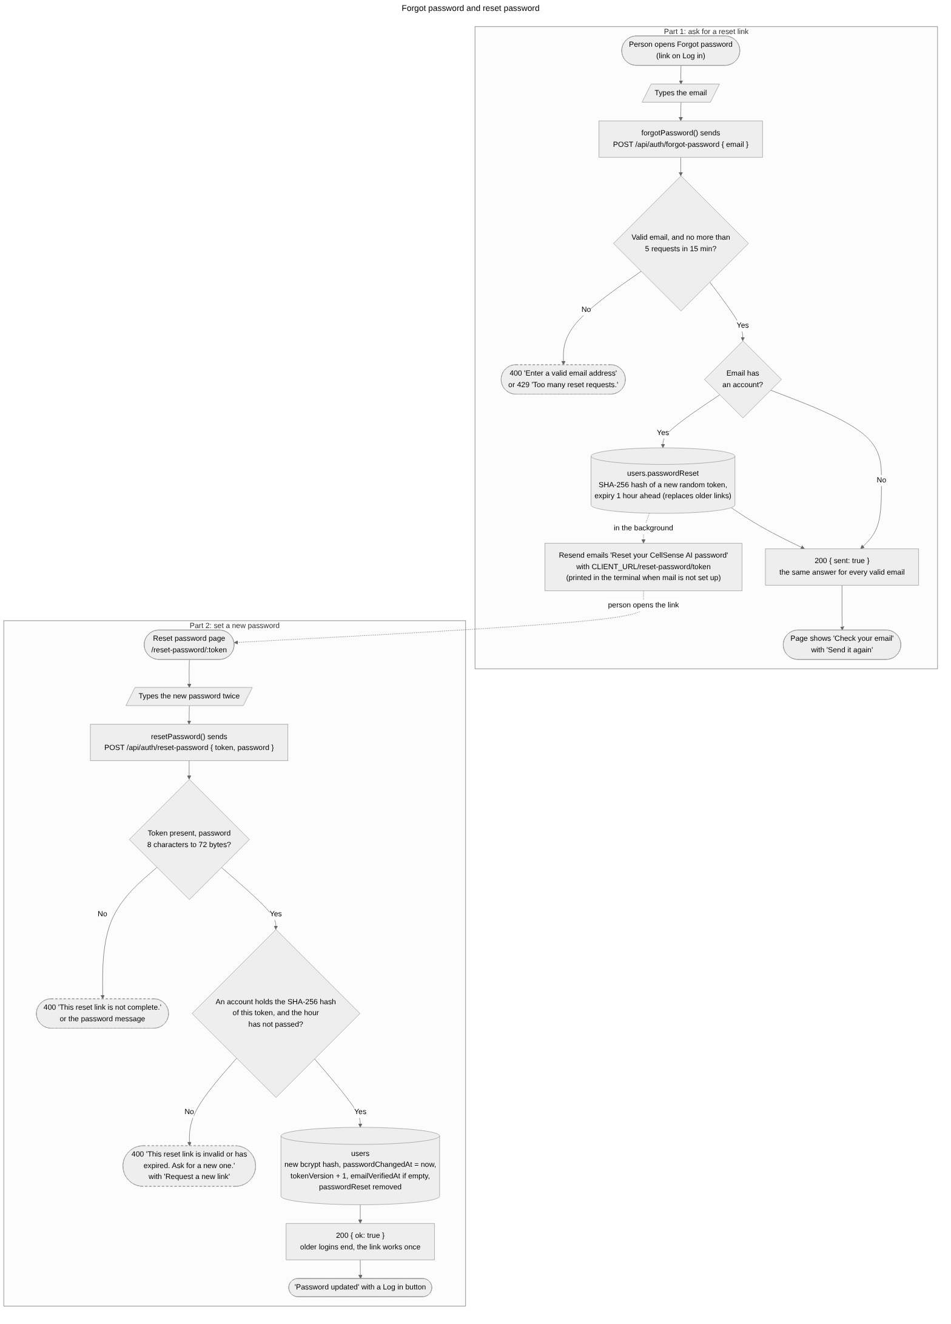
Figure 12. Password reset: the same answer for every valid email, the SHA-256 hash of the token with a one hour expiry, the email link, and the new bcrypt hash that ends every older login so the link works once.

Smart search, part 1
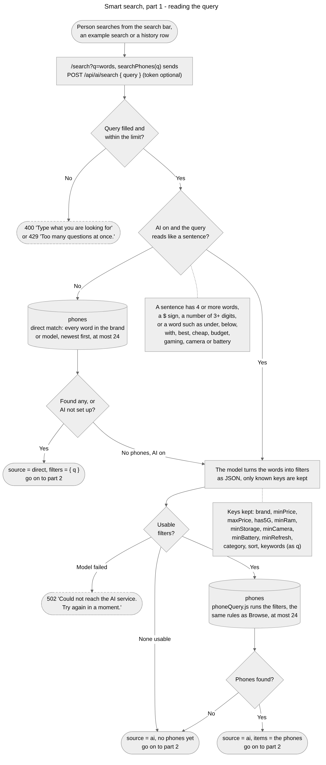
Figure 13. Smart search, part 1: the direct match on brand and model, the sentence rule, and the model turning a sentence into filters that run as the same database search as Browse.

Smart search, part 2
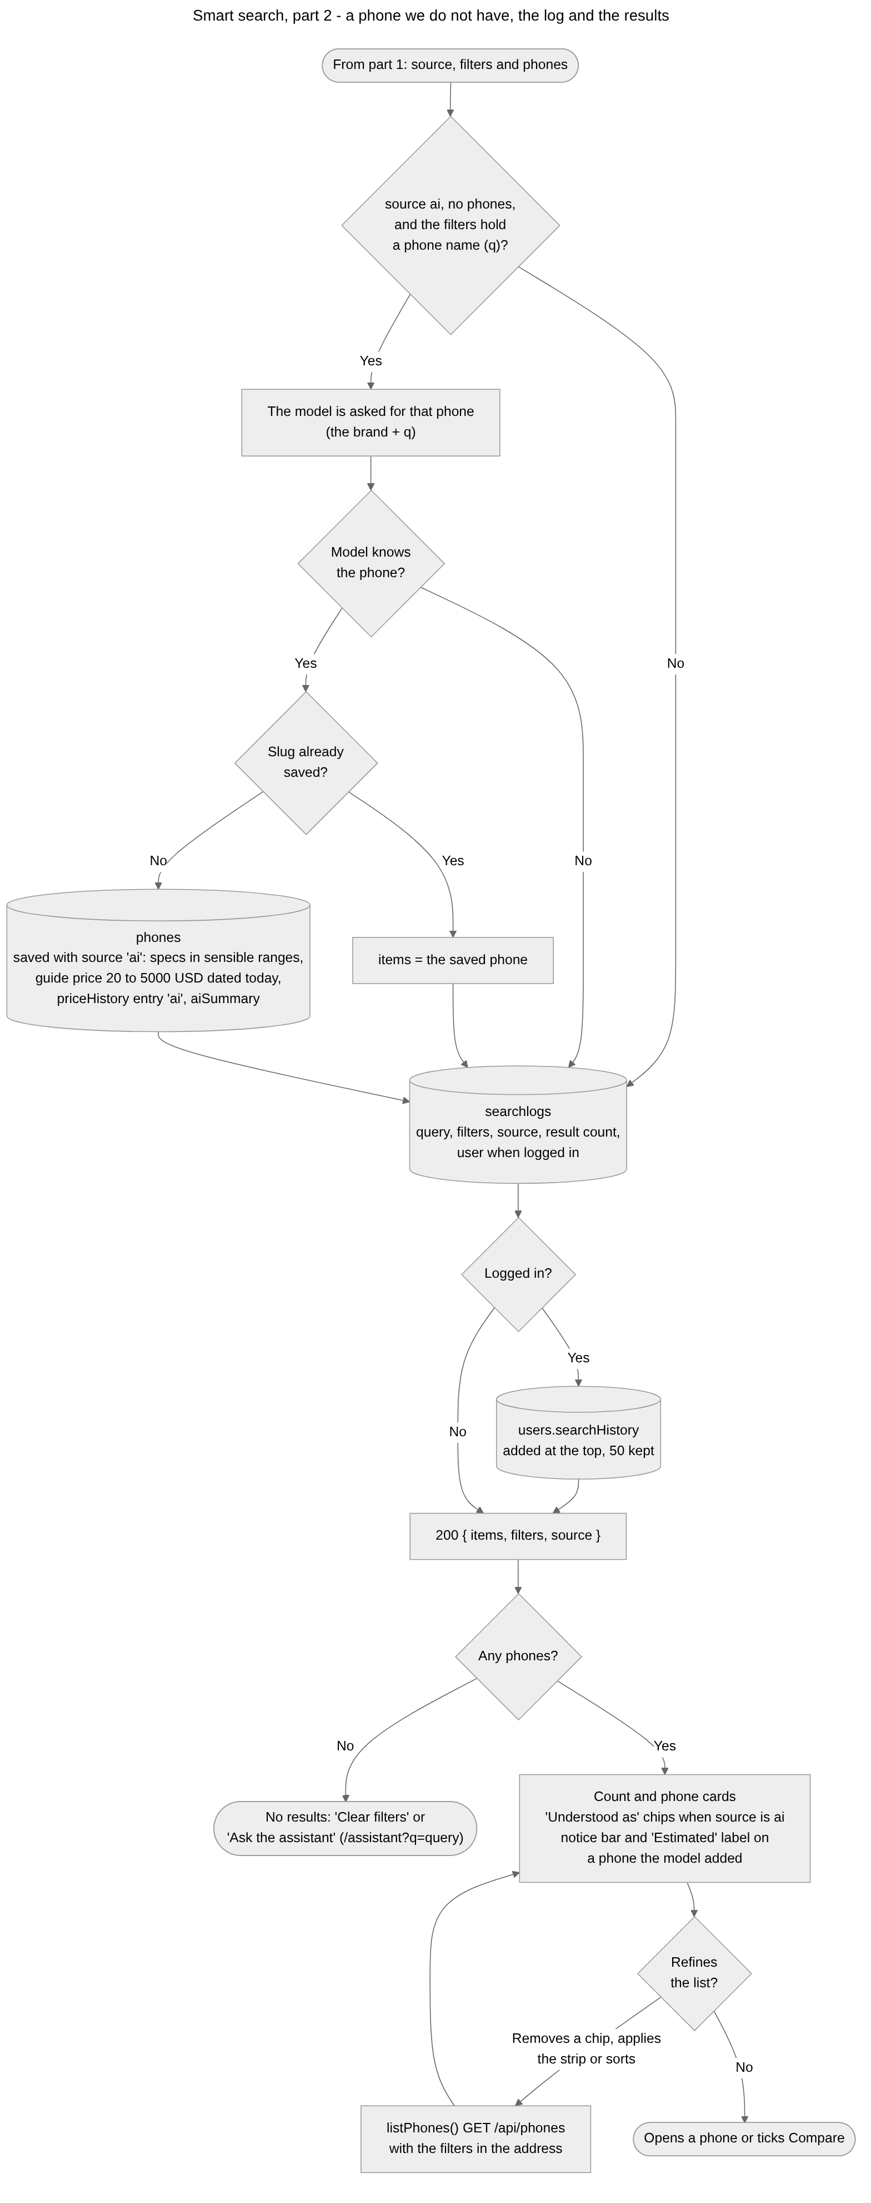
Figure 14. Smart search, part 2: the model supplying a phone we do not hold (saved with source ai and shown as Estimated), the search log and history, and the results page with its chips and filters.

Browse
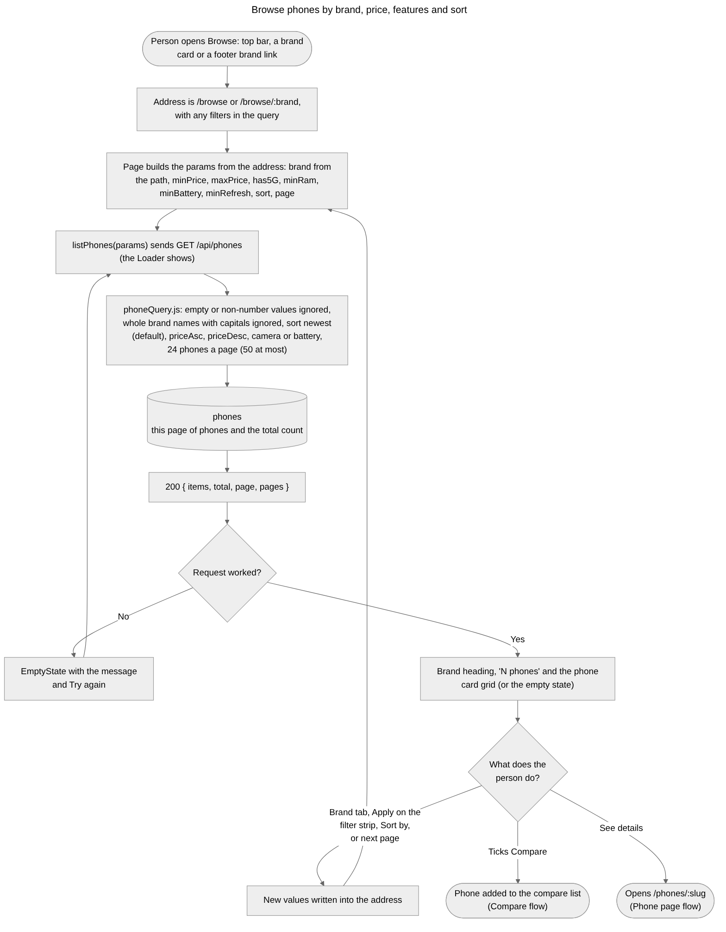
Figure 15. Browse: the brand, filters, sort and page read from the address, one MongoDB query through phoneQuery.js, 24 phones a page, and the list reloading whenever the address changes.

Open a phone page
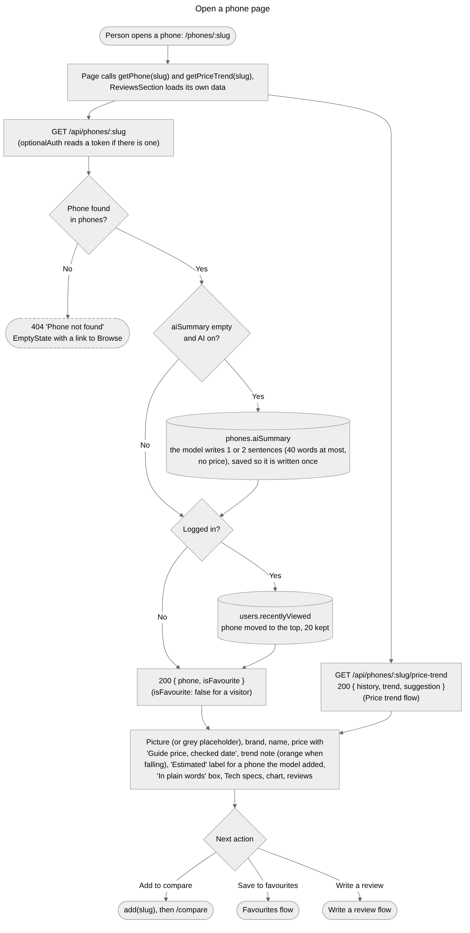
Figure 16. Phone page: the phone fetched by slug, the plain words summary written once by the model, the visit added to recently viewed, the price trend, and what the page shows.

Price trend
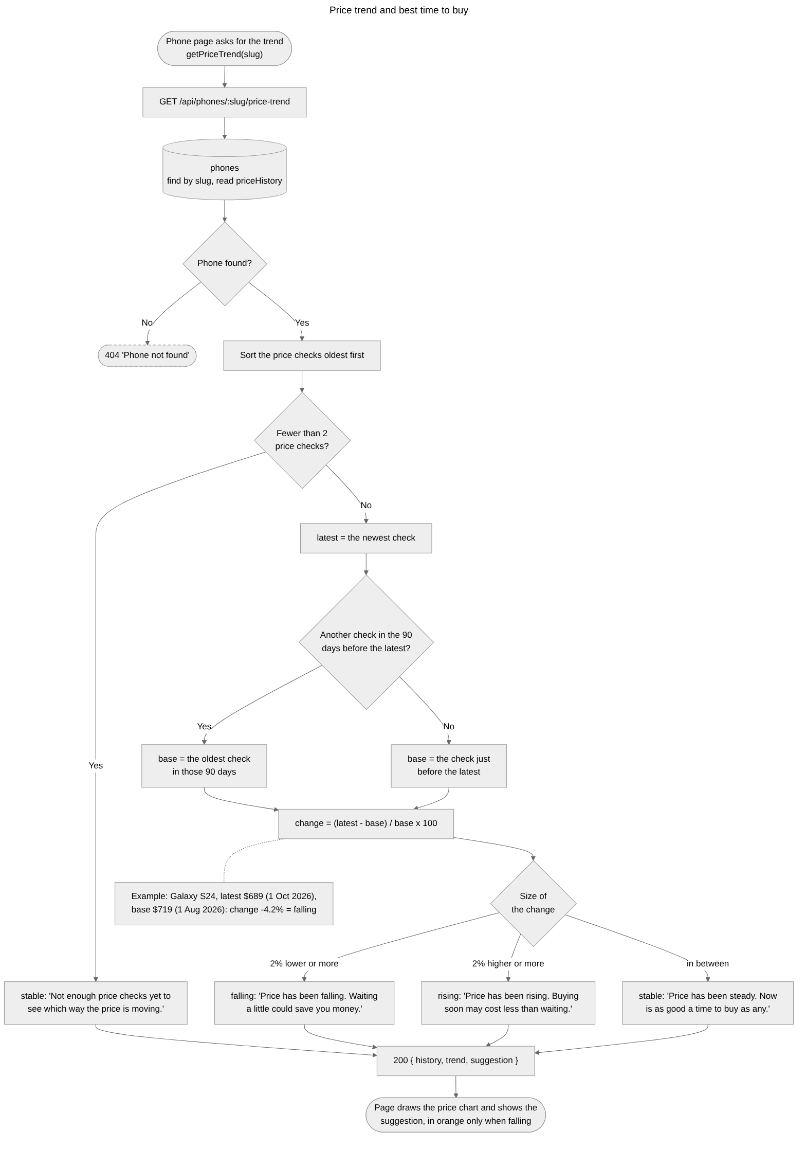
Figure 17. Price trend: the latest price compared with the oldest check in the 90 days before it (or the check just before it), a change of two percent or more read as falling or rising, and the best time to buy note.

Save and remove a favourite
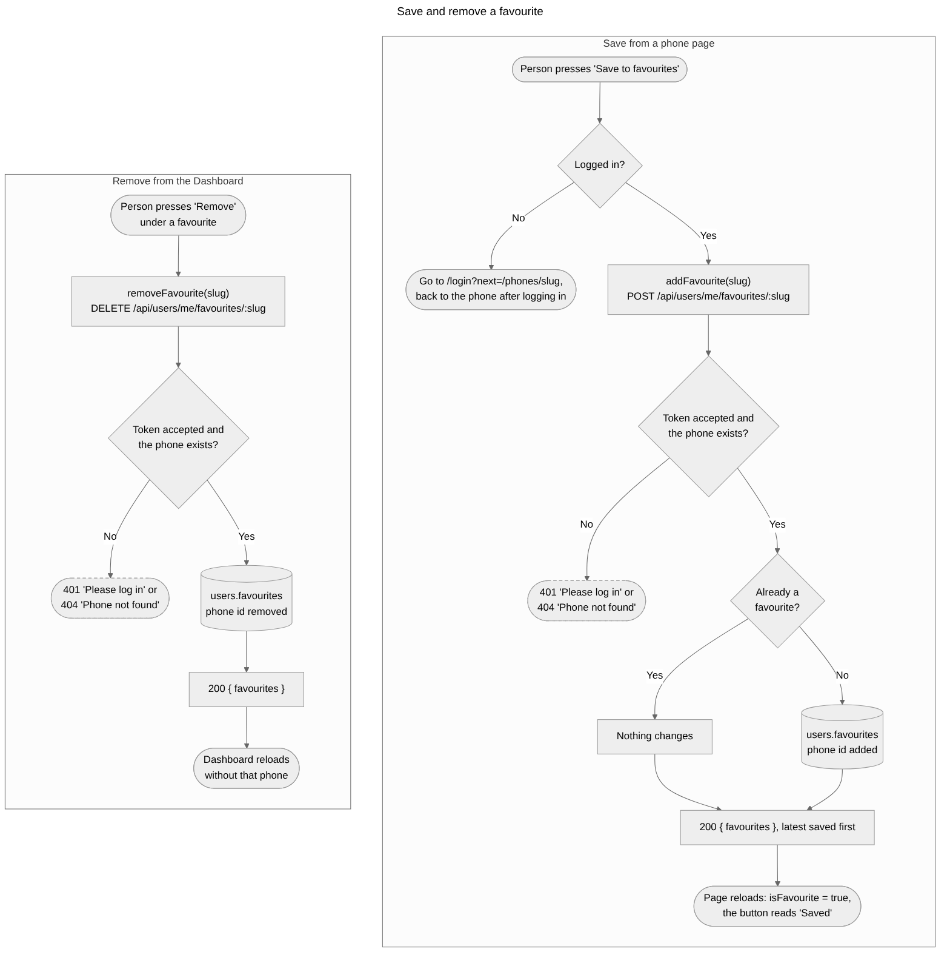
Figure 18. Favourites: saving a phone from its page (login needed, each phone once) and removing it from the Dashboard, both answering with the whole favourites list.

Compare phones
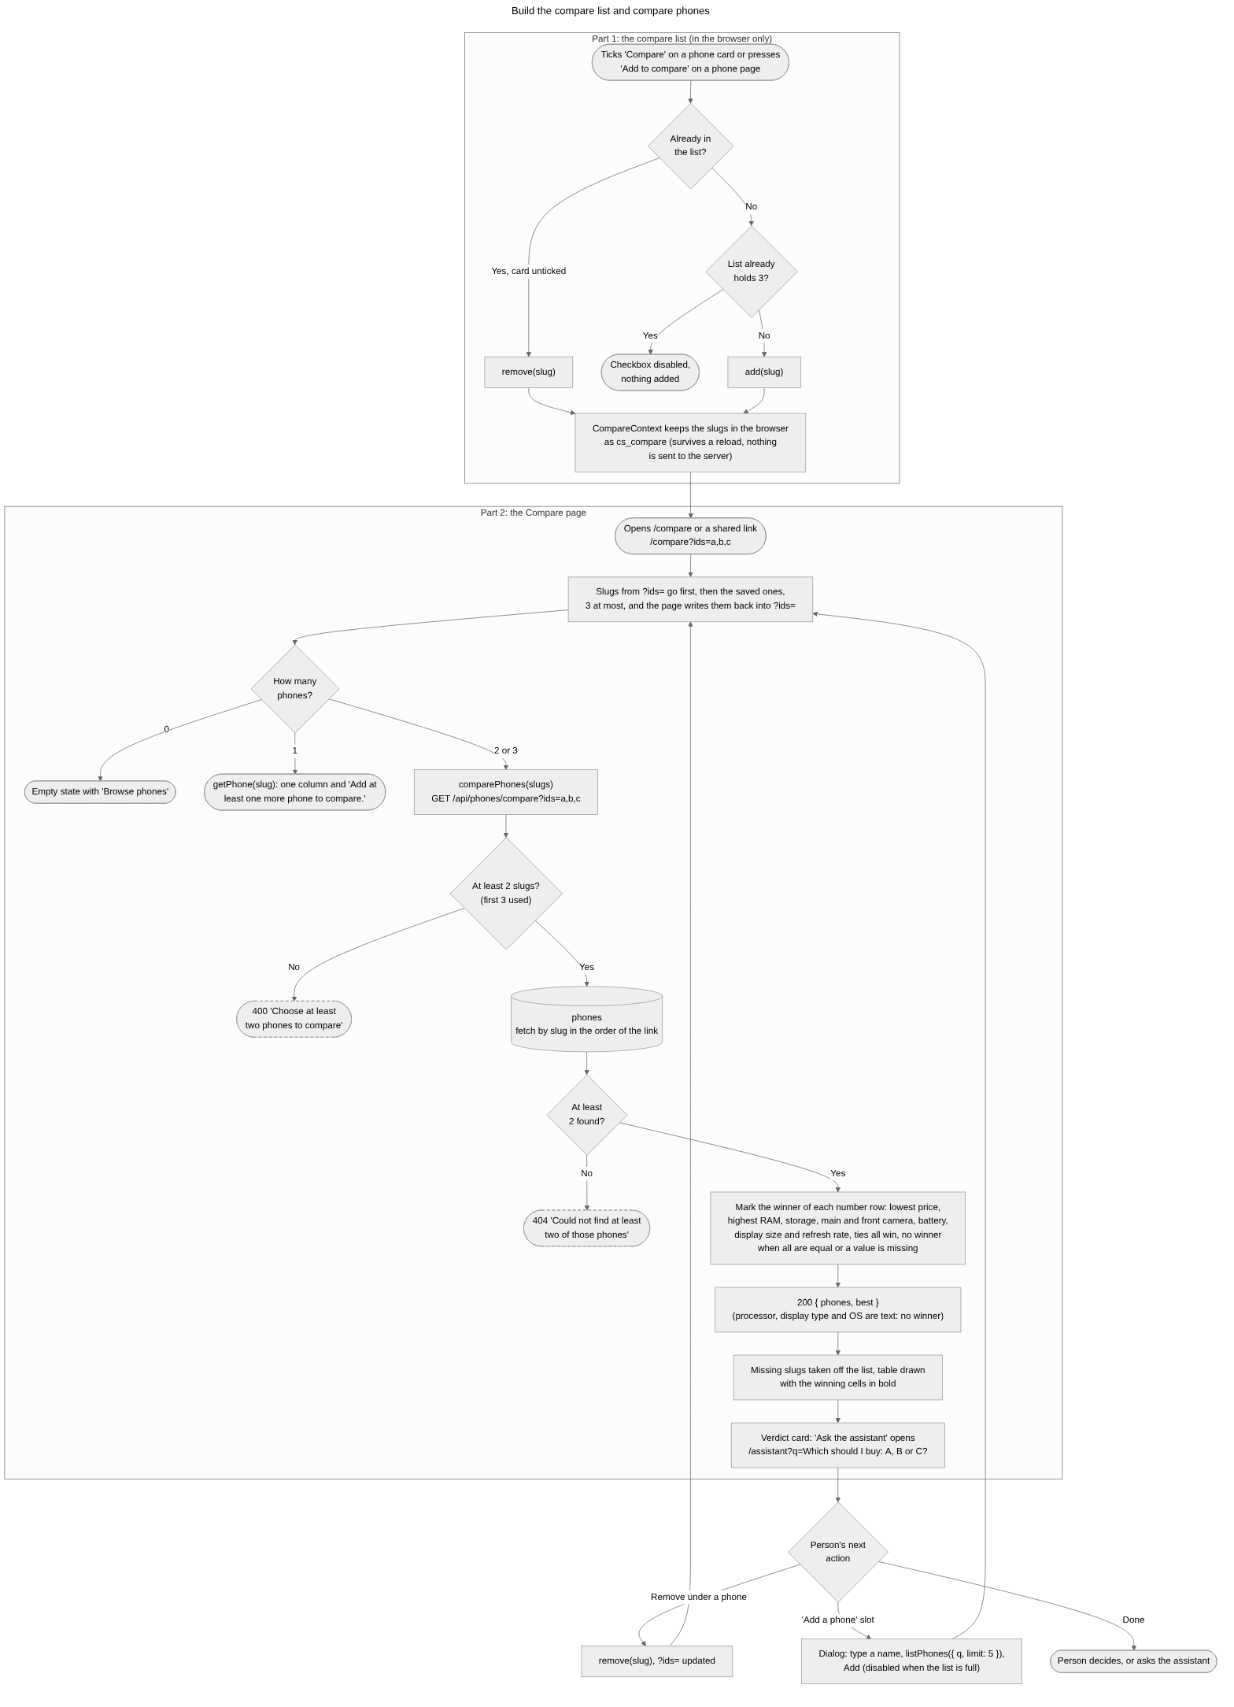
Figure 19. Compare: the compare list of up to three slugs kept in the browser, the phones fetched in the order of the link, the winner of each number row (ties all win), and the text rows with no winner.

Get a recommendation
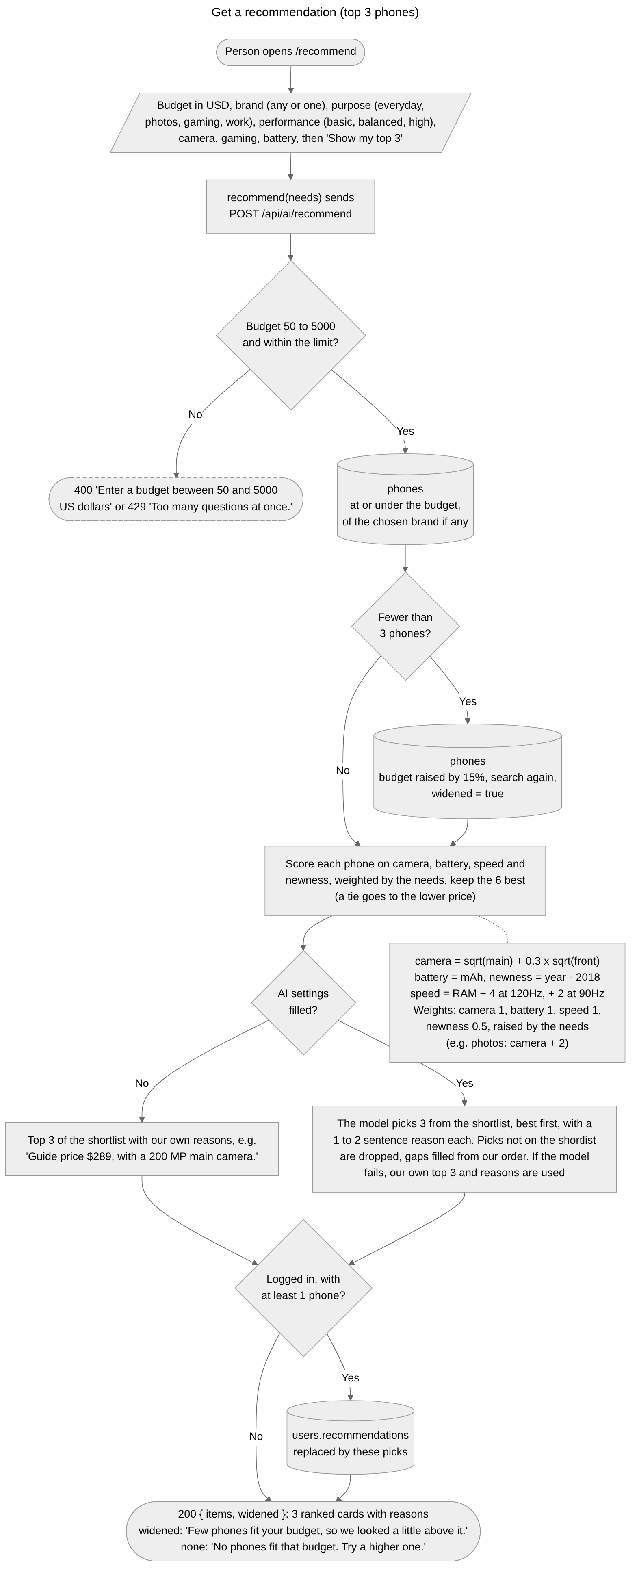
Figure 20. Recommendation: the shortlist from MongoDB inside the budget and brand (budget raised by 15 percent when fewer than three fit), scored by our own rules, ranked by the model with a reason each, and saved to the dashboard when logged in.

Ask the assistant
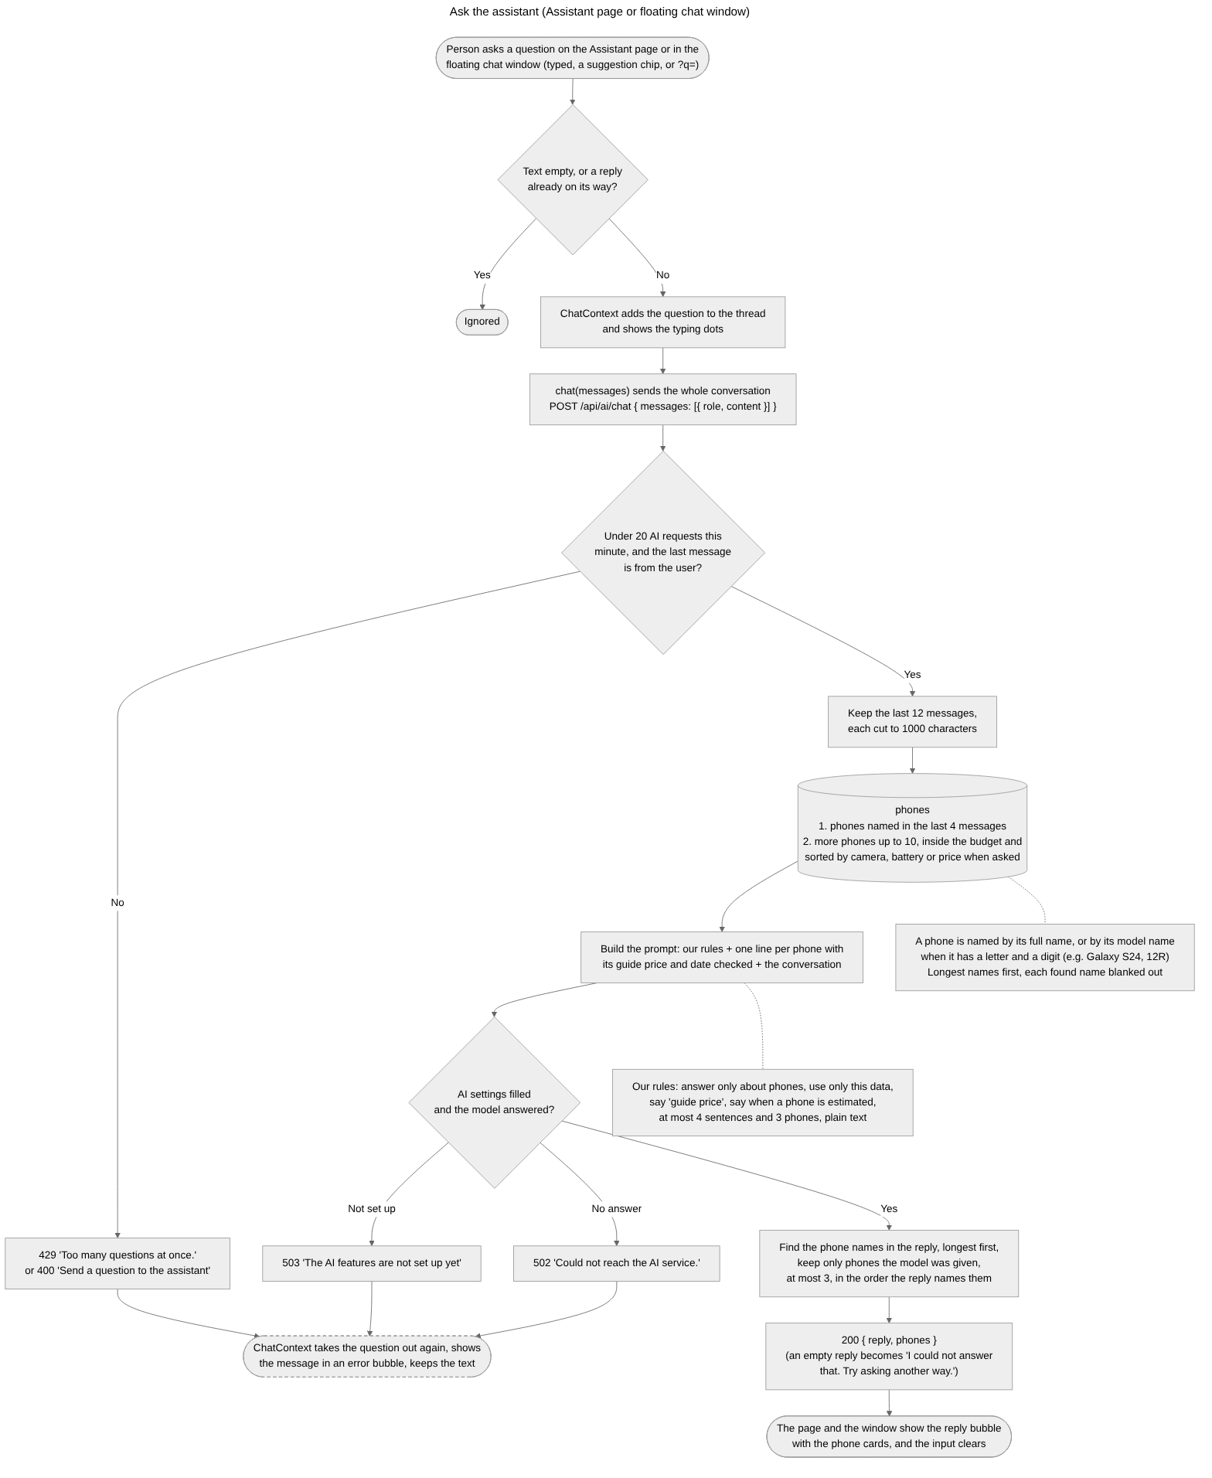
Figure 21. The assistant: the last 12 messages, the related phones pulled from MongoDB, the prompt built from our rules and phone data, the call to the model, and the reply returned with at most three phones it names.

Write a review
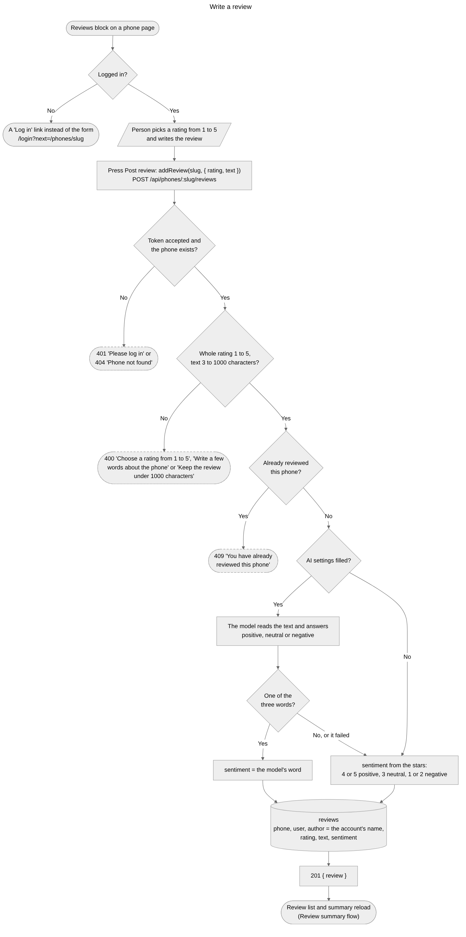
Figure 22. Write a review: login required, the rating and text checks, one review per person per phone, and the mood judged by the model or set by the stars.

Review summary
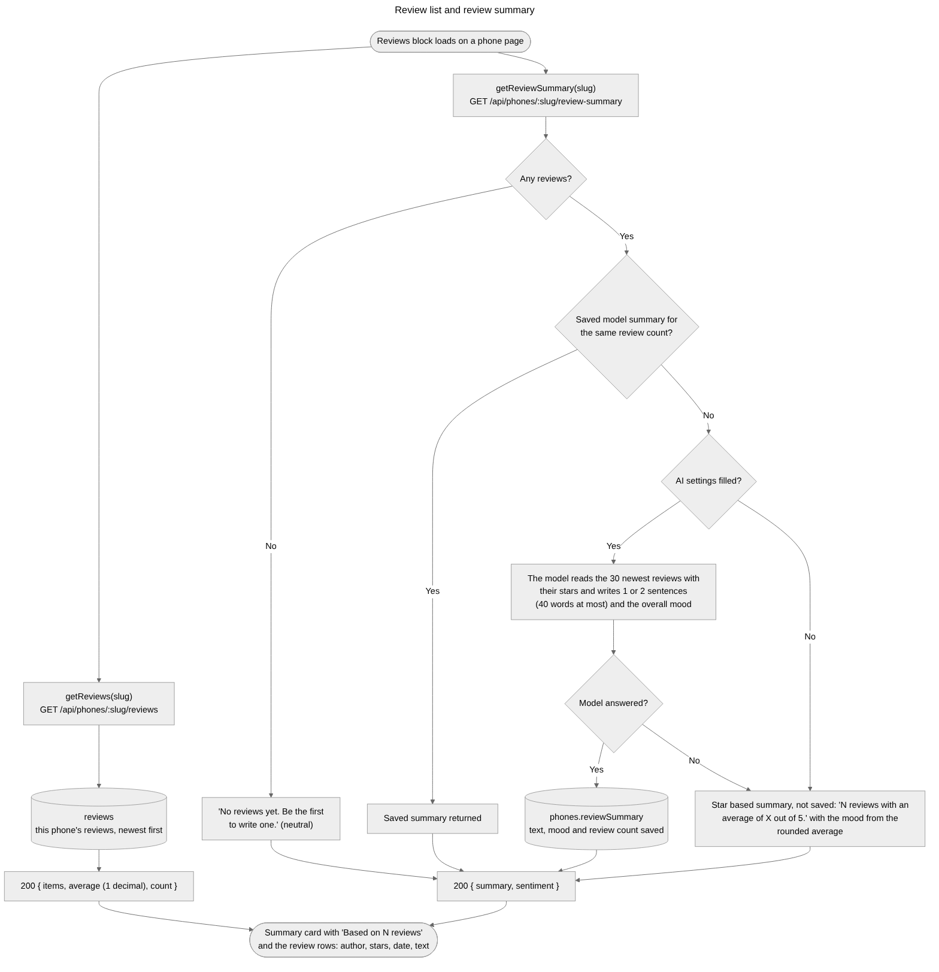
Figure 23. Review summary: the review list with its average, and the summary written by the model (saved and reused while the number of reviews stays the same) or the star based summary when the model is not set up.

Personal dashboard
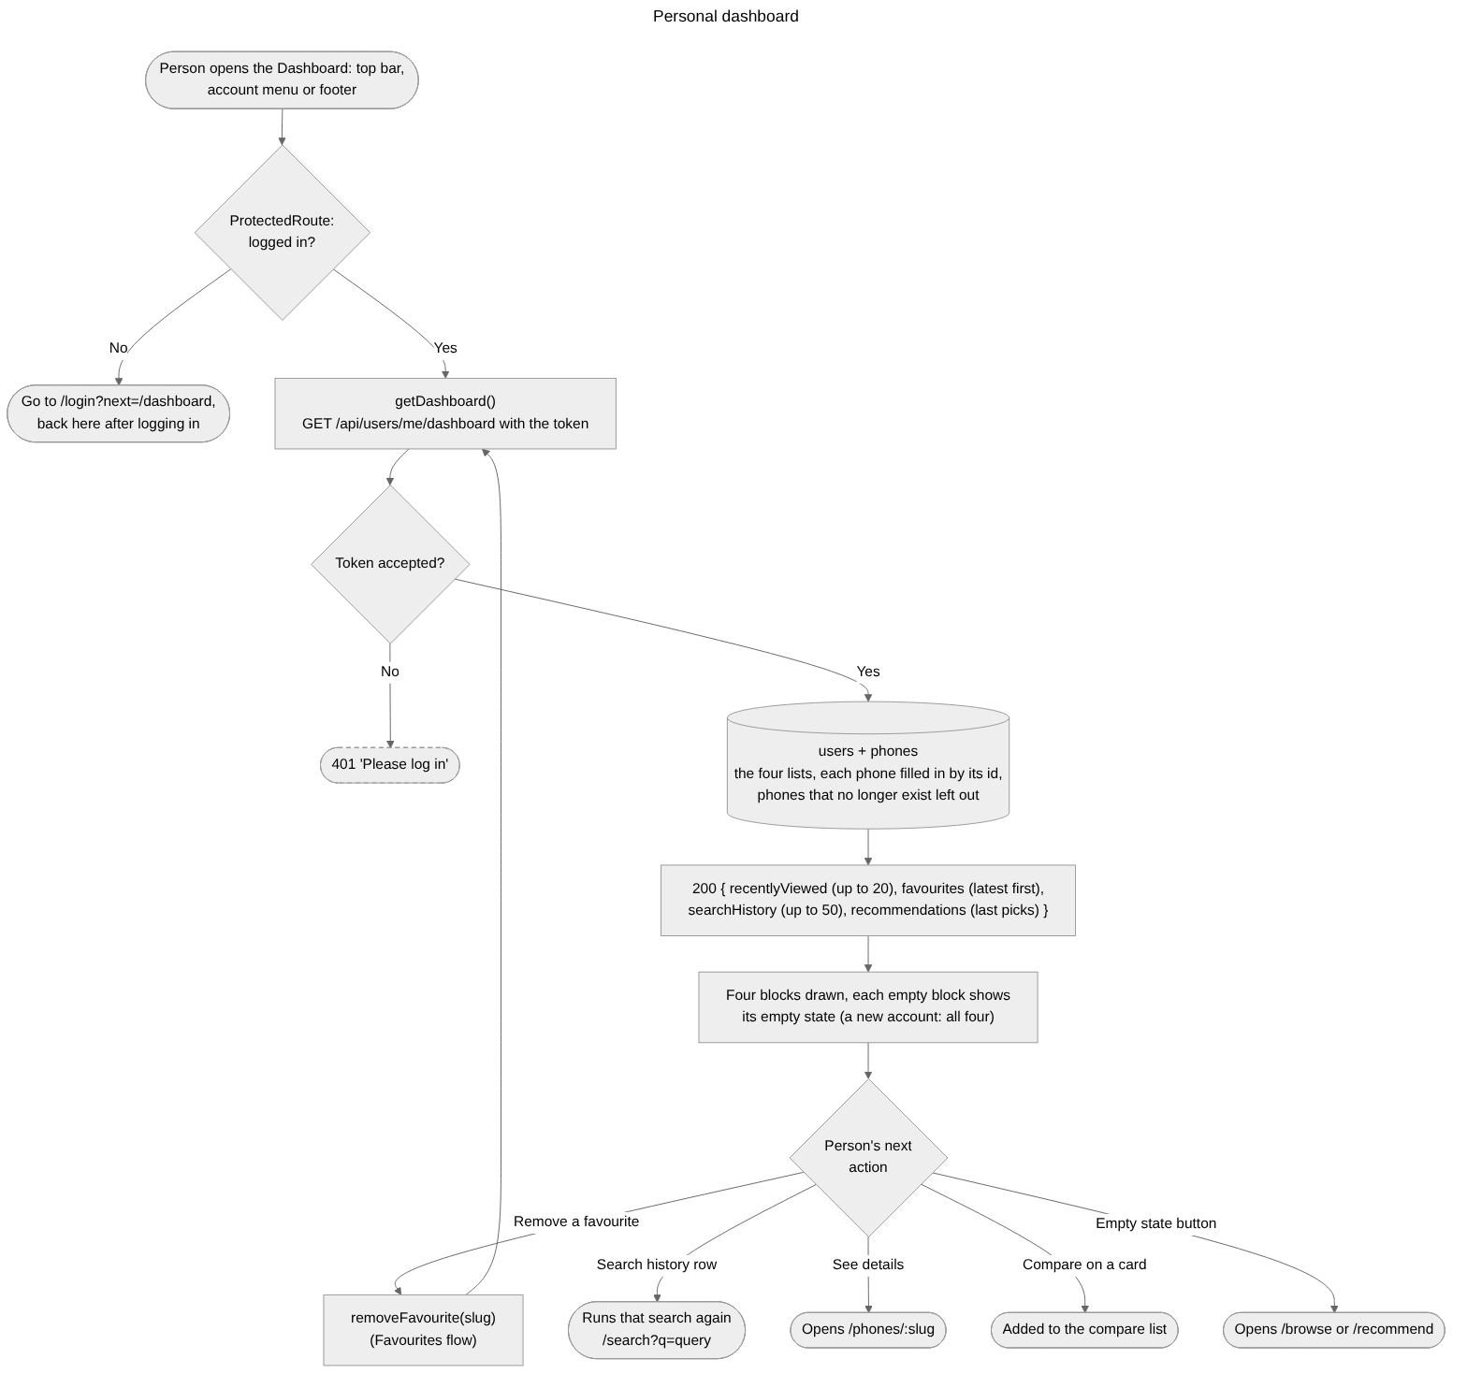
Figure 24. Dashboard: the login guard, the four lists (recently viewed, favourites, search history and the last recommendations) read from the user with each phone filled in, and the actions on the page.

Profile
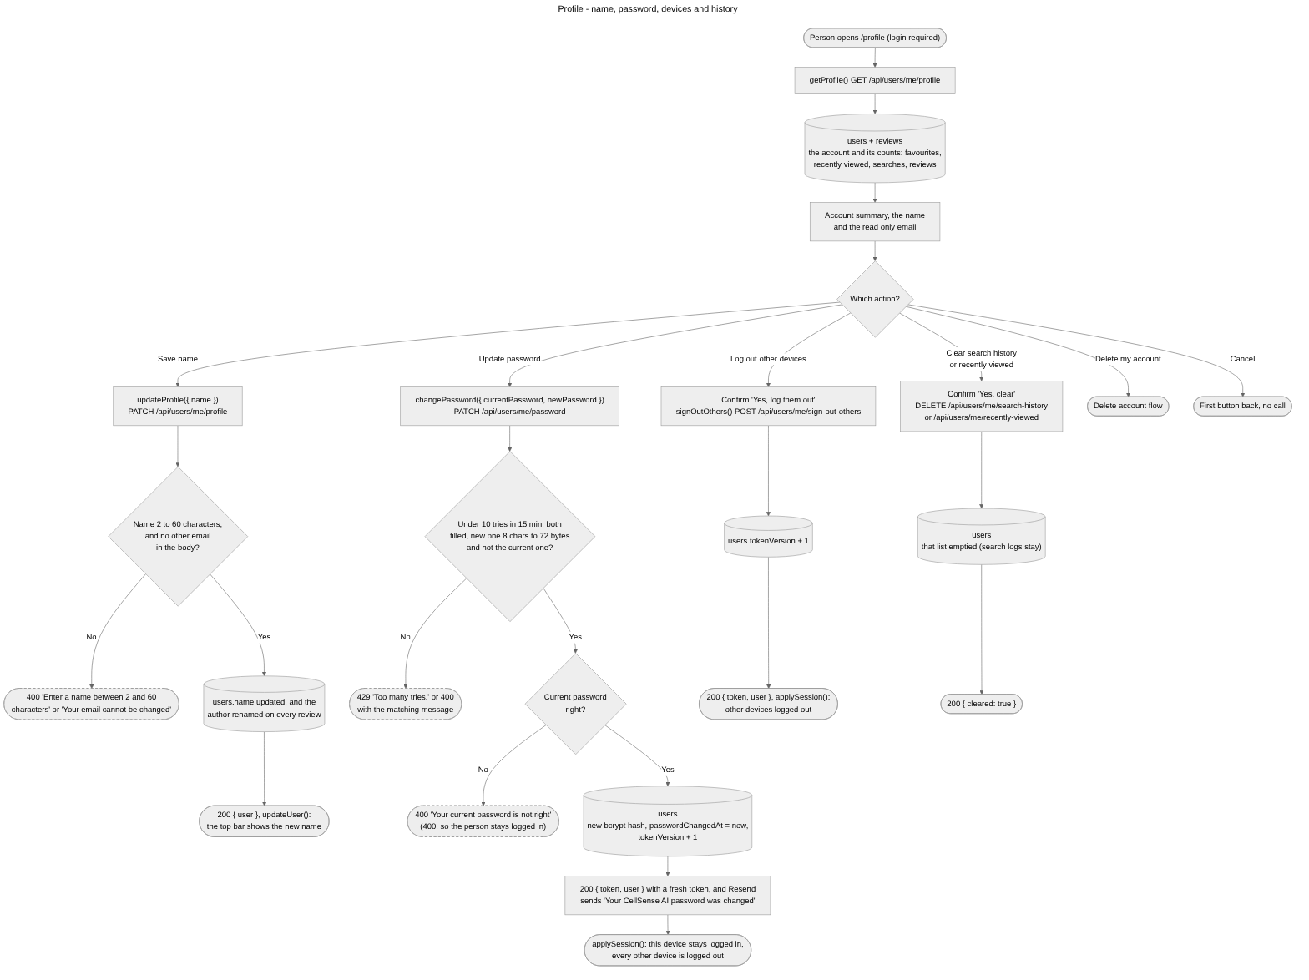
Figure 25. Profile: changing the name (and the author on every review), changing the password with a fresh token that logs out the other devices, logging out the other devices, and clearing the history.

Delete the account
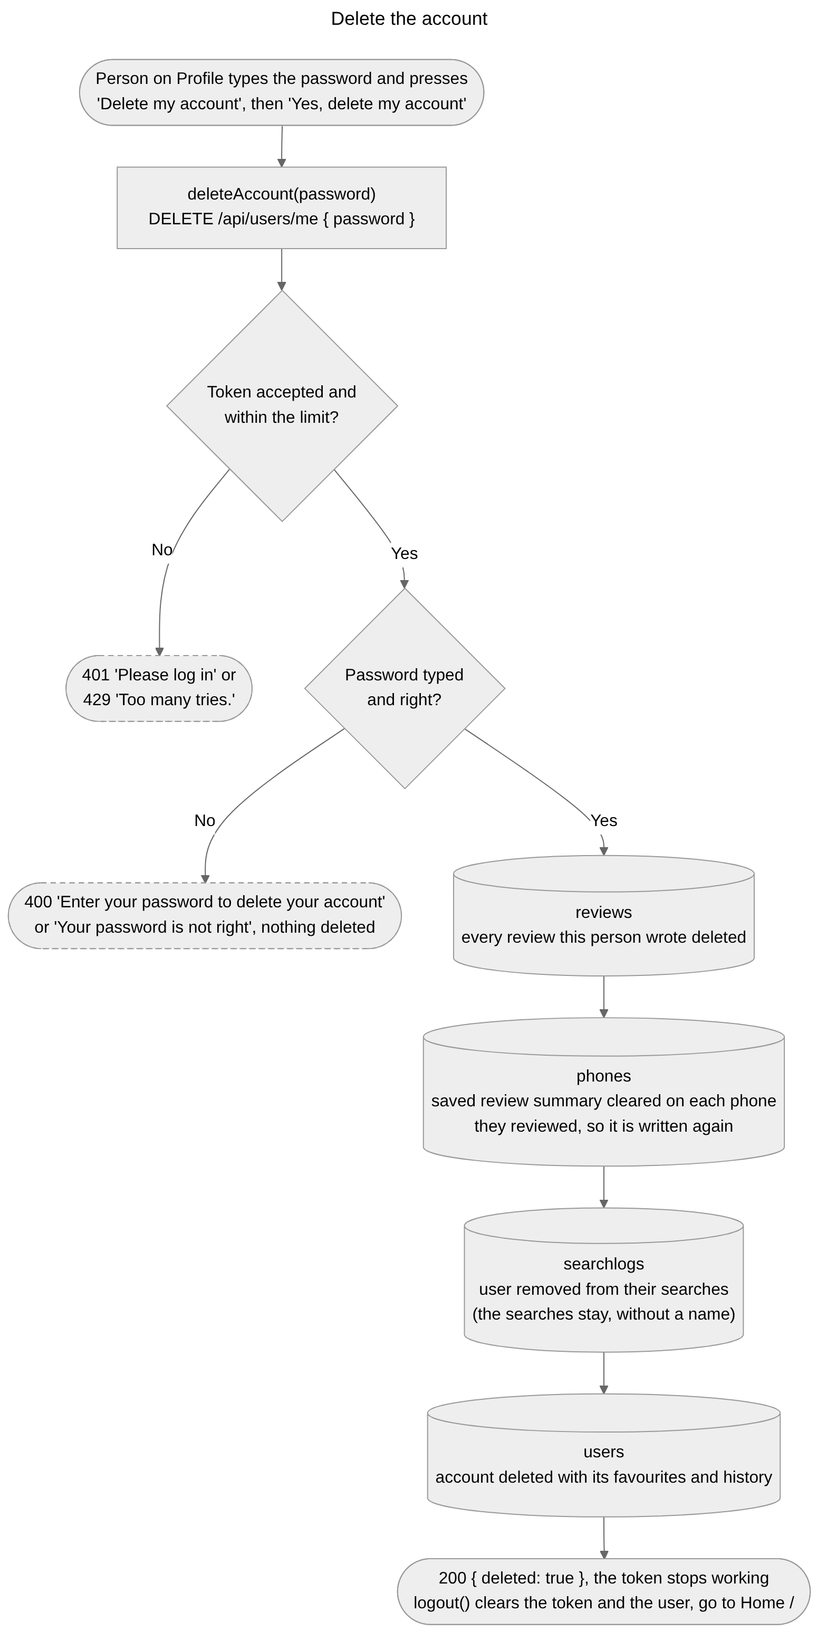
Figure 26. Delete account: the password checked again, then the user's reviews deleted, the saved review summaries cleared, the user removed from the search logs, and the account deleted.

Admin dashboard
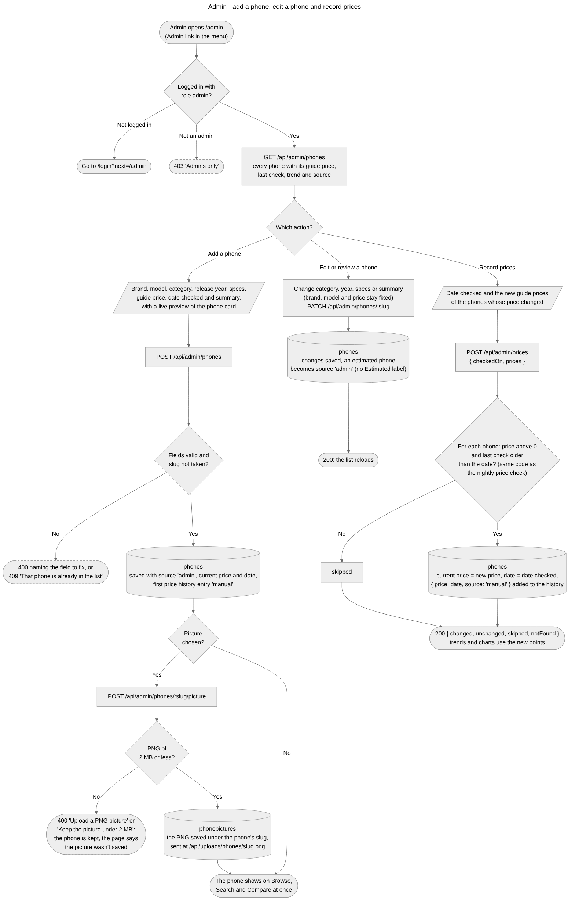
Figure 27. Admin dashboard: only accounts with the admin role get in. An admin adds a phone with its picture, edits or confirms a phone, and records new guide prices that become price history points. No step uses the language model.

Nightly price check
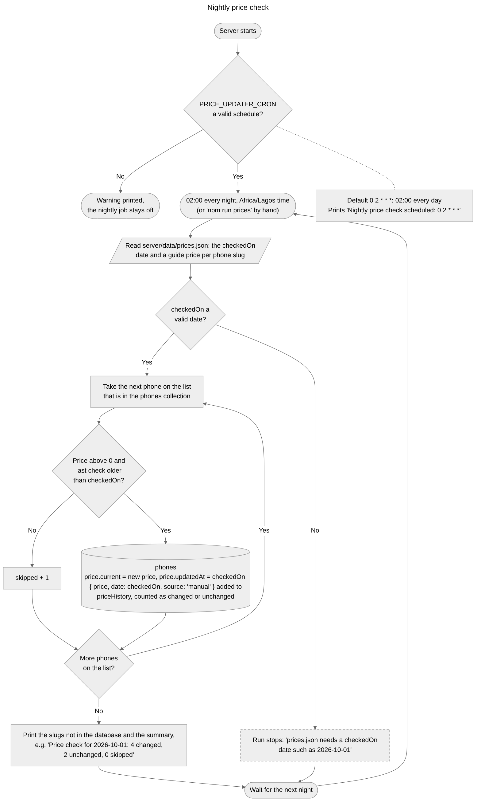
Figure 28. The nightly node-cron job at 02:00 Lagos time: read the price list in server/data/prices.json, skip phones already checked on or after its date, add { price, date, source } to the price history, update the current price, and print a summary.

4 Source code

4.1 What is in the zip
The submission zip holds one folder, cellsense-ai-project, with:
- CellSense-AI-Project-Report.docx, this report.
- ReadMe.doc, the assumptions we made.
- CellSense-AI-Demo.mp4, the demo video of the website.
- client/ is the React app.
- server/ is the Express server.
- docs/ holds the page designs (docs/ui/) and the diagrams (docs/diagrams/).

We removed both node_modules folders to keep the zip small. Running npm install in client and in server brings them back. We included both .env files on purpose, with test keys, so the site runs without filling anything in. Section 6.3 explains them.

4.2 How the code is organised
client/
public/phones/ phone pictures, one PNG per phone, named after its slug
src/
pages/ one folder per page
components/ shared parts such as the phone card, and each person's own parts
context/ the logged-in user, the compare list and the chat conversation
services/ the only files that talk to the server
hooks/useAsync.js loading, error and data for every page
styles/ theme.css with every colour and size, and global.css
server/
src/
index.js starts the server, adds security and limits, connects the routes
routes/ which address goes to which controller
controllers/ the code that runs for each request
services/ the AI calls, the database query builder, recommendations,
price trend, reviews, emails and the security check
models/ the shape of each MongoDB collection
middleware/ the login check, the admin check and the error handler
jobs/ the nightly price check
data/ phones.json (our 60 phones) and prices.json (the price list)
scripts/ seed.js loads the phones, runPriceUpdate.js runs the price check
On the client, a page never calls the server directly. It calls a function in client/src/services/, which adds the login token, sends the request and turns any failure into a plain message. The page then shows a loader, an error with Try again, an empty state or the result.
On the server, a request passes through the security and rate-limit checks in index.js. The route file then sends it to its controller, after the login check and, for admin routes, the admin check. The controller uses the models and services and sends the answer. If anything goes wrong, one error handler turns it into a clean message.
The files that matter most:
File | What it does
server/src/services/ai.service.js | Every call to the language model: search filters, the phone lookup, the assistant, the ranking, the summaries and the review mood.
server/src/services/phoneQuery.js | Turns filters into one MongoDB query. Browse and search both use it.
server/src/services/recommend.service.js | The budget shortlist, the scoring and the reasons from our rules.
server/src/services/price.service.js | The price trend and the best time to buy note.
server/src/controllers/ai.controller.js | Search, the assistant and recommendations.
server/src/controllers/auth.controller.js | Sign up with the email code, login and password reset.
server/src/routes/admin.routes.js | The admin addresses, each behind the login check and the admin check.
server/src/controllers/admin.controller.js | The admin phone list, adding and editing phones, picture uploads and recording prices.
server/src/middleware/auth.js | The login check, the optional login check and the admin role check.
server/src/jobs/priceUpdater.js | The nightly price check. It shares its price rules with the Record prices page.
client/src/services/api.js | Sends every request with the login token and unwraps the answer.
client/src/context/AuthContext.jsx | Keeps the logged-in user and the token.
client/src/components/shared/PhoneCard.jsx | The phone card used on almost every page, and in the admin form's preview.
client/src/components/shared/AdminRoute.jsx | Lets only admins open the admin pages.
client/src/services/admin.service.js | The admin pages' calls to the server.
client/src/pages/ | One folder per page, such as Home, SearchResults, PhoneDetail, Compare, Recommend, Assistant, Dashboard, Admin, AdminPhone and AdminPrices.

4.3 Who built what
Gerald built the server, the database, the AI features, the admin dashboard, the shared parts of the client (the theme, the services, the shared components and the login, compare and chat state), the Verify email, Profile and Page not found pages, and the documentation. Ibrahim built Home, Search results, Browse, Phone detail and About. Osakue built Compare, Recommend, the Assistant page, the Dashboard, Log in, Create account, Forgot password and Reset password.
Each of us worked on our own branch in GitHub and opened a pull request into a shared develop branch. Gerald reviewed every pull request before merging it. A page was only accepted once it matched its design, worked at phone, tablet and desktop widths, had its loading, empty and error states, and used the shared theme and components.

5 Test data

5.1 The data we tested with
- Phones: the 60 phones in server/data/phones.json, 12 each from Samsung, Apple, OnePlus, Xiaomi and Vivo. Six of them have monthly price checks from June to September 2026, so their trends have something to work on: the Galaxy S24, Galaxy A15 5G, iPhone 15, OnePlus 12, Redmi Note 13 Pro and Vivo V30. The other 54 have one price check, dated 1 October 2026.
- Price list: server/data/prices.json, dated 1 October 2026, with new prices for those six phones. Four of the prices changed.
- Accounts: a test user (test.user@example.com) and a second account for the Profile tests. On the shared database we also keep a test admin account: email group2@example.com, password newsecret123.
- A phone we don't have: a search for "Google Pixel 8", which the model adds as an estimated phone.

5.2 How we tested
We tested on a fresh database of our own, never on the shared one. We ran the tests in three rounds: first with the AI settings empty, then with the AI settings filled, and last with single settings changed on purpose, for example a wrong email key, to check the error messages. The expected results below were worked out from the two data files and the rules in section 2 before we ran them.
No. | What we tested | What we did | What should happen | Pass
1 | Loading the phones | Ran npm run seed on an empty database | "Seed: 60 phones added, 0 updated"
2 | Recording the price list | Ran npm run prices | "4 changed, 2 unchanged, 0 skipped", and the Galaxy S24 now costs $689
3 | Sign up sends a code | Created an account for Test User | A 6-digit code is sent, and logging in still fails until it is used
4 | The code creates the account | Typed the right code | The account is created and the person is logged in
5 | A wrong code uses a try | Typed a wrong code | "That code is not right. You have 4 tries left."
6 | Wrong password | Logged in with a wrong password | "Wrong email or password"
7 | Log in needs the security tick | Tried to log in without ticking the box | The Log in button stays disabled, and the server answers "Complete the security check" to a login sent without the tick
8 | A reset link works once | Reset the password, then used the same link again | The second time: "This reset link is invalid or has expired. Ask for a new one."
9 | Browse filters | Samsung, up to $300, cheapest first | Galaxy A05s $139, Galaxy A15 5G $199, Galaxy A25 5G $249
10 | A short search | Searched "samsung" | Matched directly: the 12 Samsung phones, newest first
11 | A sentence search | Searched "phone under $400 with a great camera" with AI on | Understood as: up to $400, camera 48 MP or more, sorted by camera. The Redmi Note 13 Pro comes first.
12 | A phone we don't have | Searched "Google Pixel 8" with AI on | One phone, the Google Pixel 8, shown with the Estimated label
13 | Compare | Galaxy S24, OnePlus 12 and Redmi Note 13 Pro | Lowest price: Redmi Note 13 Pro. Biggest battery: OnePlus 12. No winner for storage or refresh rate, because all three are equal.
14 | Price trend | Opened the Galaxy S24 page | Falling, because $689 is 4.2% below $719
15 | Recommendations | $400 budget, photos, camera matters, AI off | Redmi Note 13 Pro, Redmi Note 13 Pro+, OnePlus Nord CE 3 Lite, each with a reason
16 | A small budget | $130 budget | Budget raised by 15%, with the note on the page, and the Galaxy A05s first
17 | The assistant without AI | Asked a question with the AI settings empty | "The AI features are not set up yet"
18 | One review per phone | Posted a second review of the same phone | "You have already reviewed this phone"
19 | Dashboard needs login | Opened the dashboard logged out | Sent to Log in, and brought back after logging in
20 | Admin pages need the admin role | Opened /admin as Test User | "Admins only"
21 | Adding a phone | Added the Samsung Galaxy S25 with a picture as an admin | The phone appears on Browse and Search with its picture and first price point
22 | The same phone twice | Added the Galaxy S25 again | "That phone is already in the list"
23 | Recording prices | Recorded new prices for three phones as an admin | Each has a new current price and a new history point, and its trend updates
24 | The same date twice | Recorded prices again with the same date | Those phones are skipped
25 | The AI limit | Sent 21 searches in one minute | The 21st gets "Too many questions at once. Wait a minute and try again."

6 Installation instructions
You can try the site without installing anything at https://geraldxtra.github.io/cellsenseai. Its pages are on GitHub Pages and its server is on Render's free plan, which sleeps when nobody uses it, so the first visit after a quiet spell can take about a minute. To run it on your own computer, follow the steps below.

6.1 What you need
- A Windows, Mac or Linux computer with an internet connection. The brief recommends an Intel Core i5 or i7 processor, 8 GB of RAM or more and a 500 GB hard disk or SSD, which is more than enough.
- Node.js version 20.19 or newer, or 22.12 or newer. Download the LTS version from https://nodejs.org and install it with the default options. Typing node -v in a terminal shows the version.

6.2 Run the site
1. Unzip the project and open the cellsense-ai-project folder. You will see client, server and docs, with this report, the ReadMe and the demo video.
2. Open a terminal in the server folder and run:

npm install
npm run dev
Wait for these three lines: "MongoDB connected", "Nightly price check scheduled: 0 2 * * *" and "CellSense API running on http://localhost:5000". Leave this window open.
3. Open a second terminal in the client folder and run:

npm install
npm run dev
4. Open http://localhost:5173 in a browser.

The .env files in the zip already hold our settings, so there is nothing to fill in. The database is our MongoDB Atlas database with the 60 phones already loaded, and the AI features and email are switched on.

6.3 The .env files
We put both .env files in the zip on purpose, so you can run and test the site straight away without setting anything up. Every key in them is for testing only. We made them for this submission, and we don't use them anywhere else.
File | Setting | What it is for
server/.env | MONGODB_URI | Our MongoDB Atlas database, which holds the phones, prices, reviews and accounts.
server/.env | JWT_SECRET | Signs the login tokens.
server/.env | AI_BASE_URL, AI_API_KEY, AI_MODEL | The Groq model behind smart search, the assistant, recommendations and the summaries.
server/.env | RESEND_API_KEY, MAIL_FROM | Sends the sign-up code and the password reset email.
server/.env | TURNSTILE_SECRET_KEY | Checks the security tick on Create account and Log in.
client/.env | VITE_TURNSTILE_SITE_KEY | Shows the security tick box on those two pages.

You can put your own keys in for the AI, the email and the security check if you prefer. Please leave MONGODB_URI as it is, though. Our database is where all our phones, prices, reviews and accounts are kept, including the test admin account. If you point the site at a different database, none of that will be there and the admin pages won't work.
If a sign-up code doesn't reach your inbox, empty RESEND_API_KEY in server/.env and restart the server. The code then shows in the server window instead.

6.4 Creating an account
Click Log in, then Create account. Fill in a name, an email address and a password, tick the security box, and type the 6-digit code that arrives by email. The account is created and you are logged in.
To open the admin pages, log in with our test admin account: email group2@example.com, password newsecret123, and tick the security box. The Admin link then appears in the account menu.
To make another account an admin, open the users collection in MongoDB Atlas, find the account, change its role from user to admin, and log in again.

6.5 Using your own database instead
We suggest you use ours. If you do need your own:
1. Create a free account at https://www.mongodb.com/atlas and a free cluster.
2. Add a database user, and under Network Access add your computer's address.
3. Copy the connection string, put the password into it, and paste it into MONGODB_URI in server/.env.
4. In the server folder, run npm run seed to load the 60 phones, then npm run prices to record the price list.
5. Create an account on the site. Our test admin account is only in our database, so the admin pages won't work on yours.

6.6 If something goes wrong
Problem | What to do
The server says the port is already in use | Another copy of the server is still running. Close it, or restart the computer, and run npm run dev again.
The server says "MongoDB connection failed" | Check the internet connection and start the server again. If it still fails, use your own database as in 6.5.
Pages keep loading or say "Could not reach the server" | The server isn't running. Start it first, in the server folder.
No sign-up code arrives | Check the spam folder, or empty RESEND_API_KEY in server/.env as in 6.3 so the code shows in the server window. You can also log in with our test account.
Search finds nothing for a sentence, or the assistant says the AI isn't set up | The AI settings in server/.env are empty or the key has expired. The rest of the site still works.
A phone shows a grey box instead of a picture | Its picture is missing from client/public/phones/, or no picture was uploaded for a phone an admin added.

