
FreshFind
Fresh All Along
TechWiz 7 Project Report
Team Tech Hive
Theme: eGreen Basket
Category: Web Innovation Unleashed
Team members
Eberechukwu Uchechukwu Gerald, Team Leader
Chukwujekwu Chimdiuso Amanda
Ibrahim Ogunsola Kelvin
Uyi Osakue Uhunwa

Aptech Computer Education Nigeria
Advanced Diploma in Software Engineering
Semester 2
September 2026
Live site: https://geraldxtra.github.io/freshfind/

Contents
1 Problem Definition 3
2 Design Specifications 4
2.1 Technology 4
2.2 Pages 4
2.3 Visual design 4
2.4 Data design 5
2.5 Bookmarks 5
3 Diagrams 6
3.1 Site map 7
3.2 Flowchart, finding a market 9
3.3 Data Flow Diagram, Level 0 11
3.4 Data Flow Diagram, Level 1 13
3.5 Data model 15
3.6 Flowchart, the assistant 17
3.7 Flowchart, bookmarks 19
3.8 Flowchart, open now and nearby 21
3.9 Application structure 23
4 Test Data Used in the Project 25
4.1 Sample data 25
4.2 Test scenarios 25
5 Testing with Google Lighthouse 27
5.1 In short 27
5.2 What Lighthouse is and why we used it 27
5.3 How we ran it 27
5.4 Scores before our fixes 27
5.5 What Lighthouse flagged and what we did 27
5.6 Scores after our fixes 28
5.7 Performance before and after 28
5.8 Evidence 29
5.9 Things we kept on purpose 29
6 Project Installation Instructions 30
6.1 Requirements 30
6.2 Steps 30
6.3 Production build 30
7 Assumptions 31
8 Team and Challenges 32
8.1 Roles 32
8.2 Challenges we faced and how we handled them 32
9 AI Tools Acknowledgment 34

1 Problem Definition
Farmers markets are one of the best places to buy fresh, affordable food in Lagos, but finding the right one is harder than it should be. Information about where a market is, which days it runs and what hours it keeps is spread across flyers, WhatsApp groups, social media posts and word of mouth. There is no single place a resident can check. People end up showing up on the wrong day, arriving after the market has wound down, or travelling across town for produce that is out of season.
FreshFind solves this with a simple website that puts every market in one place. A visitor can search markets by area, day of the week or produce type, open a market to see its location on a map, its weekly schedule and the produce it usually carries, browse a produce guide that shows what is in season and where to find it, ask a built in assistant common questions, and bookmark markets and produce for the session.
The project follows the TechWiz 7 brief under the eGreen Basket theme. The brief sets clear limits. The site must be built with frontend technologies only, all information must come from JSON or text files, nothing can be written back or stored on a server, and the assistant must run on pre scripted rules rather than a live AI service.

2 Design Specifications

2.1 Technology
- React with Vite for the single page application
- React Router for moving between pages without reloading
- Plain CSS with one central theme file of variables
- JSON files for all market, produce and chatbot data
- No backend, no database, no external AI service

2.2 Pages
1. Home: hero with a search panel, markets near you, in season this week
2. Market Directory: all markets with filters for area, day, produce type and open now, plus sorting by name, next open day and distance
3. Market Detail: banner, about section, weekly schedule, typical produce, map, address and directions
4. Produce Guide: catalogue filtered by category, with season and markets for each item
5. Seasonal Picks: this week's top picks and a season calendar
6. Bookmarks: saved markets and produce with session notes, export and share
7. Contact Us: contact details and a map showing the visitor's location
8. About Us: mission, why FreshFind, and the team
9. Not Found: a friendly page for wrong links
Features shared across pages: a navbar with search, a bookmark count and non functional login and sign up buttons as the brief requires, a floating chatbot on every page, breadcrumbs on every page except Home, a live clock, a simulated visitor counter and the footer. Below 1250 pixels the navbar collapses into a menu, and at phone widths the footer stacks.

2.3 Visual design
- Colors: cream background, deep green for headings and the footer, amber yellow for primary buttons and badges, white cards with soft borders
- Fonts: Fraunces for headings, Plus Jakarta Sans for body text
- Layout: content width of 1200px, responsive at 900px and 600px
- Feel: warm, premium and clean, with hover effects and smooth transitions
Design mockups for all nine pages are in design/mockups.
Figures 1 and 2 show two of the mockups, the Home page and the Market Detail page.
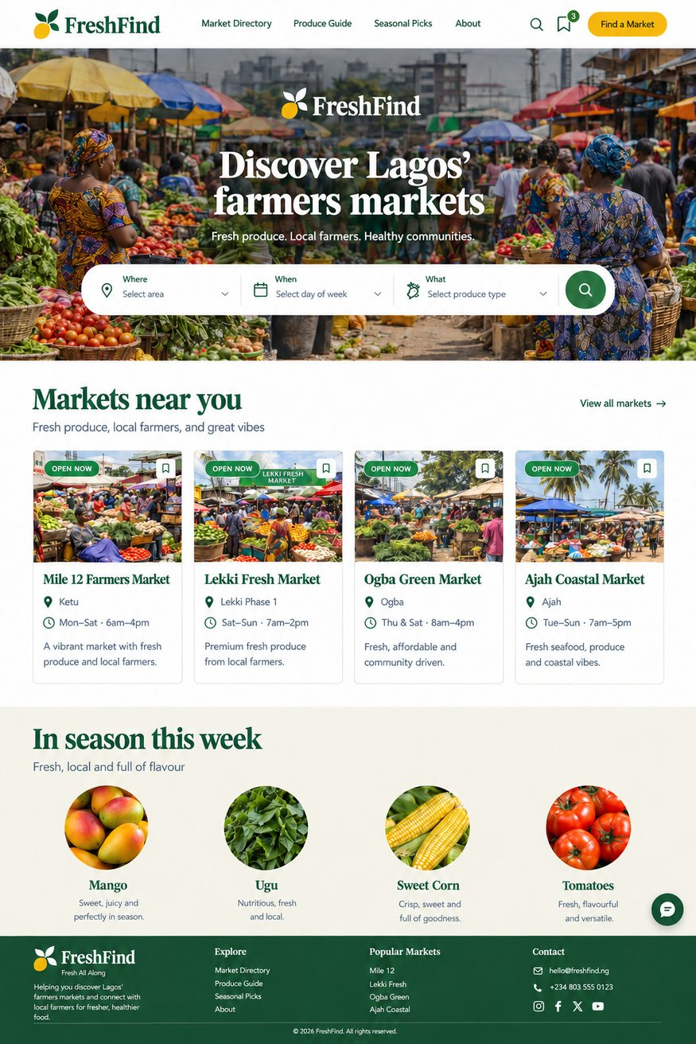  Figure 1. Home page mockup | 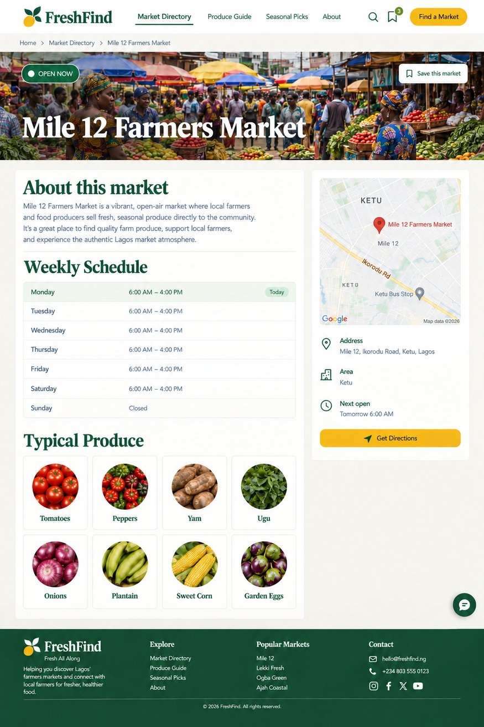  Figure 2. Market Detail page mockup

2.4 Data design
Three JSON files in src/data hold everything the site shows. Every record in a file has the same fields, listed below, and the pages only read those fields and never change them.
- markets.json: id, name, area, address, lat, lng, description, about, image, schedule (seven days with open and close times or null), produce (list of produce ids), featured.
- produce.json: id, name, category, season (month numbers), description, markets (list of market ids), image.
- chatbot.json: greeting, quick replies, fallback, entities for markets, produce and days, and intents with keywords, answers, optional actions, links and quick replies.
Records join on ids so no fact is typed twice.

2.5 Bookmarks
Bookmarks and notes are kept in the browser's session storage. They belong to that browser only and clear when the tab closes. This meets the brief, which allows no server storage and describes notes as session only.

3 Diagrams
The diagrams are written in Mermaid in docs/diagrams and rendered by GitHub. Exported images of each are in docs/diagrams/png and included below in the submitted report.
Each diagram has a written explanation in docs/diagrams/explained, covering the shapes, every step and the logic behind it.
1. Site map: how the pages link to each other and the cross page features.
2. Flowchart, finding a market: the paths from the home search, the search overlay and the directory to a market detail and a bookmark.
3. Data Flow Diagram, Level 0: the app as one process with the visitor, the three JSON stores, the browser clock and location, session storage and the map embed.
4. Data Flow Diagram, Level 1: the six processes (search and filter, market detail, produce and seasons, answering questions, bookmarks, location and maps) and the data each reads and writes.
5. Data model: how markets, produce, chatbot entities and bookmarks relate through ids.
6. Flowchart, the assistant: how a question becomes an answer using entities, intents and the data files.
7. Flowchart, bookmarks: saving, notes, export, share, remove and what happens when the tab closes.
8. Flowchart, open now and nearby: how the clock and the schedule produce the badges and how location produces distances.
9. Application structure: the router, the frame, the pages, the shared components, helpers, hooks and data.

3.1 Site map
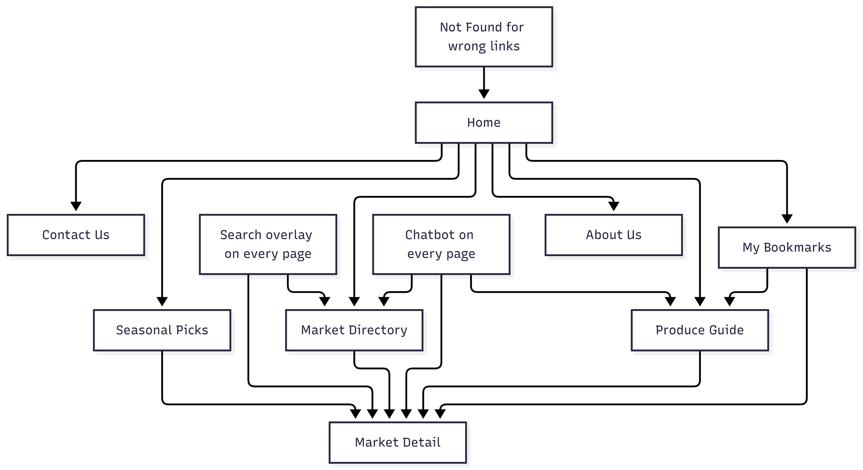
Figure 3. Site map

What it shows
The pages of FreshFind and how a visitor moves between them. It is the map of the whole site in one picture.

The shapes
- Every box is a page or a feature the visitor can reach.
- A solid arrow means "you can get from here to there with one click".
- There are no decisions on this diagram, it is structure, not logic.

The logic behind it
Every page is reachable within two clicks from Home. Market Detail is the page most arrows point to because a market is what everyone is looking for. The chatbot and the search are drawn outside the page tree because they float over every page instead of being pages themselves.

3.2 Flowchart, finding a market
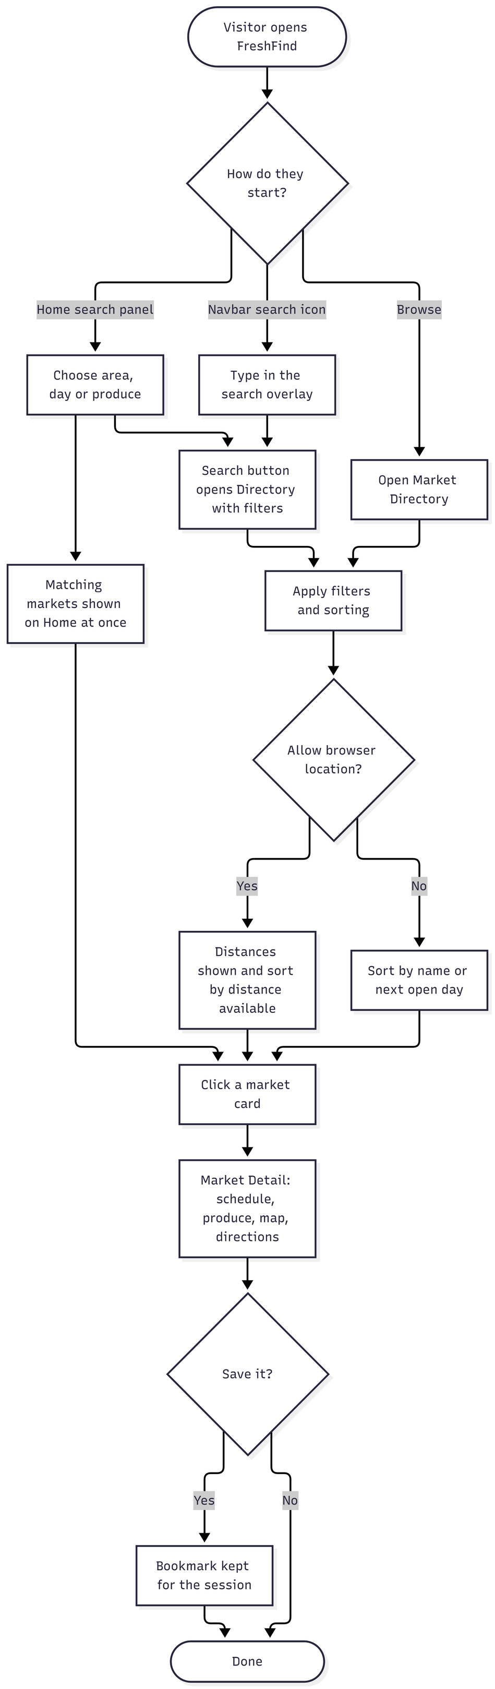
Figure 4. Flowchart, finding a market

What it shows
The steps a visitor goes through from arriving on the site to finding a market, in every way the site allows, and what the site does at each step.

The shapes
- A rounded box (a stadium shape) is a start or an end: Visitor opens FreshFind at the top, Done at the bottom.
- A diamond is a decision, a question with more than one answer. The words on the arrows leaving it are the answers.
- A plain rectangle is a step, something the site or the visitor does.
- Arrows show the order.

The logic behind it
There are three ways in and they all meet at the same Directory step, so the site has one list page, not three. Location is a decision, not a requirement: both branches continue. The last decision shows that bookmarking is optional and never blocks anything.

3.3 Data Flow Diagram, Level 0
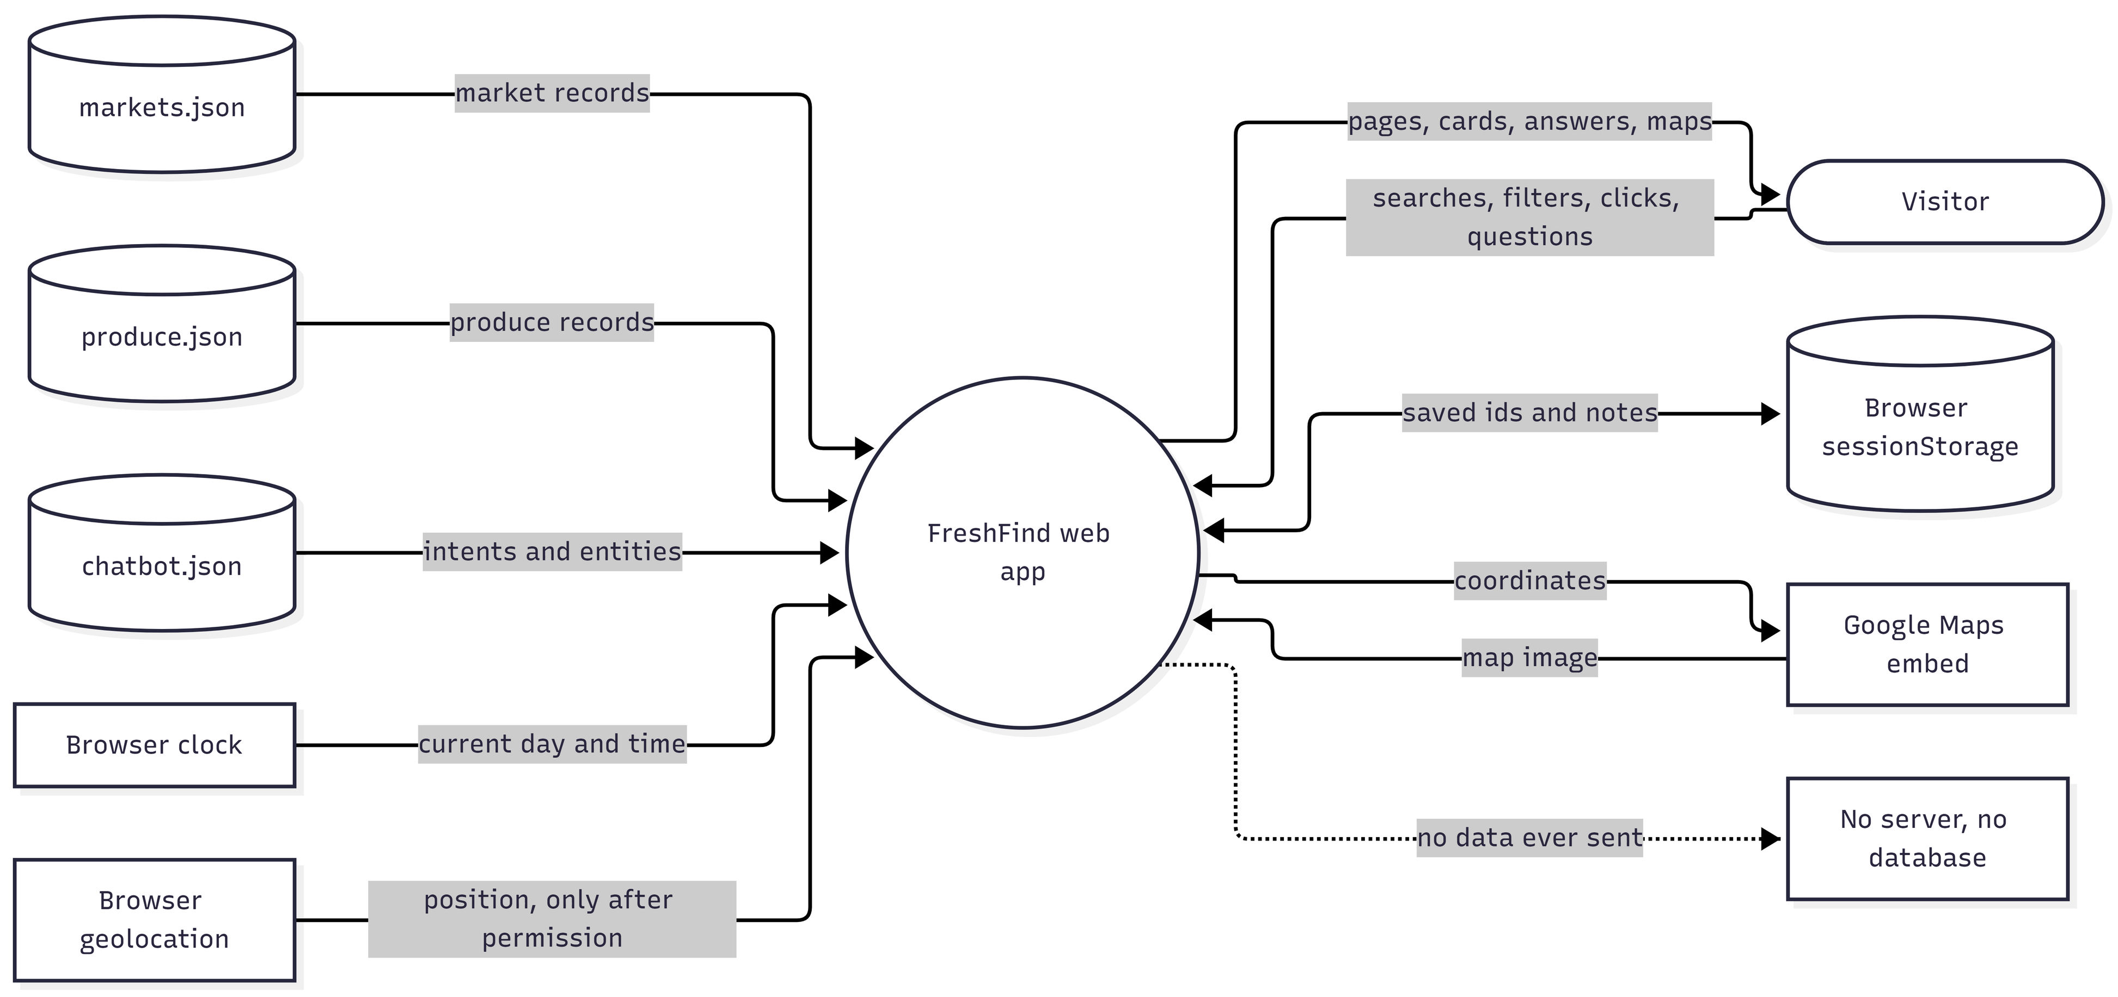
Figure 5. Data Flow Diagram, Level 0

What a DFD is
A Data Flow Diagram shows where information comes from, what handles it, where it is kept and where it goes. It does not show the order of clicks; the flowcharts do that. A Level 0 DFD, also called a context diagram, treats the whole system as one process and shows everything outside it that sends or receives data.

The shapes
- The rounded box marked Visitor is an external entity: a person outside the system who sends data in and gets data back.
- The circle marked FreshFind web app is the one process, the whole system.
- Cylinders are data stores: markets.json, produce.json, chatbot.json and the browser's sessionStorage.
- Plain boxes at the edges are other outside things the system talks to: the browser clock, the browser geolocation, the Google Maps embed, and a box for what does not exist, a server.
- Every solid arrow is a data flow and its label says what data moves. A dotted arrow marks something that never happens.

The logic behind it
The picture makes the SRS constraints visible: three read only files as the data source, one session store for bookmarks, no server. Everything the system knows comes from the three files, the clock and the visitor.

3.4 Data Flow Diagram, Level 1
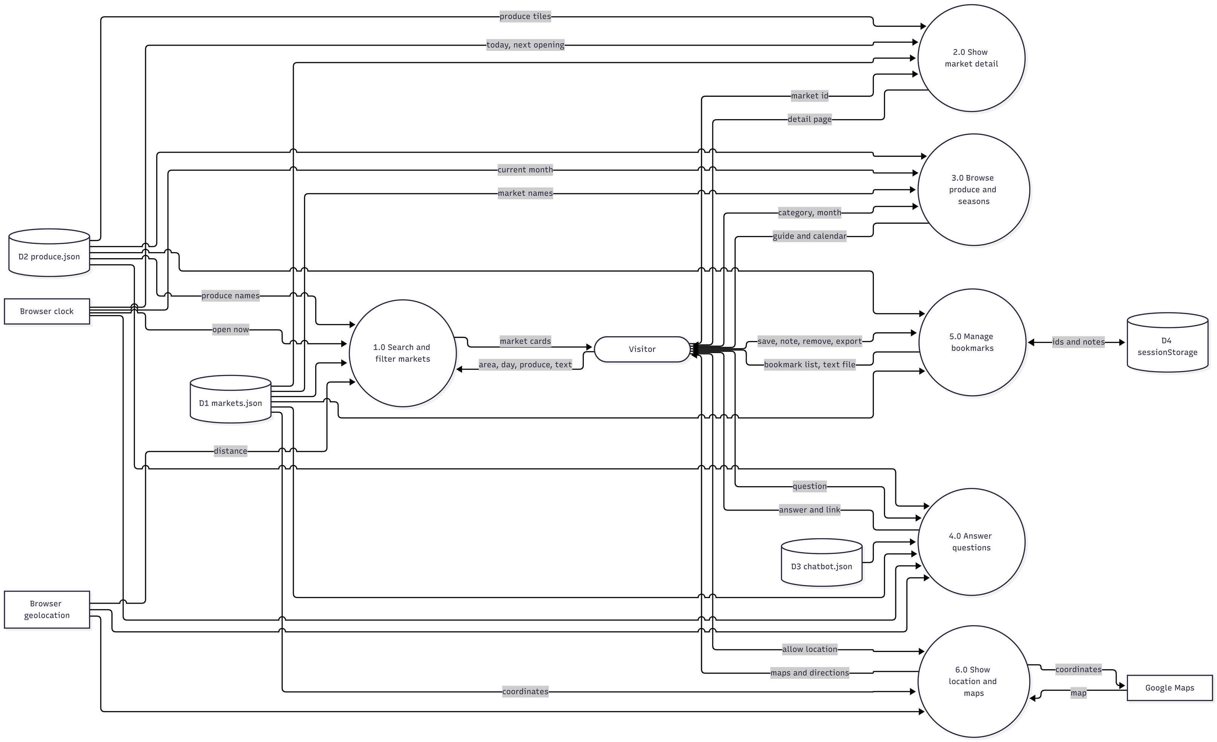
Figure 6. Data Flow Diagram, Level 1

What it shows
Level 1 opens the single circle from Level 0 and shows the six processes inside FreshFind, with the data each one reads and returns. The outside things and the stores are the same as Level 0.

The shapes
- Rounded box: the Visitor, the external entity.
- Circles numbered 1.0 to 6.0: the processes. The numbering is the DFD convention for the first level of detail.
- Cylinders D1 to D4: the data stores. D1 markets.json, D2 produce.json, D3 chatbot.json, D4 sessionStorage. Naming stores D1, D2 and so on is also the convention.
- Plain boxes: the browser clock, the browser geolocation and Google Maps.
- Labelled arrows: the data flows.

The logic behind it
Each process reads only what it needs. D1 is read by every process because markets are the heart of the site. D3 is read only by the assistant. D4 is written only by bookmarks. The clock feeds four processes, which is why one shared hook provides it.

3.5 Data model
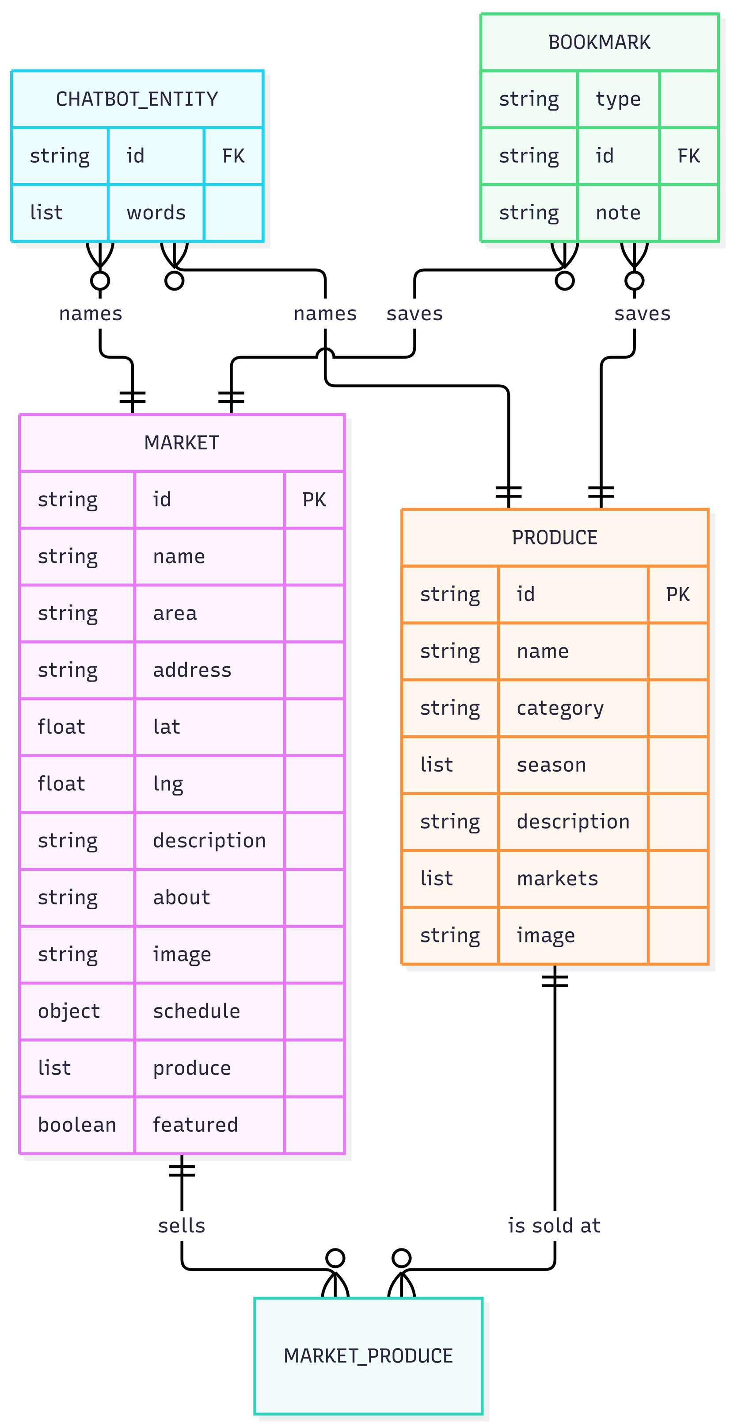
Figure 7. Data model

What it shows
The four kinds of record in the system and how they relate: markets, produce, chatbot entities and bookmarks. It is an entity relationship diagram, the standard way to draw a data model.

The shapes
- Each box is an entity, a kind of record. Inside it are the fields with their types. PK marks the primary key, the field that identifies a record, which is id. FK marks a foreign key, a field that holds another record's id.
- The lines between boxes are relationships. The symbols at the ends say how many: a double bar means exactly one, a circle with a crow's foot means zero or many. So MARKET to MARKET_PRODUCE reads "one market sells zero or many produce links", and the same from the produce side.
- MARKET_PRODUCE is the link between markets and produce. In the JSON it is not a separate file; it is the produce list inside each market and the markets list inside each produce item, which are the same links written from both sides.

The logic behind it
Everything joins on ids. A market lists what it sells by id, a produce item lists where it is sold by id, the assistant names things by id, a bookmark saves an id. No name or fact is typed twice, so a change in one record shows everywhere. Ids never change, which is why they are short lowercase words.

3.6 Flowchart, the assistant
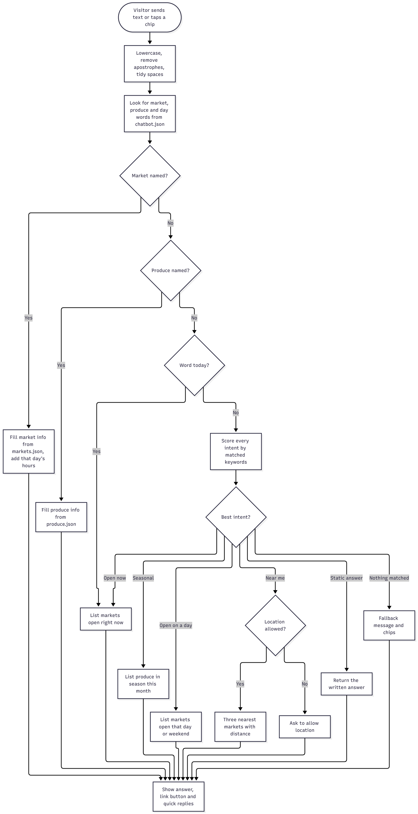
Figure 8. Flowchart, the assistant

What it shows
How one question typed into the chat becomes one answer, decision by decision. This is the exact logic of src/utils/chatbot.js.

The shapes
- Rounded box: the start, a visitor sends text or taps a chip.
- Rectangles: steps the engine takes.
- Diamonds: decisions, each with Yes and No arrows, or the list of possible best intents.
- All paths end at one rectangle, Show answer, link button and quick replies, which is what the widget draws.

The logic behind it
Entities come before intents on purpose: if someone names Mile 12, they want Mile 12, whatever else they typed. Today goes straight to open now because "open today" means right now. Scoring by keyword length means "which markets are open" beats the short word "open". Every branch ends in an answer, so the bot never stays silent.

3.7 Flowchart, bookmarks
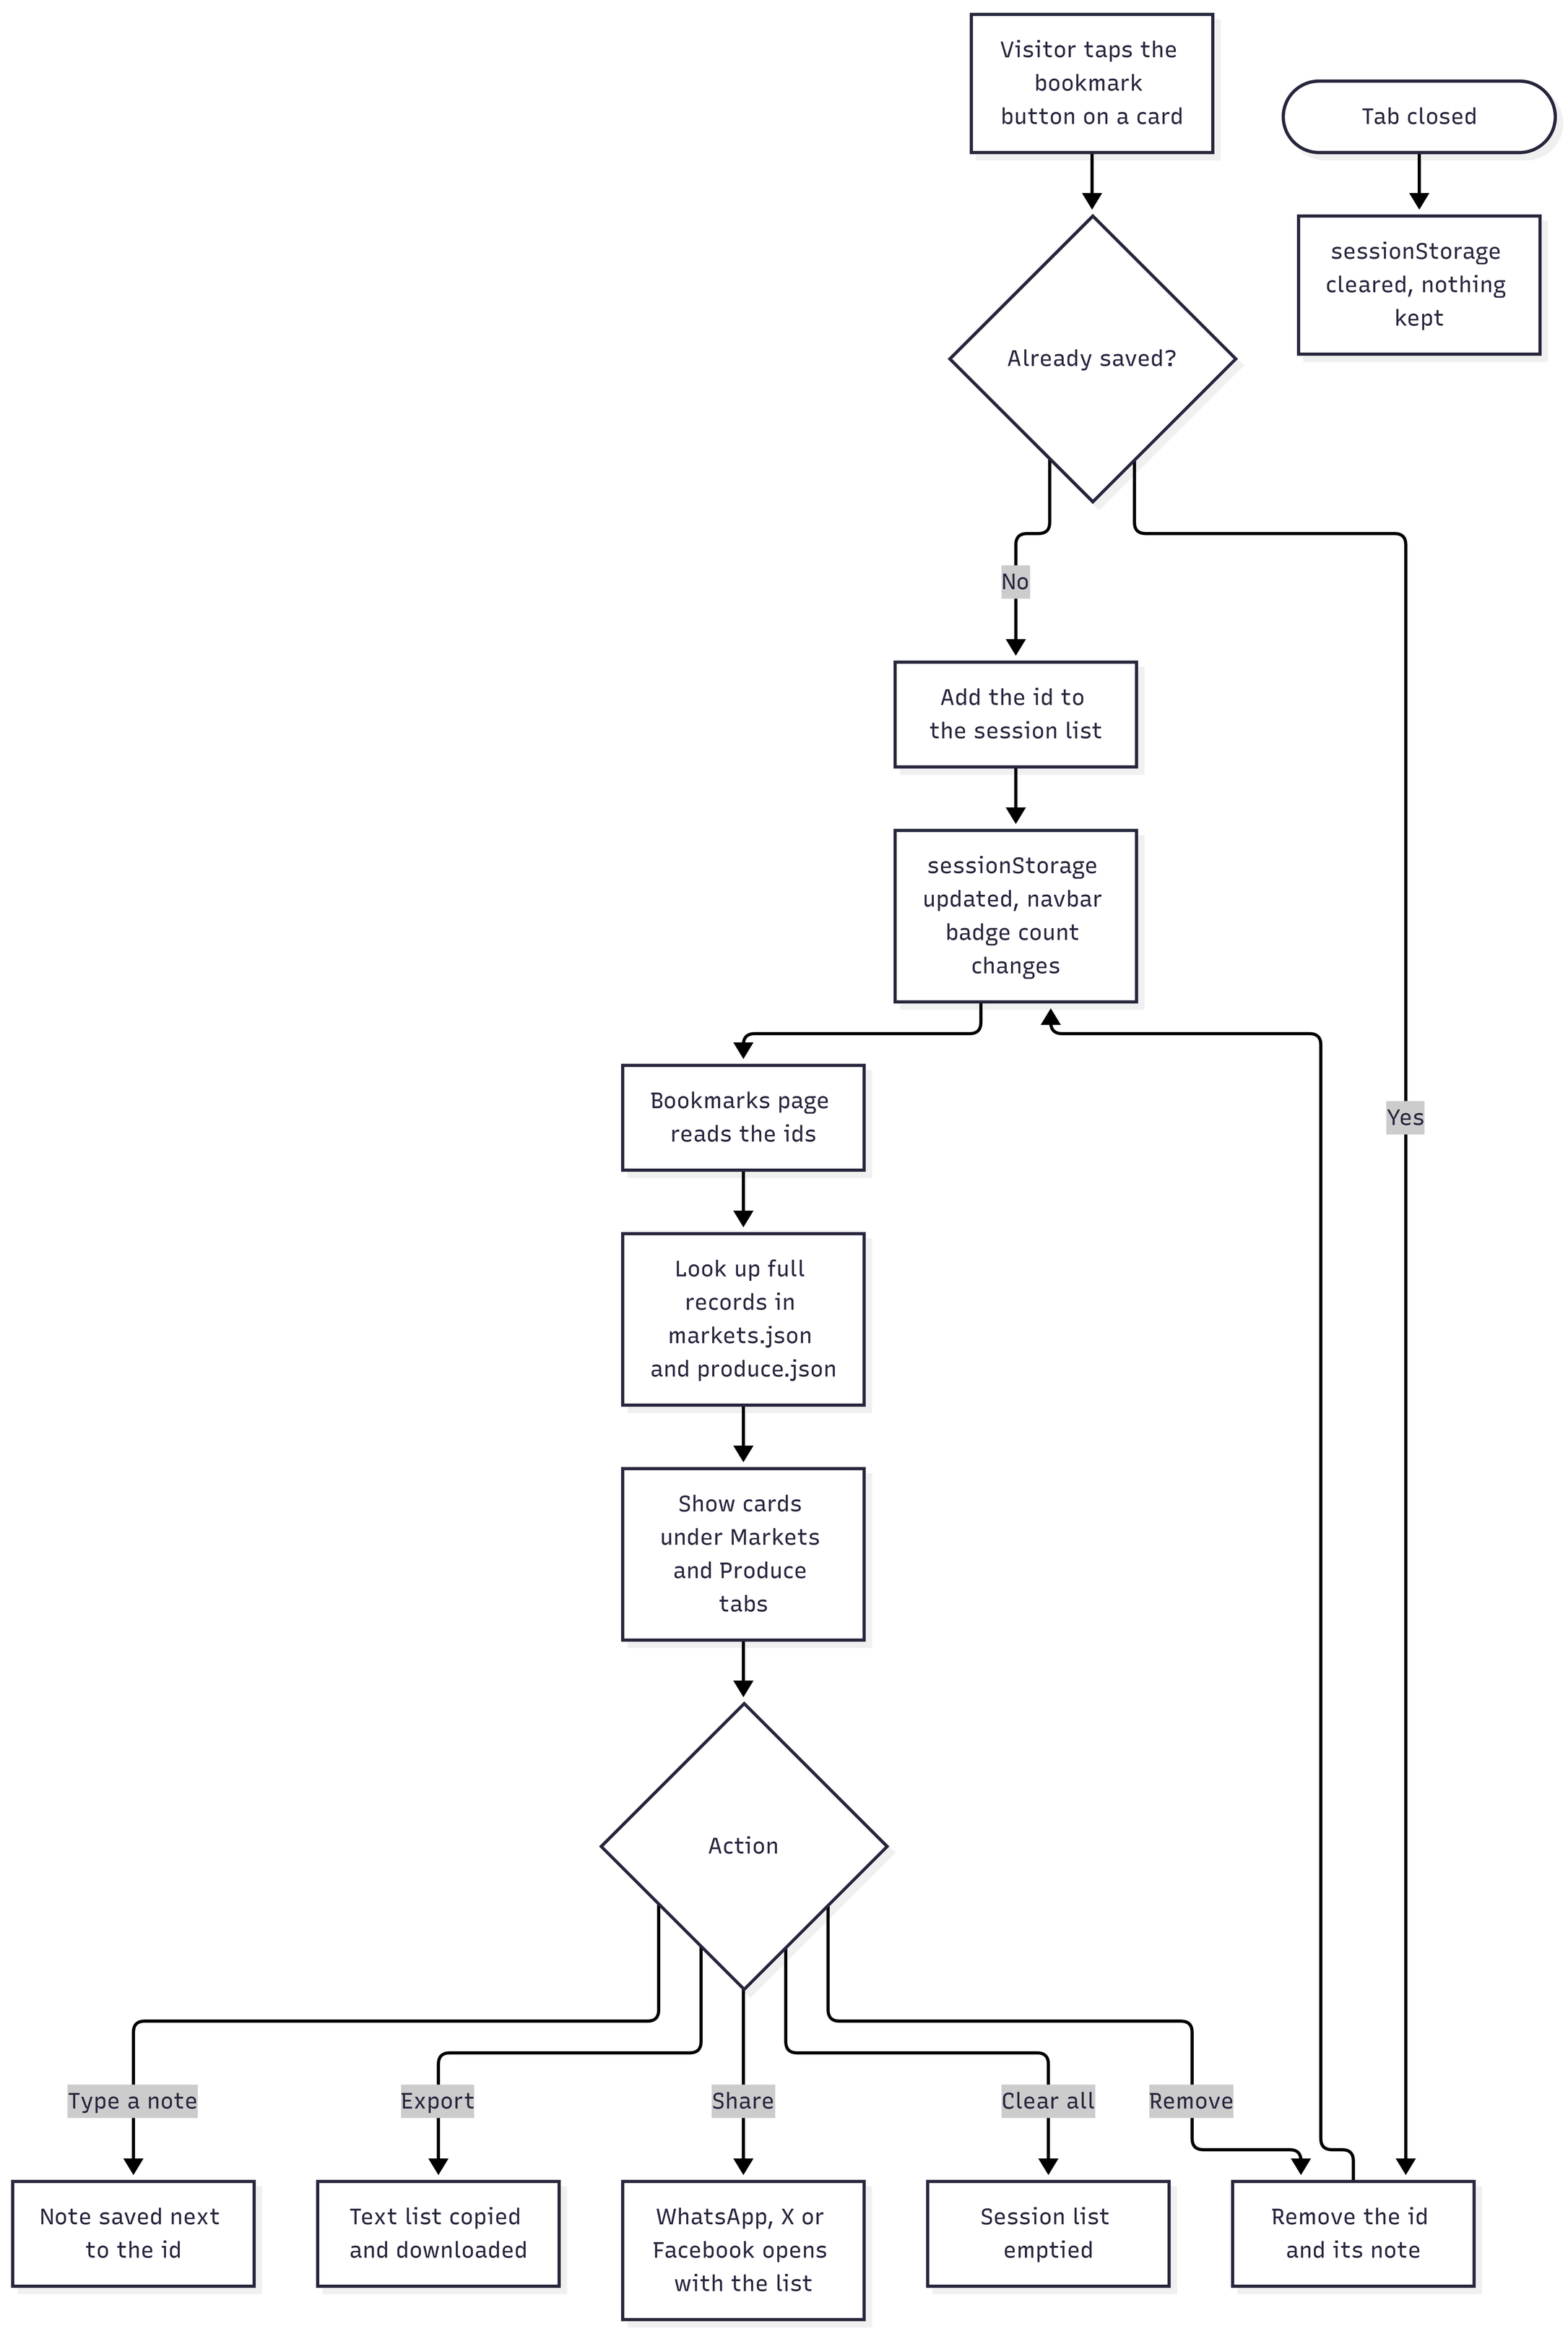
Figure 9. Flowchart, bookmarks

What it shows
What happens from the moment a visitor taps a bookmark icon until the tab closes, including notes, export, share and removal.

The shapes
- Rectangles are actions by the visitor or the site.
- Diamonds are decisions: already saved? and which action?
- The rounded box Tab closed is a separate start, because closing the tab is an event that can happen at any time.

The logic behind it
Only ids are stored, so bookmarks stay tiny and always show current data. The same toggle handles saving and removing, which is why the diamond sends both answers to the same update step. The last path is the answer to "why did my bookmarks disappear": session only, by the brief.

3.8 Flowchart, open now and nearby
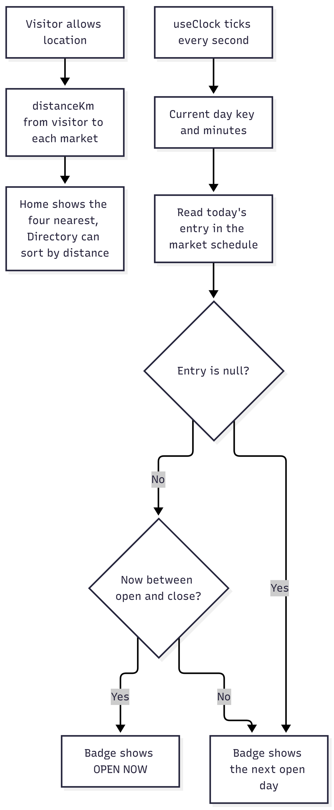
Figure 10. Flowchart, open now and nearby

What it shows
How the site decides whether a market is open at this moment, what the badge says otherwise, and how nearby markets are chosen. Two small flows on one picture: the clock flow on the left and the location flow on the right.

The shapes
- Rectangles are steps.
- Diamonds are the two decisions in the clock flow.
- The location flow has no decisions because it only runs after permission.

The logic behind it
Because every schedule stores real open and close times, one function answers the question for every market on every page and the badge is always right for the current minute. The location flow is separate because it is optional and the site must work without it.

3.9 Application structure
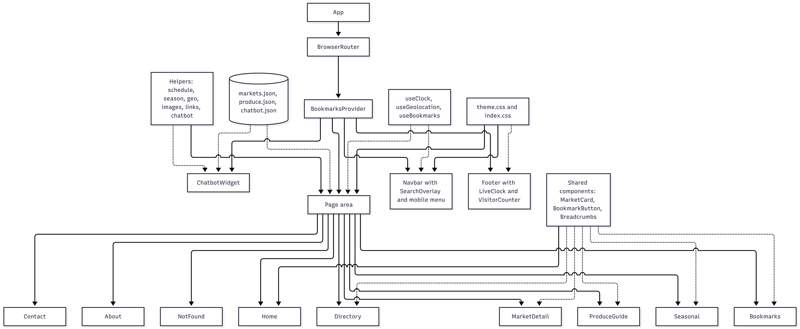
Figure 11. Application structure

What it shows
How the code is organised: what contains what, and which shared pieces support which pages. It is a picture of the folders in src.

The shapes
- Boxes are components, groups of files, or the data. The cylinder is the three data files.
- Solid arrows mean "contains" or "renders". App renders the Router, the Router renders the frame and so on.
- Dotted arrows mean "is used by". The shared components, helpers, hooks, data and theme are used by the pages but do not contain them.

The logic behind it
Shared things sit once at the top or the side and are reused, so the site behaves the same everywhere. The frame is built once and every page inherits it. Only the page area changes when the address changes, which is what a single page application means.

4 Test Data Used in the Project

4.1 Sample data
8 markets in markets.json:
Market | Area | Days and hours
Mile 12 Farmers Market | Ketu | Mon to Sat 6am to 4pm
Lekki Fresh Market | Lekki Phase 1 | Sat and Sun 7am to 2pm
Ogba Green Market | Ogba | Thu and Sat 8am to 4pm
Ajah Coastal Market | Ajah | Tue to Sun 7am to 5pm
Surulere Community Market | Surulere | Sat 8am to 3pm
Ikeja City Market | Ikeja | Mon to Sat 7am to 6pm
Oyingbo Market | Ebute Metta | Mon to Sat 6am to 5pm
Epe Fish Market | Epe | every day 6am to 1pm

- 26 produce items in produce.json across five categories, each with a season and the markets that sell it.
- 19 chatbot intents in chatbot.json plus entity lists for 8 markets, 26 produce items and the days of the week.

4.2 Test scenarios
Each scenario lists what we did and the result we expected.
Number | What we did | Expected result
1 | Home search: choose Ketu as area and press Search. | Directory opens showing only Mile 12 Farmers Market.
2 | Directory day filter: choose Sunday. | Lekki Fresh, Ajah Coastal and Epe Fish only.
3 | Directory produce filter: choose Honey. | Lekki Fresh Market only.
4 | Open now toggle at 10am on a Wednesday. | Mile 12, Ajah Coastal, Ikeja City, Oyingbo and Epe Fish.
5 | Open now toggle at 8pm on any day. | No markets and the empty state message.
6 | Sort by distance after allowing location. | The nearest market appears first with distances shown.
7 | Market Detail for Mile 12 on a Sunday. | Badge shows OPENS TOMORROW and the Sunday row shows Closed.
8 | Market Detail for an unknown id such as /market/nothing. | Not Found content.
9 | Produce Guide, Fruits tab. | Mango, Banana, Plantain, Pineapple, Watermelon, Pawpaw, Oranges.
10 | Seasonal Picks in September. | Tomatoes, Ugu, Ewedu, Okra, Spinach, Garden Eggs, Yam, Sweet Corn, Sweet Potato, Scent Leaf and the year round items appear as in season; Mango does not.
11 | Bookmark a market and a produce item. | Navbar badge shows 2 and both appear on the Bookmarks page under their tabs.
12 | Add a note to a bookmark, refresh the page. | The note is still there.
13 | Close the tab and open the site again. | Bookmarks and notes are gone.
14 | Export the bookmark list. | A text list is copied and can be downloaded.
15 | Chatbot, type which markets are open on saturday. | A list of Saturday markets with hours and a button to the Directory.
16 | Chatbot, type where can i buy yam. | The yam season and Mile 12, Ikeja City and Oyingbo, with a button to the Produce Guide.
17 | Chatbot, type mile 12. | Mile 12 area, hours and produce with a button to its page.
18 | Chatbot, type something random. | The fallback message with suggestion chips.
19 | Contact page, allow location, then deny location. | Allow location: the map centers on the visitor. Deny location: the Lagos map and a friendly message.
20 | Resize the window to 390px. | The menu button appears, no sideways scrolling, and the footer stacks on every page.
21 | Click Login or Sign Up. | Nothing happens, by design.

5 Testing with Google Lighthouse

5.1 In short
After our fixes every page scores 100 for accessibility, best practices and SEO, on both mobile and desktop. Desktop performance is between 97 and 100 on every page. On mobile, the average performance score went from 82 to 90, with the biggest jumps on Contact Us, from 70 to 97, the Home page, from 74 to 93, and My Bookmarks, from 78 to 97.

5.2 What Lighthouse is and why we used it
Google Lighthouse is a free testing tool built into Chrome. It gives a web page a score from 0 to 100 in four areas: performance, which is how fast it loads; accessibility, which is whether people with poor sight or who only use a keyboard can use it; best practices, which is general code health and safety; and SEO, which is whether search engines can read it. A score of 90 or more is green, 50 to 89 is orange, and below 50 is red. The SRS asks us to test and validate the website with Lighthouse, so we tested every page, fixed what it found, and tested again.

5.3 How we ran it
We tested the production build, not the development server, because the development server is deliberately slower. We ran npm run build, served the result with npm run preview, opened it in a Chrome incognito window so extensions could not change the scores, and ran Lighthouse from the Lighthouse tab in Chrome DevTools. Each of the eight pages was tested twice, once with the mobile setting and once with the desktop setting. The mobile setting pretends the page is running on a mid range phone with a slow connection, so it is the harder of the two. Before the first test we had already converted every photo to WebP, which cut the photos from about 100 MB to about 4 MB.
In the tables, P is Performance, A is Accessibility, BP is Best Practices and SEO is Search Engine Optimisation.

5.4 Scores before our fixes
Page | Mobile P | Mobile A | Mobile BP | Mobile SEO | Desktop P | Desktop A | Desktop BP | Desktop SEO
Home | 74 | 100 | 100 | 91 | 96 | 100 | 100 | 91
Market Directory | 84 | 98 | 100 | 91 | 98 | 98 | 100 | 91
Market Detail (Mile 12) | 78 | 98 | 100 | 91 | 98 | 98 | 100 | 91
Produce Guide | 95 | 99 | 100 | 91 | 93 | 99 | 100 | 91
Seasonal Picks | 85 | 94 | 100 | 91 | 98 | 94 | 100 | 91
My Bookmarks | 78 | 98 | 100 | 91 | 99 | 98 | 100 | 91
Contact Us | 70 | 98 | 100 | 91 | 99 | 98 | 100 | 91
About Us | 90 | 100 | 100 | 91 | 99 | 100 | 100 | 91

5.5 What Lighthouse flagged and what we did
1. Document does not have a meta description (SEO, every page). A meta description is the short summary search engines show under a link. We added a one sentence description of FreshFind to index.html. SEO went from 91 to 100 on every page.
2. Heading elements are not in a sequentially descending order (Accessibility on the Market Directory, Market Detail, Produce Guide, Seasonal Picks, My Bookmarks and Contact Us). Screen readers use headings like a table of contents, and on these pages we skipped a level. We made the footer column headings one level higher in Footer.jsx and turned the results count on the Market Directory into a heading in Directory.jsx, keeping exactly the same look through CSS.
3. Elements use prohibited ARIA attributes (Accessibility on Seasonal Picks). Each green bar in the season calendar had a label for screen readers, but the bar had no role, so the label was not allowed. We gave each bar the role of an image in Seasonal.jsx, so the label is now read out. Accessibility on Seasonal Picks went from 94 to 100.
4. Render blocking requests and network dependency tree (Performance, every page). Our fonts were loaded from inside our own stylesheet, so the page waited for Google Fonts before it could show anything. We moved the font loading into index.html, connected to Google's font servers early, and loaded the fonts without holding up the first paint.
5. LCP request discovery and improve image delivery (Performance on mobile). The Home hero photo and the market banner were set as backgrounds, so the browser only found them after our JavaScript had run, and they were bigger than a phone needs. We turned them into real images the browser fetches early with high priority in Home.jsx and MarketDetail.jsx, made smaller copies of the hero and the market photos for small screens, and let the browser pick the right size in MarketCard.jsx and images.js.

5.6 Scores after our fixes
Page | Mobile P | Mobile A | Mobile BP | Mobile SEO | Desktop P | Desktop A | Desktop BP | Desktop SEO
Home | 93 | 100 | 100 | 100 | 98 | 100 | 100 | 100
Market Directory | 78 | 100 | 100 | 100 | 100 | 100 | 100 | 100
Market Detail (Mile 12) | 79 | 100 | 100 | 100 | 98 | 100 | 100 | 100
Produce Guide | 98 | 100 | 100 | 100 | 99 | 100 | 100 | 100
Seasonal Picks | 86 | 100 | 100 | 100 | 97 | 100 | 100 | 100
My Bookmarks | 97 | 100 | 100 | 100 | 100 | 100 | 100 | 100
Contact Us | 97 | 100 | 100 | 100 | 100 | 100 | 100 | 100
About Us | 89 | 100 | 100 | 100 | 100 | 100 | 100 | 100

5.7 Performance before and after
Page | Mobile before | Mobile after | Desktop before | Desktop after
Home | 74 | 93 | 96 | 98
Market Directory | 84 | 78 | 98 | 100
Market Detail (Mile 12) | 78 | 79 | 98 | 98
Produce Guide | 95 | 98 | 93 | 99
Seasonal Picks | 85 | 86 | 98 | 97
My Bookmarks | 78 | 97 | 99 | 100
Contact Us | 70 | 97 | 99 | 100
About Us | 90 | 89 | 99 | 100

Contact Us, Home and My Bookmarks improved the most on mobile, mainly from the font fix and, on the Home page, from the hero photo being found early.
The Market Directory went down on mobile, from 84 to 78, and Market Detail stayed about the same. Both pages show market photos near the top. The mobile test pretends to be a phone with a sharp, high resolution screen, so the browser still picks the larger photo for each card and banner. The next thing we would do is add a middle size photo made for phones.
Seasonal Picks and About Us moved by one point. That is normal, because scores move a few points between runs.

5.8 Evidence
The full report for the Home page after the fixes is saved in the docs/lighthouse folder of the source code, as home-desktop.html. Open it in Chrome to see the whole report.
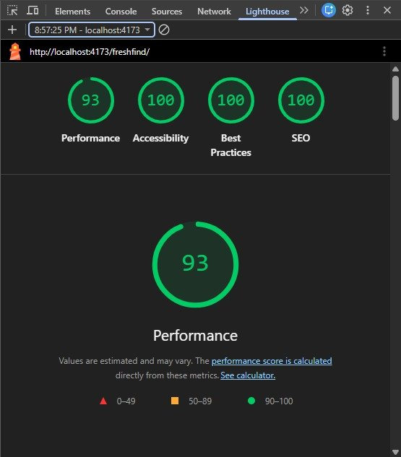  Figure 12. Home page on mobile after the fixes | 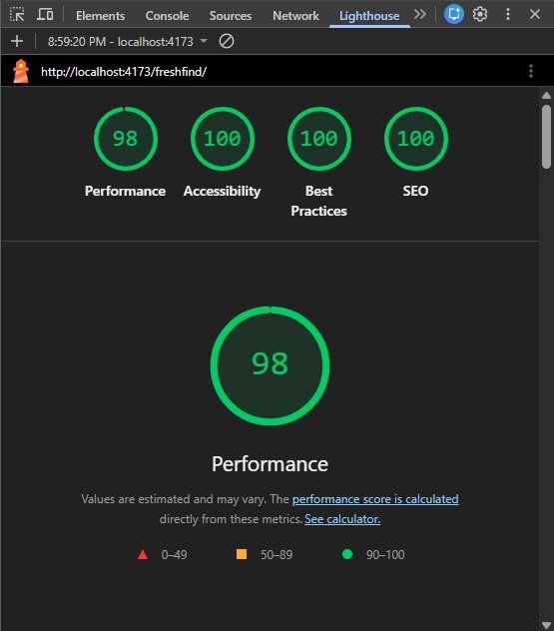  Figure 13. Home page on desktop after the fixes

5.9 Things we kept on purpose
- Reduce unused JavaScript. All nine pages come in one bundle, so once the site has loaded, moving between pages is instant. Splitting it would save about 52 KiB on the first visit, and we chose the instant page changes.
- Use efficient cache lifetimes. This is how long the browser is told to keep downloaded files. It is set by the web server that hosts the site, not by our code, and the preview server we tested on is only for testing.
- The Google Maps embeds on Market Detail and Contact Us load Google's own code. The SRS asks for an embedded map, so they stay.

6 Project Installation Instructions

6.1 Requirements
- Node.js 20.19 or newer
- npm, which comes with Node.js
- A modern browser such as Chrome, Edge or Firefox

6.2 Steps
1. Unzip the source code folder, or clone the repository.
2. Open a terminal inside the freshfind folder.
3. Run npm install to download the project dependencies.
4. Run npm run dev to start the development server.
5. Open the local address printed in the terminal, usually http://localhost:5173/freshfind/

6.3 Production build
1. Run npm run build to create the optimized site in the dist folder.
2. Run npm run preview to view the built site locally.
3. The dist folder can be uploaded to any static host such as GitHub Pages.
No environment variables, database or API keys are needed.
The site is also live at https://geraldxtra.github.io/freshfind/ and is published automatically from our dev branch with GitHub Pages.

7 Assumptions
We made these assumptions while building FreshFind.
1. All market and produce data is sample data created for this project to demonstrate the site. Market names are based on real Lagos areas, but details such as hours and produce lists are illustrative.
2. The site presents eight sample markets. More can be added by adding records to markets.json without changing any code.
3. The chatbot answers only questions covered in its JSON dataset. It matches keywords and phrases and does not learn or connect to any outside service.
4. Bookmarks and notes are kept in the browser session only and disappear when the tab is closed, as the brief requires session only notes and no server storage.
5. The login and sign up buttons are decorative. The brief asks for non functional buttons for design continuity and the site has no user accounts.
6. Seasonal information is based on general Nigerian growing seasons and is meant as a guide.
7. The visitor counter is simulated in the browser as the brief describes, not a real analytics count.
8. Map features use the browser location only after the visitor allows it. If permission is denied the site still works fully. Maps are embedded from Google Maps and need an internet connection to display.
9. Market and produce photos were generated with AI tools and are illustrations of the sample data. Team photos are real.

8 Team and Challenges
FreshFind was built by Team Tech Hive, four students of Aptech Computer Education Nigeria. Each member was responsible for their own pages, and the team leader was also responsible for the parts every page shares.

8.1 Roles

Eberechukwu Uchechukwu Gerald, Team Leader
Responsible for the Home page, the chatbot and its rule engine, the Bookmarks page and the Not Found page. Also responsible for the data files and the shared frame: the theme, Navbar, Footer, search overlay, market card, bookmark button, breadcrumbs, helpers and the bookmarks context. Planned the project from the SRS, chose the stack and the design direction, set up the repository, the branches and the working rules, and wrote the team documentation. Reviews every pull request and runs the integration testing, Lighthouse, the report and the demo video.

Chukwujekwu Chimdiuso Amanda
Responsible for the Market Directory and the Contact Us page. The Market Directory is the biggest list page on the site: filtering by area, day, produce type and open now, three sort orders including distance after location is allowed, filters arriving from the address bar, the results count and the empty state. The Contact page has the live location map that handles allowed, blocked and unsupported states.

Ibrahim Ogunsola Kelvin
Responsible for the Market Detail page and the About Us page. Market Detail is the deepest page on the site: one market loaded from the id in the address, the banner with the live open badge and save button, the weekly schedule table with today highlighted, the typical produce tiles pulled from the produce data, the map, the next opening time and the directions link. The About page has the mission, the three reasons and the team cards.

Uyi Osakue Uhunwa
Responsible for the Produce Guide and the Seasonal Picks page. The Produce Guide has the five category tabs, the search box, the season badges and the Found at links into market pages. Seasonal Picks has the banner, this week's top picks computed from the current month, and the season calendar that draws a bar for every month each item is in season.

8.2 Challenges we faced and how we handled them
1. Reading the SRS the right way. At first everything looked like a page. We learned to separate pages from features. The visitor counter, the live clock, breadcrumbs, the dummy login and the chatbot launcher are features that live inside the shared frame, so they were built once and every page inherited them.
2. Getting a consistent design out of AI image tools. Our first mockups came out as the same layout with different colors, then as different layouts with different navbars. We fixed it by writing one prompt per page that carried the same navbar, footer and style rules, generating full page views, and then editing every page against one reference so all nine matched.
3. Market photos that all looked the same. The first batch shared one camera angle and one time of day and a judge would have called them identical. We regenerated each market with its own angle, light, setting and mood so eight markets read as eight different places.
4. Running a repository for four people who were not in one room. We agreed a simple rule set: main is protected, dev is where work meets, everyone builds on their own branch and merges by pull request, only Gerald edits the data and shared files. We hit real problems on the way: a commit history that needed cleaning, a terminal that does not accept command chaining, login prompts that swallowed commands and pushes of large image folders that looked frozen. Each one taught us something we wrote into the team guide.
5. Matching the coded layout to the design. The first navbar and footer were close but not the same: text too large, logo too small, spacing off, the footer too tall. We measured against the mockup, moved the styles into proper CSS files so media queries could work, and added the phone layout at the same time.
6. Everything looked too big at 100 percent on a laptop. Our mockups were 1024 pixels wide and looked smaller than the real thing. We tightened the type scale, the spacing tokens and the card sizes, capped descriptions at two lines and widened the content area a little, then checked every page at 100 percent instead of zoomed out.
7. Keeping the chatbot inside the rules. The brief forbids a live AI service, but a chatbot that only repeats canned lines is weak. We built a rule engine that recognises market names, produce names and days, scores intents by keywords, and fills pre written answer templates from the data files. It answers real questions and it never leaves the browser.
8. Time. The whole build happened in under two days with people working remotely. What made it possible was doing the foundations first: the data files, the theme, the shared components and a team guide precise enough that each person could build their pages without waiting for anyone.
9. Understanding each other's code. The judges can ask any of us about any part. Each member wrote a walkthrough of their own pages, and we read each other's pull requests before merging.

9 AI Tools Acknowledgment
Following the TechWiz 7 guidelines, these are the AI tools Tech Hive used and what we used them for.
- ChatGPT image generation: the design mockups for the nine pages, the photos of the markets and the produce, the logo and the chatbot avatar.
- Claude: code assistance, planning from the SRS, debugging, the sample data, and help with the documentation and diagrams.
- Claude Code: code assistance inside our project, including setting up the project, converting the photos to WebP and applying the fixes we found with Lighthouse.

How we used them
We used AI as a support tool, as the guidelines allow. The design choices, the review and the testing were ours. We checked every page against the SRS, ran and read the Lighthouse tests ourselves, and changed what did not fit. We are responsible for every line we submit and will explain our code and design decisions to the judges.

