A Transparent GIS-Based Multi-Criteria Framework for Brownfield and Regeneration Site Suitability Mapping: A Case Study of Hull, United Kingdom
Ayebawanaemi Geraldine Winston
Independent Researcher, United Kingdom
Correspondence: [author email]
Abstract
England faces sustained pressure to deliver new housing on previously developed (brownfield) land rather than greenfield sites, a priority reflected in national planning policy and, at the local scale, in Hull City Council's current regeneration programme, which includes waterfront, city-centre and neighbourhood-level schemes. Identifying which land is genuinely regeneration-ready is complicated in flood-exposed estuarine cities such as Hull, where a literal, unweighted application of statutory flood-risk data would classify the majority of the administrative area as unsuitable, including sites that are, in practice, already being redeveloped under approved planning permissions. This paper presents a reproducible, open-data, GIS-based multi-criteria decision analysis (GIS-MCDA) framework that scores a 100-metre grid across Hull on ground stability, infill preference and accessibility, while treating flood risk and protected green space as differentiated constraints rather than uniform exclusions. Flood Zone 3 is treated as a strong scoring penalty and Flood Zone 2 as a lighter one, mirroring the logic of the Sequential and Exception Test used in English planning practice, while designated green space remains a hard exclusion. Face-validity checks against two known, actively developed regeneration sites (East Bank Urban Village and Albion Square) show that this differentiated treatment produces plausible outputs, whereas a hard flood-zone exclusion does not. The framework is implemented as an open, version-controlled pipeline and an interactive web application that exposes every weighting decision to the user rather than embedding it in an opaque model. The paper positions the resulting artefact explicitly as a screening and demonstration tool rather than a substitute for statutory flood-risk assessment, site investigation or professional planning judgement, and discusses the limitations of the approach and directions for further validation.
Keywords: GIS; multi-criteria decision analysis; brownfield redevelopment; urban regeneration; flood risk policy; suitability mapping; Hull; United Kingdom; reproducible research

1. Introduction
The United Kingdom continues to face a sustained shortfall in housing delivery relative to demographic and policy targets, and national planning guidance has for some years directed local authorities to prioritise the reuse of previously developed (“brownfield”) land ahead of greenfield expansion. This preference is codified in the Town and Country Planning (Brownfield Land Register) Regulations 2017, which require every local planning authority in England to maintain a public register of sites assessed as suitable, available and achievable for housing-led development (UK Government, 2017). Brownfield land is estimated to offer capacity for over one million new homes nationally (as reported in Hammond et al., 2023, citing CPRE, 2022), yet identifying which sites are genuinely regeneration-ready, rather than merely vacant or previously developed, remains a non-trivial spatial decision problem.
Hull, a city on the Humber estuary in East Yorkshire, illustrates this problem in an acute form. The city is the subject of an active, multi-strand regeneration programme: the East Bank Urban Village waterfront scheme, the Albion Square mixed-use redevelopment, and the council's Priority Streets housing improvement programme collectively represent several hundred million pounds of planned investment, and are explicitly named in Hull City Council's 2024–2028 Council Plan alongside housing, climate change and neighbourhood renewal as strategic priorities (Hull City Council, 2024). At the same time, Hull is a low-lying estuarine city, much of it below high-tide level and protected from tidal flooding by engineered defences including the Hull Tidal Surge Barrier. A substantial majority of the city's administrative area falls within Environment Agency Flood Zone 3, the highest statutory flood-risk category. This creates an apparent contradiction for any spatial suitability model: a literal, unweighted treatment of flood-zone data as a hard exclusion criterion would classify almost the entire city, including sites with live planning permission, as unsuitable for development.
This paper addresses that contradiction directly. Rather than treating flood-risk data uncritically, it asks how a GIS-based multi-criteria suitability model can be constructed so that its treatment of flood risk reflects how flood risk actually functions within the English planning system — namely as a factor that is weighed and mitigated through the Sequential and Exception Test, rather than one that operates as an automatic prohibition (Ministry of Housing, Communities and Local Government, 2024). The paper further argues that this kind of methodological decision should be made explicit and defensible rather than absorbed silently into a model's design.

1.1 Aim and Objectives
The aim of this study is to develop and demonstrate a transparent, reproducible GIS-MCDA framework for screening land in Hull for brownfield and regeneration suitability, in which the treatment of flood risk is explicitly aligned with national planning policy rather than applied as an undifferentiated constraint. The specific objectives are to: (1) construct a spatial suitability index from open geospatial data covering ground stability, infill preference and accessibility; (2) design and justify a differentiated treatment of flood risk and protected green space within the exclusion and penalty structure of the model; (3) assess the face validity of the resulting suitability surface against known, currently active regeneration sites; and (4) implement the framework as an open, reproducible pipeline with an accompanying interactive application, so that its assumptions and weights can be inspected and adjusted by others.

1.2 Research Questions
The study is organised around three questions. First, can a transparent, weighted-overlay GIS-MCDA approach produce a brownfield suitability surface for a flood-exposed estuarine city that is consistent with observed regeneration activity? Second, what is the practical effect of treating flood risk as a graduated penalty, informed by the Sequential and Exception Test, rather than as a hard exclusion? Third, what are the principal limitations of a screening-level, open-data model of this kind, and what would be required to move from a demonstration artefact towards a decision-support tool usable by a planning authority?

1.3 Contribution
This paper contributes, first, a worked demonstration of GIS-MCDA applied specifically to the coastal/estuarine flood-risk context, an area under-represented in the wider brownfield suitability literature, which has more often been developed for inland post-industrial contexts (e.g. Hammond et al., 2023, for Liverpool; Chen, 2014, for Regina). Second, it contributes a concrete, reproducible operationalisation of the Sequential/Exception Test logic as a scoring penalty within an MCDA weighting scheme, rather than treating flood zoning as a binary mask, which the results suggest is necessary for face-valid outputs in flood-exposed UK cities. Third, the entire pipeline, from raw shapefiles to an interactive suitability explorer, is released as open, version-controlled code, consistent with recommendations in the literature for transparent and inspectable spatial decision support (Malczewski, 2006).

2. Literature Review

2.1 GIS-Based Multi-Criteria Decision Analysis
Geographic Information Systems have been combined with multi-criteria decision analysis (MCDA) since at least the 1980s to support spatial decisions involving multiple, often conflicting, objectives (Malczewski, 1999). Malczewski's (2006) survey of over three hundred refereed articles published between 1990 and 2004 established GIS-MCDA as a distinct and rapidly growing methodological family, and identified weighted linear combination and its variants — in which standardised criterion layers are combined according to explicit weights — as the dominant approach in applied land-suitability work. Malczewski and Rinner's (2015) subsequent synthesis situates GIS-MCDA within the broader discipline of geographic information science and reiterates a recurring theme in the literature: that the transparency of a suitability model, in the sense that its criteria, standardisation choices and weights can be inspected and challenged, is as important to its usefulness as its predictive accuracy, particularly where outputs are intended to inform public decision-making rather than purely technical optimisation.
Applied case studies illustrate both the flexibility and the limitations of the approach. Chen (2014) applied a weighted-product GIS-MCDA model to land-use suitability in Regina, Canada, using socio-economic criteria, and explicitly noted that the reliability of such models depends heavily on the number and selection of criteria and on how their weights are determined, cautioning against over-interpreting outputs derived from a small criterion set or from weights assigned by a single analyst rather than through structured stakeholder or expert elicitation. This caution is directly relevant to the present study, which similarly relies on an initial, equally weighted criterion set pending further validation.

2.2 Brownfield and Regeneration Suitability Modelling
A distinct but overlapping literature addresses GIS-MCDA specifically for brownfield redevelopment. Hammond et al. (2023) describe a web-based decision support system developed for the Liverpool City Region, integrating land-use suitability, economic viability and ground-risk modules across approximately 32,000 hectares of post-industrial land, and evaluated through structured trials with regional planning stakeholders. Their review work (cited within the same paper) further catalogues a wide range of prior brownfield decision-support tools spanning remediation technology selection, land-use planning and sustainability assessment, and identifies increased use of qualitative, locally grounded criteria as a persistent gap. Other applications extend brownfield suitability analysis into adjacent domains, including prioritisation for green-infrastructure conversion and green-building certification criteria, generally following the same weighted-overlay logic established by Malczewski (2006).
A common feature of this literature is that exclusion and constraint layers, land uses or conditions that rule a site out entirely rather than merely reducing its score, are treated as a separate methodological category from the weighted criteria themselves (Malczewski, 1999). However, published brownfield suitability studies have rarely addressed cities in which a nationally mapped hazard layer, such as fluvial or coastal flood risk, would, if treated as a hard exclusion, remove the majority of the study area from consideration. This is the specific methodological problem addressed in the present study.

2.3 Flood Risk in English Planning Policy
In England, flood risk is managed within the planning system primarily through the Sequential Test and, where necessary, the Exception Test, both set out in the National Planning Policy Framework (NPPF). The Sequential Test requires that new development be directed towards land with the lowest probability of flooding, on the basis of Environment Agency flood zone mapping, but does not operate as an absolute prohibition on development within higher-risk zones; where no reasonably available lower-risk alternative exists, the Exception Test allows development to proceed in Flood Zones 2 or 3 provided that wider sustainability benefits are demonstrated and that flood risk to the development and to others is adequately managed (Ministry of Housing, Communities and Local Government, 2024). This graduated, evidence-based approach, rather than a blanket exclusion, is the mechanism by which flood-exposed UK cities continue to accommodate new development within statutory flood zones, generally supported by structural defences, sustainable drainage and site-specific mitigation. It is notable that the NPPF has itself continued to evolve during the course of this research, with a further revision published in August 2026 reorganising flood-risk policy into a dedicated set of provisions; this underlines that any operational suitability model of this kind should be treated as reflecting the policy environment at a particular point in time rather than as a permanently fixed rule set.

2.4 Research Gap
Taken together, the literature establishes GIS-MCDA as a well-founded and widely applied method for land and brownfield suitability assessment, and separately establishes that English flood-risk policy is explicitly non-absolute in its treatment of higher-risk zones. What is less well established in the published literature is a worked methodology that operationalises this policy nuance directly within the mathematical structure of a GIS-MCDA suitability model, particularly for a flood-exposed English coastal or estuarine city, where the naive alternative (a hard flood-zone exclusion) produces results that are readily falsifiable against observed development activity. This paper addresses that gap using Hull as a case study, and treats the resulting methodological adjustment, along with its justification and its limits, as a primary contribution of the work rather than an incidental implementation detail.

3. Study Area and Data
Hull (Kingston upon Hull) is a city of approximately 275,000 residents (ONS 2024 mid-year estimate) on the north bank of the Humber estuary in East Yorkshire, England. Much of the city lies at or below high-tide level and is protected from tidal and storm-surge flooding by engineered defences, including the Hull Tidal Surge Barrier. Reflecting this exposure, a substantial majority, on the order of four-fifths, of Hull's administrative area falls within Environment Agency Flood Zone 3. The city is simultaneously the subject of an active regeneration programme identified in Hull City Council's 2024–2028 Council Plan, which names housing delivery, economic growth, climate resilience and safer, greener neighbourhoods as core priorities, and which is being delivered in part through named schemes including the East Bank Urban Village waterfront development and the Albion Square city-centre mixed-use redevelopment, alongside the council's neighbourhood-level Priority Streets housing improvement programme (Hull City Council, 2024).

3.1 Data Sources
The analysis draws on the following open or previously licensed geospatial datasets, all clipped to the Hull administrative boundary and harmonised to the British National Grid coordinate reference system (EPSG:27700):
Dataset | Source | Role in the model
Administrative boundary | Ordnance Survey boundary data | Defines the study area and analysis extent
Building footprints | Ordnance Survey building data | Basis for the infill-preference sub-score
Superficial/bedrock geology | British Geological Survey | Basis for the ground-stability sub-score
Recorded flood outlines / Flood Zones 2 and 3 | Environment Agency | Constraint layer (graduated penalty)
Protected green space | Ordnance Survey Open Greenspace | Constraint layer (hard exclusion)
Road network | Ordnance Survey road data | Basis for the accessibility sub-score

During data preparation it was found that the administrative boundary layer was supplied in geographic coordinates (EPSG:4326) while all other layers were already in the British National Grid; this was corrected by reprojection prior to any spatial analysis, and the reprojection was verified by confirming that the reprojected boundary's extent aligned spatially with the extent of the other Hull layers.

4. Methodology

4.1 Overview
The methodology follows the weighted linear combination approach to GIS-MCDA described by Malczewski (1999, 2006), in which the study area is discretised into a regular grid, each grid cell is scored on a set of standardised criteria, a subset of layers is used to apply exclusions or penalties rather than contribute to the weighted score, and the weighted, constrained scores are aggregated into a single suitability index and classified into ordinal suitability bands. Figure 1 summarises the resulting pipeline.
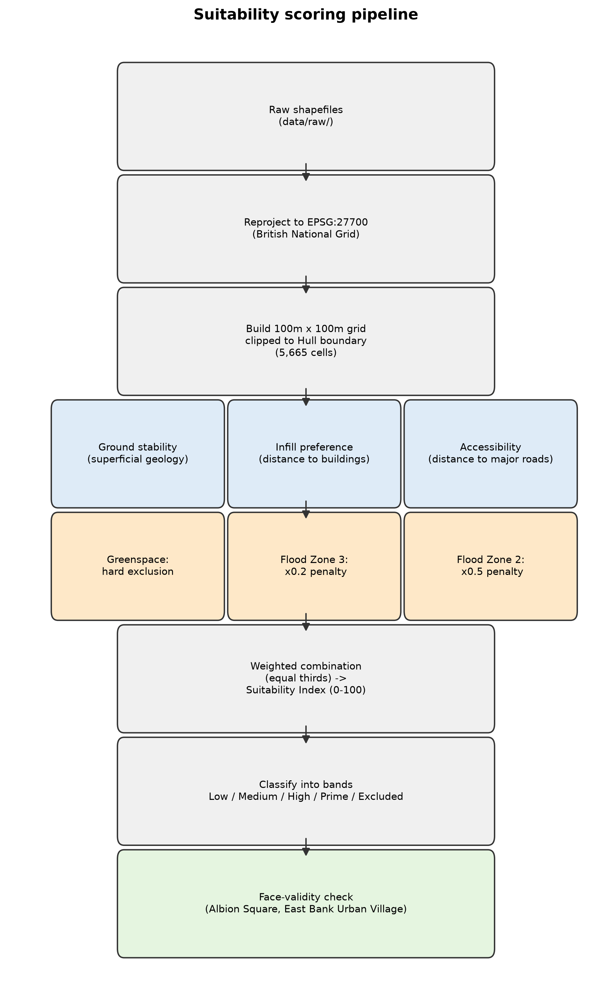
Figure 1. Suitability scoring pipeline, from raw shapefiles to classified suitability bands and the face-validity check.

4.2 Spatial Framework
Hull was discretised into a regular 100-metre grid clipped to the administrative boundary, yielding 5,665 grid cells covering the city. A 100-metre resolution was selected as a pragmatic compromise between spatial specificity, useful for distinguishing between neighbourhoods and site clusters, and computational tractability given the vector nature of the underlying source data, several layers of which (building footprints, road centrelines) are inherently finer-grained than the grid itself.

4.3 Criteria and Standardisation
Three weighted sub-scores were derived for each grid cell, each standardised to a common 0–100 range prior to aggregation.
Ground stability. Derived from British Geological Survey superficial and bedrock geology polygons, with indicative scores assigned by geological unit (for example, till-dominated units scored highly, sand and gravel units scored moderately, and alluvial units scored lowest, reflecting their differing engineering characteristics for foundation and construction purposes). It was noted during implementation that Hull's bedrock geology is dominated by a single chalk unit across most of the city, meaning that the bedrock layer alone offers limited spatial differentiation; superficial geology, which varies more locally, therefore carries most of the discriminating power in this sub-score.
Infill preference. Calculated as a linear distance decay from the nearest existing building footprint, scoring 100 at 0 metres from an existing building and declining to 0 at a distance of 300 metres or more. This operationalises a standard brownfield and sustainable-development preference for site selection close to existing development and infrastructure over greenfield expansion further from the existing urban fabric.
Accessibility. Calculated as a linear distance decay from the nearest major road (A road, B road or Primary road, including dual-carriageway variants), scoring 100 at 0 metres and declining to 0 at a distance of 800 metres or more. Ordinary local streets are dense throughout the built-up area of Hull and would not meaningfully differentiate grid cells, so proximity to the strategic road network was used instead as a proxy for how well connected a site is for larger-scale housing and mixed-use regeneration.

4.4 Exclusion and Constraint Layer
Two additional layers were treated as constraints rather than weighted criteria, but were deliberately differentiated in how they constrain the model, reflecting a substantive methodological decision that forms the core contribution of this paper.
Protected green space was treated as a hard exclusion: any grid cell substantially overlapping a mapped green space polygon was assigned an “Excluded” classification regardless of its other sub-scores, on the basis that such land is not, in general, available for redevelopment.
Flood risk was treated as a graduated penalty rather than a hard exclusion. An initial design considered treating Flood Zone 3 as a hard exclusion, mirroring the treatment applied to green space; however, this design was rejected after a preliminary run showed that approximately 78 per cent of Hull's grid cells (4,439 of the 5,665 cells), including cells intersecting the East Bank Urban Village and Albion Square regeneration sites, were classified as “Excluded” under this rule. Because both sites carry live redevelopment activity, this outcome indicated that a hard exclusion rule was empirically inconsistent with observed planning practice, rather than merely being a conservative modelling choice. The rule was revised so that Flood Zone 3 applies a strong multiplicative penalty (a factor of 0.2) to the underlying weighted score, and Flood Zone 2 applies a lighter penalty (a factor of 0.5), rather than excluding cells outright. This design choice was made specifically to reflect the logic of the Sequential and Exception Test (Ministry of Housing, Communities and Local Government, 2024), under which flood risk raises the evidentiary bar for development rather than prohibiting it categorically, particularly where flood defences and mitigation are already in place, as they are across much of Hull.

4.5 Weighting and Aggregation
The three weighted sub-scores (ground stability, infill preference and accessibility) were combined using an equal-weighted linear combination, with each criterion contributing a weight of 0.33 (normalised to sum to 1) in the default configuration. Equal weighting was adopted as a transparent, defensible starting point in the absence of a structured expert or stakeholder elicitation exercise, consistent with the caution raised by Chen (2014) regarding the sensitivity of GIS-MCDA outputs to weighting assumptions. Rather than fixing this choice, the accompanying interactive application exposes the three weights as adjustable parameters, automatically renormalised to sum to 1, so that the sensitivity of the suitability surface to alternative weighting schemes can be explored directly by any user rather than being hidden inside the analysis. The resulting weighted, penalty-adjusted score for each cell was scaled to a 0–100 Suitability Index and classified into five ordinal bands: Excluded, Low, Medium, High and Prime.

4.6 Face-Validity Assessment
Because no ground-truth dataset of “correct” regeneration suitability exists for Hull, the model was assessed for face validity rather than predictive accuracy: the approximate locations of two named, currently active regeneration sites, East Bank Urban Village and Albion Square, were checked against the classified suitability surface under both the rejected hard-exclusion design and the adopted graduated-penalty design. This is consistent with standard practice in the GIS-MCDA literature of sense-checking model outputs against known cases prior to wider application (Malczewski, 2006), while explicitly not constituting an independent statistical validation of the model's predictive performance.

4.7 Implementation and Reproducibility
The full pipeline, from raw shapefile ingestion through reprojection, grid construction, sub-score calculation, constraint application and final index aggregation, was implemented in Python using open geospatial libraries (geopandas, shapely, pyproj, rasterio). The pipeline, its outputs (static suitability maps, a standalone interactive HTML map, and a browser-based application with adjustable weights and inspectable per-cell score breakdowns) and full documentation of the methodological decisions described above are published as an open, version-controlled repository, in line with recommendations for reproducible and inspectable spatial decision-support research (Malczewski, 2006; Malczewski & Rinner, 2015).

5. Results
Across the 5,665 grid cells covering Hull, the mean Suitability Index among non-excluded cells was 18.6 on the 0–100 scale under the adopted, equally weighted configuration. The suitability surface is dominated by the Low band, consistent with expectation given that most of the city's grid cells intersect Flood Zone 3 and therefore incur the strong scoring penalty described in Section 4.4; High and Prime cells are comparatively rare and are concentrated in the west and south-west of the city, at greater distance from the estuary and, correspondingly, at lower statutory flood risk. Figure 2 shows the classified suitability surface, and Figure 3 shows the band distribution referred to above.
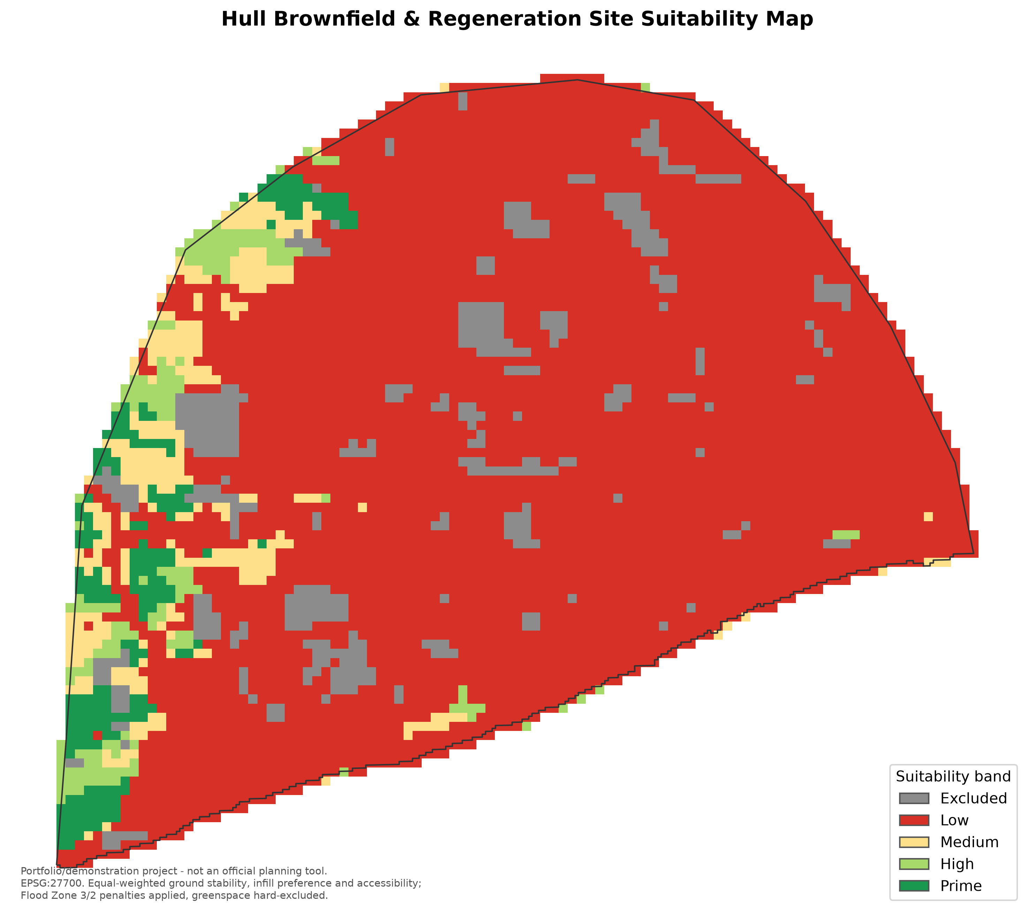
Figure 2. Classified suitability surface across Hull's 100m analysis grid (equal-weighted ground stability, infill preference and accessibility; Flood Zone 3/2 penalties applied; greenspace hard-excluded).
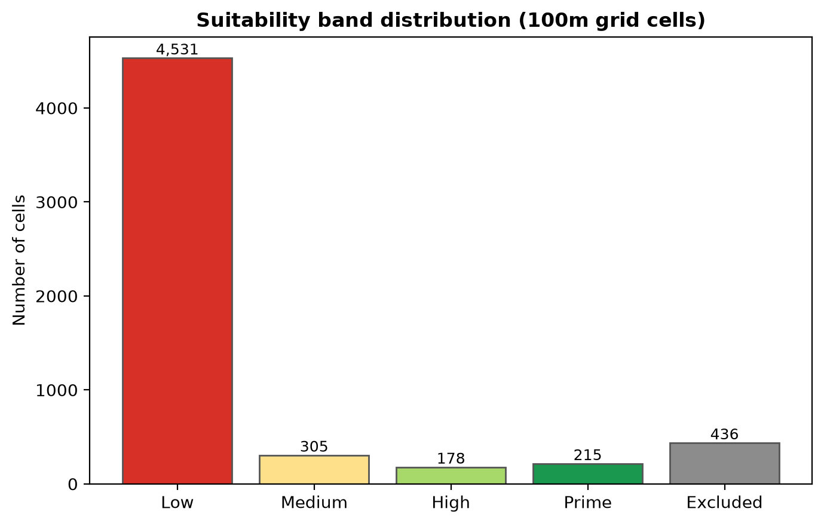
Figure 3. Distribution of grid cells across suitability bands.
The face-validity comparison described in Section 4.6 produced a clear result. Under the rejected hard-exclusion treatment of Flood Zone 3, both East Bank Urban Village and Albion Square fell within cells classified as “Excluded.” Under the adopted graduated-penalty treatment, the East Bank Urban Village site shifted into the Low suitability band, a plausible outcome for a flood-exposed site with an approved, mitigated redevelopment scheme, rather than an implausible blanket exclusion. The Albion Square site continued to show as “Excluded” under the revised rule; inspection indicated that this was attributable to the site's approximate coordinate falling within a grid cell substantially overlapping a mapped green space (Queen's Gardens), and therefore reflected the hard-exclusion rule for green space rather than a residual flaw in the flood-risk treatment. This distinction, that one apparent anomaly was correctly attributable to a different, independently justified rule rather than to an error in the revised flood-risk logic, was treated as a further, if partial, corroboration of the model's internal consistency.
The interactive application allows the sensitivity of these results to weighting assumptions to be explored directly. Increasing the relative weight assigned to infill preference concentrates High and Prime classifications more tightly around existing dense development; increasing the weight assigned to accessibility extends favourable classifications along the arterial road network. These qualitative sensitivities are consistent with the intended behaviour of a linear-combination MCDA model (Malczewski, 2000, as summarised in Malczewski, 2006) and are presented to end users explicitly, rather than being fixed inside a single, undocumented output map.

6. Discussion
The central methodological finding of this study is that a literal, undifferentiated treatment of statutory flood-zone data as a hard exclusion criterion is not merely a conservative simplification when applied to a flood-exposed English estuarine city; it produces an output that is directly falsifiable against observed planning outcomes, since it classifies actively developed, permitted sites as wholly unsuitable. Reframing flood risk as a graduated penalty, explicitly modelled on the logic of the Sequential and Exception Test rather than as an arbitrary softening of the constraint, resolved this inconsistency while preserving flood risk as a substantial, and appropriately dominant, negative influence on the overall suitability surface. This suggests that GIS-MCDA suitability studies conducted for other flood-exposed UK coastal or estuarine settlements, several of which face comparable proportions of their area falling within Flood Zones 2 and 3, would benefit from an equivalent, policy-grounded treatment of flood-risk layers rather than a generic exclusion mask carried over from suitability studies conducted in inland or lower flood-risk contexts (cf. Chen, 2014; Hammond et al., 2023).
The decision to expose model weights and the exclusion/penalty logic directly to end users, rather than presenting only a single output map, follows directly from the broader argument in the GIS-MCDA literature that the value of these models to planning and policy audiences rests substantially on their inspectability (Malczewski, 2006; Malczewski & Rinner, 2015). In this study, that transparency also served an internal quality-assurance function: it was the explicit checking of the model's outputs against named real-world sites, rather than an assumption that the initial design was correct, that surfaced the flood-exclusion problem in the first place. This supports treating face-validity checking against known cases as a standard, rather than optional, step in applied GIS-MCDA workflows of this kind.
More broadly, the study illustrates a methodological point that generalises beyond Hull: national hazard datasets (flood zones, in this case, but potentially also datasets covering, for example, contamination, subsidence, or coastal erosion risk) are frequently used in spatial suitability modelling as though they map directly onto a binary developable/undevelopable distinction, when the planning policy that actually governs decisions on such land is frequently more nuanced, weighing risk against benefit and mitigation rather than applying it as an absolute bar. Encoding that nuance explicitly, and documenting the reasoning for doing so, is presented here as good practice for applied, policy-relevant GIS-MCDA work rather than as an ad hoc fix specific to this case study.

7. Limitations and Future Work
Several limitations should be noted. First, the equal default weighting of the three criteria (ground stability, infill preference, accessibility) was adopted as a transparent starting point rather than derived from a structured expert elicitation or stakeholder consultation process, such as the Analytic Hierarchy Process used in comparable studies (as reviewed in Malczewski, 2006); the interactive application mitigates this limitation by making the weights adjustable, but does not resolve the underlying need for a defensible default. Second, Hull's bedrock geology is dominated by a single chalk unit across most of the study area, which limits the spatial discriminating power of the ground-stability sub-score at bedrock level; a more detailed treatment incorporating superficial geology variation, made ground and known contamination records, where available, would likely improve this component. Third, the face-validity assessment conducted in this study, checking two known sites against the classified output, is a useful but limited form of validation; it is not equivalent to a formal accuracy assessment against a comprehensive, independently derived set of confirmed regeneration or non-regeneration sites, and the model's outputs should not be interpreted as validated predictions in the statistical sense. Fourth, the model does not currently incorporate land ownership, ground contamination history, utility infrastructure capacity, or development viability and cost, each of which materially affects whether a site is genuinely regeneration-ready in practice and each of which is addressed, at least partially, in more comprehensive decision-support systems such as that described by Hammond et al. (2023) for Liverpool. Fifth, the 100-metre grid resolution, while a reasonable compromise for a city-wide screening tool, is coarser than parcel-level analysis and can, as observed with the Albion Square case, produce apparent anomalies driven by which land use dominates a given cell rather than by the specific site of interest. Finally, the model reflects flood-risk and planning policy as understood at the time of writing; national planning policy in England, including the treatment of flood risk within the NPPF, is subject to periodic revision, most recently in August 2026, and any operational use of a model of this kind would require its policy assumptions to be reviewed against the currently applicable framework.
Future work could usefully extend this study in several directions: conducting a structured weight-elicitation exercise with planning or GIS professionals; incorporating additional constraint layers such as land ownership and known contamination where data permit; validating the framework against the Hull Brownfield Land Register once a sufficiently detailed comparison dataset is available; and testing the transferability of the graduated flood-risk penalty approach in other UK coastal or estuarine cities with comparable flood exposure, to assess whether the specific penalty values adopted here (0.2 for Flood Zone 3, 0.5 for Flood Zone 2) require local calibration or generalise reasonably well.

8. Conclusion
This paper has presented a transparent, reproducible GIS-based multi-criteria decision analysis framework for screening brownfield and regeneration suitability in Hull, United Kingdom, and has shown that a graduated, policy-grounded treatment of flood risk, rather than a hard exclusion, is necessary to produce outputs consistent with observed regeneration activity in a flood-exposed estuarine city. The resulting suitability surface, and the interactive application through which it can be explored and its weighting assumptions adjusted, is intended as a screening and demonstration tool that makes its assumptions explicit and inspectable, rather than as a replacement for statutory flood-risk assessment, site investigation, or professional planning judgement. The methodological approach of encoding graduated planning-policy logic, rather than binary hazard exclusion, directly into the structure of a GIS-MCDA model is offered as a transferable contribution for suitability studies conducted in other flood-exposed UK settlements.

References
Chen, J. (2014). GIS-based multi-criteria analysis for land use suitability assessment in City of Regina. Environmental Systems Research, 3(1), 13. https://doi.org/10.1186/2193-2697-3-13
Hammond, E. B., Coulon, F., Hallett, S. H., Thomas, R., Dick, A., Hardy, D., Dickens, M., Washbourn, E., & Beriro, D. J. (2023). From data to decisions: Empowering brownfield redevelopment with a novel decision support system. Journal of Environmental Management, 347, 119145. https://doi.org/10.1016/j.jenvman.2023.119145
Hull City Council. (2024). Council Plan 2024–2028.
Malczewski, J. (1999). GIS and Multicriteria Decision Analysis. John Wiley & Sons.
Malczewski, J. (2006). GIS-based multicriteria decision analysis: a survey of the literature. International Journal of Geographical Information Science, 20(7), 703–726. https://doi.org/10.1080/13658810600661508
Malczewski, J., & Rinner, C. (2015). Multicriteria Decision Analysis in Geographic Information Science. Springer.
Ministry of Housing, Communities and Local Government. (2024). National Planning Policy Framework. HM Government, United Kingdom.
UK Government. (2017). The Town and Country Planning (Brownfield Land Register) Regulations 2017 (SI 2017/403). HM Government, United Kingdom.

Data and Code Availability
The analysis pipeline, interactive application, and full methodological documentation, including the reasoning underlying the flood-risk and green-space treatment described in Section 4.4, are available in an open, version-controlled repository at: github.com/Geraldine-Winston/hull-brownfield-suitability-mapping. Source geospatial data are derived from Ordnance Survey, British Geological Survey, and Environment Agency products under their respective open licensing terms.

Author's Note on Verification (added post-draft)
This draft was cross-checked against the live analysis pipeline and its outputs in the project repository (github.com/Geraldine-Winston/hull-brownfield-suitability-mapping) on 2 September 2026. Figures 1-3 were generated directly from src/export_outputs.py rather than drawn by hand. The following figures were corrected to match the pipeline's actual output: the Hull population estimate (approximately 260,000 -> approximately 275,000, ONS 2024 mid-year estimate) and the proportion of grid cells classified as "Excluded" under the rejected hard flood-zone-exclusion design (approximately 79 per cent -> approximately 78 per cent, i.e. 4,439 of 5,665 cells). The description of the accessibility sub-score in Section 4.3 was also corrected: it is derived from distance to the major road network only (A/B/Primary roads, 800m decay), not the full road network as originally stated, since local streets are too dense across Hull to differentiate grid cells. All other numeric claims checked (5,665 grid cells; mean Suitability Index of 18.6 among non-excluded cells; penalty factors of 0.2 for Flood Zone 3 and 0.5 for Flood Zone 2; equal one-third weighting of the three sub-scores; the face-validity outcomes for Albion Square and East Bank Urban Village under both the rejected and adopted flood-risk treatments) matched the repository's code and outputs exactly.
Two claims outside the repository's own data were spot-checked externally: the NPPF revision "published in August 2026" (Section 2.3) is accurate - the revised NPPF was published on 17 August 2026 and restructured flood-risk policy into a dedicated chapter, consistent with the paper's description. Academic citations (Malczewski, Chen, Hammond et al., and the cited government sources) were not independently verified against their original publications as part of this check. The general dataset provenance described in Section 3.1 (Ordnance Survey, British Geological Survey, Environment Agency) is plausible but could not be confirmed against a Hull-specific source-validation record: the repository's data/raw/dataset_validation_links.xlsx file appears to have been carried over from a different project (it references an Oxfordshire boundary layer and generic filenames without the Hull-specific naming used in this project's actual data) and should be treated as unverified for this paper.

