${photo}
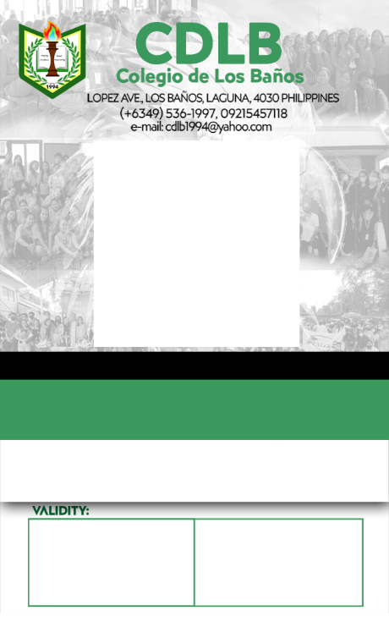
LRN: ${lrn}
${id_number}
${strand}
${name}
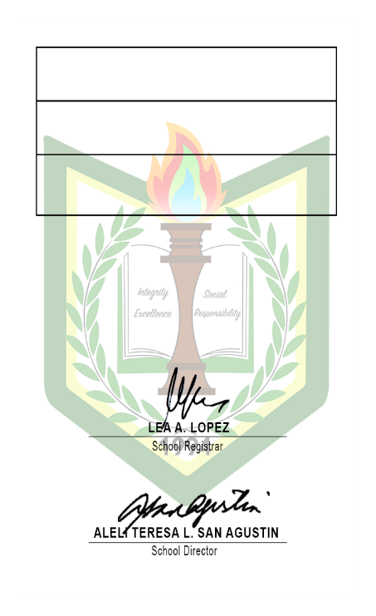
${guardian_contact}
${guardian_name}
${address}

