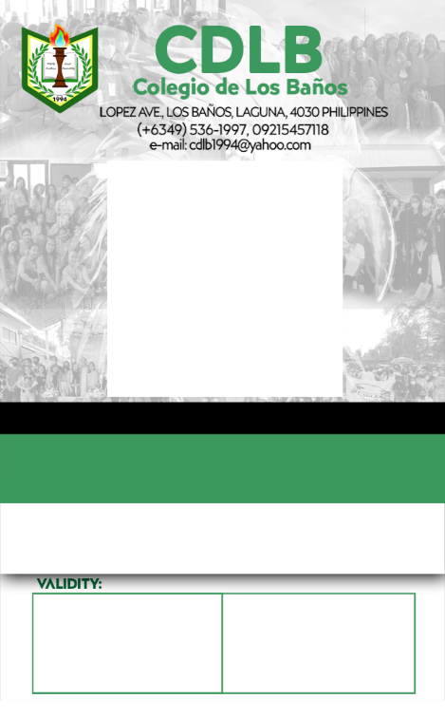
${strand}
${strand}
${name}
${photo}
LRN: ${lrn}
${id_number}

${address}
${guardian_name}
${guardian_contact}
TERMS & CONDITIONS
1. This card is non-transferable and must be used only by the Cardholder whose name appears hereon.
2. This card must be worn within the CDLB campus at all times.
3. Tampering it in any way will invalidate this card.
In case of emergency, pls notify
Contact Number:
Home Address
${name}

