2015-2016学年 第1学期
2015 级《计算机导论》考试试题
考试时间：2016年1月4日
班级 学号 姓名

- 要求答案写在答题纸上，写上题号，不必抄题，英文答卷；
- 要求在答题纸和试题纸上都写上班级、学号和姓名，交卷时一并交上来；
- 要求在每个大题号(I, II, III,IV,V)前划一个满页的横线，以便教师批阅。

- Choice Questions(25 questions, 1 score for each question)

  - In extended ASCII, each symbol is _____ bits.
a. 7 b. 8 c. 9 d. 10
  - In _____ number representation, there are two representations for 0.
a. sign-and-magnitude b. one’s complement c. two’s complement d. a and b
  - In the _____ method to synchronize the operation of the CPU with the I/O device, a large block of data can be passed from an I/O device to memory directly.
a. programmed I/O b. DMA c. interrupt-driven I/O d. isolated I/O
  - A _____ bus connects the CPU and memory.
a. control b. address c. data d. all of the above
  - The network layer protocol of TCP/IP is called _____.
a. TCP b. UDP c. IP d. a and b
  - The IP address is currently _____ bits in length.
a. 4 b. 8 c. 32 d. any of the above
  - _____ topology needs cable terminators.
a. bus b. ring c. star d. all of the above
  - A process in the ready state goes to the running state when _____.
a. it finishes running b. it enters memory c. it gets access to the CPU
d. it requests I/O
  - In paging, a program is divided into equally sized sections called _____.
a. pages b. frames c. segments d. partitions
  - The _____ scheduler creates a process from a job and changes a process back to a job.
a. job b. process c. virtual d. queue
  - The _____ model is the basis for today’s computers.
a. Pascal b. Ron Newman c. von Neumann d. Charles Babbage
  - _____ is a step-by-step method for solving a problem or doing a task..
a. An algorithm b. A construct c. A recursion d. An iteration
  - _____ can occur if a process has too many resource restrictions.
a. Starvation b. Synchronization c. Paging d. Deadlock
  - A _____ is a set of rules that controls the interaction of different devices in a network or internetwork.
a. model b. protocol c.synchronization point d. dialog
  - Recursion is a process by which an algorithm calls _____.
a. a subalgorithm b. a search algorithm c. a sorting algorithm d. itself
  - The _____ layer of the OSI model is responsible for node-to-node delivery of a frame between two adjacent stations.
a. transport b. network c. data-link d. session
  - A _____ is a device that can route a packet based on its network layer address.
a. bridge b. repeater c. router d. all of the above
  - A binary search starts the process _____ of a list.
a. at the beginning b. at a random location c. in the middle d. at the end
  - A program is comprised of a finite number of _____.
a. instructions b. memory cells c. i/o devices d. hard drives
  - The _____ memory contains a copy of a portion of main memory.
a. CPU b. cache c. main d. ROM
  - To subtract two binary numbers, take the _____ of the second number, and then add.
a. inverse b. one's complement c. two's complement d. square root
  - A _____ document has fixed contents.
a. static b. dynamic c. active d. all of the above
  - _____ is a protocol for accessing and transferring documents on the WWW.
a. FTP b. SMTP c. TELNET d. HTTP
  - Use a _____ search for an unordered list.
a. bubble b. binary c. insertion d. sequential
  - The data in _____ are erased if the computer is powered down.
a. RAM b. ROM c. a tape drive d. a CD-ROM

- Questions(5 questions, 4 scores for each question)

  - What are the components of an operating system?
  - Name the layers of the OSI model.
  - What are four necessary conditions for deadlock?
  - What are the subsystems of the von Neumann computer model?
  - Name four types of network connecting devices.

- Calculation(4 subjects, 5 scores for each subject)

- Using an 8-bit allocation, first convert the following numbers to two’s complement, do the operation, and fill the blanks with the result in hexadecimal.
A | B | A  (two’s complement in hexadecimal) | B  (two’s complement in hexadecimal) | A + B  (two’s complement in hexadecimal)
19 | -23
-42 | 71
127 | -128
-32 | -105

- Show the result of the following operations, and then convert the result to hexadecimal.
Operations | results (in hexadecimal)
x99 XOR xFF
X47 AND x10
( NOT x51 ) OR xCC
( xFF XOR xBB ) OR ( xFF AND xBB )

- Change the -7.1875 decimal numbers to binary numbers, and show it in 32-bit IEEE format, and then convert the result to hexadecimal.

- A computer has 64MB of memory. Each word is 4 bytes. How many bits are needed to address each single word in memory?

- Analyzing(3 subjects)

- ( 8 scores ) A computer with simple architecture is shown as below. The figure shows the memory and CPU before the execution of the program. Please describe the contents of memory location(200, 201 and 202) and registers(R1, R2, R3, I and PC) after the execution of the program.
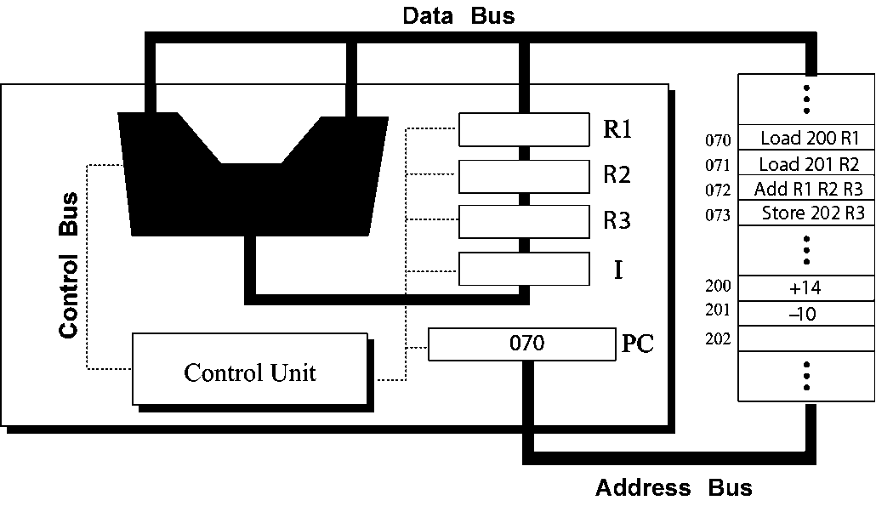
- ( 6 scores ) A list contains the following elements. Using the binary search algorithm, trace the steps followed to find 22. At each step, show the values of first, last and mid.
4, 7, 8, 10, 14, 21, 22, 36, 62, 77, 81, 91

- ( 6 scores ) Using the insertion sort algorithm, manually sort the following list and show your work in each pass.
23, 78, 45, 8, 32, 56

- Design(2 subjects)

- ( 7 scores ) Write a recursive algorithm in pseudocode to find the Fibonacci value Fib(n) using following definition.
0 if n＝0
Fib(n) ＝ 1 if n＝1
Fib(n-1) + Fib(n-2) if n＞1

- ( 8 scores ) The ASCII codes for the uppercase letters A to Z are x41 to x5A. The ASCII codes for the lowercase letters a to z are x61 to x7A.
  - Convert the uppercase letters to the lowercase letters.
  - Convert the lowercase letters to the uppercase letters.
Show the mask and operation. Test with A←→a and Z←→z.

