2016-2017学年 第1学期
2016 级《计算机导论》考试试题A卷
考试时间：2017年1月5日
班级 教学号 姓名

- 要求答案写在答题纸上，写上题号，不必抄题，英文答卷；
- 要求在答题纸和试题纸上都写上班级、学号和姓名，交卷时一并交上来；
- 要求在每个大题号(I, II, III,IV,V)前划一个满页的横线，以便教师批阅。

- Choice Questions(20 questions, 1 score for each question)

1. The step by step solution that expresses the logical solution to a particular problem of interest is called a(n) ________.
A. algorithm B. answer C. program D. process
2. The ASCII character set includes ________ characters.
A. 256 B. 128 C. 65536 D. 4,294967296
3. The most common way to represent signed integers in computer science is ________.
A. sign-and magnitude B. one’s complement C. two’s complement D. unsigned integers
4.What is -31 in Excess_127 notation? ________
A. 01100001 B. 11100001 C. 10011111 D. 01100000
5. Computer is based on the ________ model..
A. Intel B. Microsoft C. input/output D. von Neumann
6. The place where programs and data are stored during processing is ________..
A. display B. main memory C. floppy disk D. hard disk
7. A computer stores data and program as a ________ pattern.
A. unary B. hexadecimal C. binary D. numeric
8. A byte consists of ______ bits.
A. 2 B. 4 C. 8 D. 16
9. If the memory address space is 32MB and the word size is 8 bits, then ______bits address are needed to access each word.
A. 25 B. 16 C. 8 D. 22
10. The three steps in the running of a program on a computer are performed ______in this specific order.
A. fetch, decode, and execute B. fetch, execute, and decode
C. decode, fetch, and execute D. decode, execute, and fetch
11.A ______is a device that can route a packet based on its network layer address.
A. bridge B. router C. repeater D. all of the above
12. In the ______method to synchronize the operation of the CPU with the I/O device, the I/O device informs the CPU when it is ready for data transfer.
A. programmed I/O B. DMA C. interrupt-driven I/O D. isolated I/O
13. A(n) ________ search is used if the list being searched is not ordered.
A. heap B. binary C. 8. selection D. sequential
14. Using the XOR (exclusive OR) operator, if two input is 1, the output is ________.
A. 0 B. 1 C. indeterminate D. equal to the number of inputs that are 1
15. The ______ is a computer subsystem that performs operations on data.
A. memory B. CPU C. I/O hardware D. RAM
16. The idea of a sorting algorithm is to ________.
A. determine if a particular item is present or not B. arrange data according to their value
C. compute the sum of all the items in an array D. output the items in an array
17. Recursion is a process by which an algorithm calls ________.
A. a sorting algorithm B. itself C. a search algorithm D. a subalgorithm
18. The transport layer protocol of TCP/IP is called _______.
A. TCP B. UDP C. IP D. a and b
19. ______ is a program that facilitates the execution of other programs.
A. Hardware B. A queue C. An application program D. An operating system
20. A process in the ready state goes to the running state when _________.
A. it gets access to the CPU B. it enters memory C. it finishes running D. it requests I/O

- Questions(5 questions, 4 scores for each question)
  - What are the components of an operating system?
  - Name the layers of the OSI model.
  - What are the three types of sorting algorithms?
  - What are the subsystems of the von Neumann computer model?
  - What kinds of states can a process be in?

- Calculation(4 subjects, 5 scores for each subject)

- Change the following decimal numbers to 8-bit Sign-and-magnitude, one’s complement and two’s complement integers, and fill the blanks with the result value in hexadecimal or “overflow” string.
decimal number | Sign-and-magnitude | One’s complement | two’s complement
 |  |  | 0x80
 |  | 0xFF
 | 0xFF
+255
+100

- Show the result of the following operations, and then convert the result to hexadecimal.
Operations | results (in hexadecimal)
(xF0) XOR (x0F)
(xAA) OR (x55)
(x48) AND (x00)
( NOT (x51) ) OR (xFF)
( ( NOT (x2D) ) AND (x78) ) OR
( (x2D) AND (NOT (x78) ) )

- Using an 8-bit allocation, first convert each of the following numbers to two’s complement, do the operation, Write the detailed calculation process and then convert the result to hexadecimal..
(1) 100 + 20
(2) 100 - 10
- Change the -100.125 decimal numbers to binary numbers, and show it in 32-bit IEEE format, Write the detailed calculation process and then convert the result to hexadecimal.

- Analyzing(3 subjects, 20 scores)

- ( 8 scores ) A computer with simple architecture is shown as below. The figure shows the memory and CPU before the execution of the program. Please describe the contents of memory location(200, 201 and 202) and registers(R1, R2, R3, I and PC) after the execution of the program.
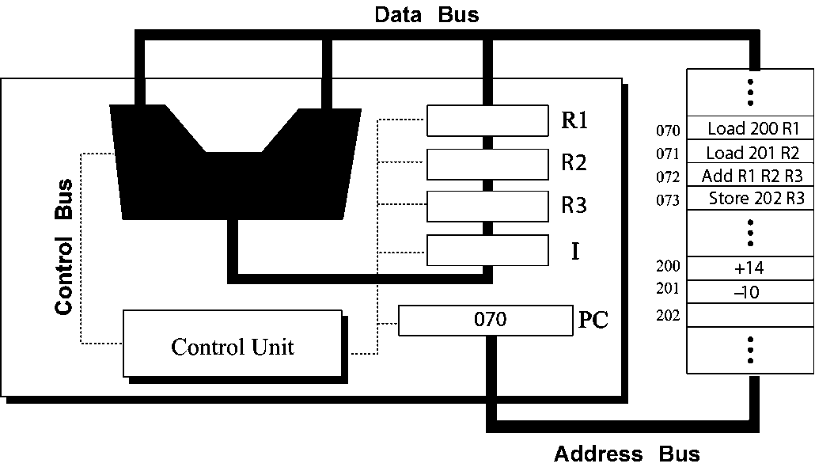
- ( 6 scores ) A list contains the following elements. Using the binary search algorithm, trace the steps followed to find 23. At each step, show the values of first, last and mid.
3, 7, 8, 10, 14, 21, 23, 36, 62, 77, 81, 100

- ( 6 scores ) Using the insertion sort algorithm, manually sort the following list and show your work in each pass.
23, 78, 45, 8, 32, 56, 2, 10

- Design(2 subjects, 20 scores)

- ( 10 scores ) Write a recursive algorithm in pseudocode to find the Fibonacci value Fib(n) using following definition.
0 if n＝0
Fib(n) ＝ 1 if n＝1
Fib(n-1) + Fib(n-2) if n＞1

- ( 10 scores ) The ASCII codes for the uppercase letters A to Z are x41 to x5A. The ASCII codes for the lowercase letters a to z are x61 to x7A.
  - Convert the uppercase letters to the lowercase letters. Show the mask and detailed operation. Test with A→a.
  - Convert the lowercase letters to the uppercase letters. Show the mask and detailed operation. Test with z→Z..

