2016-2017学年 第1学期
2016 级《计算机导论》考试试题A卷答案
考试时间：2017年1月5日

- Choice Questions(20 questions, 1 score for each question)
ABCDD BCCAA BCDAB, BBDDA

- Questions(5 questions, 4 scores for each question)
  - What are the components of an operating system?
A: Memory Manager, Process Manager, Device Manager and File Manager
  - Name the layers of the OSI model.
A: Physical layer, Data link layer, Network layer, Transport layer, Session layer, Presentation layer and Application layer.
  - What are the three types of sorting algorithms?
A: Answer: bubble sort, selection sort and insertion sort.
  - What are the subsystems of the von Neumann computer model?
A: Memory, arithmetic logic unit, control unit, and input/output.
  - What kinds of states can a process be in?
A: Ready state, running state, waiting state

- Calculation(4 subjects, 5 scores for each subject)
- Change the following decimal numbers to 8-bit Sign-and-magnitude, one’s complement and two’s complement integers, and fill the blanks with the result value in hexadecimal or “overflow” string.
decimal number | Sign-and-magnitude | One’s complement | two’s complement
-128 | overflow | overflow | 0x80
0 | 0x00或0x80 | 0xFF | 0x00
-127 | 0xFF | 0x80 | 0x81
+255 | overflow | overflow | overflow
+100 | 0x64 | 0x64 | 0x64

- Show the result of the following operations, and then convert the result to hexadecimal.
Operations | results (in hexadecimal)
(xF0) XOR (x0F) | 0x00修改为0xFF
(xAA) OR (x55) | 0xFF
(x48) AND (x00) | 0x00
( NOT (x51) ) OR (xFF) | 0xFF
( ( NOT (x2D) ) AND (x78) ) OR  ( (x2D) AND (NOT (x78) ) ) | 0x55

- Using an 8-bit allocation, first convert each of the following numbers to two’s complement, do the operation, Write the detailed calculation process and then convert the result to hexadecimal..
(1) 100 + 20
A: 100 = (01100100)₂
20 =(00010100)₂
100 + 20 = (01100100)₂ ₊ (00010100)₂ = (01111000)₂ = 0x78
(2) 100 - 10
A: 100 = (01100100)₂
-10 =( 11110110)₂
100 - 10 = (01100100)₂ ₊ ( 11110110)₂ = (01011010)₂ = 0x5A
- Change the -100.125 decimal numbers to binary numbers, and show it in 32-bit IEEE format, Write the detailed calculation process and then convert the result to hexadecimal.
A: 100 = (01100100)₂
0.125 = (0.001)₂
-100.125 = -(01100100.001)₂ = -2⁶ x (1.100100001) ₂
Excess data is 127+6 = (10000101)₂
32-bit IEEE format data is (1 10000101 100100001 00000000000000) ₂ = 0xC2C84000

- Analyzing(3 subjects, 20 scores)
- ( 8 scores ) A computer with simple architecture is shown as below. The figure shows the memory and CPU before the execution of the program. Please describe the contents of memory location(200, 201 and 202) and registers(R1, R2, R3, I and PC) after the execution of the program.
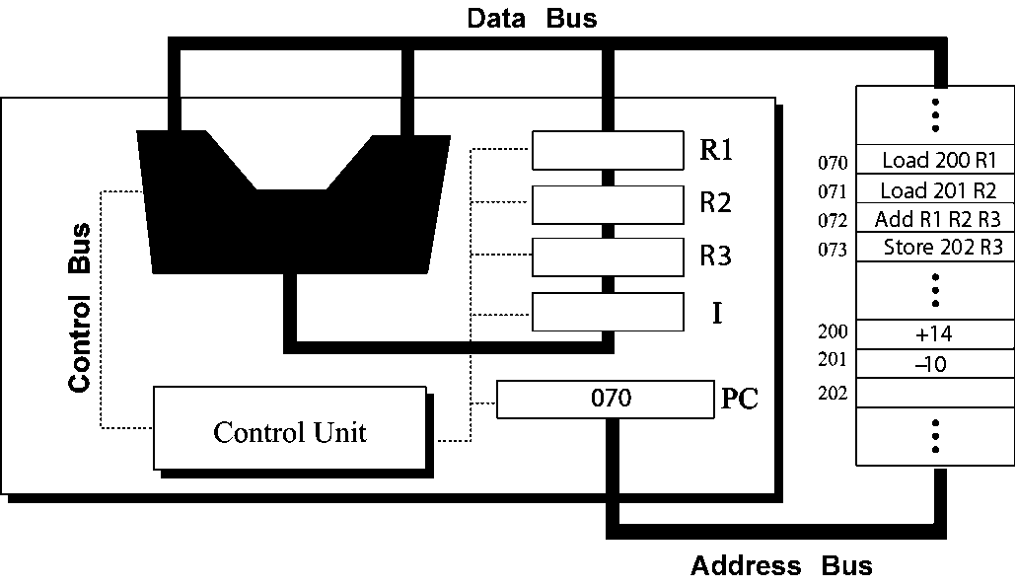
A: PC = 070
I = Load 2000, R1 → R1 = +14, PC = 071
I =Load 201, R2 → R2 = -10, PC = 072
I =Add R1,R2,R3 →R3 = +14 -10 = 4, PC = 073
I =Store 202, R3 → (202) = 4, PC = 074
- ( 6 scores ) A list contains the following elements. Using the binary search algorithm, trace the steps followed to find 23. At each step, show the values of first, last and mid.
3, 7, 8, 10, 14, 21, 23, 36, 62, 77, 81, 100
A:
Index: 0 , 1 , 2, 3, 4, 5, 6, 7, 8, 9, 10, 11
Data: 3, 7, 8, 10, 14, 21, 23, 36, 62, 77, 81, 100
First, last and mid is point to index.
Pass 1: first = 0, last = 11, so the mid = (first + last)/2 = (0+11)/2 = 5
Data(mid)= data(5) = 21 < 23
Pass 2: first = mid+1 = 5+1 = 6, last = 11, mid = (first + last)/2 = (6+11)/2 = 8
Data(mid) = data(8) = 62 >23
Pass 3: first = 6, last = mid -1 = 8 -1 = 7, mid = (first + last)/2 = (6+7)/2 = 6
Data(mid) = data(6) = 23, the target 23 is found.
- ( 6 scores ) Using the insertion sort algorithm, manually sort the following list and show your work in each pass.
23, 78, 45, 8, 32, 56, 2, 10
A:
Data: 23, | 78, 45, 8, 32, 56, 2, 10
Pass1: 23, 78, | 45, 8, 32, 56, 2, 10
Pass2: 23, 45,78, | 8, 32, 56, 2, 10
Pass3: 8,23, 45,78, | 32, 56, 2, 10
Pass4: 8,23, 32, 45,78, | 56, 2, 10
Pass5: 8,23, 32, 45, 56, 78, | 2, 10
Pass6: 2, 8,23, 32, 45, 56, 78, | 10
Pass7: 2, 8, 10, 23, 32, 45, 56, 78|

- Design(2 subjects, 20 scores)
- ( 10 scores ) Write a recursive algorithm in pseudocode to find the Fibonacci value Fib(n) using following definition.
0 if n＝0
Fib(n) ＝ 1 if n＝1
Fib(n-1) + Fib(n-2) if n＞1
A:
Name: Fib
Input n
If n = = 0 then
Return 0
endif
If n = = 1 then
Return 1
Endif
If n > 1
Return Fib(n-1) + Fib(n-2)
Endif
End
- ( 10 scores ) The ASCII codes for the uppercase letters A to Z are x41 to x5A. The ASCII codes for the lowercase letters a to z are x61 to x7A.
  - Convert the uppercase letters to the lowercase letters.
  - Convert the lowercase letters to the uppercase letters.
Show the mask and detailed operation. Test with A←→a and Z←→z.
A:
- if an uppercase letter is X, it’s from start letter x41 = (01000001)₂ to (01011010)₂ continuely.
The lowercase letter is Y, it’s from start letter x61 = (01100001)₂ to (01111010)₂ continuely.
The different bit of X and Y is third bit from left, so the mask is (00100000)₂, or (11011111)₂

Mask= (00100000)₂
Y = X OR (00100000)₂
Test : ‘A’ or mask = (01000001)₂ or (00100000)₂ = (01100001)₂ =’a’

(2)
Mask = (11011111)₂
X = Y AND (11011111)₂
Test : ‘a’ and mask = (01100001)₂ and (11011111)₂ = (01000001)₂ =’A’

