2017-2018学年 第1学期
2017级《计算机导论》考试试题
考试时间：2018年1月9日
班级 学号 姓名

- 要求答案写在答题纸上，不必抄题；
- 要求在每个大题号(I, II, III,IV,V)前划一个满页的横线，以便教师批阅；
- 要求在答题纸和试题纸上都写上班级、学号和姓名，交卷时一并交上来。

- Choice Questions(20 questions, 1 score for each question)
- The ______ is a computer subsystem that performs operations on data.
A. CPU B. memory C. I/O hardware D. RAM
- The idea of a sorting algorithm is to ________.
A. determine if a particular item is present or not B. arrange data according to their value
C. compute the sum of all the items in an array D. output the items in an array
- Recursion is a process by which an algorithm calls ________.
A. a sorting algorithm B. itself C. a search algorithm D. a subalgorithm
- A ______is a device that can route a packet based on its network layer address.
A. bridge B. router C. repeater D. all of the above
- In the ______method to synchronize the operation of the CPU with the I/O device, the I/O device informs the CPU when it is ready for data transfer.
A. programmed I/O B. DMA C. interrupt-driven I/O D. isolated I/O
- A(n) ________ search is used if the list being searched is not ordered.
A. heap B. binary C. 8. selection D. sequential
- Using the XOR (exclusive OR) operator, if two input is 1, the output is ________.
A. 0 B. 1 C. indeterminate D. equal to the number of inputs that are 1
- The transport layer protocol of TCP/IP is called _______.
A. TCP B. UDP C. IP D. a and b
- The _____ model is the basis for today’s computers.
A. Pascal B. Ron Newman C. von Neumann D. Charles Babbage
- In extended ASCII, each symbol is _____ bits.
A. 7 B. 8 C. 9 D. 10
- The most common way to represent signed integers in computer science is ________.
A. sign-and magnitude B. one’s complement C. two’s complement D. unsigned integers
- What is -21 in Excess_127 notation? ________
A. 01100001 B. 11100001 C. 10011111 D. 01101010
- The place where programs and data are stored during processing is ________..
A. display B. main memory C. floppy disk D. hard disk
- A computer stores data and program as a ________ pattern.
A. unary B. hexadecimal C. binary D. numeric
- A process in the ready state goes to the running state when _________.
A. it gets access to the CPU B. it enters memory C. it finishes running D. it requests I/O
- The step by step solution that expresses the logical solution to a particular problem of interest is called a(n) ________.
A. algorithm B. answer C. program D. process
- A byte consists of ______ bits.
A. 2 B. 4 C. 8 D. 16
- If the memory address space is 64MB, then ______bits address are needed to access each word.
A. 25 B. 16 C. 8 D. 28 有问题
- The three steps in the running of a program on a computer are performed ______in this specific order.
A. fetch, decode, and execute B. fetch, execute, and decode
C. decode, fetch, and execute D. decode, execute, and fetch
- ________ numbers are commonly used for counting and addressing.
- Sign-and magnitude B. One’s complement C. Two’s complement D. none of the above

- Fill-in-the-blank((15 questions, 1 score for each question)
- The von Neumann model specifies a ________ subsystem, an __________ unit subsystem, a ________ unit subsystem, and an ________ subsystem.
- Images use the bitmap graphic or ______ graphic method for data representation.
- A bit pattern is a ________,of bits that can represent a symbol.
- Unsigned numbers are commonly used for ________ and ________.
- If there is a carry after addition of the leftmost digits, the carry is ________.
- A computer has 128MB of memory, Each word in this computer is 8 bytes, ________ bits are needed to address any single word in memory?
- There are ________ bytes in 16 terabytes.
- A ________ is a connecting device that filters traffic.
- The transport layer protocol of TCP/IP is called TCP and ________.
- The seven layers of the OSI model are Physical layer, Data link layer, ________layer, ________ layer, Session layer, Presentation layer and Application layer.

- Calculation(5 subjects, 4 scores for each subject)
  - For an 8-bit allocation, fill in the following blank in hexadecimal.
Sign-and-magnitude  (hexadecimal) | one’s complement  (hexadecimal) | two’s complement  (hexadecimal)
x61
 | xAA
 |  | x80

  - Using an 8-bit allocation, first convert each of the following numbers to two’s complement, do the operation, Write the detailed calculation process and then convert the result to hexadecimal..
(1) 48+50
(2) -59-63
  - Show the result of the following operations, Write the detailed calculation process and then convert the result to hexadecimal..
(xAA OR x55 ) XOR (NOT(x88) AND xAA )
  - Change the -11.625 decimal numbers to binary numbers, and show it in 32-bit IEEE format, Write the detailed calculation process and then convert the result to hexadecimal.
  - A gray scale picture is digitized using 256 different gray levels, if the picture is composed of 800x600 pixels, how many bytes of memory are needed to store it?

- Analyzing(4 subjects, 5 scores for each subject)
- A list contains the following elements. Using the binary search algorithm, trace the steps followed to find 83. At each step, show the values of first, last and mid.
1, 10, 19, 21, 25, 35, 41, 66, 77, 83, 90, 99
- A computer uses memory-mapped I/O addressing. The address bus uses 12 lines(12 bits), If memory is made of 4000 bytes, how many four-register controllers can be accessed by this computer?
- An operating system uses 0 virtual memory but requires the whole program to be in physical memory during execution (no paging or segmentation), this computer has 30 address lines, The size of virtual memory is 4GB. Each programs size is 256MB.
(1) How many programs can be run concurrently by this operating system?
(2) How many of them can be in memory at any time?
(3) How many of them must be on disk?
- A computer with simple architecture is shown as below. The figure shows the memory and CPU before the execution of the program. Please describe the contents of memory location(200, 201 and 202) and registers(R1, R2, R3, I and PC) after the execution of the program. (The R1,R2,R3 are 8-bit register.)
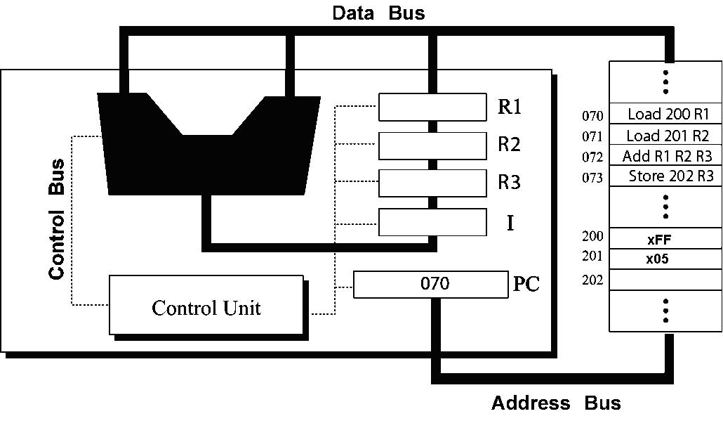

- Design(2 subjects, 25 scores)
- (10 scores )Write a recursive algorithm in pseudocode to find the combination of n objects taken k at a time using following definition.
C(n,k)=1 , if k=0 or n=k
C(n,k)=C(n-1,k)+C(n-1,k-1) , if n>k>0
- (15 scores)Imaging a power plant pumps water to a city using eight pumps. The states of the pumps (on or off) can be represented by 8-bit pattern. For example, the pattern 10001111 shows that pumps 1 to 4(from right), and 8 are on(running) while pumps 5, 6, and 7 are off(shut down).
(1) How can you shut down all pumps?
(2) then, how can you let the pumps 1, 5, 7 running, and remain other pumps unchanged?
(3) then, how can you shut down pump 7, let the pumps 3, 4 and 8 running, and remain other lamps unchanged?
(4) finally, how can you let all the pumps running?

