2017-2018学年 第1学期
2017 级《计算机导论》考试试题A卷答案

- Choice Questions(20 questions, 1 score for each question)
ABBBB, DADCB, CDBCA, ACAAD

- Questions( 15scores )
Memory, arithmetic logic, control, input/output.
Vector
String
Counter, address
Discarded
24
2⁴⁴
Bridge
UDP
Network, Transport

- Calculation(4 subjects, 5 scores for each subject)
  - For an 8-bit allocation, fill in the following blank.
Sign-and-magnitude  (hexadecimal) | one’s complement  (hexadecimal) | two’s complement  (hexadecimal)
x61H | x61 | x61
xD5 | xAA | xAB
overflow | overflow | x80

  - Using an 8-bit allocation, first convert each of the following numbers to two’s complement, do the operation, Write the detailed calculation process and then convert the result to hexadecimal..
(1) 48+50 = 0b0011 0000 + 0b0011 0010 = 0b0110 0010 = 0x62
(2) -59-63 = 0b1100 0101 + 0b11000001 = 0b0111 1010 = 0x86
  - Show the result of the following operations, Write the detailed calculation process and then convert the result to hexadecimal..
(xAA OR x55 ) XOR (NOT(x88) AND xAA ) = xDD
  - Change the -11.625 decimal numbers to binary numbers, and show it in 32-bit IEEE format, Write the detailed calculation process and then convert the result to hexadecimal.
A: 11 = (1011)₂, 0.625 = (0.101)₂
-11.625 =- (1011.101)₂ = - 2³ *(1.011101)₂
Excess code 127 +3 = (1000 0010)₂
32-bit IEEE format: 1 1000 0010 011101 0 00000000 00000000 = 0xC13A0000
  - A gray scale picture is digitized using 256 different gray levels, if the picture is composed of 800x600 pixels, how many bytes of memory are needed to store it?
800x600xlog ₂256 /8 = 800x600 =480000bytes

- Analyzing(4 subjects, 20 scores)
- A list contains the following elements. Using the binary search algorithm, trace the steps followed to find 83. At each step, show the values of first, last and mid.
1, 10, 19, 21, 25, 35, 41, 66, 77, 83, 90, 99
A:
List= 1, 10, 19, 21, 25, 35, 41, 66, 77, 83, 90, 99
index: 0 1 2 3 4 5 6 7 8 9 10 11
(1) first =0, last =11 , mid =(0+11) // 2 = 5, list[5] = 35
list[5] < 83, discards the left side from index 0 to 5.
(2) First = 6, last = 11, mid =(6 + 11) //2 = 8, list[8] = 77
List[8] < 83 , discards the left side from index 6 to 8.
(3) first = 9, last= 11, mid=(9+11)//2 =10, list[10] = 90
List[10] > 83, discards the right side from index 10 to 11.
(4) first = 9, last = 9, mid = 9, list[9] = 83
List[9] = 83 , found the value 83 at index 9.
- A computer uses memory-mapped I/O addressing. The address bus uses 12 lines(12 bits), If memory is made of 4000 bytes, how many four-register controllers can be accessed by this computer?
A: (2¹² – 400) / 4 = 96/4 = 24
- An operating system uses 0 virtual memory but requires the whole program to be in physical memory during execution (no paging or segmentation), this computer has 30 address lines, The size of virtual memory is 4GB. Each programs size is 256MB.
(1) How many programs can be run concurrently by this operating system? 4x2³⁰/256x2²⁰ = 16
(2) How many of them can be in memory at any time? 2³⁰/256x2²⁰ = 4
(3) How many of them must be on disk? 16-4 = 12
- A computer with simple architecture is shown as below. The figure shows the memory and CPU before the execution of the program. Please describe the contents of memory location(200, 201 and 202) and registers(R1, R2, R3, I and PC) after the execution of the program. (The R1,R2,R3 are 8 bit register.)
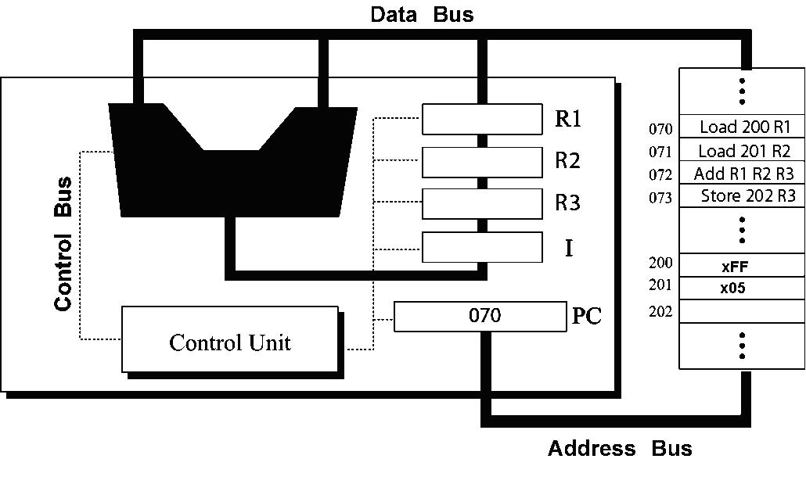

A: PC = 070
I = Load 2000, R1 → R1 = xFF, PC = 071
I =Load 201, R2 → R2 = x05, PC = 072
I =Add R1,R2,R3 →R3 = xFF+x05 = x04, PC = 073
I =Store 202, R3 → (202) = 4, PC = 074

- Design(2 subjects, 25 scores)
- ( 10 scores ) Write a recursive algorithm in pseudocode to find the combination of n objects taken k at a time using following definition.
C(n,k)=1 , if k=0 or n=k
C(n,k)=C(n-1,k)+C(n-1,k-1) , if n>k>0
A:
Name: C
Input n, k
If k = = 0 or n ==k then
Return 1
endif
If n >k and k>0 then
Return C(n-1,k)+C(n-1,k-1)
Endif

End
- （15 scores）Imaging a power plant pumps water to a city using eight pumps. The states of the pumps (on or off) can be represented by 8-bit pattern. For example, the pattern 10001111 shows that pumps 1 to 4(from right), and 8 are on(running) while pumps 5, 6, and 7 are off(shut down).
(1) How can you shut down all pumps?（4 scores）
(2) then, how can you let the pumps 1, 5, 7 running, and remain other pumps unchanged?（4 scores）
(3) then, how can you shut down pump 7, let the pumps 3, 4 and 8 running, and remain other lamps unchanged?（4 scores）
(4) finally, how can you let all the pumps running?（3 scores）
A: (1)L=L and 0b00000000 =0b00000000
(2)L =L or 0b01010001 =0b01010001
(3)L= L and 0b10111111 =0b00010001 ; L= L or 0b10001100 = 0b10011101
(4) L=L or 0b11111111 =11111111

