/* Name: Shubham Sarang
Roll no: 1345
Unit 1: Sorting
Program: Bubble sort*/

#include<iostream>

using namespace std;

int main()
{
int arr[20],n,i,temp,j;

cout<<"**Bubble sorting**"<<endl<< endl;

cout<<"Enter size of array=";
cin>>n;

cout<<endl;

cout<<"Enter number of elements=";

for(i=0;i<n;i++)
{
cin>>arr[i];
}

cout<<endl;

cout<<"Array before sorting=";

for(i=0;i<n;i++)
{
cout<<arr[i]<<"\t";
}

//Swapping/sorting

for(i=0;i<n-1;i++)
{
for(j=i+1;j<n;j++)
{
if(arr[i]>arr[j])
{
temp=arr[j];
arr[j]=arr[i];
arr[i]=temp;
}
}
}

cout<<endl;

cout<<"Array after sorting=";

for(i=0;i<n;i++)
{
cout<<arr[i]<<"\t";
}

}//end main
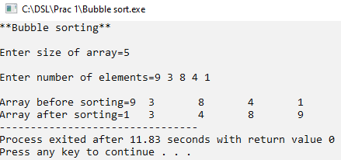
/*Selection sort
Name: Shubham Sarang
ROll NO: 1345
Unit 1 Sorting
Program: Selection sort
*/
#include<iostream>
using namespace std;
int main()
{
int n, arr[20];
int i, min, loc, tmp, j;

cout<<"**Selection Sorting**"<<endl<<endl;

cout<<"Enter size of array: ";
cin>>n;

cout<<endl;

cout<<"Enter number of elements: ";

for(i=0; i<n; i++)
{
cin>>arr[i];
}

cout<<endl;
//selection sort processing
for(i=0; i<n; i++)
{
//Assume min value and its loc
min= arr[i];
loc= i;
for(j=i+1; j<n; j++)
{
if(arr[j] < min)
{
min = arr[j];
loc = j;
}
}
//found the min value and loc
//swap the value at i and loc
tmp = arr[i];
arr[i] = min;
arr[loc] = tmp;
}
//Display sorted array
cout<<"The sorted elements are : ";

for(i=0; i<n; i++)
{
cout<<arr[i]<<" ";
}

}//end main

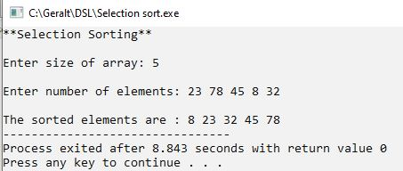

/*
Name: Shubham Sarang
ROll NO: 1345
Unit 1 Sorting
Program: Insertion sort
*/
#include<iostream>
using namespace std;
int main()
{
int n, arr[20], i;

cout<<"**Insertion Sorting**"<<endl<<endl;

cout<<"Enter size of array: ";
cin>>n;

cout<<endl;

cout<<"Enter number of elements: ";

for(i=0; i<n; i++)
{
cin>>arr[i];
}

cout<<endl;
//Insertion sort logic
for(i=1; i<n; i++)
{
tmp = arr[i];
loc = i-1;
while(tmp < arr[loc] && loc>=0)
{
arr[loc+1] = arr[loc];
loc--;
}
arr[loc+1] = tmp;
}
//Display sorted array
cout<<"The sorted elements are : ";

for(i=0; i<n; i++)
{
cout<<arr[i]<<" ";
}

}//End main
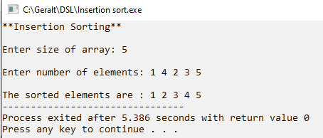

/*
Name: Shubham Sarang
ROll NO: 1345
Unit 1 Sorting
Program: Shell sort
*/
#include<iostream>
#include<math.h>
using namespace std;
int main()
{
int n, extractData, arr[20], i, gap, loc;

cout<<"*** Shell sort ***"<<endl;
cout<<"Enter size of array: ";
cin>>n;
cout<<endl;
cout<<"Enter elements: ";
for(i=0;i<n;i++)
{
cin>>arr[i];
}
cout<<endl;

gap=floor(n/2);

while(gap>0)
{
for(i=0 ; i<n-gap ; i++)
{
extractData= arr[i+gap];
loc = i+gap;

while((loc-gap)>=0 && extractData < arr[loc-gap])
{
arr[loc] = arr[loc-gap];
loc = loc - gap;
}//end of inner while
arr[loc] = extractData;
}//end of for
gap = floor(gap/2);
}//end of while

cout<<"Sorted array :";
for(i=0;i<n;i++)
{
cout<<arr[i]<<" ";
}
}//end main
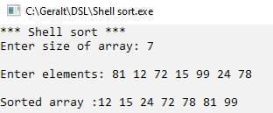

/*Radix sort
Name: Shubham Sarang
ROll NO: 1345
Unit 1 Sorting
Program: Radix sort
*/
#include<iostream>
using namespace std;
int main()
{
int n, arr[20], i, j, p, max, k, r, passes=0;
int bucket[10][20], b_count[10], divisor=1;

cout<<"**Radix Sorting**"<<endl<<endl;

cout<<"Enter size of array: ";
cin>>n;

cout<<endl;

cout<<"Enter number of elements: ";

for(i=0; i<n; i++)
{
cin>>arr[i];
}

//find largest number
max = arr[0];
for(i=1; i<n; i++)
{
if(arr[i] > max)
{
max = arr[i];
}
}

while(max>0)
{
max=max/10;
passes++;
}
//Logic
for(p=0; p<passes; p++)
{
//initialize the b_count array to 0
for(k=0; k<10; k++)
{
b_count[k] = 0;
}//end of k

//extract digit, place in bin, update b_count
for(i=0; i<n; i++)
{
r = (arr[i]/divisor) % 10;
bucket[r][b_count[r]] = arr[i];
b_count[r]++;
}//end of i
i=0;
//Collect the bins
for(j=0; j<10; j++)
{
for(k=0; k<b_count[j]; k++)
{
arr[i] = bucket[j][k];
i++;
}
}

divisor = divisor * 10;
}
//Display array
cout<<"The sorted elements are : ";

for(i=0; i<n; i++)
{
cout<<arr[i]<<" ";
}

}//end main
