    Name: | Shubham Sarang
Roll No | 1345
Topic | Stacks
Title of Program | Array Based Stack

/*
Name: Shubham Sarang
Roll no: 1345
Unit 3:Stacks
Program: Array based Stack
*/
#include<iostream>
#include<conio.h>
#define MAX 5

using namespace std;

//1. Node template NOT REQUIRED

//2. Stack template
class AStack
{
int a[MAX];
int tos;
public:
AStack()
{
tos = -1;
}
void Push(int x);
void Pop();
void Peek();
void Display();
int Full();
int Empty();
};

//3. Functions
void AStack::Push(int x)
{
if(Full())
{
cout<<"Stack overflow!!!";
}
else
{
tos++;
a[tos] = x;
}
}

void AStack::Pop()
{
if(Empty())
{
cout<<"Stack underflow!!!";
}
else
{
cout<<a[tos]<<" popped";
tos--;
}
Display();
}

void AStack::Peek()
{
cout<<" Element at the top of the stack: "<<a[tos];
}

void AStack::Display()
{
int cnt = tos;
while(cnt!= -1)
{
cout<<"\n"<<a[cnt]<<"\n";
cnt--;
}
}

int AStack::Full()
{
if(tos == MAX-1)
{
return 1;
}
else
{
return 0;
}
}

int AStack::Empty()
{
if(tos == -1)
{
return 1;
}
else
{
return 0;
}
}

//4.MENU

int main()
{
int ch, num;
AStack s;
while(1)
{
system("cls");

cout<<"****Array Based Stack***"<<endl;

cout<<"1. Push an element in stack \n";
cout<<"2. Pop an element in stack \n";
cout<<"3. Peek stack \n";
cout<<"4. Display stack \n";
cout<<"5. Exit \n";

cout<<"Enter choice: ";
cin>>ch;

switch(ch)
{
case 1:
cout<<"Push element: ";
cin>>num;
s.Push(num);
getch();
break;
case 2:
cout<<"Pop element: ";
s.Pop();
getch();
break;
case 3:
cout<<"Peek element: ";
s.Peek();
getch();
break;
case 4:
cout<<"Display stack: ";
s.Display();
getch();
break;
case 5:
exit(1);
default:
cout<<"Wrong choice bruv";
getch();
}
}
}

Ouput:
Add element:
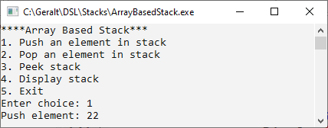
Stack overflow:
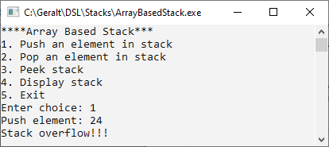
Element popped:
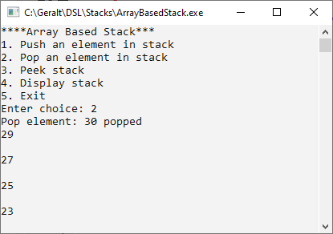

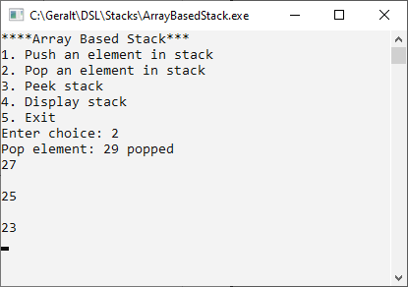
Peek:
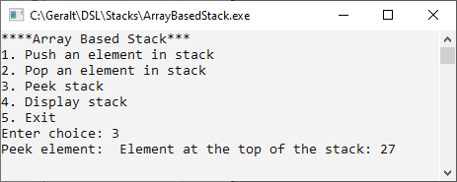

Display:
