    Name | Shubham Sarang
Roll No | 1345
Topic | Queues
Programs | 1) Ordinary Queues 2) Circular Queues 3) Double-Ended Queues 4) Priority Queues

Ordinary Queue:
#include<iostream>
#include<conio.h>
#define MAX 5

using namespace std;

// Queue template

class OQueue
{
int front, rear, a[MAX];
public:
OQueue()
{
front = -1;
rear = -1;
}
void Enqueue(int x);
void Dequeue();
void PeekFront();
void PeekRear();
void Display();
int Full();
int Empty();
};

//Functions

void OQueue::Enqueue(int x)
{
if(Full())
{
cout<<"Queue Overflow!!";
return;
}
if(front == -1)
{
front++;
}
rear++;
a[rear]=x;
}

void OQueue::Dequeue()
{
if(Empty())
{
cout<<"Queue underflow!!";
return;
}
int tmp = a[front];

if(front == rear)
{
front = -1;
rear = -1;
}
else
{
front++;
}
cout<<"Element "<<tmp<<" dequeued";
}

int OQueue::Full()
{
int result = rear == MAX-1 ? 1:0;
return result;
}

int OQueue::Empty()
{
int result = rear == -1 ? 1:0;
return result;
}

void OQueue::PeekFront()
{
if(Empty())
{
cout<<"Queue underflow!!";
return;
}
cout<<"Element at the front: "<<a[front];
}

void OQueue::PeekRear()
{
if(Empty())
{
cout<<"Queue underflow!!";
return;
}
cout<<"Element at the rear: "<<a[rear];
}

void OQueue::Display()
{
if(Empty())
{
cout<<"Queue underflow!!";
return;
}

cout<<"Queue: \n";
for(int i=front; i<=rear; i++)
{
cout<<a[i]<<"\n";
}
}

//Menu

int main()
{
OQueue o;
int num, ch;
while(1)
{
system("cls");
cout<<"***Ordinary Queue***\n\n";
cout<<"1. Perfrom Enqueue on queue\n";
cout<<"2. Perfrom Dequeue on queue\n";
cout<<"3. PeekFront of queue\n";
cout<<"4. PeekRear of queue\n";
cout<<"5. Display queue\n";
cout<<"6. Exit\n\n";
cout<<"Enter the choice you've made: ";
cin>>ch;
switch(ch)
{
case 1:
cout<<"Add Element: ";
cin>>num;
o.Enqueue(num);
getch();
break;
case 2:
o.Dequeue();
getch();
break;
case 3:
o.PeekFront();
getch();
break;
case 4:
o.PeekRear();
getch();
break;
case 5:
o.Display();
getch();
break;
case 6:
exit(1);
default:
cout<<"Wrong option bruv";
getch();
break;
}
}
}
Output:
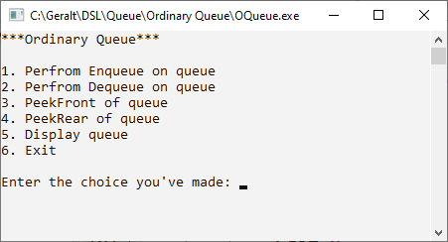
Menu:

Enqueue:
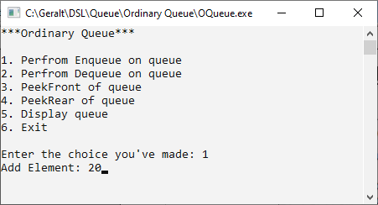
Queue overflow:
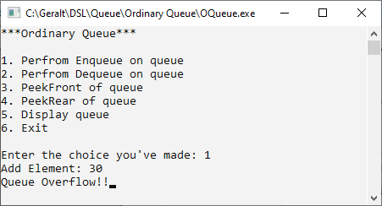
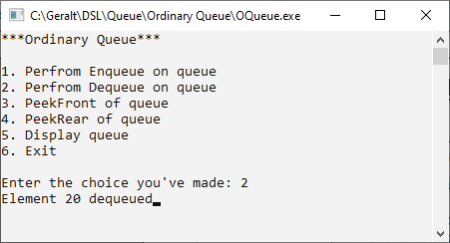
Dequeue:
Queue:
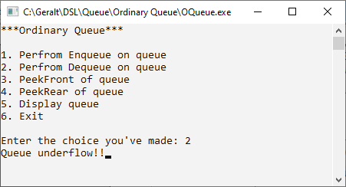
PeekFront:
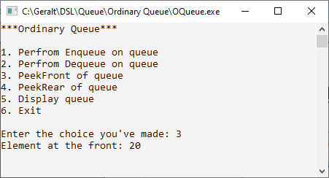
PeekRear:
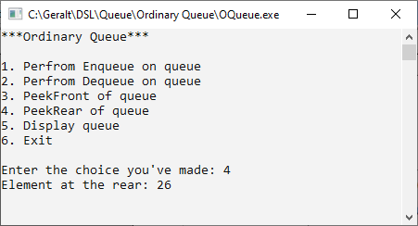
Display:
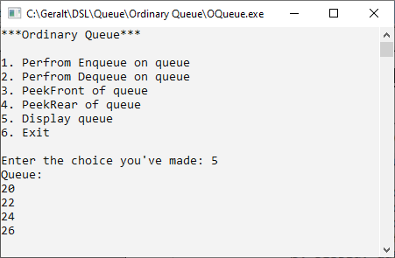
Circular Queue:
Code:

#include <iostream>
#include <conio.h>
#define MAX 4
using namespace std;

// 2. Queues Template
class CQueue
{
int A[MAX];
int front;
int rear;
int cnt;

public:
CQueue()
{
front = -1;
rear = -1;
cnt = 0;
}
void Enqueue(int x);
void Dequeue();
void PeekFront();
void PeekRear();
void Display();
int Full();
int Empty();
}; // 3. Functions
int CQueue ::Full()
{
if (cnt == MAX)
{
return 1;
}
else
{
return 0;
}
} // end of the Full
int CQueue ::Empty()
{
if (cnt == 0)
{
return 1;
}
else
{
return 0;
}
} // end of the Empty
void CQueue ::Enqueue(int x)
{
if (Full())
{
cout << "Queue OverFlow";
return;
}
if (front == -1)
{
front++;
}
if (rear == MAX - 1)
{
rear = 0;
}
else
{
rear++;
}
A[rear] = x;
cnt++;
} // End Of Enqueue
void CQueue ::Dequeue()
{
if (Empty())
{
cout << "Underflow!!";
return;
}
int tmp = A[front];
if (front == rear)
{
front = -1;
rear = -1;
}
else
{
if (front == MAX - 1)
{
front = 0;
}
else
{
front++;
}
}
cout << "Dequeued Element is : " << tmp;
cnt--;
} // end of Dequeue
void CQueue ::Display()
{
if (Empty())
{
cout << "Empty!!";
return;
}
int j = front;
for (int i = 1; i <= cnt; i++)
{
cout << A[j] << " ";
if (j == MAX - 1)
{
j = 0;
}
else
{
j++;
}
}
} // end of the Display
void CQueue ::PeekFront()
{
if (Empty())
{
cout << "Underflow!!";
}
else
{
cout << "Element at the Front is " << A[front];
}
} // end of the PeekFront
void CQueue ::PeekRear()
{
if (Empty())
{
cout << "Underflow!!";
}
else
{
cout << "Element at the Rear is " << A[rear];
}
} // end of the PeekRear
// 4. Menu
int main()
{
CQueue c;
int num, ch;
while (1)
{
system("cls");
cout << "*** Circular Queue ***" << endl;
cout << "1. Enqueue Element" << endl;
cout << "2. Dequeue Element" << endl;
cout << "3. Peek Front Operation" << endl;
cout << "4. Peek Rear Operation" << endl;
cout << "5. Display the Queue" << endl;
cout << "6. Exit" << endl
<< endl;
cout << "Enter your choice: ";
cin >> ch;
switch (ch)
{
case 1:
cout << "Enter a Value : ";
cin >> num;
c.Enqueue(num);
getch();
break;
case 2:
c.Dequeue();
getch();
break;
case 3:
c.PeekFront();
getch();
break;
case 4:
c.PeekRear();
getch();
break;
case 5:
c.Display();
getch();
break;
case 6:
exit(1);
default:
cout << "Incorrect choice !";
getch();
break;
cout << endl;
} // end of switch
} // end of while
} // end of main
Output:
Enqueue:
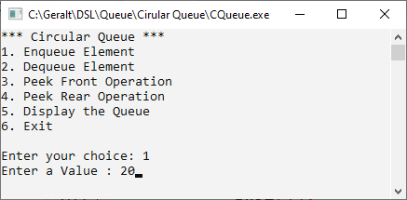
Dequeue:
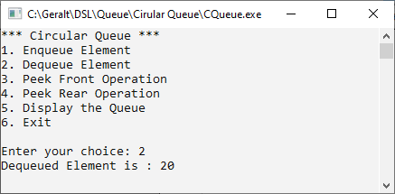
PeekFront:
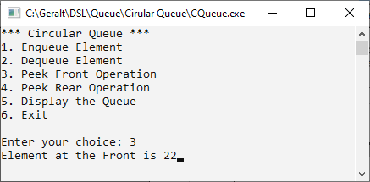
PeekRear:
Display:
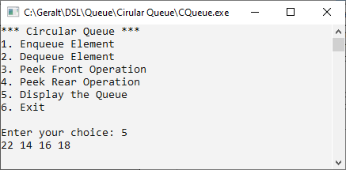
Double-Ended Queue:
Code:

#include <iostream>
#include <conio.h>
using namespace std;

// 1. Node Template
class DEQNode
{
public:
int data;
DEQNode *right;
DEQNode *left;
};

// 2. Queues Template
class DEQueue
{
DEQNode *front;
DEQNode *rear;

public:
DEQueue()
{
front = NULL;
rear = NULL;
}
void EnqueueFront(int x);
void EnqueueRear(int x);
void DequeueFront();
void DequeueRear();
void PeekFront();
void PeekRear();
void Display();
int Empty();
};

// 3. Functions
int DEQueue ::Empty()
{
int sig = (front == NULL && rear == NULL)
? 1
: 0;
return sig;
}
void DEQueue ::EnqueueFront(int x)
{
DEQNode *t = new DEQNode();
t->data = x;
t->right = NULL;
t->left = NULL;
if (front == NULL)
{
front = t;
rear = t;
}
else
{
t->right = front;
front->left = t;
front = t;
}
}
void DEQueue ::EnqueueRear(int x)
{
DEQNode *t = new DEQNode();
t->data = x;
t->right = NULL;
t->left = NULL;
if (front == NULL)
{
front = t;
rear = t;
}
else
{
t->left = rear;
rear->right = t;
rear = t;
}
}
void DEQueue ::DequeueFront()
{
if (Empty())
{
cout << "Queue Underflow" << endl;
return;
}
DEQNode *tmp = front;
if (front == rear)
{
front = rear = NULL;
}
else
{
front = front->right;
front->left = NULL;
}
cout << "Dequeued Element from front " << tmp->data;
delete tmp;
}
void DEQueue ::DequeueRear()
{
if (Empty())
{
cout << "Queue Underflow" << endl;
return;
}
DEQNode *tmp = rear;
if (front == rear)
{
front = rear = NULL;
}
else
{
rear = rear->left;
rear->right = NULL;
}
cout << "Dequeued Element from front " << tmp->data;
delete tmp;
}
void DEQueue ::Display()
{
DEQNode *tmp = front;
if (Empty())
{
cout << "Queue Underflow";
return;
}
while(tmp != NULL)
{
cout<<tmp->data<<" ";
tmp = tmp->right;
}
}
void DEQueue ::PeekFront()
{
if (Empty())
{
cout << "Queue Underflow!!";
return;
}
DEQNode *tmp = front;
cout << "Element at the Front is " << tmp->data;
}
void DEQueue ::PeekRear()
{
if (Empty())
{
cout << "Queue Underflow!!";
return;
}
DEQNode *tmp = rear;
cout << "Element at the Rear is " << tmp->data;
} // 4. Menu
int main()
{
DEQueue q;
int num, ch;
while (1)
{
system("cls");
cout << "*** Double Ended Queue ***" << endl;
cout << "1. Enqueue Front Element" << endl;
cout << "2. Enqueue Rear Element" << endl;
cout << "3. Dequeue Front Element" << endl;
cout << "4. Dequeue Rear Element" << endl;
cout << "5. Peek Front Operation" << endl;
cout << "6. Peek Rear Operation" << endl;
cout << "7. Display the Queue" << endl;
cout << "8. Exit" << endl
<< endl;
cout << "Enter your choice: ";
cin >> ch;
switch (ch)
{
case 1:
cout << "Enter a Value : ";
cin >> num;
q.EnqueueFront(num);
getch();
break;
case 2:
cout << "Enter a Value : ";
cin >> num;
q.EnqueueRear(num);
getch();
break;
case 3:
q.DequeueFront();
getch();
break;
case 4:
q.DequeueRear();
getch();
break;
case 5:
q.PeekFront();
getch();
break;
case 6:
q.PeekRear();
getch();
break;
case 7:
q.Display();
getch();
break;
case 8:
exit(1);
default:
cout << "Incorrect choice !";
getch();
break;
cout << endl;
} // end of switch
} // end of while
} // end of main

Output:
Enqueue front:
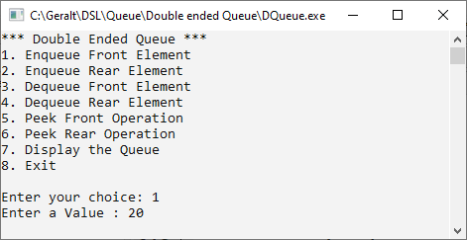
Enqueue rear:
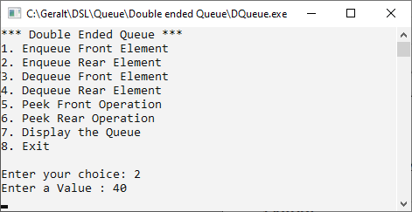

Dequeue front:
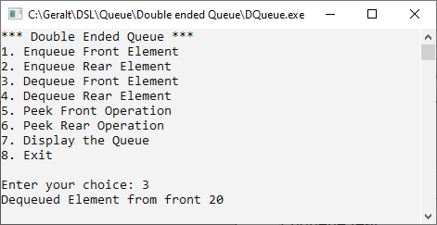
Dequeue rear:
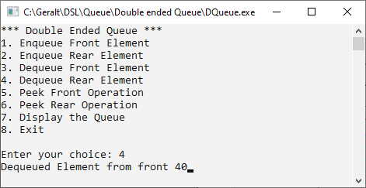

PeekFront:
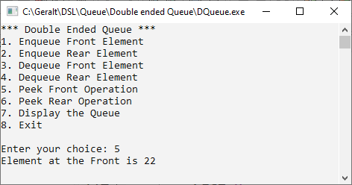
PeekRear:
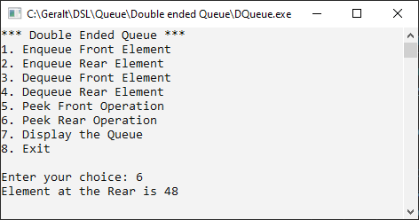
Display:
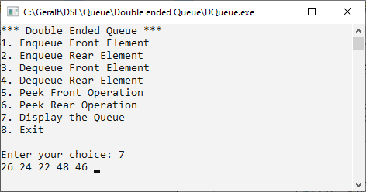

Priority Queue:
CODE:
#include<iostream>
#include<conio.h>

using namespace std;

//1. Node template
class PNode
{
public:
int data;
int priority;
PNode *next;
};

//2. Queue template

class PQueue
{
PNode *front;
public:
PQueue()
{
front = NULL;
}
void Enqueue(int x, int p);
void Dqueue();
void PeekFront();
void PeekRear();
void Display();
};

//3. Functions

void PQueue::Enqueue(int x, int p)
{
PNode *t = new PNode();
t->data = x;
t->priority = p;
t->next = NULL;

//first node
if(front == NULL)
{
front = t;
return;
}
//Traverse in order
PNode *tmp = front;
PNode *prev = NULL;

while(tmp != NULL && tmp->priority < t->priority)
{
prev = tmp;
tmp = tmp->next;
}

//Insert t at the correct position in the queue

if(tmp == front) //Front node Insertion
{
t->next = front;
front = t;
}
else if(tmp == NULL) //Last node insertion
{
prev->next = t;
}
}

void PQueue::Dqueue()
{
PNode *tmp = front;
if(front->next == NULL)
{
front == NULL;
}
else
{
front = front->next;
}
cout<<"Element "<<tmp->data<<" dequeued with priority "<<tmp->priority;
delete tmp;
}

void PQueue::PeekFront()
{
PNode *tmp = front;
cout<<"Element at the front is "<<tmp->data<<" with priority "<<tmp->priority;
}

void PQueue::PeekRear()
{
PNode *tmp = front;
while(tmp->next != NULL)
{
tmp = tmp->next;
}
cout<<"Element at the front is "<<tmp->data<<" with priority "<<tmp->priority;
}

void PQueue::Display()
{
if(front == NULL)
{
cout<<"Empty Queue";
return;
}
PNode *tmp = front;
cout<<"Data | Priority \n";

while(tmp != NULL)
{
cout<<tmp->data<<" | "<<tmp->priority<<"\n";
tmp = tmp->next;
}
}

//4. Menu

int main()
{
int ch, num, pri;
PQueue p;

while(1)
{
system("cls");
cout<<"***Priority Queue*** \n\n";

cout<<"1. Enqueue \n";
cout<<"2. Dequeue \n";
cout<<"3. Peek front \n";
cout<<"4. Peek rear \n";
cout<<"5. Display queue \n";
cout<<"6. Exit \n";

cout<<"Enter your choice: ";
cin>>ch;

switch(ch)
{
case 1:
cout<<"Enqueue element: ";
cin>>num;
cout<<"Enter priority: ";
cin>>pri;
p.Enqueue(num,pri);
getch();
break;
case 2:
cout<<"Dequeue element: ";
p.Dqueue();
getch();
break;
case 3:
cout<<"Peek front: ";
p.PeekFront();
getch();
break;
case 4:
cout<<"Peek rear: ";
p.PeekRear();
getch();
break;
case 5:
cout<<"Display queue: \n";
p.Display();
getch();
break;
case 6:
exit(1);
break;
default:
cout<<"Wrong opt bruv";
getch();
break;
}//end switch
}//end while
}//end main
OUTPUT:
ADD ELEMENT:
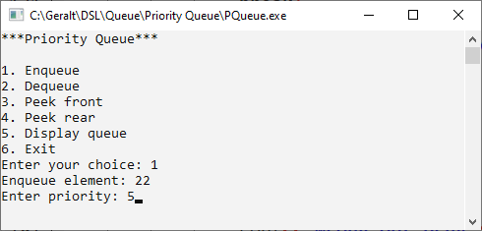
Display:
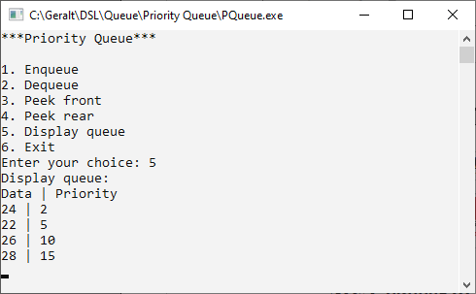
PeekFront:
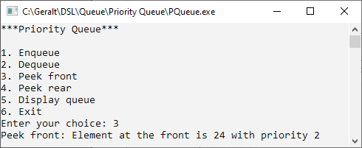
PeekRear:
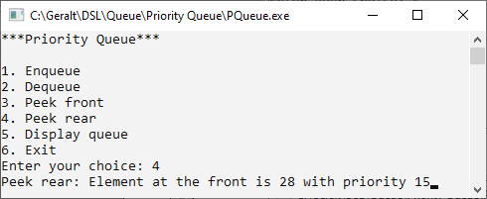
Dequeue:
