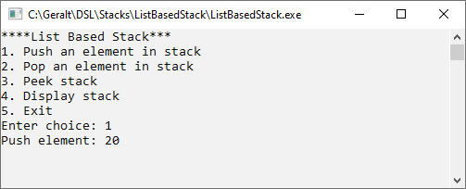
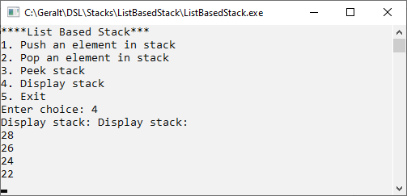
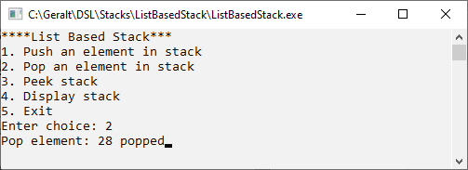
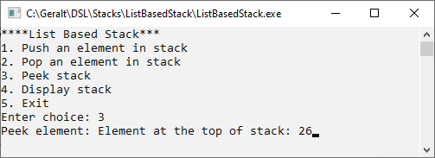
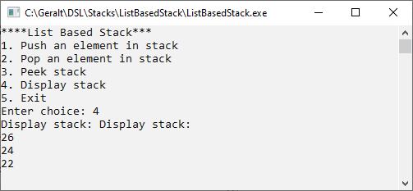


Program No | 13
Name | Shubham Sarang
Roll No | 1345
Topic | Stacks
Title of Program | ListBasedStack

/*
Name: Shubham Sarang
Roll no: 1345
Unit 3:Stacks
Program: List based Stack
*/

#include<iostream>
#include<conio.h>
using namespace std;

class SNode
{
public:
int data;
SNode *next;
};

class LStack
{
SNode *tos;
public:
LStack()
{
tos = NULL;
}
void Push(int x);
void Pop();
void Peek();
void Display();
};

void LStack::Push(int x)
{
SNode *t = new SNode();
t->data = x;
t->next = NULL;
if(tos == NULL)
{
tos = t;
}
else
{
t->next = tos;
tos = t;
}
}
void LStack::Pop()
{
SNode *tmp = tos;
cout<<tmp->data<<" popped";
tos = tos->next;
delete tmp;
}

void LStack::Peek()
{
if(tos == NULL)
{
cout<<"Empty Stack";
return;
}
cout<<"Element at the top of stack: "<<tos->data;
}

void LStack::Display()
{
SNode *cnt = tos;
if(tos == NULL)
{
cout<<"Empty Stack";
return;
}
cout<<"Display stack: \n";
while(cnt != NULL)
{
cout<<cnt->data<<"\n";
cnt = cnt->next;
}
}

int main()
{
int ch, num;
LStack l;
while(1)
{
system("cls");

cout<<"****List Based Stack***"<<endl;

cout<<"1. Push an element in stack \n";
cout<<"2. Pop an element in stack \n";
cout<<"3. Peek stack \n";
cout<<"4. Display stack \n";
cout<<"5. Exit \n";

cout<<"Enter choice: ";
cin>>ch;

switch(ch)
{
case 1:
cout<<"Push element: ";
cin>>num;
l.Push(num);
getch();
break;
case 2:
cout<<"Pop element: ";
l.Pop();
getch();
break;
case 3:
cout<<"Peek element: ";
l.Peek();
getch();
break;
case 4:
cout<<"Display stack: ";
l.Display();
getch();
break;
case 5:
exit(1);
default:
cout<<"Wrong choice bruv";
getch();
}
}
}

Output:

