Theorem 1

*The typical set* A(n) *has the following properties: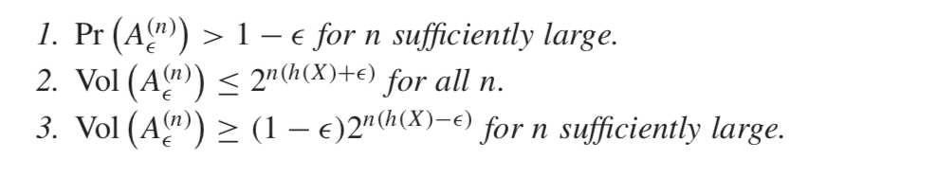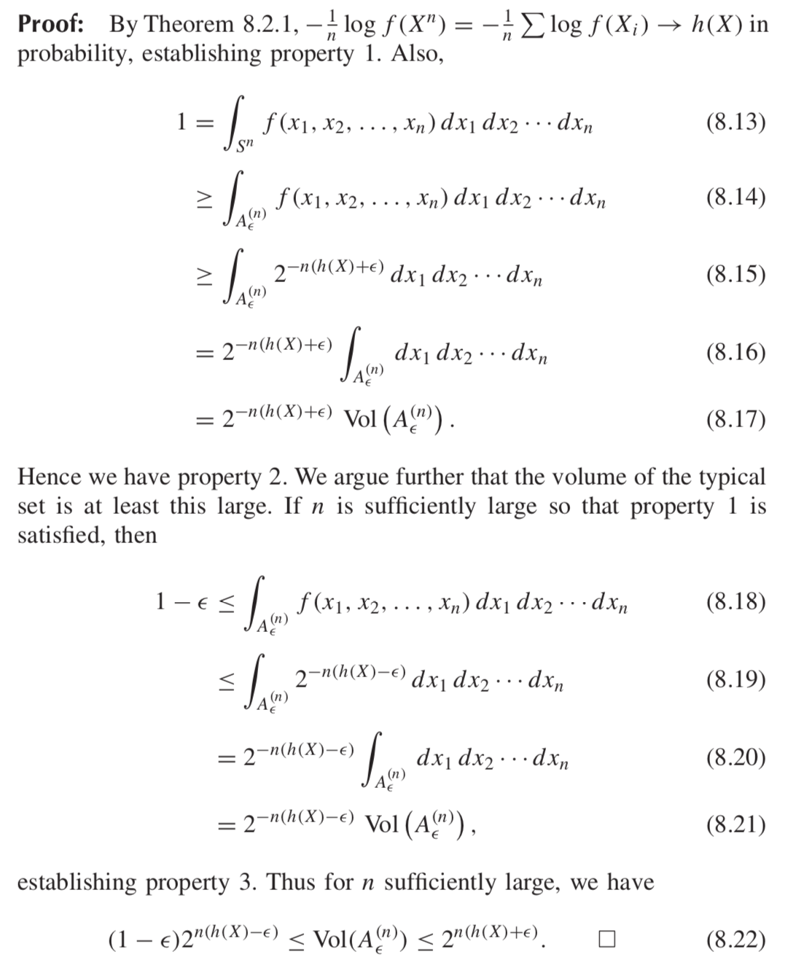*

Theorem 2

*The set* A(n) *is the smallest volume set with probability*

≥ 1 − e *, to first order in the exponent.*

Theorem 3

D(f ||g) ≥ 0, *with equality iff* f = g *almost everywhere (a.e.).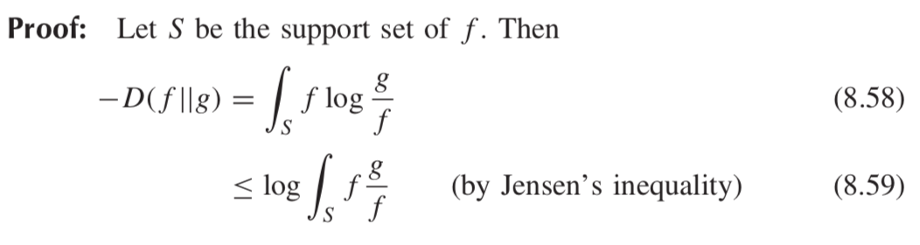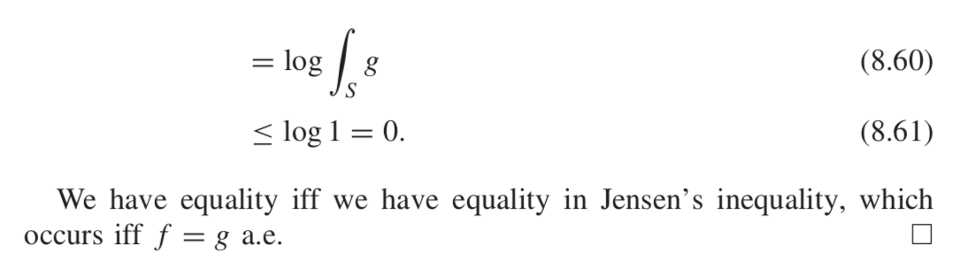*

Corollary I (X; Y ) ≥ 0 *with equality iff* X *and* Y *are independent.* Corollary h(X|Y ) ≤ h(X) *with equality iff* X *and* Y *are independent.*

Theorem 4

*Let the random vector* **X** ∈ **R**n *have zero mean and covariance* K = E**XX**t *(i.e.,* Kij = EXiXj*,* 1 ≤ i*,* j ≤ n*). Then* h(**X**) ≤ 1/2log(2πe)n|K|*, with equality iff* **X** ∼ N(0, K)*.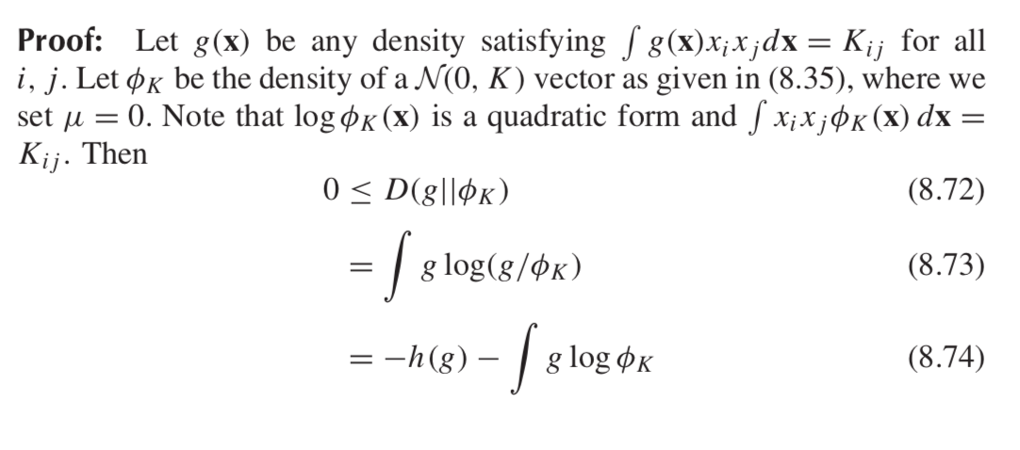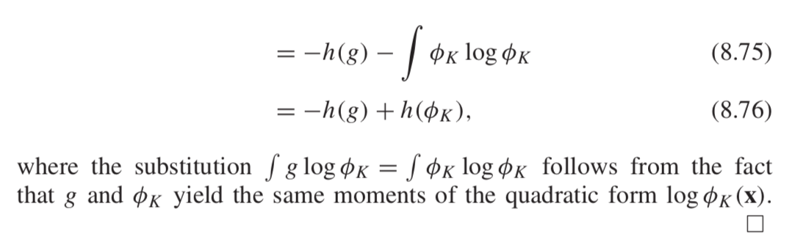*

Theorem 5 (*Estimation error and differential entrop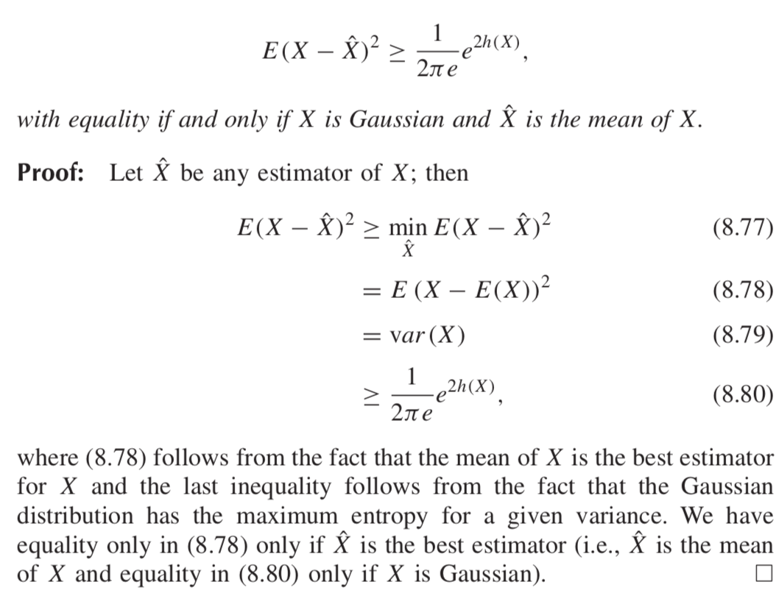y* )   
*For any random variable* X *and estimator* Xˆ *,*