Delta Team

Ryan Norrbom, Gerardo Cordero, Eric Williams-Phillips, Bayleigh Kelton

CSD310

Assignment 10.1

Feb 24th, 2024

Milestone 2: ERD & Example Data

For Milestone #2, we have outlined an ERD with relationships that show how Bookings, Sales, and Inventory relate to the Customers, Equipment, and Trips tables.

* **ERD Components**:
  + **Entities**: Customers, Trips, Equipment, Bookings, Sales, Inventory.
  + **Relationships**:
    - Customers can have multiple bookings and sales.
    - Trips are linked to bookings.
    - Equipment is linked to sales and tracked in inventory.

We have two Python Scripts and One SQL file. The created.py file is the main file and can be run within an IDE. The file will prompt the user for credentials, in plain text only, for their mySQL admin credentials. The script then creates the database for Outland Adventures. Following the creation of the Table, it will generate the example data.

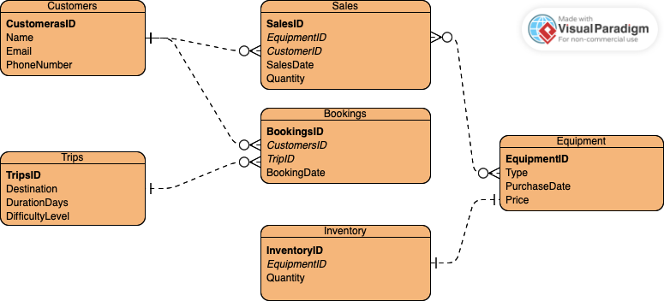

Figure 1: ERD Final Version

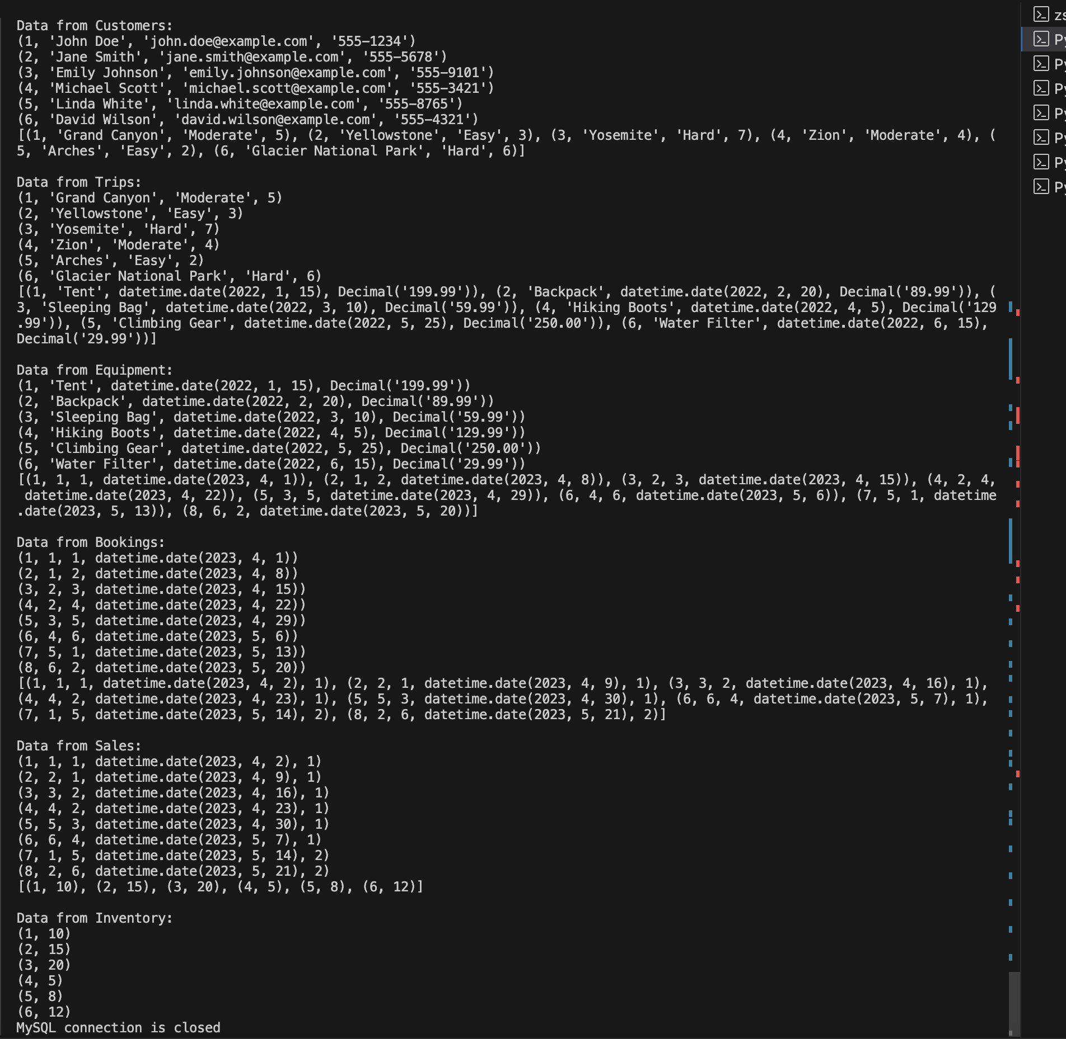

Figure 2: Out Put Displaying Data on the Tables

Discord Invite URL: <https://discord.gg/wqpx4NU4>

Ryan Norrbom GitHub Repository URL: <https://github.com/GeraltOfCodea/csd-310>

Eric Williams-Phillips GitHub Repository URL: <https://github.com/EricsMemory/csd-310>