Delta Team

Ryan Norrbom, Gerardo Cordero, Eric Williams-Phillips, Bayleigh Kelton

CSD310

Assignment 11.1

Feb 29th, 2024

Milestone 3: Python & Reports

For Milestone #3, we developed four reports to meet the needs of Outland Adventures with the resources available for the project. They are as follows:

* **Equipment Aging Report**: Lists equipment with purchase dates to identify potential needs for replacement or maintenance.
* **Trip Utilization Report:** Shows booking numbers for each destination to gauge popularity.
* **Equipment Sales Report**: Details sales quantities by equipment type to show customer preferences and revenue sources.
* **Repeat Customer Report**: Counts trips booked per customer to highlight customer loyalty and retention.

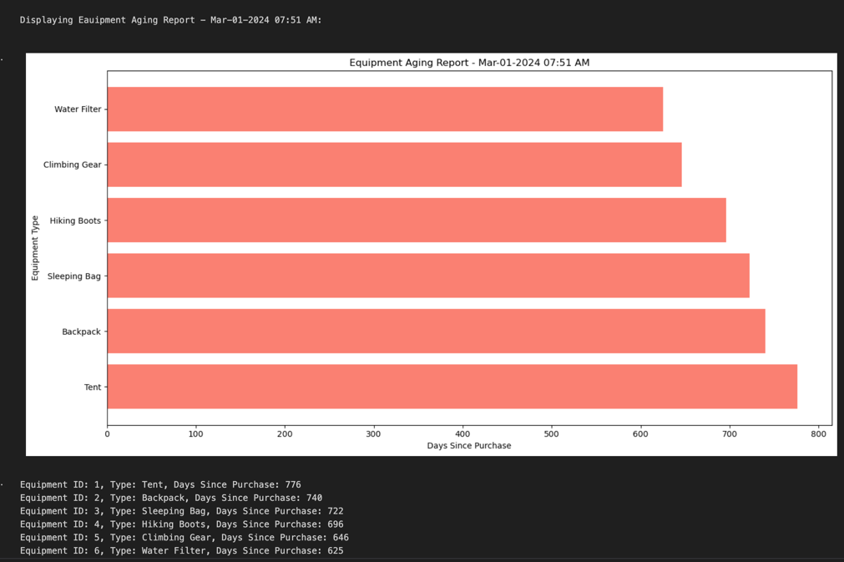

Figure 1: Equipment Aging Report

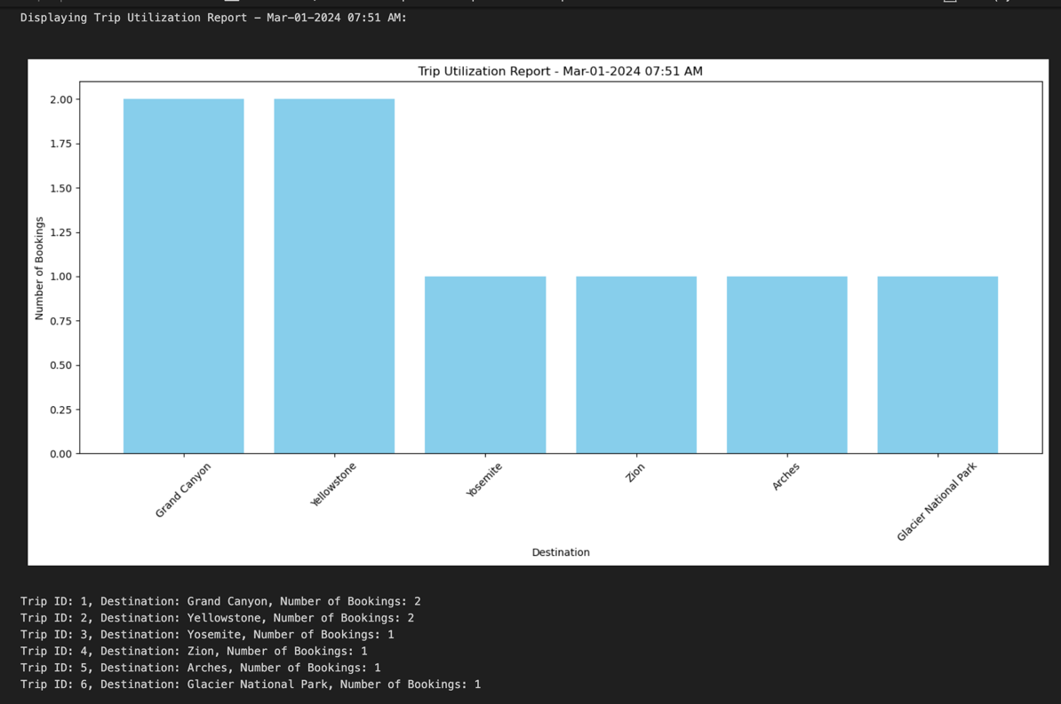

Figure 2: Trip Utilization Report

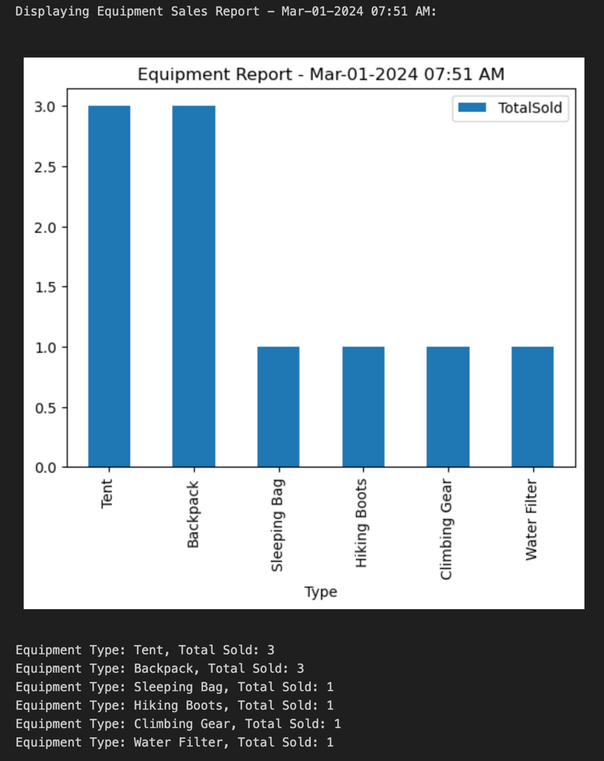

Figure 3: Equipment Sales Report

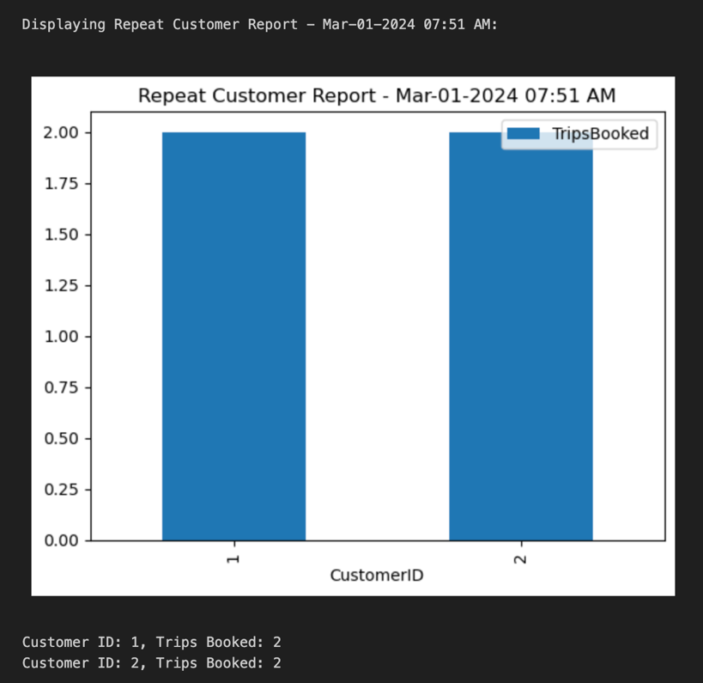

Figure 4: Repeat Customers Report

Discord Invite URL: <https://discord.gg/wqpx4NU4>

Ryan Norrbom GitHub Repository URL: <https://github.com/GeraltOfCodea/csd-310>

Eric Williams-Phillips GitHub Repository URL: <https://github.com/EricsMemory/csd-310>

Gerardo Cordero GitHub Repository URL: <https://github.com/onetimesomeday/csd-310>