Ryan Norrbom

CSD310

Assignment 2.2

Jan 20th, 2024

Duplicating an ERD – GeraltofCodea

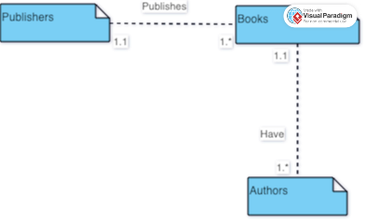

Figure 1: ERD, created on Visual Paradigm

GitHub Repository URL: <https://github.com/GeraltOfCodea/csd-310>