Ryan Norrbom

CSD310

Assignment 2.3

Jan 20th, 2024

Basic User Entity and NoSQL Databases – GeraltofCodea

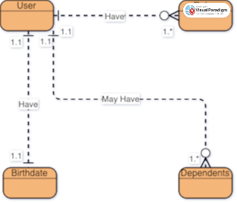

Figure 1: Entity Relationship, created on Visual Paradigm

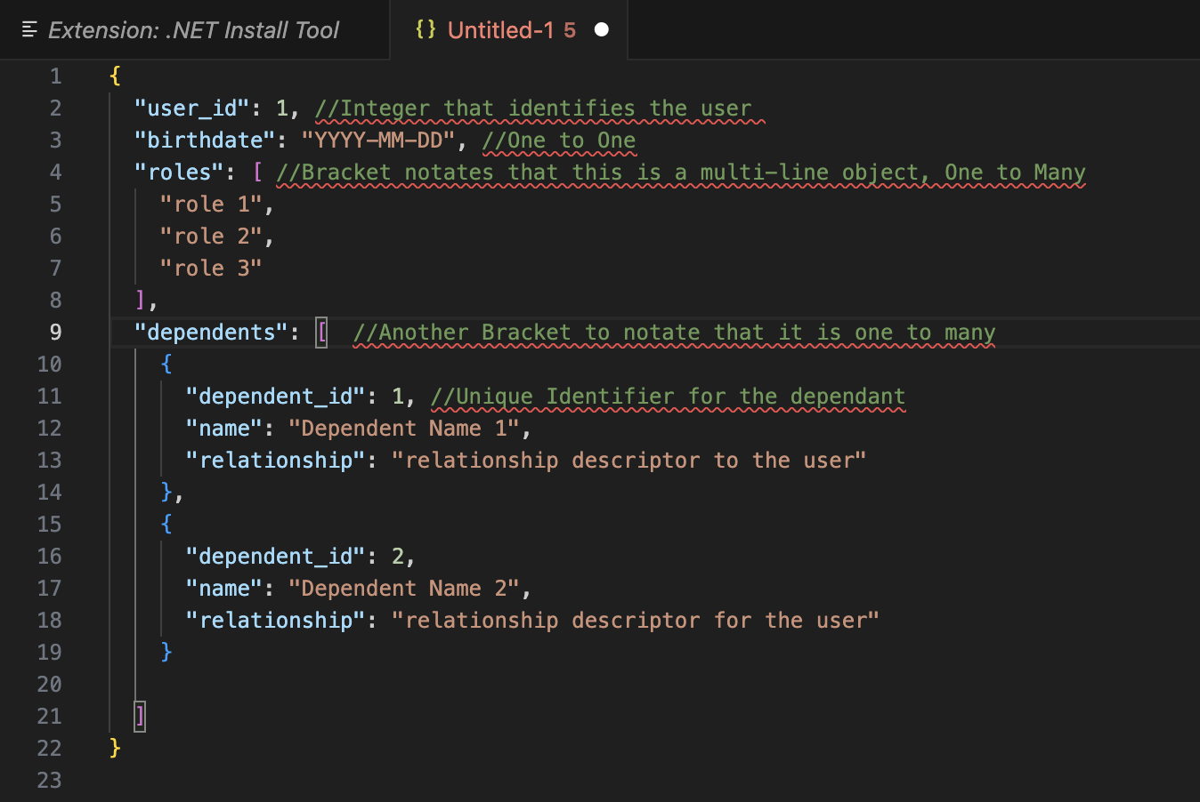

Figure 2: NoSQL User Database

GitHub Repository URL: <https://github.com/GeraltOfCodea/csd-310>