Ryan Norrbom

CSD310

Assignment 3.2

Jan 28th, 2024

1NF to 3NF for Books – GeraltofCodea

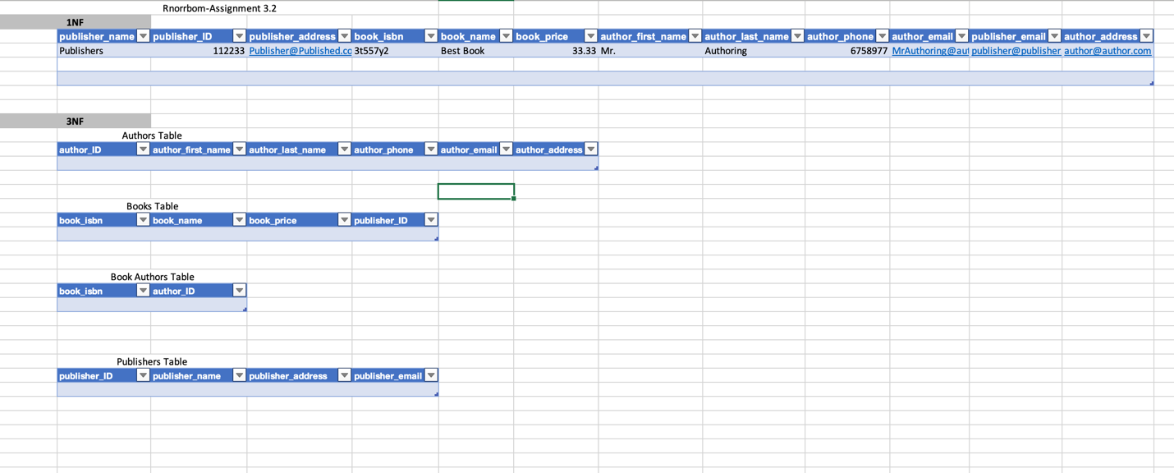

Figure 1: ERD, created on Visual Paradigm

GitHub Repository URL: <https://github.com/GeraltOfCodea/csd-310>