Ryan Norrbom

CSD310

Assignment 4.2

Feb 2nd, 2024

MySQL on My Machine – GeraltofCodea

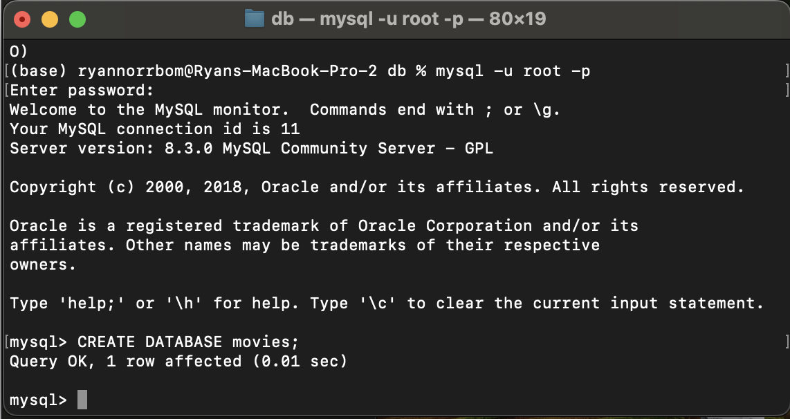

Figure 1: Connection Edition

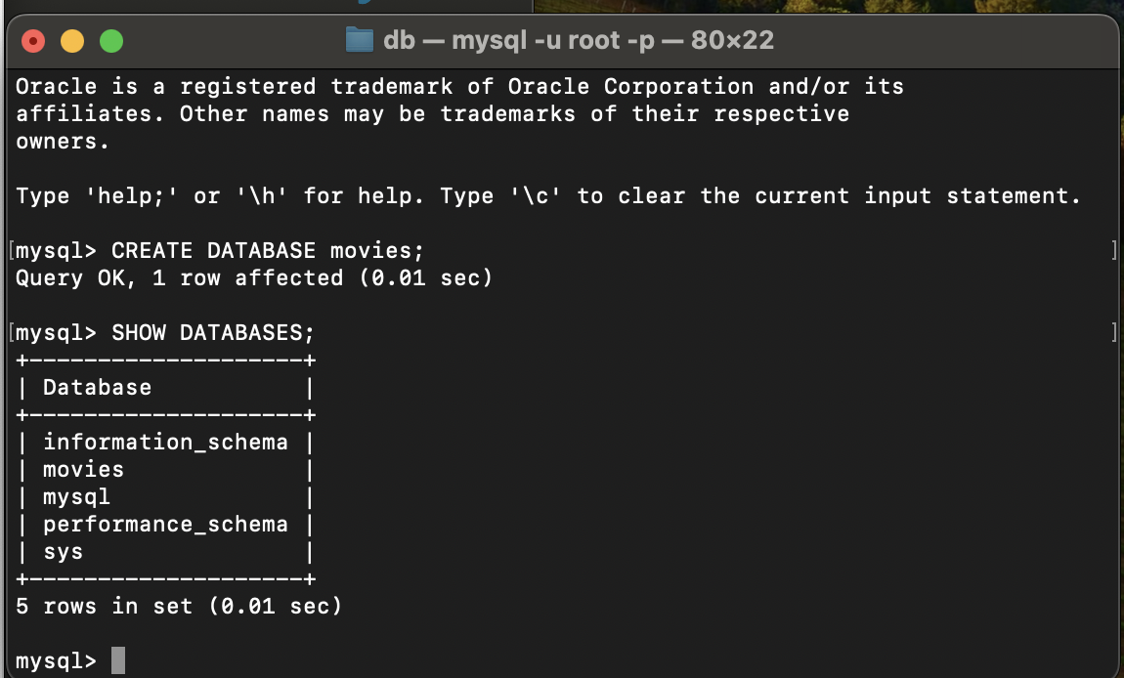

Figure 2: Databases (w/Movies)

GitHub Repository URL: <https://github.com/GeraltOfCodea/csd-310>