Ryan Norrbom

CSD310

Assignment 5.2

Feb 4th, 2024

MySQL Commands – GeraltofCodea

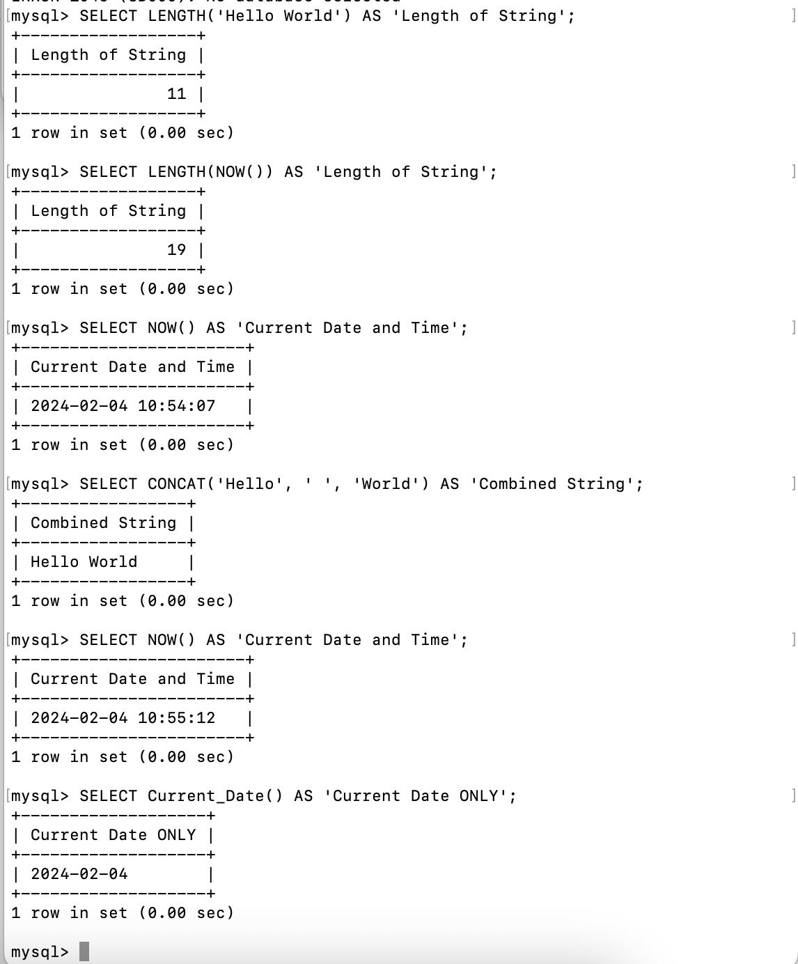

Figure 1: SQL Functions

* **NOW() Function**
  + **Purpose**: To retrieve the current date and time. NOW() grabs the current date as it is, including the time. In Figure 1, you can see that NOW ran across multiple time periods and outputs the explicit time. In contrast, Current_Date() only captures the date, also seen in Figure 1.
  + **SQL** **Statement**: *SELECT NOW() AS 'Current Date and Time';*

* **LENGTH() Function**
  + **Purpose**: To measure the length of a string. As seen in the image below, it can be used for text as well as the length of a function output, such as NOW().
  + **SQL** **Statement**: *SELECT LENGTH('Hello World') AS 'Length of String';*

* **CONCAT() Function**
  + **Purpose**: To concatenate (combine) multiple strings into one.
  + **SQL Statement**: *SELECT CONCAT('Hello', ' ', 'World') AS 'Combined String';*

GitHub Repository URL: <https://github.com/GeraltOfCodea/csd-310>

**References**:

MySQL functions. (n.d.). https://www.w3schools.com/sql/sql_ref_mysql.asp