Ryan Norrbom

CSD310

Assignment 5.3

Feb 4th, 2024

An ERD for Movies – GeraltofCodea

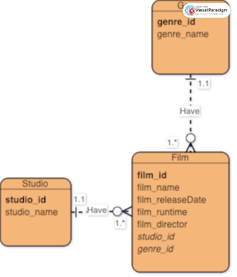

Figure 1: Movies ERD

GitHub Repository URL: <https://github.com/GeraltOfCodea/csd-310>