Ryan Norrbom

CSD310

Assignment 6.2

Feb 10th, 2024

Movies: DB Edition – GeraltofCodea

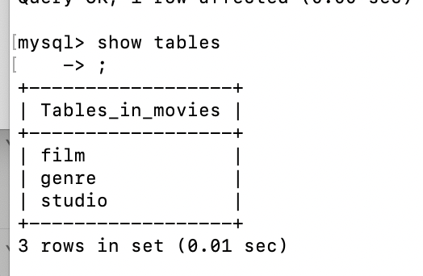

Figure 1: Movies Table

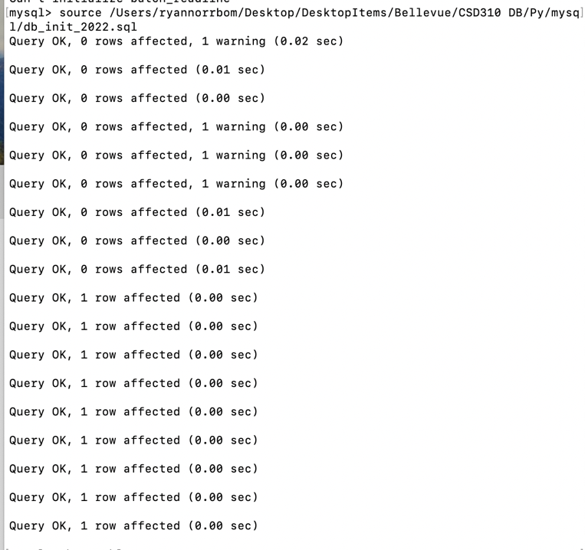

Figure 2: db_init_2022 run

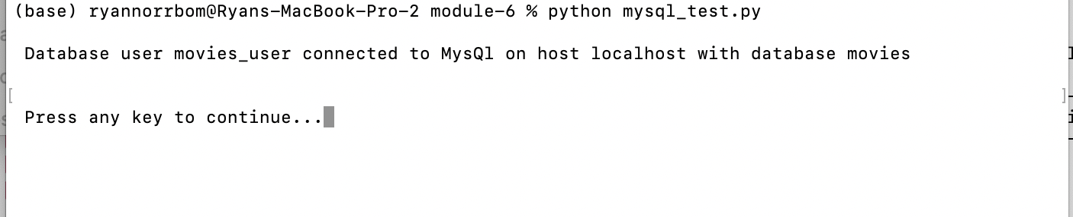

Figure 3: Successful Python Connection

GitHub Repository URL: <https://github.com/GeraltOfCodea/csd-310>