Ryan Norrbom

CSD310

Assignment 7.2

Feb 17th, 2024

Movies: Table Queries – GeraltofCodea

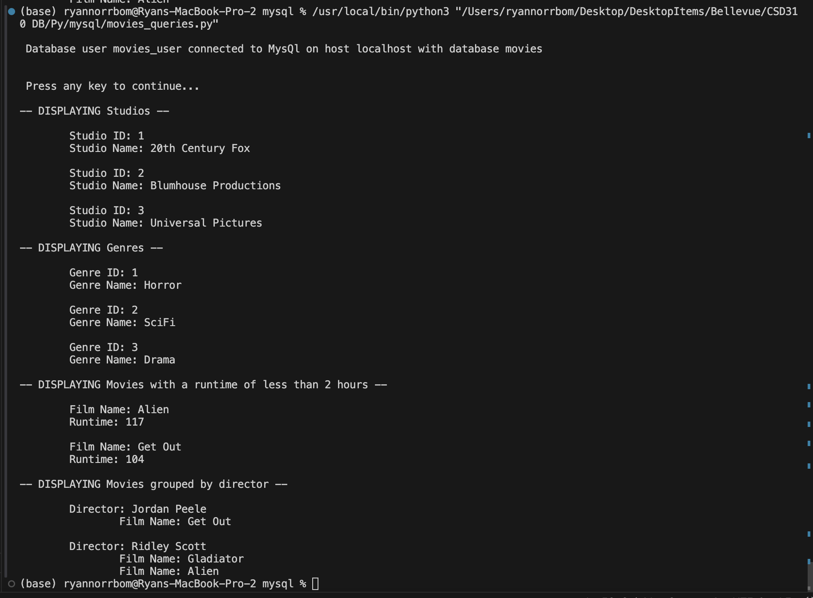

Figure 1: Python Code Execution

GitHub Repository URL: <https://github.com/GeraltOfCodea/csd-310>