Ryan Norrbom

CSD310

Assignment 8.2

Feb 17th, 2024

Movies: Updates & Deletes – GeraltofCodea

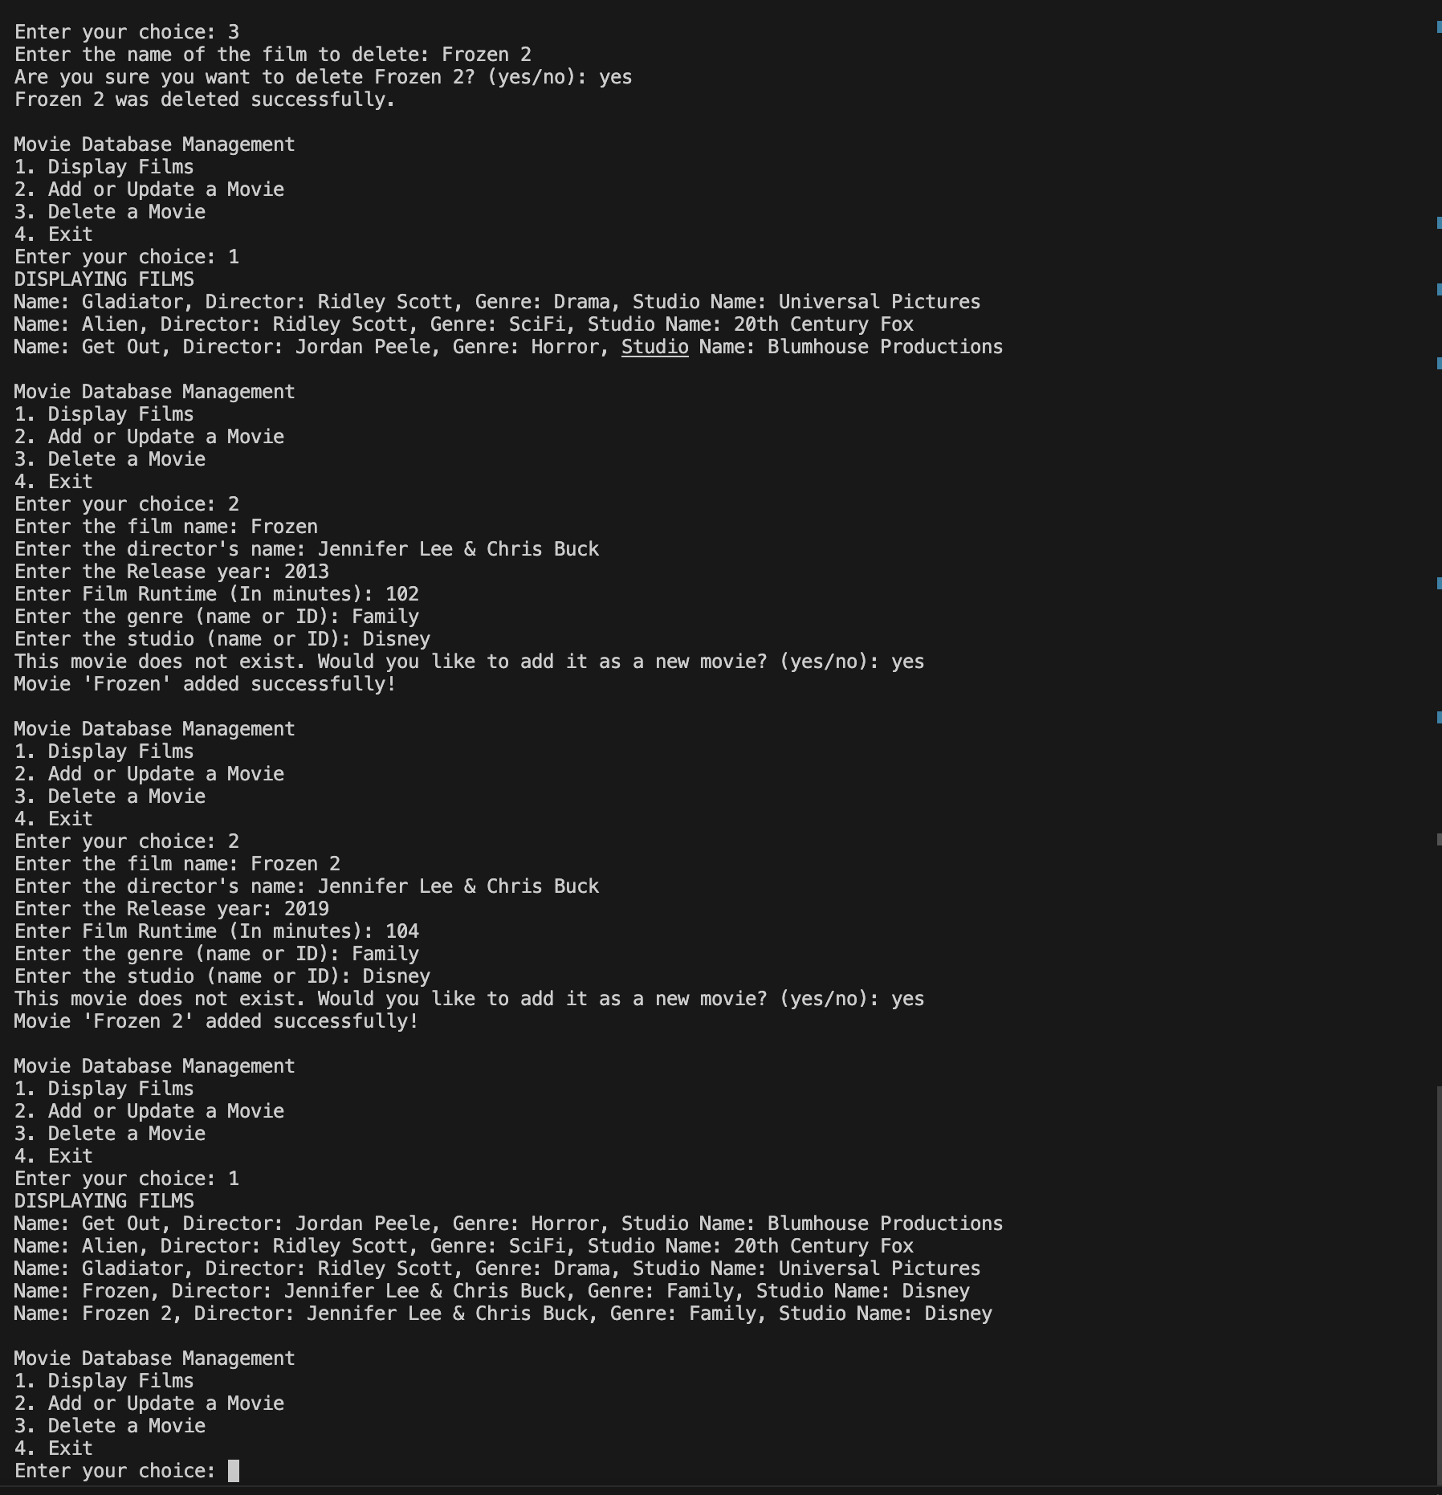

Figure 1: Movies Create/Update/Delete

Figure 2: Alien to Horror, Gladiator Gone

GitHub Repository URL: <https://github.com/GeraltOfCodea/csd-310>