Ryan Norrbom

CSD340

Assignment 1.2

March 22nd, 2024

HTML Starter Pack

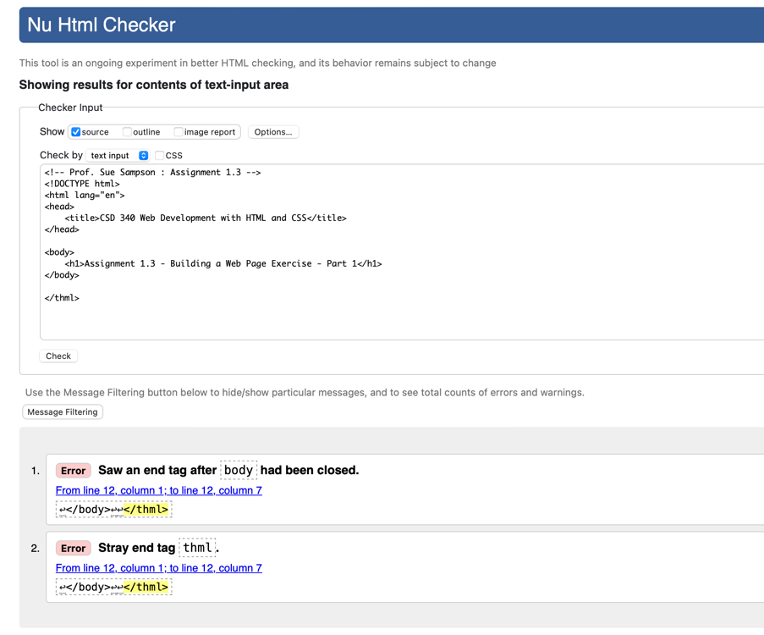

Figure 1: First Check, errors!

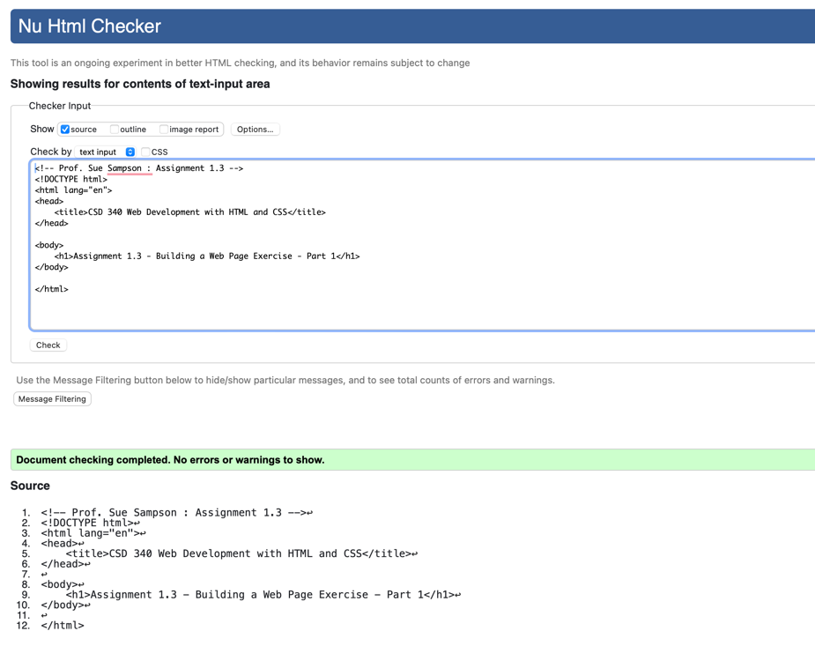

Figure 2: Fixed HTML

Figure 3: Starter code in browser

GitHub Repository URL: <https://github.com/GeraltOfCodea/csd-340>