Ryan Norrbom

CSD340

Assignment 3.2

March 29th, 2024

GitHub Pages

GitHub Pages URL: <https://geraltofcodea.github.io/csd-340/>

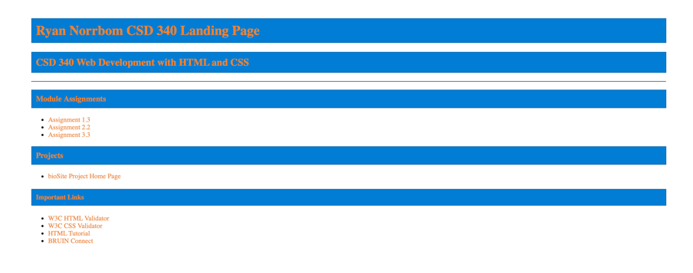

Figure 1: Home Page

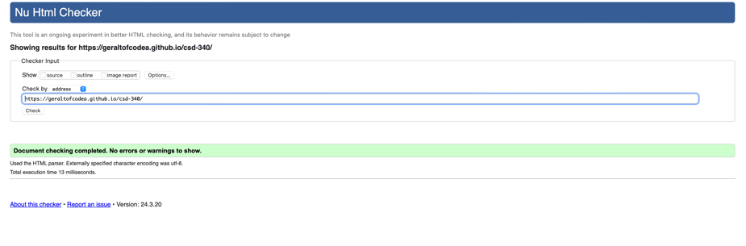

Figure 2: HTML Passed!

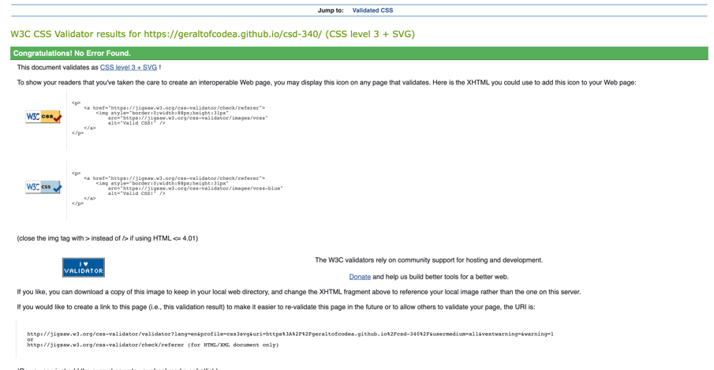

Figure 3: CSS Passed!

GitHub Repository URL: <https://github.com/GeraltOfCodea/csd-340>