Gerard Cano 17/1/25

**Programació**

**Act vectors1**

[Link vectors_act 1](https://github.com/GerardCano2006/Programation/blob/main/src/AEA2/Act_vector1.java)

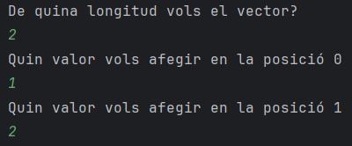

**Act vectors2**

[Link vectors_act 2](https://github.com/GerardCano2006/Programation/blob/main/src/AEA2/Act_vector2.java)

**Act matrius1**

[Link matriu act 1](https://github.com/GerardCano2006/Programation/blob/main/src/AEA2/Act1_matrius.java)

