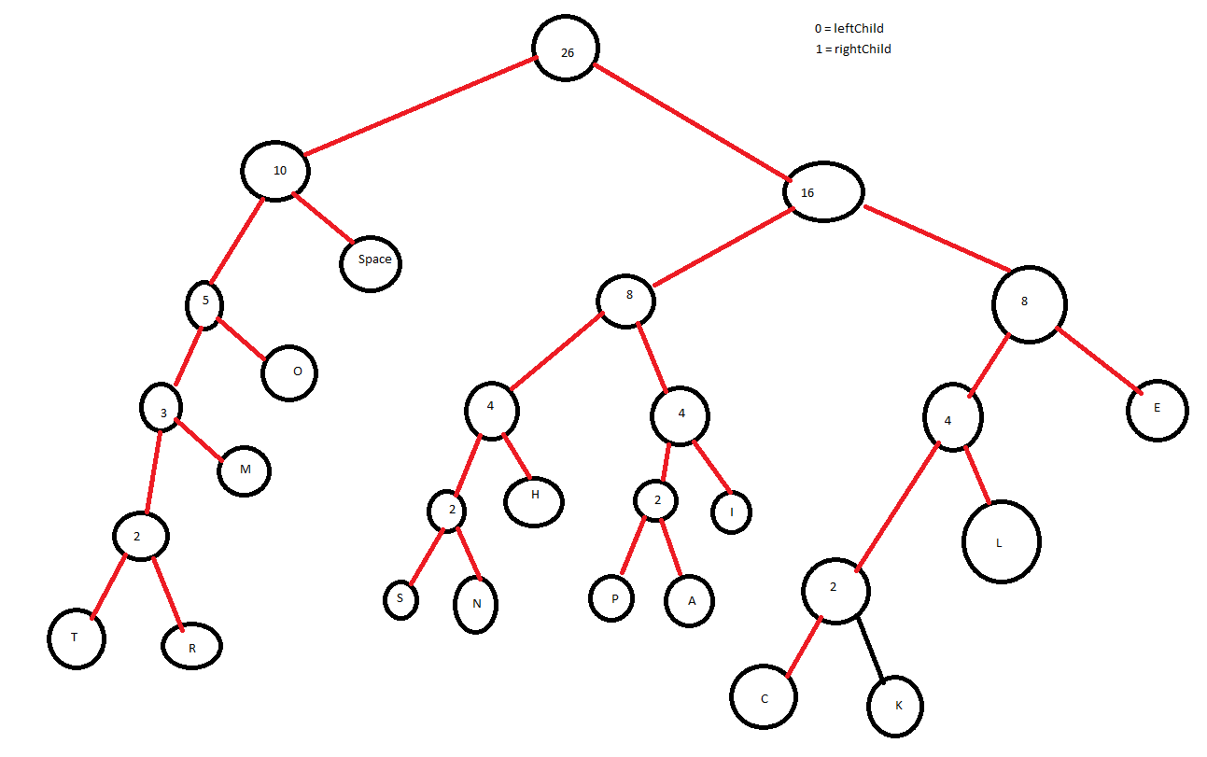Character frequency table

|  |  |  |  |  |  |  |  |  |  |  |  |  |  |  |
| --- | --- | --- | --- | --- | --- | --- | --- | --- | --- | --- | --- | --- | --- | --- |
| 1 | 2 | 4 | 1 | 2 | 1 | 1 | 2 | 1 | 2 | 1 | 1 | 1 | 1 | 5 |
| T | h | e | r | i | s | n | o | p | l | a | c | k | m | Space |

* Character Encoding
  + T = 00000
  + H = 1001
  + E = 111
  + R = 00001
  + I = 1011
  + S = 10000
  + N = 10001
  + O = 001
  + P = 10100
  + L = 1101
  + A = 10101
  + C = 11000
  + K = 11001
  + M = 0001
  + SPACE = 01

Encoded Sequence = 000001001111000011110110111000001100010010110100110110101110001110111011011110011110110010010001111