**Atributos de priorización**

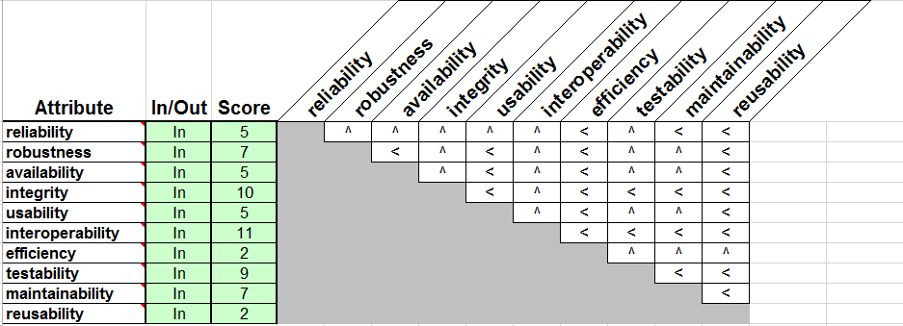

**Criterios**

|  |  |  |  |  |  |  |  |  |
| --- | --- | --- | --- | --- | --- | --- | --- | --- |
| Attribute | reliability | robustness | availability | integrity | usability | interoperability | testability | maintainability |
| Score | 5 | 7 | 5 | 10 | 5 | 11 | 9 | 7 |
| *Access Audit* |  |  |  | x |  |  |  |  |
| *Access Control* |  |  |  | x |  |  |  |  |
| Accuracy | x |  |  |  |  |  |  |  |
| *Application Independence* |  |  |  |  |  |  |  |  |
| *Application Reliability* | x |  | x |  |  |  |  |  |
| Auditability |  |  |  | x |  |  | x |  |
| Augmentation costs |  |  |  |  |  |  |  |  |
| *Commonality* |  |  |  |  |  | x |  |  |
| *Communication Efficiency* |  |  |  |  |  |  |  |  |
| Communicativeness |  |  |  |  | x |  |  |  |
| Complexity | x |  |  |  |  |  | x | x |
| *Computational Failure Recovery* | x |  | x |  |  |  |  |  |
| Conciseness |  |  |  |  |  |  |  | x |
| Consistency | x |  |  |  |  |  |  | x |
| Data commonality |  |  |  |  |  | x |  |  |
| *Document Accessibility* |  |  |  |  |  |  |  | x |
| Dynamic memory allocation | x |  |  |  |  |  | x | x |
| Error handling |  | x |  |  | x | x |  |  |
| Error tolerance | x |  |  |  |  |  |  |  |
| Expandability |  |  |  |  |  |  |  |  |
| *Failure Maintenance Testability* |  |  |  |  |  |  | x |  |
| *Generality* |  |  |  |  |  | x |  |  |
| GUI Standards |  |  |  |  | x |  |  | x |
| *Guidelines consistency* |  |  |  |  |  |  |  | x |
| *Hardware Failure Recovery* | x |  | x |  |  |  |  |  |
| Hardware independence |  |  |  |  |  |  |  |  |
| Hazard analysis |  | x |  |  |  |  |  |  |
| Inline code use |  |  |  |  |  |  | x | x |
| Instrumentation |  |  |  | x |  |  | x | x |
| Interface standards |  |  |  |  |  | x |  |  |
| *Modularity* | x |  |  |  |  | x | x | x |
| Module size |  |  |  |  |  |  | x |  |
| MTBF | x |  | x |  |  |  |  |  |
| MTTR |  |  | x |  |  |  |  |  |
| *Operability* |  |  |  |  | x |  |  |  |
| *Power Usage Efficiency* |  |  |  |  |  |  |  |  |
| *Processing Efficiency* |  |  |  |  | x |  |  |  |
| Response times |  |  |  |  | x |  |  |  |
| Security |  |  |  | x |  |  |  |  |
| *Self-descriptiveness* |  |  |  |  |  |  | x | x |
| *Simplicity* | x |  |  |  |  |  | x | x |
| *Software system independence* |  |  |  |  |  | x |  |  |
| *Storage Efficiency* |  |  |  |  |  |  |  |  |
| *System Compatibility* |  |  |  |  |  | x |  |  |
| *System Reliability* | x |  | x |  |  |  |  |  |
| *Traceability* |  |  |  |  |  |  | x | x |
| *Training* |  |  |  |  | x |  |  |  |
| *User Testability* |  |  |  |  |  |  | x |  |
| count | 12 | 2 | 6 | 5 | 7 | 8 | 12 | 13 |

**Atributos de compensación**

