La parte de instalación del sistema OPNsense la salté, pero para instalar solo deben entrar con el usuario: installer y la contraseña: opnsense y seguir los pasos de instalación.

Login de primer inicio: root
Contraseña de primer inicio: opnsense
Nos muestra un conjunto de opciones como lo siguiente:
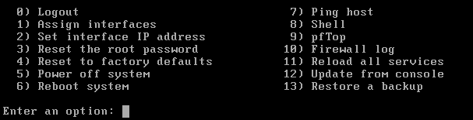
Seleccionamos la opción 1) Assign Interfaces.
Do you want to configure LAGGs now? [Y/N]: N
Do you want to configure VLANs now? [Y/N]: N
Nos muestra las interfaces que definimos cuando creamos la máquina virtual.
En mi caso:
em0 -> WAN (NAT)
em1 -> LAN Test (Máquinas virtuales con salida a internet sin acceso a red de gestión)
em2 -> Admin OPT1 (Solo host windows)
Enter the WAN interface name or ‘a’ for auto-detection: em0
Enter the LAN interface name or ‘a’ for auto-detection: em1
Enter the Optional Interface 1 name or ‘a’ for auto-detection: em2
Enter the Optional Interface 2 name or ‘a’ for auto-detection (or nothing if finished): Enter
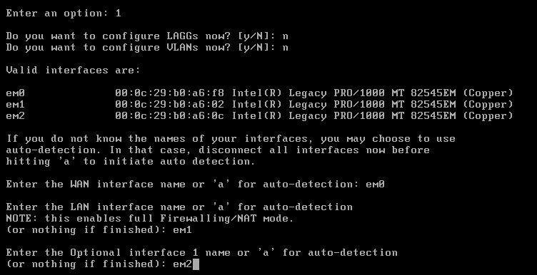
The interfaces will be assigned as follows:
WAN -> em0
LAN -> em1
OPT1 -> em2
Do you want to proceed? [y/n]: y

Nos regresa al menu inicial, con configuraciones por defecto para las interfaces. Ahora estableceremos las direcciones IP que definimos al principio.
Seleccionamos la opción 2) Set interface IP Address
Available interfaces:
1 – LAN (em1 – static, idassoc6)
2 – OPT1 (em2)
3 – WAN (em0 – dhcp, dhcp6)
Enter the number of the interface to configure: 3
Configure IPv4 address WAN interface via DHCP? [y/n]: N
Enter the new WAN IPv4 address. Press Enter for none: 192.168.174.130
Enter the new WAN IPv4 subnet bit count (1 to 32): 24
For a WAN, enter the new WAN IPv4 upstream gateway address
For a LAN, press (enter) for none: 192.168.174.1
Do you want to use the gateway as the IPv4 name server, too? [y/n]: n
Enter the IPv4 name server or press ENTER: 8.8.8.8
Configure IPv6 address WAN interface via DHCP6? [y/n]: n
Enter the new WAN IPv6 address. Press ENTER for none: ENTER
Do you want to change the web GUI protocol from HTTPS to HTTP? [Y/N]: N
Do you want to generate a new self-signed web GUI certificate? [y/n]: n
Restore web GUI access defaults? [y/n]: n

Seleccionamos la opción 2) Set interface IP Address
Available interfaces:
1 – LAN (em1 – static, idassoc6)
2 – OPT1 (em2)
3 – WAN (em0 – dhcp, dhcp6)
Enter the number of the interface to configure: 1
Configure IPv4 address LAN interface via DHCP? [y/n]: N
Enter the new LAN IPv4 address. Press Enter for none: 172.16.1.1
Enter the new LAN IPv4 subnet bit count (1 to 32): 24
For a WAN, enter the new WAN IPv4 upstream gateway address
For a LAN, press (enter) for none: ENTER
Configure IPv6 address LAN interface via DHCP6? [y/n]: n
Enter the new LAN IPv6 address. Press ENTER for none: ENTER
Do you want to enable the DHCP server on LAN? [Y/N]: N
Do you want to change the web GUI protocol from HTTPS to HTTP? [Y/N]: N
Do you want to generate a new self-signed web GUI certificate? [y/n]: n
Restore web GUI access defaults? [y/n]: n
Tenemos configuradas dos interfaces de red hasta ahora.
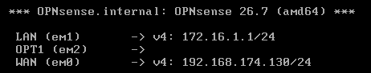

Seleccionamos la opción 2) Set interface IP Address
Available interfaces:
1 – LAN (em1 – static, idassoc6)
2 – OPT1 (em2)
3 – WAN (em0 – dhcp, dhcp6)
Enter the number of the interface to configure: 2
Configure IPv4 address OPT1 interface via DHCP? [y/n]: N
Enter the new LAN IPv4 address. Press Enter for none: 172.16.10.1
Enter the new LAN IPv4 subnet bit count (1 to 32): 24
For a WAN, enter the new WAN IPv4 upstream gateway address
For a LAN, press (enter) for none: ENTER
Configure IPv6 address LAN interface via DHCP6? [y/n]: n
Enter the new LAN IPv6 address. Press ENTER for none: ENTER
Do you want to enable the DHCP server on LAN? [Y/N]: N
Do you want to change the web GUI protocol from HTTPS to HTTP? [Y/N]: N
Do you want to generate a new self-signed web GUI certificate? [y/n]: n
Restore web GUI access defaults? [y/n]: n

Quedaron configuradas las tres interfaces:
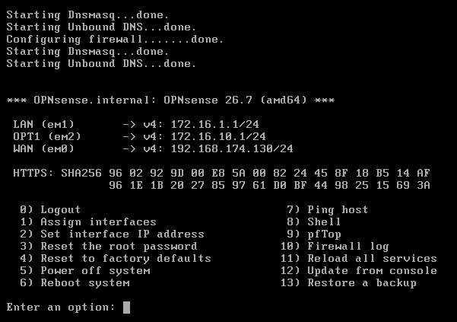

Iniciamos la máquina Kali
Primero veremos que interfaces de red tenemos.
Nmcli connection show
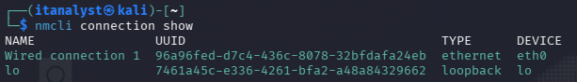
nmcli connection show “Wired connection 1”| grep “ipv4” -> Vemos las propiedades de la conexión.
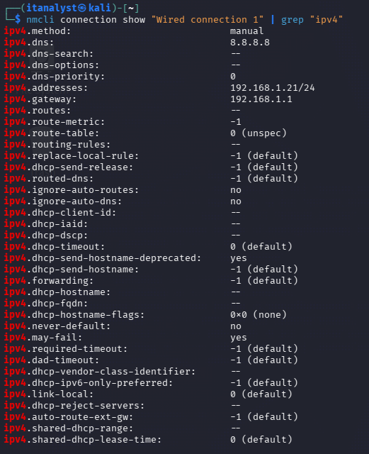
Sudo nmcli connection down “Wired connection 1” -> Apagamos la tarjeta de red para hacer las modificaciones.
Sudo nmcli connection modify “Wired connection 1” ipv4.addresses 172.16.1.3/24 ipv4.gateway 172.16.1.1 ipv4.dns “8.8.8.8” ipv4.method manual -> Asignamos ip estática
Sudo nmcli connection up “Wired connection 1” -> Encedemos la tarjeta de red con los cambios hechos.
Hacemos ping nuevamente al firewall y ya deberíamos recibir respuesta.
Ping 172.16.1.1

Establecemos una regla en el firewall para tener acceso desde nuestra máquina Windows con la dirección 172.16.10.2

